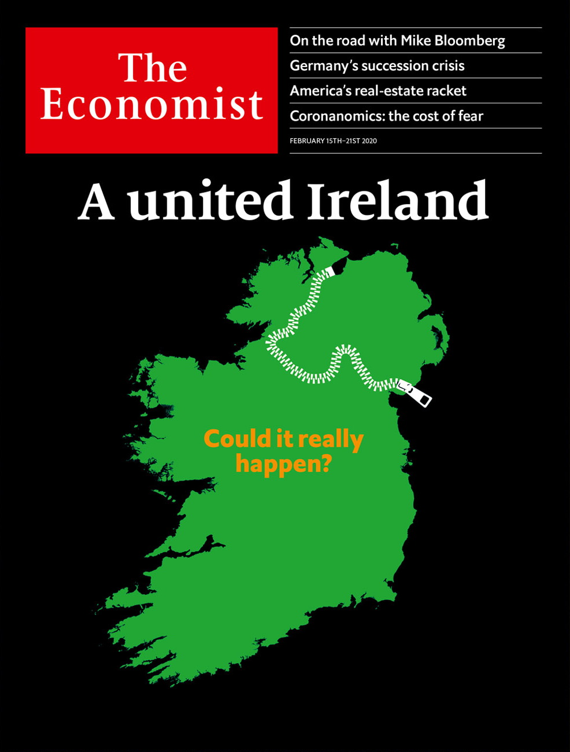

# Table of Contents

The world this week

Politics this week

Business this week

KAL’s cartoon

Leaders

A united Ireland: Could it really happen?

Germany: Bad heir day

Disease and growth: Viral slowdown

The wrong person for the Fed: Shel-no

Property in America: The real-estate racket

Letters

Letters to the editor: On housing

Briefing

A united Ireland: Is some revelation at hand?

United States

The economics of migration: Delayed reaction

Political revenge: Department of Selective Justice

Mayor Pete’s progress: Seeking an edge, edge

Ethical landmines: Watch your step

Trumpenomics: Vin-dictive

Lexington: Mike Bloomberg’s moment

The Americas

Canadian health care: Justin Trudeau’s drug problem

El Salvador: Bukele up

Bello: “What is Peronism?”

Asia

Social conservatism in the Philippines: Papal power

Duterte v America: A treaty for a visa

Ethnic tensions in Kazakhstan: Fire and fury

Elections in Delhi: Capital loss

Banyan: Belt and roadblock

China

The virus and the economy: Business in paralysis

The virus and politics: The hard men

Chaguan: Death of an everyman

Middle East and Africa

Diplomacy: Frustrated are the peacemakers

Qatar: Tamim the gloriously tolerant

Religious politics in Israel: Shabbat riders

Kenya: I shot the DJ

The International Criminal Court: A day of reckoning nears

Europe

Germany’s government: Trouble at the top

Kosovo: A new start

Russia: Show trials

France: The emoji wars

Charlemagne: Making Europe boring again

Britain

Northern Ireland: Blessed are the merciful

Competition policy: Ripping into the rip-off merchants

Reshuffle: Number 11’s new incumbent

Restitution of cultural artefacts: Spears and spires

Politics: Leftward ho!

Growth: Keeping down with the trends

Public toilets: Spending a penny

Public transport: Omnibus no longer

Bagehot: The perils of Lennonism

International

Covid-19: Curbing the Asian contagion

Covid-19 and trade: A deadly disease disrupts

Business

Armsmakers in the Middle East: From muskets to missiles

Restaurants: Chasing Ronald

Remote advertising: Hoarding cash

Elliott v SoftBank: Singer-Son time

Bartleby: Teenage picks

Business education: MBAs with Chinese characteristics

Schumpeter: The Qualcommunist manifesto

Finance and economics

Real estate in America: Tearing down the house

The International Monetary Fund: Structural adjustment

The World Bank: The Goldberg variations

Sustainability-linked debt: Green paper

African currencies: Value judgments

Buttonwood: Eyeing the storm

Free exchange: Trickle-up economics

Science and technology

Metabolites and you: Shed-loads of chemicals

Climate change: Goodish news

Solar physics: Hot topics

Animal behaviour: Lake-bed properties

Books and arts

Power from the people: Too much of a good thing

The Academy Awards: Creepy crawlies

Johnson: Original sins

Tom Stoppard’s new play: Laughter in the dark

Economic and financial indicators

Economic data, commodities and markets

Graphic detail

Behavioural finance: Price and prejudice

Obituary

Li Wenliang: The man who knew



### Friday, February 14, 2020

|  |  |
| --- | --- |
| The world this week | 3 |
| Leaders | 5 |
| Letters | 1 |
| Briefing | 1 |
| United States | 6 |
| The Americas | 3 |
| Asia | 5 |
| China | 3 |
| Middle East and Africa | 5 |
| Europe | 5 |
| Britain | 9 |
| International | 2 |
| Business | 7 |
| Finance and economics | 7 |
| Science and technology | 4 |
| Books and arts | 4 |
| Economic and financial indicators | 1 |
| Graphic detail | 1 |
| Obituary | 1 |

|  |  |  |
| --- | --- | --- |
|  | Sections | Leaders |

The world this week

Politics this week

.

Business this week

.

KAL’s cartoon

.

|  |  |  |
| --- | --- | --- |
|  | Sections | Leaders |

|  |  |  |  |
| --- | --- | --- | --- |
|  | Articles | Sections | Next |

# Politics this week

Feb 15th 2020 |



A general election in Ireland produced a shock win for Sinn Fein, formerly the political wing of the IRA, a terrorist group. The party took the most first-choice votes, but ended up coming second in terms of seats in the Dail (parliament). Ireland now faces weeks or months of negotiations to produce a new government, which might bring Sinn Fein to power for the first time, as part of a coalition.

Annegret Kramp-Karrenbauer abruptly resigned as leader of Germany’s ruling Christian Democrats, and said she will not be a candidate to succeed Angela Merkel as the country’s chancellor. This followed a damaging row over the party’s conduct in the eastern state of Thuringia, where it in effect ended up working with the xenophobic Alternative for Germany.

Boris Johnson, Britain’s prime minister, gave the final approval to continue HS2, a high-speed rail link between London and northern cities. The project was on hold after the costs rose above £100bn ($130bn). Mr Johnson also announced other ambitious transport plans outside London, such as road improvements, 4,000 zero-emission buses and “Mini Holland” schemes to promote bike lanes in town centres.

## The military option

El Salvador’s president, Nayib Bukele, brought rifle-toting troops into the country’s National Assembly to force it to approve a $109m loan to finance his crime-fighting programme. Lawmakers decried an “attempted coup”. He eventually left the building.

Adriano da Nóbrega, the reputed head of a paramilitary group accused of killing Marielle Franco, a left-wing city councillor in Rio de Janeiro in 2018, was himself killed. Police in the north-eastern Brazilian state of Bahia say Mr da Nóbrega opened fire when they tried to arrest him and was shot dead. Opposition politicians speculated that he was killed to keep him quiet.

Pope Francis decided against ordaining married men in the Amazon, a region that has a shortage of Catholic priests. Rather than weakening the church’s commitment to priestly celibacy, he used an “Apostolic Exhortation” to urge bishops to “be more generous in encouraging those who display a missionary vocation to opt for the Amazon region”.

## Former front-runners fall foul

Bernie Sanders won the New Hampshire primary, but not by much. Pete Buttigieg was a close second and Amy Klobuchar, another moderate, came third. Elizabeth Warren and Joe Biden trailed far behind. The next contest in the race for the Democratic presidential nomination is in Nevada on February 22nd.

With the ink barely dry on his impeachment acquittal in the Senate, Donald Trump took his revenge on witnesses who had testified to the House. Lieutenant-Colonel Alexander Vindman, a point man on Ukraine, was booted off the National Security Council and marched out of the White House. Gordon Sondland was dismissed as America’s ambassador to the European Union.

Four prosecutors who recommended a stiff prison term for Roger Stone, a confidant of Mr Trump who has been convicted on charges relating to the Mueller probe, resigned from the case after the Justice Department pushed for a lighter punishment. Mr Trump had earlier tweeted that he thought the prosecutors’ recommendation was “horrible and unfair”.

## See you in court (maybe)

The new Sudanese government said it would hand over Omar al-Bashir to face war-crime charges before the International Criminal Court. Mr Bashir was deposed as Sudan’s president in April last year amid huge street protests against his bloody regime, which was behind the genocide in Darfur. When or where he will appear before ICC judges is unclear.

The White House confirmed that the leader of al-Qaeda’s offshoot in the Arabian peninsula had been killed. Qasim al-Raymi was hit by a missile in Yemen, where his group carried out most of its attacks. It was also behind the massacre at the Charlie Hebdo magazine in Paris in 2015.

Five more Turkish troops were killed by the Syrian army as it continued its offensive against rebels in Idlib province, the last opposition holdout. Turkish troops are in the area under an agreement trying to de-escalate the conflict. Turkey struck back at Syrian positions.

## The new normal

The lunar new-year holiday, extended in many Chinese provinces because of the spread of a new coronavirus, officially ended. But many businesses remained closed because of quarantine and travel restrictions. Among the fatalities was a doctor, Li Wenliang, who had been reprimanded in January by police in Wuhan, the centre of the epidemic, for revealing the threat. Many people mourned for him online, calling for freedom of speech. The Communist Party reshuffled the leadership of Hubei province, which contains Wuhan. It also demoted the top official responsible for Hong Kong affairs.

Rodrigo Duterte, the president of the Philippines, ended an agreement making it easy for American soldiers to visit the country for joint exercises. Without evidence, he accused American forces of bringing nuclear weapons to the country. He also denounced America’s decision to cancel the visa of Ronald dela Rosa, an ally who led his bloodthirsty war on drugs.

India’s ruling Bharatiya Janata Party was thrashed in elections in Delhi. The opposition retained its lopsided majority in the local assembly, following months of protests against the BJP’s anti-Muslim amendments to citizenship laws.

The EU suspended preferential tariffs for $1bn-worth of Cambodian exports because of Cambodia’s suppression of democracy. Hun Sen, its strongman prime minister, said his country would not “bow down” to foreigners.

An off-duty soldier killed 29 people in a shooting spree in the city of Nakhon Ratchasima in Thailand. He was apparently enraged by a financial dispute with the family of his commanding officer.

Mobs attacked villages in Kazakhstan inhabited by Dungans, a tiny ethnic group with origins in China, after rumours spread that Dungans had attacked an elderly Kazakh man. Eight people died, scores were injured and thousands fled to nearby Kyrgyzstan.



“Parasite”, a South Korean comedy thriller,was the surprise winner at the Oscars. It beat the bookies’ favourite, “1917”, to scoop best picture, the first foreign film to do so, and best director. Hollywood stars spouted platitudes about diversity and stealing baby cows. The ceremony had its worst-ever viewing figures.

This article was downloaded by calibre from <https://www.economist.com/the-world-this-week/2020/02/15/politics-this-week>

|  |  |  |  |
| --- | --- | --- | --- |
|  | Articles | Sections | Next |

|  |  |  |  |
| --- | --- | --- | --- |
| Previous | Articles | Sections | Next |

# Business this week

Feb 15th 2020 |

SoftBank reported only a tiny operating profit of ¥2.6bn ($24m) for the latest quarter because of more losses at its Vision Fund for startups, which has come under scrutiny after a number of poor investments, most notably in WeWork. The drop in earnings comes after Elliott, an activist hedge fund known for its combative push for change at the companies it invests in, pressed the Japanese conglomerate to undertake a $20bn share buy-back. Son Masayoshi, SoftBank’s boss, took a conciliatory approach to Elliott’s intervention, saying “We are thankful that such a distinguished investor has joined us as a friend.”

The day before it released its earnings, SoftBank had some good news when a federal judge ruled in favour of T-Mobile’s takeover of Sprint. SoftBank, which is Sprint’s parent company, saw its share price soar by 12% after the acquisition cleared its last hurdle. But media reports suggest that Deutsche Telekom, the parent company of T-Mobile, might seek better terms because Sprint’s financial position has weakened since the deal was announced in April 2018.

## Thiam to go

Tidjane Thiam was ousted as chief executive of Credit Suisse, following last year’s revelations that the Swiss bank had conducted surveillance on two former executives. With a plot worthy of a spy novel, the bank’s former chief operating officer hired private detectives to trail the executives. One monitoring episode was even dubbed “Operation Küsnacht” after the rich suburb in which it was carried out. Mr Thiam insists he was unaware of the spying. He was supported by investors, but that was not enough to save his job. The bank, meanwhile, reported a 69% rise in annual net profit.

Barclays said that its chief executive, Jes Staley, was being investigated by regulators about his past links to Jeffrey Epstein, a deceased financier who trafficked under-age girls for sex. Mr Staley says he has had no contact with Epstein since taking the reins at the bank in December 2015. The board expressed confidence in Mr Staley, who has been “sufficiently transparent”.

Amid continuing tension between staff and management, Google’s head of human resources said she was leaving the role to spend more time with her family. Google has warned its employees to tone down their sometimes public opposition to its dealings, such as a censored search engine in China and defence work.

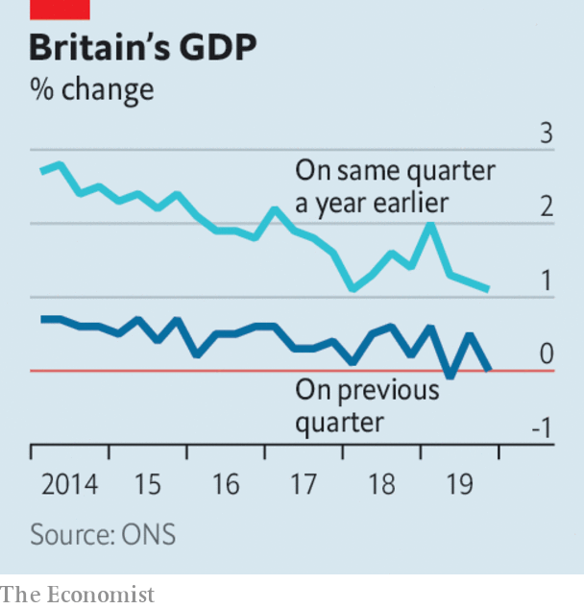

British GDP was flat in the final quarter of 2019 compared with the previous three months. Year on year, the economy grew by just 1.1%, the weakest by that measure since the start of 2018. A lack of capital investment was a major drag on the economy in the fourth quarter, a factor that also had a negative impact in the previous two quarters.

Turkey’s banking regulator intervened to prop up the lira during a bout of volatile trading, tightening the restrictions on foreign-exchange swaps and other forex transactions between Turkish and foreign banks that were imposed in August 2018 during a run on the currency. The regulator’s intervention did little to boost the lira, which still traded at nine-month lows of above six to the dollar.

In a move that would create China’s first global carmaker, Geely announced that it intends to merge with Volvo, which its chairman, Li Shufu, bought in 2010 but is run as a separate operation. The combined company would list in Hong Kong. By integrating the two marques, Mr Li who has investments in several other carmakers and mobility firms, may be seeking to create a multibrand corporate model similar to that of Volkswagen.

Weighed down by fines associated with emissions-cheating software Daimler’s annual net profit plummeted by 64% to €2.7bn ($3bn), its worst performance in a decade despite record sales of Mercedes-Benz cars. Daimler is also struggling with the industry’s shift to electric cars.

The International Energy Agency found that, “defying expectations”, global energy-related carbon-dioxide emissions didn’t grow last year, even though the world economy grew by 2.9%. Emissions actually fell in America by 2.9%, in the EU by 5% and in Japan by 4%. But emissions were up in developing countries, thanks to their use of coal, with Asia responsible for the vast bulk of the increase.

## The environmental profit

With his feet firmly under the table as the new chief executive of BP,Bernard Looney set out a target for the energy company to achieve net zero carbon-dioxide emissions by 2050 and to push for carbon pricing. BP assured investors it could do this without hurting the bottom line, or “performing while transforming” as it put it, but was vague about the role of fossil fuels in its newfound battle against climate change. More details are promised in September.

This article was downloaded by calibre from <https://www.economist.com/the-world-this-week/2020/02/15/business-this-week>

|  |  |  |  |
| --- | --- | --- | --- |
| Previous | Articles | Sections | Next |

|  |  |  |  |
| --- | --- | --- | --- |
| Previous | Articles | Sections | Next |

# KAL’s cartoon

Feb 15th 2020 |

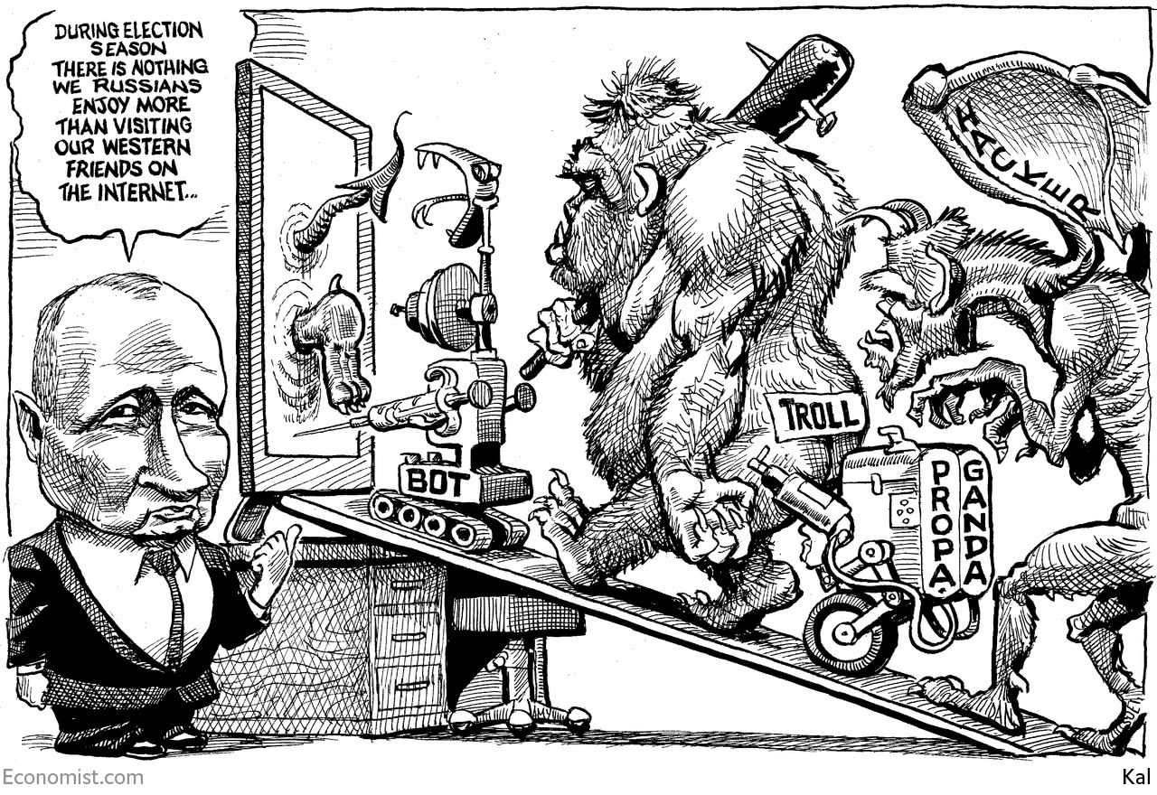

This article was downloaded by calibre from <https://www.economist.com/the-world-this-week/2020/02/15/kals-cartoon>

|  |  |  |  |
| --- | --- | --- | --- |
| Previous | Articles | Sections | Next |

|  |  |  |
| --- | --- | --- |
| The world this week | Sections | Letters |

Leaders

A united Ireland: Could it really happen?

.

Germany: Bad heir day

.

Disease and growth: Viral slowdown

.

The wrong person for the Fed: Shel-no

.

Property in America: The real-estate racket

.

|  |  |  |
| --- | --- | --- |
| The world this week | Sections | Letters |

|  |  |  |  |
| --- | --- | --- | --- |
|  | Articles | Sections | Next |

#### A united Ireland

# Irish unification is becoming likelier

Time to start thinking about what it might mean

Feb 13th 2020 |

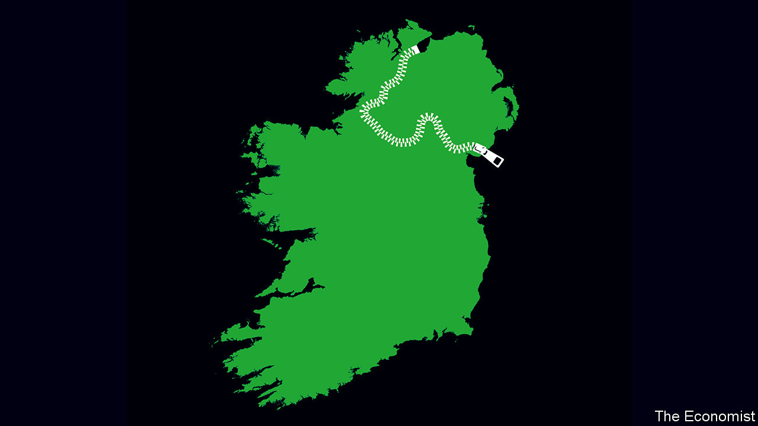

FOR MOST of the century since Ireland gained independence from Britain, control of the country has alternated between two parties. On February 8th that duopoly was smashed apart, when Sinn Fein got the largest share of first-preference votes in the republic’s general election. The party, with links to the Irish Republican Army (IRA), which bombed and shot its way through the 1970s, 1980s and 1990s, won with a left-wing platform that included promises to spend more on health and housing. Yet it did not hide its desire for something a lot more ambitious. “Our core political objective”, its manifesto read, “is to achieve Irish Unity and the referendum on Unity which is the means to secure this.”

Scottish independence has grabbed headlines since Brexit, but it is time to recognise the chances of a different secession from the United Kingdom. Sinn Fein’s success at the election is just the latest reason to think that a united Ireland within a decade or so is a real—and growing—possibility.

That prospect means something far beyond the island of Ireland. The Irish diaspora includes more than 20m Americans. Parties to ethnic conflicts across the world have long found common cause with Northern Ireland’s Roman Catholics, who contend that the separation from the south is an illegitimate vestige of 500 years of incompetent and often callous domination from London. Ireland, source of pubs, poets, playwrights and too many Eurovision songs for anyone’s good, has soft power to rival a country many times its size.

Until today, however, unification has never been more than a Republican fantasy. Even as the IRA waged a bloody campaign in the 20th century, the north’s constitutional status was cemented by a solid Protestant majority and the financial and military backing of the British state. The Good Friday agreement of 1998 took the heat out of the struggle, bringing an end to the Troubles, which had claimed over 3,500 lives. Many Catholics were content to have representation in Northern Ireland’s government thanks to that agreement, and to see their culture, flag and sports celebrated and subsidised. The Protestants have their terrorists, too, and a campaign for unification was thought to risk opening old wounds, with bloody consequences.

Brexit is one reason all this has changed. The north voted against, but the biggest unionist party and England voted for. Nationalists were not the only ones to be angered by the current home secretary, who suggested using the threat of food shortages to soften up the south in the negotiations, heedless of the famine in the 1840s when all of Ireland was under British rule. Brexit also creates an economic border in the Irish Sea, between Northern Ireland and Britain, even as it keeps a united Ireland for goods. Although services will become harder to trade with the south, trading goods will be easier than with Britain. In that the north’s six counties are affected more by what happens in Dublin, the value of having a say in who governs there will grow.

The pressure for unification is about more than Brexit. Northern Ireland’s census in 2021 is likely to confirm that Catholics outnumber Protestants for the first time. The republic has also become more welcoming. The influence of the Catholic church has faded dramatically and society has become more liberal. Over the past three decades restrictions on contraception have been lifted and gay marriage has been legalised. All this explains why support for unification in Northern Ireland appears to have risen in recent years. In some polls respondents show roughly equal support for it and the status quo.

That leads to the last reason for thinking that unification is more likely. Even though the Good Friday agreement reconciled some Catholics to remaining in the United Kingdom, it also set out how the north could peacefully rejoin the republic (see article). A British secretary of state who thinks it likely that a majority favours unification is bound to call a vote on the north’s constitutional status. To change the republic’s constitution, another referendum would be required in the south.

The EU has already said that Northern Ireland could rejoin the bloc under Ireland’s membership after such a vote, meaning that for Northern Irish voters a referendum on Irish unity is also a second referendum on Brexit. Unlike an independent Scotland, which would have to go it alone (at least until the EU agreed to admit it), Northern Ireland would immediately rejoin a larger, richer club, from which it could win big subsidies—if not, perhaps, as big as the subsidy it gets from Westminster today.

There are obstacles and uncertainties. Sinn Fein’s recent success may turn some in the north against unification. Brexit may turn out to have less effect than expected. A British secretary of state may use the wriggle room in the Good Friday agreement to hold off calling a referendum. Many British politicians worry that such a vote would be an administrative headache or, worse, provoke violence. So do their Irish counterparts (barring Sinn Fein), though they must always be seen to be fully behind unification.

Yet sooner than most people expect, the momentum for a united Ireland could come to seem unstoppable. If Scotland chooses independence, many in Northern Ireland would lose their ancestral connection to Britain. If the government in Westminster persistently refused to recognise that there was a majority in favour of unification in Northern Ireland, that could be just as destabilising as calling a referendum.

## The green shoots of unification

The island of Ireland needs a plan. The priority should be to work out how to make unionists feel that they have a place in a new Ireland. Work is needed on the nuts and bolts of unification—including how to, and indeed whether to, merge two health systems (one of which is free), the armed forces and police services, and what to do about the north’s devolved assembly. It helps that the republic has a fine record for the sort of citizen-led constitutional consultations that might help sort things out. Politicians from Britain and Ireland need to start talking, too. The price of ending violence two decades ago was for Northern Ireland, the republic and Britain to jointly set out a political route to a united Ireland. If the people of the north and the republic choose that path, the politicians must follow it. ■

This article was downloaded by calibre from <https://www.economist.com/leaders/2020/02/13/irish-unification-is-becoming-likelier>

|  |  |  |  |
| --- | --- | --- | --- |
|  | Articles | Sections | Next |

|  |  |  |  |
| --- | --- | --- | --- |
| Previous | Articles | Sections | Next |

#### Bad heir day

# Angela Merkel should quit soon

Germany’s chancellor should encourage a successor to emerge quickly

Feb 15th 2020 |

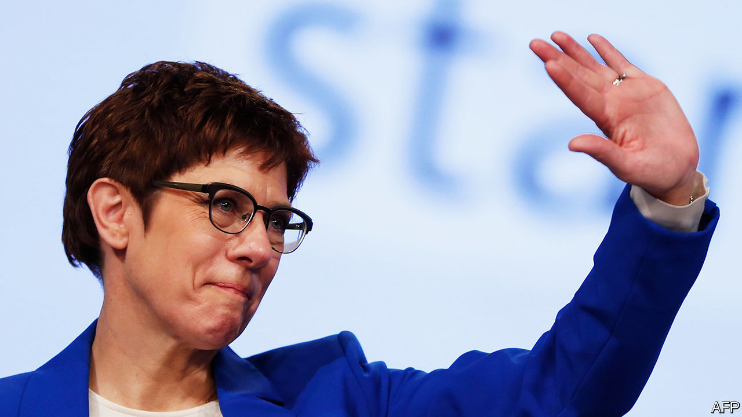

IT HOLDS HARSH views about immigrants, worries loudly about racial purity and detests the European Union (EU). For all these reasons, the Alternative for Germany (AfD), a far-right party, is considered toxic in its own country. Any mainstream German politician who dares get too close to it is tainted. Nonetheless, many are tempted, for the AfD is popular, particularly in the disadvantaged east of the country, where in each of three state elections last year it took around a quarter of the vote. To many voters there, the party’s claims that immigrants, liberals and the EU are to blame for Germany’s problems sound plausible. Many centre-right politicians would like to woo the same voters with watered-down versions of the same arguments. Some even think that it would make sense to do a deal with the demagogues.

They are wrong, as recent events reveal. In Thuringia, an eastern state, two of Germany’s most respectable parties, the Christian Democratic Union (CDU), which leads the national ruling coalition, and the much smaller Free Democrats, are now plunged into crisis (see article). Their chapters in Thuringia went along with a plan to wrest the state government from the ex-communist Die Linke and install a Free Democrat as premier. Yet this could work only with the help of the local AfD, a particularly nasty branch of the outfit.

The reaction was instant: national condemnation, mass demonstrations and a threat to bring down the ruling coalition in Berlin itself. Within a couple of days the whole thing had fallen apart. But the damage has been immense. Because of her failure to defuse the crisis before it happened, Annegret Kramp-Karrenbauer, the national leader of the CDU, has felt obliged to say she will quit her job. (She was already on thin ice, after a series of poor election results, a spate of gaffes and dismal poll ratings.) She is also withdrawing from the contest to be the official candidate of the CDU to succeed Angela Merkel as chancellor after an election that is expected in 2021. As Germany contemplates Mrs Merkel’s departure after 15 years in power, it is less clear than ever who will take over.

Centrists will celebrate that the firewall keeping out the AfD has done its job. But the problem is unlikely to go away. In Germany’s disgruntled east, extremists of right and left are so popular, and the political landscape so fragmented, that winning elections and forming state governments without either one is increasingly hard. Until there is a realignment of German politics, the chances of another, graver breach of the firewall will remain. The danger lies within the CDU itself, which in the twilight of Mrs Merkel’s reign seems to have little consensus on what its core principles should be. One of the leading contenders to take over from Ms Kramp-Karrenbauer is Friedrich Merz, who speaks openly of his desire to filch as many as half of the AfD’s voters. How does he intend to do that except, to some extent, by aping their agenda?

The CDU could take a different course. Thanks to the spectacular rise of the Greens in recent state elections, last year’s European Parliament elections and in opinion polls, it looks likely that at the next general election the CDU and the Greens will together win a majority of seats in the Bundestag, opening up the chance of a new kind of coalition. If “black-green” is the answer, though, a lot of horse-trading will be needed; the two parties are at odds over heavy industry, euro-zone integration, the scale of public spending and Germany’s defence posture.

This debate is only just beginning. While the CDU decides which way it wants to take Germany, policy paralysis has descended on Europe’s biggest economy. And a paralysed Germany means a paralysed EU, not least because it will take up the rotating EU presidency in the second half of this year. The greatest favour that Mrs Merkel could do her country would be to force the pace, by announcing her imminent departure. Germany must not go on like this. ■

This article was downloaded by calibre from <https://www.economist.com/leaders/2020/02/15/angela-merkel-should-quit-soon>

|  |  |  |  |
| --- | --- | --- | --- |
| Previous | Articles | Sections | Next |

|  |  |  |  |
| --- | --- | --- | --- |
| Previous | Articles | Sections | Next |

#### Viral slowdown

# How China’s coronavirus epidemic could hurt the world economy

Covid-19 brings many unquantifiable risks

Feb 15th 2020 |

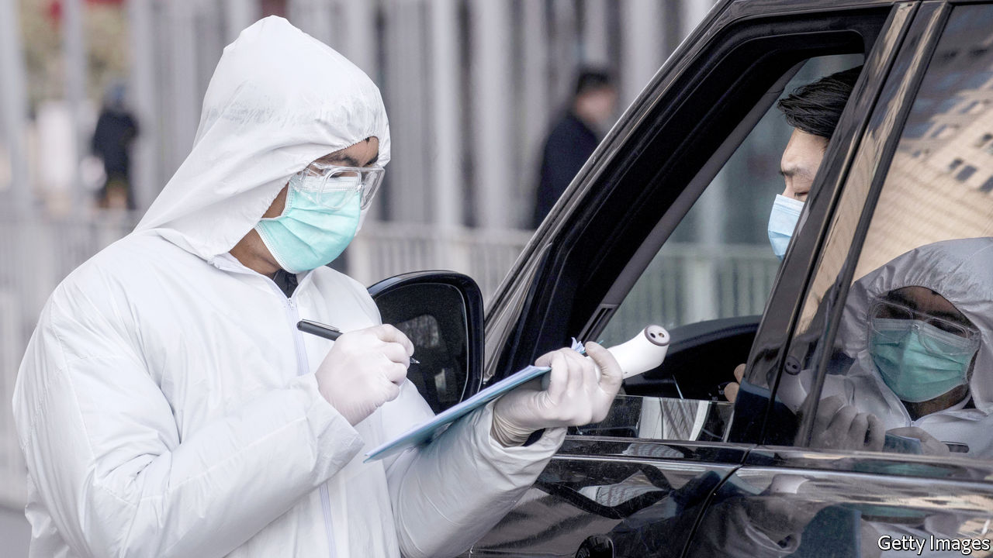

WHEN SHOCKS hit the global economy, Wall Street looks to history to see what will happen next. The outbreak in China of covid-19, a respiratory disease, invites a comparison to the last one, SARS. In that outbreak in 2003 China suffered a sharp hit to its growth, followed by a strong rebound. Although covid-19 has now claimed more lives than SARS, investors remain optimistic that its economic effects will follow a similar path.

On February 13th Hubei province, centre of the outbreak, announced 14,840 new confirmed cases, a sharp rise. That was because it suddenly started including CT-scan diagnoses, not just specific tests for the virus. Although the statistical fog is thick, indicators such as the fall in new cases outside Hubei and the total of suspected cases suggest that the rate of fresh infections may be trending lower.

Most economists have thus only nudged down their forecasts for full-year global growth. Chinese stocks and commodities, which track economic prospects, have clawed back ground after initial falls. Global stockmarkets are higher than they were in January, when the severity of the outbreak became clear. We hope their optimism is justified. Yet the comparison makes two assumptions: in supposing that containing the virus maps neatly onto a better economic outlook; and in thinking that the world still works as it did when SARS was a threat.

There is an inherent tension between China’s apparent success in containing the epidemic and its growth prospects. Though less lethal, covid-19 seems more infectious than SARS. China has slowed its advance only by severely limiting people’s movement and closing businesses. If the government were to relax these controls too hastily, progress could stall or even go into reverse. So far, officials have erred on the side of caution. Provinces accounting for more than 90% of Chinese exports have kept factories either shut or running at low capacity since January 31st, when the lunar new-year holiday was due to end.

It is hard to overstate the effect on the economy. Coal consumption is more than a third lower than the average for this time of year. Property sales are down by more than 90%. After the holiday some 200m people usually leave their home towns to return to work. This year the trains that carry migrants have been nearly empty. Cities have warned outsiders that they might face 14-day quarantines. Nine out of ten companies surveyed by the American Chamber of Commerce in Shanghai have employees working from home. Couriers still zoom around on their electric motorbikes, but the takeaway trade is not saving restaurants because people fear eating meals prepared by strangers who may be infected. Grabbing a latte is a risk too far. Starbucks has shut half its 4,000-plus cafés in China.

The second doubt is over the relevance of SARS as a comparison. The global economy has changed since 2003, when SARS struck. China now accounts for 16% of global GDP, up from 4% back then. And it is the world’s second-biggest importer, so any weakness, however temporary, is felt far and wide. Already, some of its firms are trying to get out of contractual commitments to import copper and liquefied natural gas. And its tourists, who spend $250bn a year on overseas travel, are staying at home.

Accounting for China’s increased size is easy. But the economy has not just grown since 2000; its manufacturers have also become enmeshed in supply chains of mind-boggling complexity. A factory in Wuhan may provide parts to a firm elsewhere in China, which in turn supplies a factory in Stuttgart, with the final product emerging in Michigan. Just-in-time production leaves little room for delays. Many firms cannot trace all their suppliers, making it hard to predict the impact of work stoppages in China on their output, let alone on global GDP (see article). History provides little guidance on the effects of disrupted supply chains, because the world economy has not been organised around them for long.

Some problems have already emerged. Hyundai has halted some car production in South Korea because parts are short. So has Nissan in Japan. Facebook has stopped taking orders for its new virtual-reality headset and Nintendo has delayed shipments of new gaming devices. Foxconn, which makes smartphones for Apple and Huawei, has restarted its factories but with skeletal staffing. And these are just the brands you have heard of. China churns out a third of the world’s chemicals, half of its LCD screens and two-thirds of its polyester. Companies that think they are isolated from China could be in for a surprise.

It is also possible that the virus spreads rapidly outside China. Infections in developing countries may be going undetected. Vietnam has quarantined 10,000 people, but most governments could not enact the measures that China is using to slow the disease, so covid-19 could yet become a pandemic. Wall Street’s optimism, in other words, is premature. If economists have a bias, it is to focus on things that are measurable and quantifiable. Alas, the covid-19 outbreak brings many risks that are not. ■

This article was downloaded by calibre from <https://www.economist.com/leaders/2020/02/15/how-chinas-coronavirus-epidemic-could-hurt-the-world-economy>

|  |  |  |  |
| --- | --- | --- | --- |
| Previous | Articles | Sections | Next |

|  |  |  |  |
| --- | --- | --- | --- |
| Previous | Articles | Sections | Next |

#### Shel-no

# Why the Senate should reject Judy Shelton’s nomination to the Fed

It is not her views that are the problem so much as her motives

Feb 13th 2020 |

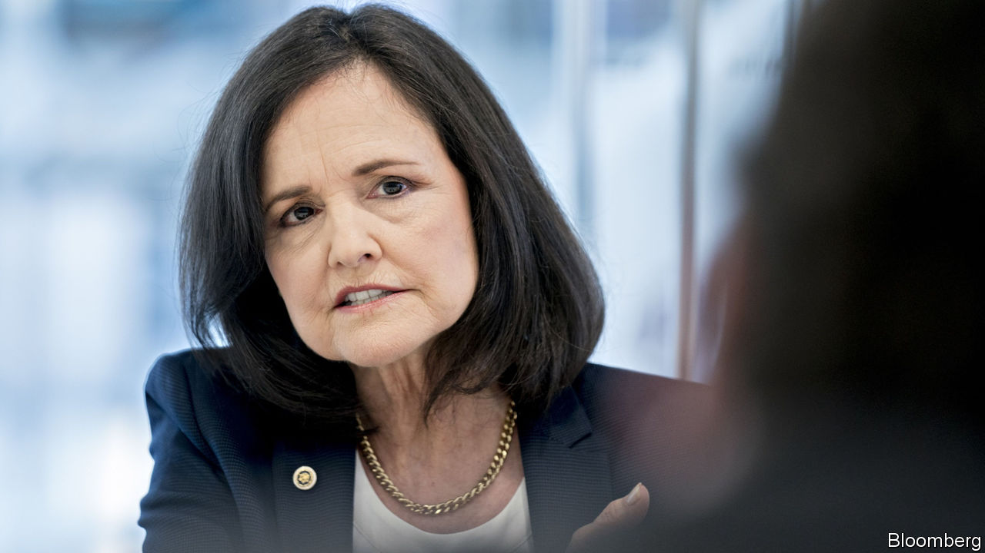

FOR MUCH of the past decade the Federal Reserve has operated without all its seven governors. Presidents Barack Obama and Donald Trump have struggled to find nominees whom the Senate, which must approve appointments to the Fed, finds acceptable. On February 13th, after we went to press, Mr Trump’s latest candidates for the job—Judy Shelton and Christopher Waller—were due to appear before the Senate Banking Committee for a grilling. Mr Waller, head of research at the St Louis Fed, is a perfectly good candidate. Unfortunately Ms Shelton, a former think-tanker, adviser to Mr Trump and official at the European Bank for Reconstruction and Development, is not fit for the Fed. Whatever she says, the Senate should reject her nomination.

The problem with Ms Shelton is not her belief, shared by Mr Trump, that interest rates should be lower, nor her status as an outsider to the clubby world of central banking. Annoyingly for the experts, Mr Trump is probably right when he grumbles—as he frequently does—that the Fed has been too hawkish during his presidency. For two decades the Fed has made mistakes because of groupthink. Just as in the 2000s central bankers and economists were blind to financial risks, so in the 2010s they have perennially overestimated the risk of inflation. Setting interest rates is a technical job, but more intellectual diversity among those who steer the economy would be no bad thing.

Instead, two other factors disqualify Ms Shelton. First, her past views crossed the line where unconventional thinking ends and quackery begins. She has spent much of her career questioning whether central banks should exist at all, and calling for a return to the gold standard, which would remove much of the Fed’s power to set monetary policy. True, she would not be the first central banker with a record of gold-standard advocacy. Alan Greenspan, who chaired the Fed from 1987 to 2006, had such a history when he was appointed. But since then decades of experience have shown that, for all its problems, today’s monetary regime is superior. It has led to inflation that is low and stable. America is in its longest-ever economic expansion, and poor workers are enjoying large pay rises (see [article](https://www.economist.com/node/21779946)). To rip up this framework would risk these advances for little gain. Ms Shelton’s campaign to go back in time lacks common sense.

The second problem is Ms Shelton’s record of changing her mind on interest rates. She has transformed from a hawk who predicted that low rates would cause “ruinous inflation” in the early 2010s, when the unemployment rate was near 9%, to a dove who wants the Fed to cut rates “expeditiously” today, when jobs are booming. In principle this is no cause for shame. Central bankers change their minds often, and some have undergone similar wholesale transformations. But Ms Shelton’s change of heart looks calculated to advance her career. In addition to wanting rate cuts, she now argues that the Fed should work “hand in hand” with Congress and the White House and that it should pursue a weaker dollar to help exporters—sycophantic echoes of Mr Trump. Ms Shelton has even suggested that there should be an international economic summit, in the spirit of Bretton Woods, held at Mr Trump’s Mar-a-Lago resort.

Ms Shelton is right that the Fed’s independence is more principle than law. But that is all the more reason to defend it, by opposing the appointment of cronies. The central bank already looks vulnerable. If Mr Trump wins re-election, he could choose to replace Jerome Powell, the Fed’s chair. If he loses, the new occupant of the White House may want to pick a fight with the Fed. Bernie Sanders is now the front-runner for the Democratic nomination (see [article](https://www.economist.com/node/21779975)). He once sponsored legislation designed to give Congress more control over monetary policy, and in 2015 denounced an interest-rate rise as evidence of a “rigged economic system”. Democrats and Republicans alike have grown accustomed to the ballooning deficits that low interest rates make possible. Washington will be in no mood for tighter monetary policy if that proves necessary.

The Fed is one of the few parts of America’s government not to have been afflicted by the country’s toxic partisan divides and win-at-all-costs politics. The Senate must protect the central bank by rejecting overtly political nominations to its board. It should say no to Ms Shelton. ■

This article was downloaded by calibre from <https://www.economist.com/leaders/2020/02/13/why-the-senate-should-reject-judy-sheltons-nomination-to-the-fed>

|  |  |  |  |
| --- | --- | --- | --- |
| Previous | Articles | Sections | Next |

|  |  |  |  |
| --- | --- | --- | --- |
| Previous | Articles | Sections | Next |

#### Time for disruption in the property market

# The cost of buying and selling homes is too high

Ending America’s real-estate racket

Feb 15th 2020 |

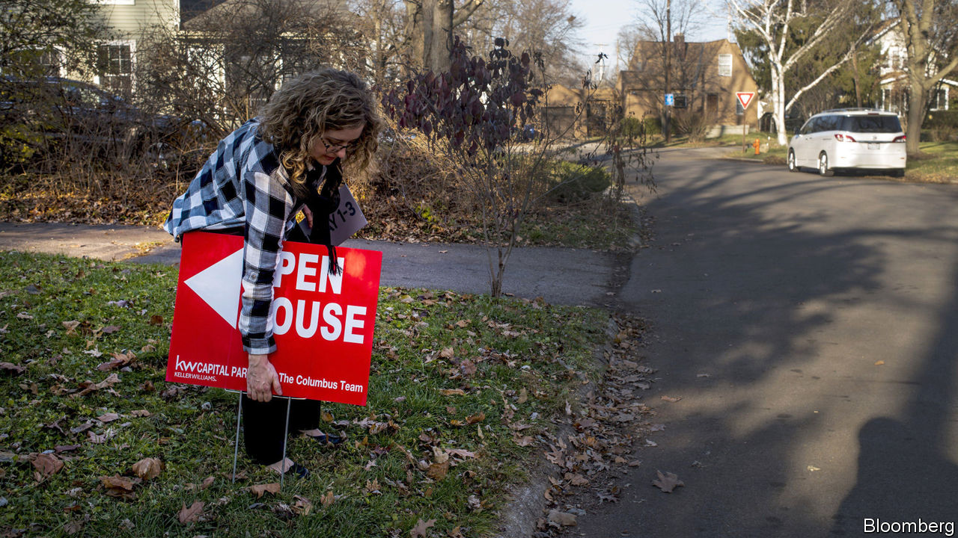

THE STAKES are high. Along with getting married and choosing a career, buying or selling a home is one of the biggest decisions most people make. In America, especially, the sums are vast. In total the country’s residential property is worth $34trn—as much as the value of all its publicly listed firms—and last year people traded properties worth $1.5trn. Yet compared with other industries and other countries, buying and selling property in America is cumbersome—and extraordinarily expensive. In an industry crying out for technological disruption, the only revolutionary change over the past decade has been the rise of celebrity estate agents who star in reality TV shows including “Million Dollar Listing” and “Flip or Flop”.

The scale of the commissions extracted by the real-estate industry in America is jaw-dropping. Fees run at 5-6% of the value of a property, three times the average level in other developed countries (see [article](https://www.economist.com/node/21779977)). In total they amounted to $75bn last year, or 0.4% of GDP. Other marketplaces—for shares, groceries, advertising and romance—have been transformed by technology. But in property the old ways persist. America still has 2m realtors.

Although online platforms such as Zillow and Redfin have made some inroads, allowing buyers to do much of the searching themselves, fees have not budged. An inefficient property market has knock-on effects on the economy. In the 1950s, 20% of households moved each year; today only 9% do. The slowdown in labour mobility has many causes, but in a country where most people own homes, high fees do not help.

At the heart of the problem is a knot of obsolete practices that seem to favour insiders rather than the buyers and sellers of property. Unlike the practice in most countries, the seller usually pays fees to both their own agent and the buyer’s. Agents acting on behalf of buyers thus have an incentive to steer their clients away from properties with low fees—one study has found that such homes are 5% less likely to sell, the opposite of what you would expect in a healthy market. Most transactions are listed on 800-odd common industry databases, known as multiple listing services (MLS). The government worries that their rules and tacit codes of behaviour might muffle competition, by prompting agents to search for homes based on how high fees are, or by restricting the distribution, sale or licensing of data. (The National Association of Realtors, a lobbying group, argues that the industry is competitive and MLSs benefit consumers.)

What to do? America’s trust-busters last looked into the industry in depth in 2008, when they tried to ensure MLSs were open to internet-based firms. Now, after a decade in which fees have not fallen materially, they are investigating again. The Department of Justice has subpoenaed some of the private firms that help run MLSs to establish whether agents operating on them are puffing up fees or steering clients towards properties with higher fees, and whether access to MLS data is being unfairly restricted. Two big class-action lawsuits are under way against the industry.

Boosting competition is a complex problem, but the antitrust policemen are right to intervene. They should seek to enforce two principles. First, that agents are genuinely free to compete by lowering commissions—or by abandoning the practice of requiring sellers to pay two sets of fees. Second, that any firm which wants to gain access to industry data can do so freely at reasonable prices. The best tests of whether regulators succeed are whether commissions fall towards levels in the rest of the rich world and the market share of new entrants rises.

Plenty of entrepreneurs are keen to get involved. Some $6bn of venture capital flowed into “prop tech” firms in 2019. Opendoor and Zillow have algorithms that crunch data to determine the value of a home, and allow them to make “instant offers” to sellers that are all cash and can be paid within days. Other firms have developed tools to lift agents’ productivity, such as automatic home-tour booking systems. Competition can make America’s property market work better. If regulators lower the barriers to entry, they will be knocking on an open door.■

This article was downloaded by calibre from <https://www.economist.com/leaders/2020/02/15/the-cost-of-buying-and-selling-homes-is-too-high>

|  |  |  |  |
| --- | --- | --- | --- |
| Previous | Articles | Sections | Next |

|  |  |  |
| --- | --- | --- |
| Leaders | Sections | Briefing |

Letters

Letters to the editor: On housing

.

|  |  |  |
| --- | --- | --- |
| Leaders | Sections | Briefing |

|  |  |  |  |
| --- | --- | --- | --- |
|  | Articles | Sections | Next |

#### On housing

# Letters to the editor

A selection of correspondence

Feb 15th 2020 |

Letters are welcome via e-mail to letters@economist.com



## As safe as houses

Though your attempt at presenting the issue of home ownership was engaging and unique, the coverage was incomplete ([Special report on housing](https://www.economist.com/special-report/2020/01/16/housing-is-at-the-root-of-many-of-the-rich-worlds-problems), January 18th). Home-ownership rates vary wildly across countries for a number of reasons. For example, to cite Romania’s high rate of private-home ownership, which went from zero to 95% virtually overnight after the collapse of communism, as somehow a failure because Romania still “has its fair share of social problems” is absurd. As is mentioning Japan’s affordable homes without acknowledging its declining population. To verify if these two variables are related consider Youngstown, Ohio, where the population is also falling and housing is exceedingly affordable.

You correctly point out that the rapid rate of job creation in San Francisco has pushed home prices to record high levels, but this is more the result of misguided local policy that has prevented developers from building homes than anything else. In fact, Texas and Utah have enjoyed even stronger job creation, but home prices in those states are manageable because construction has been relatively active.

Home ownership provides immense benefits for our country (economic growth), local communities (civic engagement) and for families (wealth creation and stability that allows children to excel). In your dismissal of the positive values of home ownership, several questions should be asked. Who would own property, if not homeowners? Would it be landlords, small and corporate, and the government, but not the mass of citizens? Would a corporate oligarch-controlled property market provide for a better society? What about a government-owned one? The answer to all these is a resounding no.

LAWRENCE YUN  
Chief economist  
National Association of Realtors  
Washington, DC

I don’t agree that “Singapore’s public-housing system helps improve social inclusion” and is the model to copy. Its subsidised housing market is an income-regressive apology for a social-security system, one positioned in a wildly unequal society, where the elderly and disabled still have to clean the tables of the expats and tax havenites who make their lives increasingly unaffordable. If Singaporeans were provided with a respectable and progressive welfare programme, they might rely less on their government for housing and invest their funds in other assets.

MEGHNA BASU  
Singapore



Reaching retirement age without the security of home ownership is irresponsible. The senior citizen who has paid rent for 30 years has still bought property—for the landlord. Tenants have no long-term security. They can be asked to leave a property at any time. Landlords may fail to make repairs or control noxious neighbours. Home ownership is the surest kind of nest-egg. People are living longer. Security of place is basic to a comfortable old age.

JULIA VIERA  
Coronado, California

Nimbyism significantly contributes to bad policies that exacerbate the growing gulf between those seeking housing and housing availability. Policymakers would do well to read your report and examine thoughtful, sustainable solutions that treat rental housing as a valuable part of their communities. Proper zoning and planning can address the affordability crisis by making it easier to add more supply as well as lowering our respective carbon footprints. As more people choose to rent a serious conversation is long overdue to address their needs, rather than continually crafting policy to protect homeowners.

ROBERT PINNEGAR  
President and CEONational Apartment Association  
Arlington, Virginia

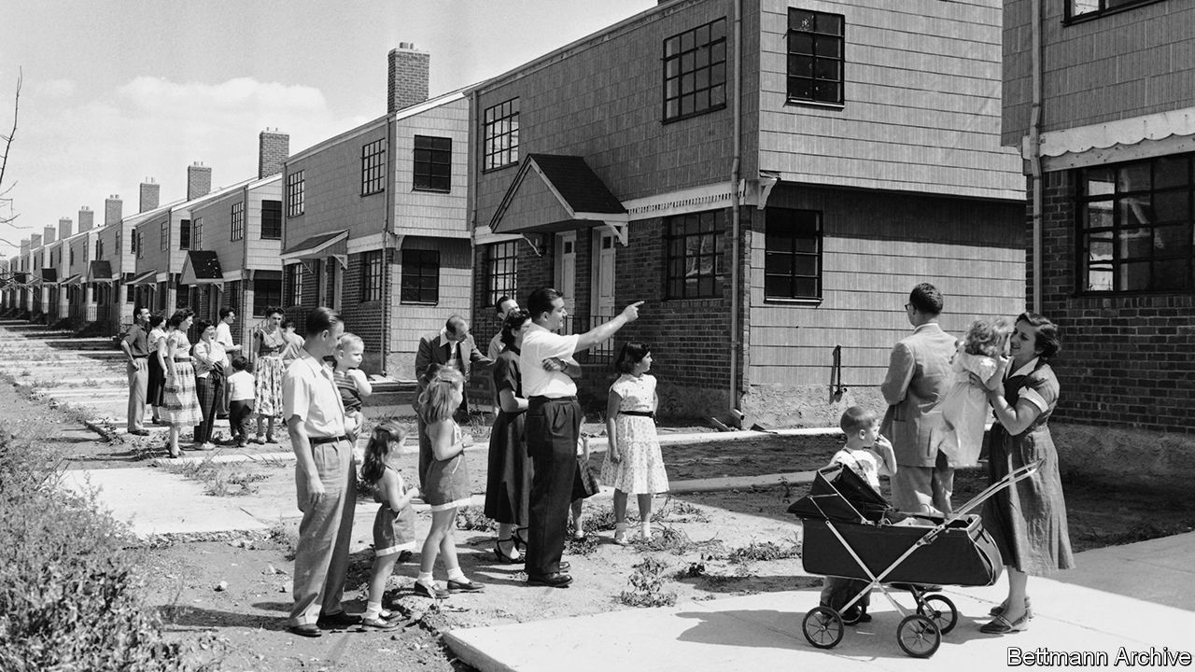

Contrary to the implications in your report, today’s independent mortgage banks are appropriately regulated, not just by the federal Consumer Financial Protection Bureau and state regulators, but also by counterparty agreements with Fannie Mae, Freddie Mac, Ginnie Mae, and the lenders that extend them credit. As a result of the regulations that were implemented after the financial crisis, these companies are operating in the safest and soundest mortgage-lending environment for decades.

In the aftermath of the crisis, it was the independent mortgage banks that stepped up to support the housing recovery, providing credit to millions of well-qualified low-to-moderate-income, minority, veteran and first-time homebuyers. Rather than fret over their market share, regulators should focus on why these banks are being driven away from the mortgage business.

BOB BROEKSMIT  
President and CEOMortgage Bankers Association  
Washington, DC

Demographics drive house prices, too. The labour-force participation rate for women has ballooned over the past 75 years and dual-income couples now account for the majority of households. The resulting growth in household income helps explain in part why house prices have risen. But the age of first marriage has also increased, so attaining a dual household income comes later in life. “Still single” millennials will find it increasingly harder to step onto the home-ownership ladder.

JOHN SWETTENHAM  
Ottawa

Modular construction saves building time, loss of material and environmental costs because of the easy ways to disassemble entire buildings in blocks. In Amsterdam, undeveloped sites are being leased out for ten years to social-housing associations. High quality flats are built within a few months. After the lease period, the buildings are disassembled, refurbished in a factory and moved to another location for re-use. Modular construction is 100 years old, espoused by great names in architecture such as Le Corbusier and the Bauhaus school.

FRANK VAN OOIJEN  
Breda, Netherlands

Made-to-measure smart materials use 3D printing. In 2018 Amazon invested in Plant Prefab, which makes prefabricated smart homes. “Alexa, construct me a home” may soon be an option. The resulting lower housing costs will truly be something to build on.

CHRISTOPH FEEST  
Neuried, Germany

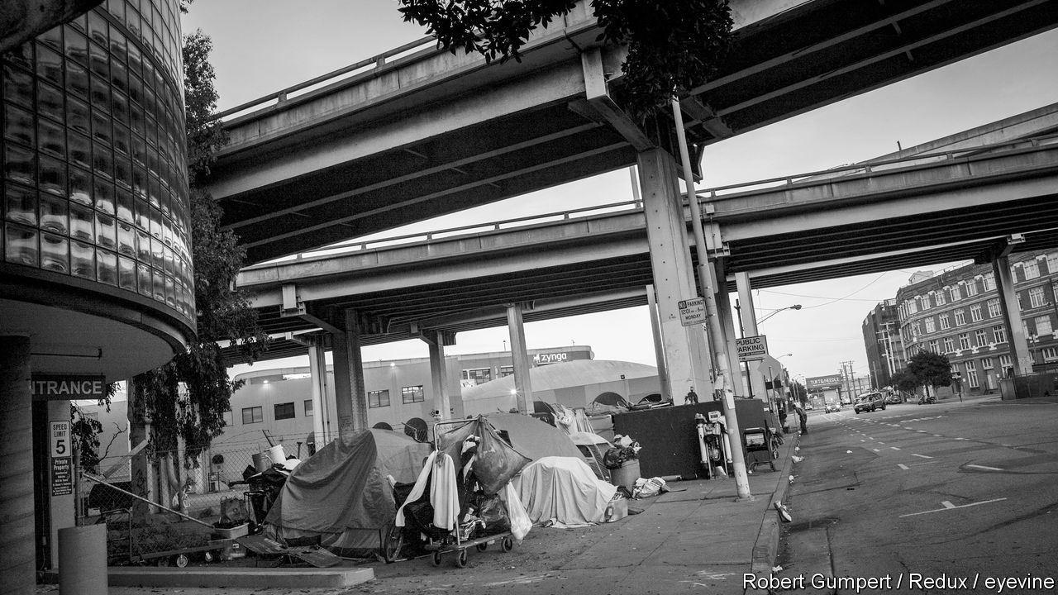

Homelessness isn’t just about economics; a large number of rough sleepers suffer from mental illness. Meanwhile, developers are constructing ever-higher apartment buildings in our cities that are bought for investment by the wealthy, who rarely use them. And they block the sunlight.

REBECCA TAUB  
New York

Part of the appeal of homeowners is the notion that they are motivated to maintain their property. Yet a recent survey found that a third of millennial dads do not even own a hammer. Perhaps we have lost the do-it-yourself culture, or career mobility has undermined the enjoyment of labouring on your home. Your questioning of home ownership was uncomfortable, but necessary in a changing world.

GERALD LOEBSouth Pasadena, California

Renters miss out on one of the great pleasures of home ownership: making the final mortgage payment.

KEN OBENSKI  
Kona, Hawaii

This article was downloaded by calibre from <https://www.economist.com/letters/2020/02/15/letters-to-the-editor>

|  |  |  |  |
| --- | --- | --- | --- |
|  | Articles | Sections | Next |

|  |  |  |
| --- | --- | --- |
| Letters | Sections | United States |

Briefing

A united Ireland: Is some revelation at hand?

.

|  |  |  |
| --- | --- | --- |
| Letters | Sections | United States |

|  |  |  |  |
| --- | --- | --- | --- |
|  | Articles | Sections | Next |

#### Is some revelation at hand?

# Brexit and Sinn Fein’s success boost talk of Irish unification

It would not be an easy process

Feb 13th 2020 | BELFAST, DUBLIN, LONDON AND WASHINGTON, DC

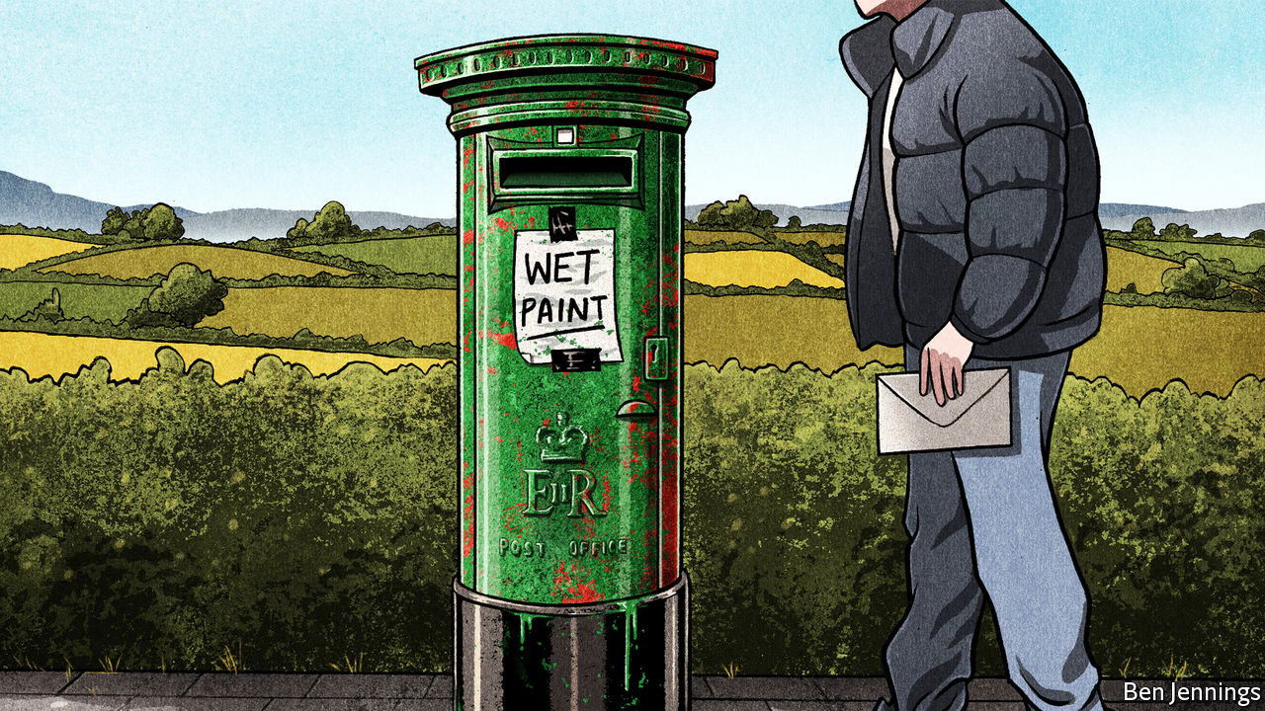

UNDER THE cavernous roof of the Royal Dublin Society’s Simmonscourt Hall, Mary Lou McDonald, the president of Sinn Fein, is facing a gaggle of reporters. The atmosphere is electric; the day before, February 8th, Sinn Fein had won more first-choice votes in the general election than any of Ireland’s other parties, which was a stunning upset. “We asked people to give us a chance, a chance to deliver the platform that we have set out,” Ms McDonald says, “and that platform is about solving the housing crisis, it’s about getting to grips with the crisis in our health services, it’s about giving families and workers a break, giving them some breathing space.”

The words could belong to any European politician whose insurgent party has broken up a staid political establishment. But Sinn Fein is also something more. All major political parties in the republic are, in principle, committed to seeing the six counties which remained in the United Kingdom in 1922 rejoin the 26 counties which gained their independence, and thus create a united Ireland. Sinn Fein, though, sees that cause as a real and pressing ambition. The party has international standing; as well as now being a force in the Irish Dail, it is the second-largest party in Northern Ireland. And it has a deeply troubling past. From the 1970s on, it was the political wing of the Irish Republican Army (IRA), a paramilitary organisation which tried to push the British state out of Northern Ireland through terrorism.

Sinn Fein’s new popularity does not have much to do with all that. Pundits attribute its success instead to its promise to spend more on public services and to the widespread desire to vote for a party beyond the centre/centre-right duopoly of Fianna Fail and Fine Gael. The fact that, under Ms McDonald, Sinn Fein has lost a lot of the stigma produced by its terrorist association also helped. But if its newfound prominence does not derive from a fresh thirst for Irish unification, it is still one of three reasons why that prospect is starting to look like an unexpectedly big issue.

Of the other two reasons, the most obvious is another political upset: Brexit. In 2016 52% of the United Kingdom voted to leave the EU. But 56% of Northern Ireland voted to stay. Michael Collins, who was the Irish republic’s ambassador to Germany at the time, remembers that “The first call I got at 7.30 [the morning after the Brexit vote] was from a member of the German Bundestag, saying ‘Does this mean now that we have Irish Unity?’” Not in the short term. But the fact that unification would allow Northern Ireland to rejoin the EU is now a big part of the debate.

For the third reason, step away from the hurly-burly of electoral politics to take in the deep tides of demography. When the six counties of Northern Ireland opted out of independence in 1922, they thought they were ensuring that a part of the island would always remain under Protestant control; Protestants outnumbered Roman Catholics there by two to one.

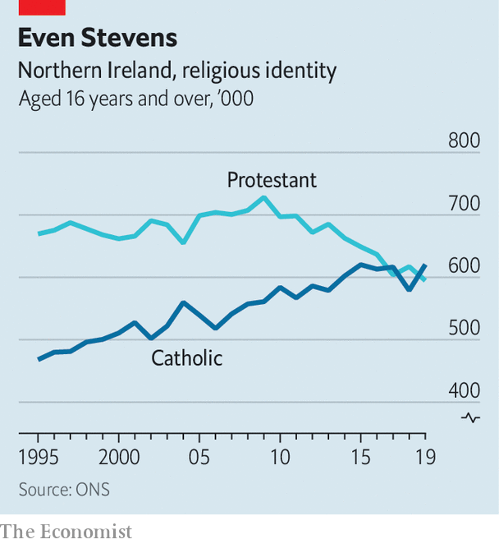

That edge has been dulled. Analysis by The Economist of the censuses of 2001 and 2011, along with results of Britain’s quarterly labour-force survey, strongly suggests that Catholics are now the single biggest confessional grouping in Northern Ireland (see chart). Gerry Adams, who was president of Sinn Fein from 1983 to 2018, and who is widely believed also to have been a senior figure in the IRA—a charge he completely rejects—once quipped that though “outbreeding unionists may be an enjoyable pastime...it hardly amounts to a political strategy.” Yet it has still brought about a change. If the 2021 census bears this out, the finding will add to the fears of unionists.

The unionists, who have dominated Northern Ireland since partition, are for the most part Protestants whose identities are bound up with Britishness—whether through support for the British government itself, British traditions or the idea that the royal family is the ultimate defender of their faith. Even before Sinn Fein’s success in the south, Peter Robinson, the former leader of the Democratic Unionist Party, the biggest party in Northern Ireland, was warning his fellow unionists to prepare for a referendum.

## Study reading-books and history

The possibility of such a referendum is enshrined in the Good Friday agreement (also known as the Belfast agreement). Reached in 1998, this deal marked the end of the decades of violence which grew out of civil-rights protests against the province’s unionist-dominated parliament in the 1960s and the backlash against them. In 1972 that parliament was dissolved and the province, garrisoned with British soldiers, ruled directly from London. Over 3,500 people died during these “Troubles”, a majority of them civilians, a tenth of them British soldiers; some 2,000 were killed by the IRA and other republican paramilitaries, half that number by paramilitaries on the unionist side.

The Good Friday agreement created a new devolved government in the north in which power would be shared between the two communities. It recognised that Northern Ireland was part of the United Kingdom and that the republic of Ireland had an interest in its people, who would have the right to be recognised as Irish, British or both. It also provided a political path to a united Ireland, should the people north and south of the border both want it. But none of those involved thought that path would be walked down any time soon.

The decades since have been mostly peaceful, and the north has become a much more “normal” place. But although its workplaces are increasingly mixed and its police force reformed, in their schools and their houses the communities remain separated. Because it is hard to close religious establishments to make way for integrated ones, over 90% of the population is still segregated at school (though not at university). The threat of violence has left public housing mostly segregated. Six-metre “peace walls” mark places where troublemakers from one community might mount incursions against the other. Remnants of the old paramilitary organisations persist; they are mostly concerned with drug crime and extortion, but they still sometimes engage in political violence.

The route to unification that the agreement sets out is fairly simple. “If at any time it appears likely” to the British secretary of state for Northern Ireland that a majority would back reunification, Britain must call a referendum and honour its result. “Appears likely”, though, does give the minister room for manoeuvre. The Constitution Unit at University College London says he should take into account a number of factors. A consistent majority for unification in opinion polls would certainly be one, as might a Catholic majority, or a nationalist majority in Northern Irish elections. None of these has as yet been seen. But opinion polls have been showing increasing support for unification since the Brexit vote, and some now have it neck and neck with the status quo; Catholics may already be a plurality; and although unionists got more votes than nationalists at the British general election last December, the nationalists won more seats.

Since February 8th, Ms McDonald has warned that Britain, and “London in particular”, need to get ready for unification, because “constitutional change is coming.” If Sinn Fein is to enter into a coalition, or provide any support to a governing party, its price is likely to include the beginning of preparations for a referendum. Aengus Ó Snodaigh, a Sinn Fein parliamentarian, says the as-yet-undefined Irish government would have to bring people together from across the island “to sit down and figure out what type of society we want.”

If the north were to vote for unification, the south’s constitution would have to be changed, which would require its people, too, to have a vote. In “A Treatise on Northern Ireland”, Brendan O’Leary, a political scientist at the University of Pennsylvania, suggests that the “rational order” would be for such a vote to take place after some time spent negotiating the form of unification.

That is, at the moment, an open issue, and one which would not just be up to Ireland. Richard Humphreys, an Irish high-court judge, points out that, even after unification, the Good Friday agreement would still give Britain a role as a guarantor of citizenship, and its devolved institutions would be expected to function in Ireland as they do now in the United Kingdom. In the longer term, Mr O’Leary outlines three plausible outcomes to a unification process: a unitary state run from Dublin; a devolved government in the north not unlike today’s; or a confederation of two states. Each would raise different questions about the workings of the new state, including the courts, the army and public services.

Constitutional implications aside, issues of identity and economics are likely to drive any initial decision. Both are being changed by Brexit. Take identity first. The Good Friday compromise rested, to some extent, on the idea that all British Islanders were European. As John Hewitt, a Northern Irish poet, put it in 1974:

I’m an Ulsterman, of planter stock. I was born in the island of Ireland, so secondarily I’m an Irishman. I was born in the British archipelago, and English is my native tongue, so I’m British. The British archipelago consists of offshore islands to the continent of Europe, so I’m European.

Quite a few Northern Irish people, of all confessions and none, feel that Brexit has stripped them of their European identity. There are a lot of people who are not against the idea of a united Ireland but have long wondered whether it is worth the trouble. Now that unification would bring a return to the EU—the European Council has confirmed that the “entire territory” of a united Ireland would be part of the union—they may be swayed in that direction.

Many in the north also realise that life in a united Ireland would feel a lot less alien to them today than it would have in the republic’s clerically policed past. A country where, 30 years ago, contraceptives were tightly controlled, abortion banned and gay rights unheard of, now boasts, in the person of Leo Varadkar, still taoiseach (prime minister) at the time The Economist went to press, a national leader who is both gay and of mixed race. A woman who wants an abortion in Dublin is better placed than her sister in Belfast, where unionists have opposed liberalising abortion law. Gay marriage is legal in Northern Ireland only because Westminster mandated it over unionist objections.

All this said, identity is about little things as well as big ones, and there would be an almost limitless number of them to fiddle with and take umbrage over. “When I opened my curtains in the morning [after Northern Ireland rejoined the republic], is the postbox still red or is it green?” asks Mike Nesbitt, a former leader of the Ulster Unionist Party (UUP). Mark Daly, a senator for Fianna Fail, argues that there need to be agreements made in advance to prevent nationalists from rubbing their victory in unionists’ faces. What would stop nationalists naming Belfast’s main airport after Mr Adams, for example? Other questions abound. Would there be a new flag? A new national anthem? Would the state commemorate British soldiers from the north who died in the Troubles? The national conversations Mr Ó Snodaigh envisages would have issues galore to chew on.

Then there is the economy. It has long been a reason for persuadable voters in the north to stick with the status quo, and for Irish politicians supportive of unification in principle not to strive for it in practice. As Mr Collins’s early-morning caller knew, the last reunification of a partitioned country was remarkably expensive. In the 30 years after the fall of the Berlin Wall, some €2trn ($2.2trn) was spent rebuilding the economy of the east.

Northern Ireland, though poorer than the south, is nothing like as badly off as East Germany was compared with the west. In 1989 West Germany boasted four times the east’s GDP per person. But it also had four times its population, whereas the republic of Ireland is less than three times larger than the north (see table). And the north’s economy is in a long-standing mess, scarred by the Troubles and “left behind” by deindustrialisation. Harland and Wolff, which laid the keel of Titanic in 1909, went into administration last August; its two gigantic cranes, Samson and Goliath, tower over the Belfast skyline as silent monuments to decline. Official data suggest that the public sector in Northern Ireland accounts for well over 50% of local GDP and that it raises enough tax to pay for only two-thirds of its spending. The British government makes up the difference.

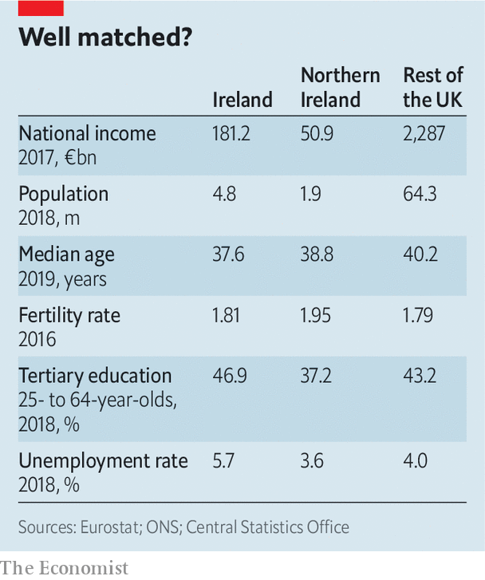

Nationalist economists claim that Northern Ireland’s fiscal deficit is artificially inflated by statistical trickery. They say, for instance, that if the region broke free from Britain it would not have to repay the portion of Britain’s public debt built into those figures. There is precedent here. In the 1920s Ireland’s republican leaders negotiated down the British government’s initial demand that their new nation take on a pro rata share of public-debt and pension liabilities. On the other hand, during the run-up to the Scottish independence referendum in 2014 the British government insisted that a newly independent Scotland would have to assume responsibility for its share of British public debt.

Covering Northern Ireland’s fiscal deficit would be a tall order for the republic. It would have some help. In a recent interview Mick Mulvaney, President Donald Trump’s chief of staff, told The Economist that “we expect that both philanthropists and the private sector in America would stand ready to help Northern Ireland in the event of reunification.” The EU would obviously play a role. But providing just half of the north’s current subsidy would cost the republic some 3% of its national income.

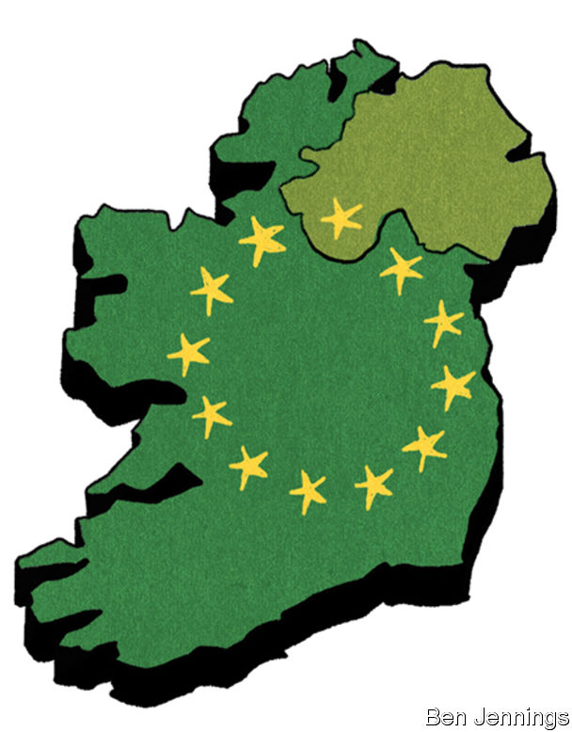

This strongly suggests that in a newly united Ireland the north would face spending cuts—as might the south. That is grist to the mill of unionists who argue against unification on the basis of poor public services (the issue which, ironically, just boosted Sinn Fein’s vote). “You’re given Scandinavian rates of taxation with southern European standards of health care and services,” says Steve Aiken, the leader of the UUP. “I just don’t know why people in the Irish republic put up with it.” The National Health Service performs worse in Northern Ireland than in any other part of the United Kingdom. But it is free at the point of need. Many northern nationalists, never mind unionists, shudder at the thought of the south’s insurance-based model.

Brexit further complicates the economics of Irish reunification. To some, it is another argument for remaining part of Britain. Northern Irish businesses sell twice as much to the mainland as to the republic. But for others, Brexit makes it essential to leave Britain. An official analysis of the effects of a free-trade agreement between Britain and the EU sees it lowering Northern Ireland’s national income by 8% over the long run, compared with just 5% for the United Kingdom as a whole.

## Scots Wha Hae

On top of this, the possibility of a further political upset looms. Brexit did not just take the people of Northern Ireland out of the EU against their will; it did the same for the people of Scotland, 62% of whom had voted to stay in. The Scottish National Party, which currently forms a minority government in Edinburgh, sees being taken out of the EU against its will as grounds for Scotland to have a second vote on independence. It has no mechanism for forcing the Westminster government to go along with this, but that does not mean it will not happen. And this time the nationalists might win.

Given the strength of the ties between Northern Ireland’s Protestants and Scotland, such a vote would be a heavy blow to unionists. “A lot of people here would feel they had lost the mothership,” says James Wilson, an Ulsterman and former British soldier. A United Kingdom consisting just of England, Northern Ireland and Wales would look fundamentally incoherent—not a fatal flaw in a state, but a serious one.

For the time being, only Sinn Fein is arguing for a unification process to start soon. The more common nationalist position still cleaves to the spirit of St Augustine: “Lord, give me a border poll—but not yet.” Claire Hanna, an MP for the Social and Democratic Labour Party, the north’s other nationalist party, says that although a united Ireland is now on her agenda in a way it was not before Brexit, reconciliation (see [article](https://www.economist.com/node/21779923)), the economy and public services remain her priorities.

One observer in Dublin holds unification to be “like the pursuit of happiness—it can’t be pursued directly, it can only ensue from a position of harmony and peace.” It is a nice, if somewhat quietist, sentiment. But it is one that just a couple more political surprises could put to severe test. ■

This article was downloaded by calibre from <https://www.economist.com/briefing/2020/02/13/brexit-and-sinn-feins-success-boost-talk-of-irish-unification>

|  |  |  |  |
| --- | --- | --- | --- |
|  | Articles | Sections | Next |

|  |  |  |
| --- | --- | --- |
| Briefing | Sections | The Americas |

United States

The economics of migration: Delayed reaction

.

Political revenge: Department of Selective Justice

.

Mayor Pete’s progress: Seeking an edge, edge

.

Ethical landmines: Watch your step

.

Trumpenomics: Vin-dictive

.

Lexington: Mike Bloomberg’s moment

.

|  |  |  |
| --- | --- | --- |
| Briefing | Sections | The Americas |

|  |  |  |  |
| --- | --- | --- | --- |
|  | Articles | Sections | Next |

#### Delayed reaction

# Immigration to America is down. Wages are up

Are the two related?

Feb 15th 2020 | CLEVELAND AND SAN FRANCISCO



IN BOTH 2018 and 2019 nominal wages rose by more than 3%, the fastest growth since before the recession a decade ago. Americans at the bottom of the labour market are doing especially well. In the past year the wages of those without a high-school diploma have risen by nearly 10%. Intriguingly, this has come as America has turned considerably less friendly to immigrants, who are assumed by many to steal jobs from natives and lower the wages of less-educated folk. The two phenomena may be connected—but only for a while.

For the first time in half a century America’s immigrant population appears to be in sustained decline, both in absolute terms and as a share of the total. Net migration to America (ie, the difference between people arriving and people leaving the country) fell to 595,000 in 2019, the lowest in over a decade. This is a profound shift in a country which has often prided itself on its openness to outsiders.

The number of highly qualified immigrants continues to rise. San Francisco airport remains just as crammed with Allbirds-and-gilet-wearing tech investors from all over the world. It appears instead that the overall decline in the foreign-born population is a result of falling numbers of low-skilled migrants. Those numbers slumped a decade ago because of the recession that began in 2007, changing demographics in Mexico and tougher border policing. More recently the number of low-skilled migrants appears to be in decline again. That is probably a consequence of policies implemented by President Donald Trump, as well as the off-putting effects of his rhetoric on foreigners.

Many factors lie behind America’s growing wages. Labour demand is exceptionally high, with unemployment at 3.6%, giving some workers more bargaining power. Ambitious increases in state-level minimum wages in recent years have boosted the wages of the lowest earners. Nominal wages are rising not just in America but across rich countries—even though the foreign-born population in many of them continues to grow rapidly.

There are nonetheless scraps of evidence that some workers are benefiting from America’s growing antipathy to immigrants. Gordon Hanson of Harvard University suggests that if the impact of reduced low-skill migration is showing up anywhere, it will be in three particular occupations: housekeepers, building-and-grounds maintenance workers, and drywall installers. These occupations rely heavily on immigrant labour and the services they provide cannot be traded internationally. Average wages in those occupations are rising considerably faster than wages in other low-paid jobs, according to calculations by The Economist.

Intriguing evidence also shows up geographically. According to research by William Frey of the Brookings Institution, a think-tank, five big metro areas saw absolute declines in their foreign-born populations in 2010-18. Wages in those areas are now rising by 5% a year, according to our calculations. Cleveland, which is in one such area, has pockets of severe poverty but seems to be doing better than before. Many of the city centre’s astonishingly grand buildings are being converted into luxury lofts for millennials.

The apparent short-term boost to wages may encourage politicians to go further. Inspired by the president, some Republican senators are pushing to cut immigration by half in order, they say, to boost workers’ wages. But several recently published academic papers, looking at other occasions when America has clamped down on immigration, suggest that these episodes ultimately offer little benefit to native workers—and may even harm them.

Restrictions on Chinese labourers were some of America’s earliest anti-immigration measures. Mary Coolidge, who wrote one of the world’s first studies of the effect of immigration on pay, could see no benefit to the expulsion. The perceived decline in wages in California which had motivated the reform, she argued in 1909, was “due to a number of causes with which Chinese competition had nothing to do.” Expulsion did little to raise earnings. A few decades later America enacted its first big immigration reform, shutting out immigrants from Europe for the first time. A paper released in December, by Ran Abramitzky of Stanford University and colleagues, finds that after the border closure of the 1920s the occupation based earnings of native-born workers actually declined.

Giovanni Peri of the University of California, Davis, and his colleagues find that during the Depression state and local governments sent up to 500,000 residents of Mexican descent to Mexico, a move intended to boost American wages. Cities subject to a larger number of repatriations saw little change or even declines in native employment and wages. Another paper, by Michael Clemens of the Centre for Global Development and two colleagues, looks at the expulsion of 500,000 Mexican seasonal workers in the 1960s, concluding that the exclusion “did not increase the employment or wages of native workers”.

The lesson from all these papers is that, over time, the economy adjusts to a fall in the number of immigrants. In the short term, native workers may well see a wage boost as labour supply falls. But businesses then reorient production towards less labour-intensive products; natives take jobs previously occupied by foreign-born folk, which may be worse paid; and bosses invest in labour-saving machinery, which can reduce the pay of remaining workers.

Even the apparent short-term benefits to wages are a poor economic argument for tough immigration restrictions. Migrants have economic effects far beyond the labour market. They spur innovation and entrepreneurship and they help create trade links between America and their home countries. Both low- and high-skilled migration are linked with higher productivity.

As America ages, it will need a lot more people willing to work in health care. Study after study finds a positive association between immigration and long-run economic growth—and therefore, ultimately, the living standards of all Americans. The Trump administration’s immigration restrictionism may achieve a temporary boost in wages of the low-paid now, but at a cost to the country’s future prosperity.■

For more on this story listen to [Economist.com/podcast/checksandbalance](http://Economist.com/podcast/checksandbalance)

This article was downloaded by calibre from <https://www.economist.com/united-states/2020/02/15/immigration-to-america-is-down-wages-are-up>

|  |  |  |  |
| --- | --- | --- | --- |
|  | Articles | Sections | Next |

|  |  |  |  |
| --- | --- | --- | --- |
| Previous | Articles | Sections | Next |

#### The DoJ heads south

# Acquittal has emboldened Donald Trump

In Bill Barr, the attorney-general, the president seems to have found his Roy Cohn

Feb 15th 2020 | WASHINGTON, DC

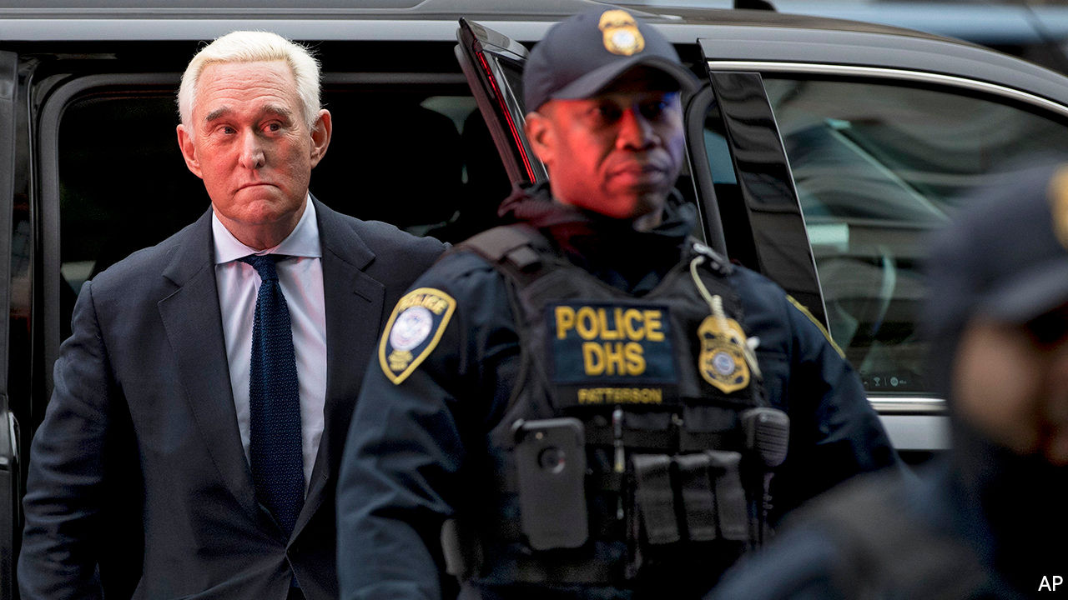

SUSAN COLLINS, a moderate Republican senator from Maine, voted to acquit Donald Trump in his impeachment trial. “I believe the president has learned from this case,” she said, before downgrading that “belief” to a “hope”. On February 12th a reporter asked Mr Trump what lesson he had learned from impeachment. “That the Democrats are crooked,” he replied. “That they’re vicious.” Welcome to the retribution project.

First Mr Trump showed that he would retaliate against those who testify against him. On February 7th he fired Gordon Sondland, America’s ambassador to the EU, who had told Congress that “everyone was in the loop” regarding efforts to pressure Volodymyr Zelensky, Ukraine’s president.

That same day Alexander Vindman, a lieutenant-colonel who had told Congress that Mr Trump’s call to Mr Zelensky was “inappropriate”, was removed from the National Security Council (NSC). Mr Trump suggested that the army should consider disciplinary action. Mr Vindman’s brother was also removed from his NSC job. Robert O’Brien, Mr Trump’s national security adviser, defended the dismissals, saying that America is “not a country where a bunch of lieutenant-colonels can get together and decide what the policy is of the United States.”

Then Mr Trump showed he will help those who break the law on his behalf. On February 11th four federal prosecutors abruptly withdrew from the case against Roger Stone, a sometime adviser to Mr Trump, after the Department of Justice pushed for him to receive a lighter sentence. Mr Stone was convicted of seven felonies related to his obstruction of Robert Mueller’s inquiry and facing a sentence of up to nine years.

On the same day Jessie Liu—who as US Attorney for Washington, DC, oversaw the prosecutions of several Trump associates, including Mr Stone and Paul Manafort—learned that the administration had withdrawn her nomination to a Treasury Department post. Last month she was removed from her former position and replaced by a top aide to William Barr, Mr Trump’s attorney-general.

The Department of Justice is not meant to be like other departments of the federal government, which jump when the president claps. But that distinction seems to have vanished. Mr Trump tweeted that the prosecutors’ recommendation of up to nine years for Mr Stone was “horrible and very unfair”. Later that day the government filed an amended sentencing request. It argued that the court should consider Mr Stone’s “advanced age, health, personal circumstances and lack of criminal history”, that the initial recommendation “could be considered excessive and unwarranted”, and that “it is unclear to what extent the defendant’s obstructive conduct actually prejudiced the government at trial”. As it happened, that same morning Mr Barr gave a speech to a group of sheriffs blasting “rogue DAs who undermine” law enforcement with lenient sentencing.

This article was downloaded by calibre from <https://www.economist.com/united-states/2020/02/15/acquittal-has-emboldened-donald-trump>

|  |  |  |  |
| --- | --- | --- | --- |
| Previous | Articles | Sections | Next |

|  |  |  |  |
| --- | --- | --- | --- |
| Previous | Articles | Sections | Next |

#### Seeking an edge, edge

# Is Pete Buttigieg doing well or badly?

The joint victor of Iowa did well again in New Hampshire, yet remains stuck in the polls

Feb 15th 2020 | SOUTH BEND, INDIANA

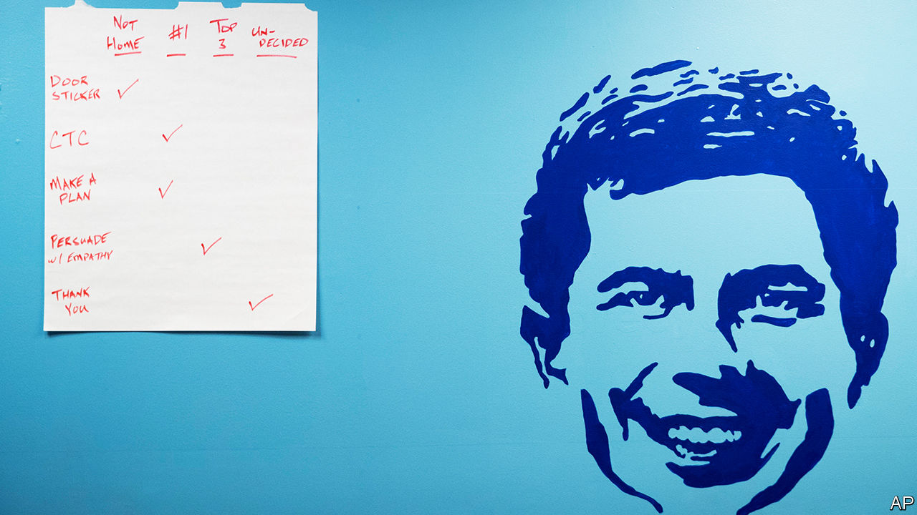

ORDINARILY A candidate who comes first equal in Iowa and backs that up with a strong second in New Hampshire would leap to the front of the primary pack. In the case of Pete Buttigieg, who won 24% of New Hampshire’s primary votes to Bernie Sanders’s 26%, one week after narrowly taking the most delegates from Iowa’s caucuses, that has not happened. In YouGov’s poll for The Economist, Mr Buttigieg remains stuck behind Mr Sanders, Joe Biden (still), Elizabeth Warren and Mike Bloomberg. Voters who have seen plenty of Mr Buttigieg in the early states evidently think he might be the party’s best bet to beat Donald Trump in November. Democrats elsewhere still seem unsure about who he is.

Mr Buttigieg is ridiculously young to be doing so well. It is 13 years since the pudgy-faced Rhodes scholar graduated from Oxford. Since then he has already got through three brief careers. First he was a globe-trotting financial analyst at McKinsey, a consultancy. Then he became a navy reservist, volunteering for an active tour as a “dirt sailor” (one who serves with the army) in Afghanistan. He completed eight years as mayor of South Bend, a once-glum-but-now-reviving city of 100,000 souls in northern Indiana where Mr Buttigieg was brought up by his parents, both professors at Notre Dame university. The fact that Mrs Buttigieg was a linguist and Mr Buttigieg senior was an expert on Gramsci is sometimes used to cast doubt on his rustbelt credentials. But the Midwest is home to cultural theorists as well as welders.

In conversations with The Economist over the past year, Mr Buttigieg has compared his rise to that of Emmanuel Macron in France or Matteo Renzi in Italy. Each was under 40 when first elected. America has never had a presidential candidate quite like him, not just because of his age or his family’s Maltese ancestry. He has taken to calling himself a “progressive veteran”. He is a brainy polyglot able to converse in Arabic, Dari, French, Norwegian and Spanish, among other tongues. He likes to chat about philosophy. One wealthy donor, who has spent time in conversation with all the main Democratic contenders, lauds him as “fantastic” and the “most intellectually curious by a mile” of all of them.

More striking, he is gay, married and unabashed in talking about how his Christian (Episcopalian, formerly Catholic) faith brought him to the “love of his life” his husband Chasten, a teacher. That seems to be a powerful combination for many voters. Some may be hostile to having a gay candidate, but plenty of conservative Democrats are swayed by his faith and his talk of respect for fellow veterans. At rallies older voters get weepy when he describes finding love. Some also swoon at his thoughtfully articulated sentences.

Mr Buttigieg has shown some guts too. Over six months in Kabul, as a lieutenant, he was officially deployed in counter-intelligence but in fact was often used “as a glorified driver”. Taking others around the Afghan capital—he counted 119 sorties outside the base—meant he was at some risk, but he never came under attack. He says “it was scary” at times, such as when rockets were fired at the base.

He was perhaps braver when, on his return, he published a column that first spelt out how he came to accept he was gay. “I was well into adulthood before I was prepared to acknowledge the simple fact…It took years of struggle and growth for me to recognise,” he wrote. For a buttoned-up man, that bout of self-examination, just before he sought re-election as mayor in 2015, was difficult. The city’s voters, more liberal than most Hoosiers, cheered his frankness and he won with 80.4%.

A self-described introvert (though he played guitar in a teenage band, “Turkish Delight”) he has never been shy of stating his ambitions for office. At Harvard, in 2004, he told a student newspaper that “politics is in my bones” and said he planned to devote his life to it. He also wrote columns on domestic and foreign politics for the Harvard Crimson. One could prove to be relevant this year: he pondered the lessons of the “intense and unpredictable” 1968 Democratic convention.

In his earliest electoral bid, a no-hoper effort to be Indiana’s state treasurer in 2010, he spent a year criss-crossing the state in a green Taurus. He learned fundraising (he is adept at it, with only Mr Sanders outdoing him for donors). Jeff Harris, his first campaign manager, now a political operative, recalls that he put in 50 hours a week calling potential donors, between glad-handing voters and local party chiefs. He lacked gumption only once, when he declined to sample dishes of deep-fried turkey testicles and brain sandwiches offered in rural southern Indiana.

## One year of history

Crushed in a landslide, nonetheless “he won by losing”, reckons Jack Colwell, a political columnist in South Bend. That race—and his aborted run to be Democratic national chairman in 2017—brought him to public attention and the eyes of party chiefs. In the mayoral races, managed by Mike Schmul (an old friend who now runs his presidential campaign), he proved popular among old voters and moderates who have abandoned the Republican Party.

As for his record in South Bend, that was decent but not miraculous: economic decline and population loss went on for decades after Studebaker closed a massive car plant in 1963. Mr Colwell reckons the young, technocratic mayor was the “catalyst” in getting outsiders to invest, clearing abandoned housing, improving city services, seeing poverty and joblessness fall and the population stabilise. Tony Flora, a union leader in the city, praises him for standing with organised labour, and for helping undocumented workers, notably Latinos, get identity papers.

Yet some say he overstates his success. Several other cities in the Midwest—Ann Arbor, Kalamazoo, Madison—have done well too, partly lifted by years of national economic recovery. South Bend was also helped by the presence of Notre Dame on its boundary. One political rival grumbles that Mr Buttigieg is most skilled at spin, taking credit, and self-promotion. Another complains that the ex-mayor verges on monomania when it comes to his career.

Some African-Americans in the city have also criticised Mr Buttigieg, mostly because he demoted the city’s first black police chief and removed a black fire chief soon after taking office in 2011. South Bend has seen a fall in the numbers of black police officers and signs of rising racial segregation in housing. Questions about this dog him on the trail. Even sympathisers agree that Mr Buttigieg was too slow to take such concerns seriously. The candidate has admitted he was naive in failing to see how badly segregated the city’s schools still are. His polling among African-American Democrats remains dire, despite (or perhaps because of) making a long list of promises to right past wrongs on race.

At just 38, he lacks any national or even state-level governing or legislative experience. And though no one has ever before jumped from a mayor’s office directly to the White House, he can at least say that voters in the first two primary states have shrugged off such historic niceties. Gramsci advocated “pessimism of the spirit; optimism of the will”. That could be an unofficial Buttigieg campaign slogan as the primary heads to larger, more racially mixed states.■

Dig deeper:

Sign up and listen to Checks and Balance, our new [newsletter](https://www.economist.com/checksandbalance/) and [podcast](https://www.economist.com/podcasts/2020/02/07/checks-and-balance-our-new-weekly-podcast-on-american-politics) on American politics[The Democratic primaries will be a contest between radicals and repairers](https://www.economist.com/leaders/2020/02/06/the-democratic-primaries-will-be-a-contest-between-radicals-and-repairers)Mike Bloomberg’s (very expensive) moment[Bernie Sanders and Pete Buttigieg emerge from New Hampshire as the Democrats’ favourites](https://www.economist.com/united-states/2020/02/12/bernie-sanders-and-pete-buttigieg-emerge-as-the-democrats-favourites)

This article was downloaded by calibre from <https://www.economist.com/united-states/2020/02/15/is-pete-buttigieg-doing-well-or-badly>

|  |  |  |  |
| --- | --- | --- | --- |
| Previous | Articles | Sections | Next |

|  |  |  |  |
| --- | --- | --- | --- |
| Previous | Articles | Sections | Next |

#### Watch your step

# Donald Trump loosens America’s restrictions on landmines

The new ones are supposed to blow themselves up

Feb 13th 2020 |

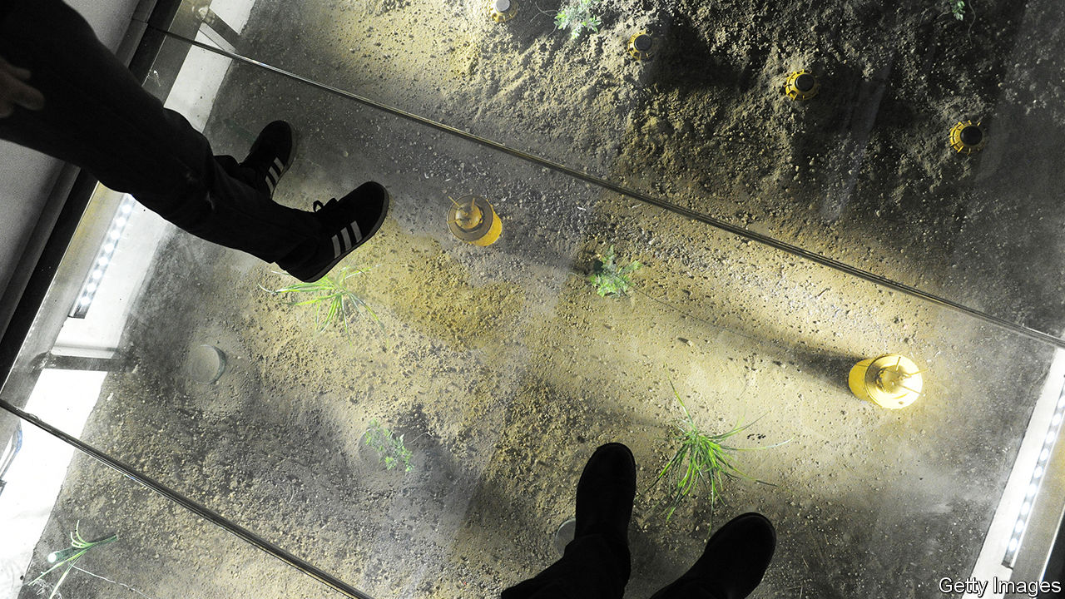

DURING THE Gulf war of 1991, no fewer than 117,000 landmines were showered over Kuwait and Iraq by American planes. This barely dented the Pentagon’s vast stockpile of 19m. Just under a quarter of the devices scattered in the path of Saddam Hussein’s army were anti-personnel landmines (APLs), the sort that would soon be banned by the Anti-Personnel Mine Ban Convention of 1997, widely known as the Ottawa treaty, a cause famously championed by Princess Diana. It was the last occasion on which America made significant use of APLs. But a new ruling by the Trump administration suggests that the weapons could make a comeback.

The Ottawa treaty has 164 parties, all of which ban the production and use of APLs (anti-vehicle mines, among others, are still allowed). America is not among them. When the treaty was finalised, America declined to join (other holdouts include China, Cuba, Iran, Russia and Syria). President Bill Clinton said he hoped America would sign up later but his successor, George W. Bush, flatly rejected the idea. In 2014 Barack Obama made an important compromise by confining the use of APLs to the Korean peninsula, where he pointed to “unique circumstances”—America’s need to defend a long border against a large North Korean army. But everywhere else, America would at last come into line with the treaty. “We were signalling our clear aspiration to eventually accede to the Ottawa Convention,” said the White House at the time.

Mr Trump, who generally takes the view that anything favoured by his predecessor is inherently suspect, and has already loosened rules on cluster munitions since December 2017, rescinded Mr Obama’s landmine policy on January 31st, allowing senior commanders outside the Korean peninsula to use APLs once more and permitting their production to resume. The Pentagon said that it had conducted a study which demonstrated “a critical capability gap” in its arsenal.

Landmines have a number of military uses. They are typically used to channel opposing armies away from particular areas and into others. A minefield can force an enemy to turn, which exposes their flank and makes them especially vulnerable, says Vincent Brooks, a retired general who commanded American forces in South Korea in 2016-18. They can also be used to “canalise” the enemy, channelling attackers into unfavourable terrain, where they may be more exposed to concentrated artillery fire. But for all that, America has made little use of landmines in the past three decades, having cleared its last minefield, at the Guantanamo naval base in Cuba, in 1996-99 and having used a single APL in Afghanistan in 2002 (the purpose is unknown).

Why has Mr Trump decided he needs them now? The memorandum setting out the change in landmine policy opens by pointing to “the re-emergence of long-term, strategic competition”, language that the Pentagon typically uses to refer to China and Russia. Some experts suggest that the need to slow and disrupt a possible Russian offensive through eastern Europe is a possible rationale, especially because NATO’s strategy relies on buying time to reinforce its frontline positions.

But the policy shift probably has much more to do with North Korea than either of those countries. Although Mr Obama’s restrictions permitted the use of APLs on the Korean peninsula, after the Pentagon said it could not do without them, he had earlier pledged that America would not produce any new ones, even to replace existing stocks. Since the batteries and other components in landmines degrade over time, that policy essentially amounted to an eventual blanket ban, with the aim of forcing the armed forces to shift to remotely detonated mines (which are not covered by Ottawa). America’s stockpile was last replenished in 1997, and is expected to become obsolete by the early 2030s. Mr Trump’s new guidance crucially allows the development and production of new devices. The Pentagon may be especially eager to restock its cupboard as nuclear talks with North Korea falter and the prospect of conflict returns.

Yet landmines are reviled weapons, and not without good reason. “They’re indiscriminate,” says General Brooks, “so anyone or anything that moves through that area can be a problem.” That includes friendly forces—modern armies shun static defences in favour of what they call “manoeuvre warfare”, so today’s defensive minefield can be tomorrow’s headache. And that also includes civilians. Landmine casualties have fallen sharply over the years, but at least 2,000 people were killed or wounded by manufactured or improvised APLs in 2018, according to data collected by the Landmine and Cluster Munition Monitor, a research group. Laying a mine can cost a few dollars; clearing one can require $1,000.

The Pentagon has an answer to this. It says that it only possesses, would only produce and would only use “non-persistent” landmines with the capacity to self-destruct or, failing that, to self-deactivate, with a battery losing its charge, within 30 days (some models can blow themselves up in as little as a few hours). It claims that such features are remarkably reliable. In 2004 the Bush administration said it had tested over 67,000 landmines in a variety of conditions “with no failures of the self-destruct system”. Today the Pentagon says that only six landmines out of 1m are expected to remain active as duds, a rate of less than one in 167,000. But experts and NGOs roll their eyes at such claims.

“When the technology is brought into the battlefield, we see that the actual data doesn’t match with the promises,” says Erik Tollefsen, head of Weapons Contamination for the International Committee of the Red Cross. He says that impressive reliability rates are usually derived from tests in sterile conditions, and prove wildly exaggerated in practice. In 2002 a report by the Government Accountability Office, an agency that audits the federal government, noted that during the Gulf war one in 10,000 mines were expected to remain active, which would have produced 12 duds. The actual figure was almost 2,000.

The development of “smart” landmines has stalled in part because research funding plummeted when the Ottawa treaty came into force 20 years ago. “There isn’t a full technological solution to it that’s 100% certain at this point,” acknowledges General Brooks. “But honestly that’s the nature of anything and everything that happens in conditions of war”.

Others argue that there are perfectly viable alternatives. In 2001 a Pentagon-sponsored study by the National Research Council, an arm of the United States National Academies, noted that “the rapid emergence of new technologies after 2006 will create opportunities for the development of systems that can outperform today’s antipersonnel landmines and that would be compliant with Ottawa”. In particular, remotely activated mines (rather than victim-activated ones) are allowed under the treaty if the person triggering the device has the would-be victim in sight, although this makes them harder to use at range and hostage to a breakdown of communications. In 2018 Finland—a late and reluctant signatory to Ottawa, given its long border with Russia—said it was developing a new, remote-controlled variety of anti-personnel “bounding” mine that leaps into the air and fires metal bullets downwards. In the world of weaponry, that is what passes for humane. ■

This article was downloaded by calibre from <https://www.economist.com/united-states/2020/02/13/donald-trump-loosens-americas-restrictions-on-landmines>

|  |  |  |  |
| --- | --- | --- | --- |
| Previous | Articles | Sections | Next |

|  |  |  |  |
| --- | --- | --- | --- |
| Previous | Articles | Sections | Next |

#### Vin-dictive

# American drinkers of European wine face mounting tariff bills

Mounting the barricades for Barolo

Feb 15th 2020 | WASHINGTON, DC

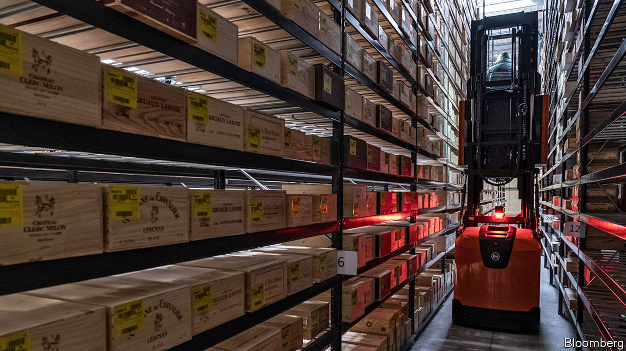

“TARIFFS COST American jobs” is a sobering chant. And for the 30 marchers (with 200 signs and marshalled by six police vehicles) in Washington, DC, that was the point. On February 9th they met to protest against the looming threat of tariffs of up to 100% on wine imported from the European Union. Kevin Rapp, an importer of Italian wines and the march organiser, got involved because, if tariffs happen, they would close his business. In vino veritas.

It all started on October 18th, when as part of a long-running dispute over subsidies for Airbus, a European aircraft manufacturer, the Trump administration hit wine from France, Spain, Germany and Britain with tariffs of 25%. In a normal year wine imports fall by 10-20% from October to November, as retailers stop stocking up for the holiday season. In November 2019 purchases fell by over 30% once the duties were in place.

Regulations require many middlemen between makers and drinkers of wine, which means that the industry has both low margins and lots of markups. Christopher Lombardo of IBISWorld, a market-research firm, reports that so far many distributors have opted to swallow the tariffs at the expense of their profit margins. For smaller businesses, he warns, this is unsustainable.

If the tariff of 25% has stained balance sheets red, a jump to 100% would put many out of business. “We would be done,” says Andrea Wallace, who works for a wine importer that has already paid $40,000 in duties. When the tariffs were applied her company had two containers of wine “on the water”, which suddenly became 25% more expensive than they had planned for. Now, she says, “we’re all gun-shy” about putting wine on the water, in case they get hit.

Hard-nosed officials may discount this. At a hearing to discuss a tariff threat on French champagne, United States Trade Representative officials quizzed merchants about whether drinkers could switch to different sorts of wines—perhaps even the American sort? The suggestion is an affront to sommeliers, who see the quality or character of a wine as intrinsically linked to its origin.

Thus far winesellers have avoided passing the full cost of the tariffs on to drinkers. But according to Chris Bitter of Vintage Economics, a market-research company, the most extreme scenario would see tariffs covering almost all imported European wine, more than a quarter of American consumption by value, and around one in every six bottles sold. If that happens, expect Barolo- drinkers to mount the barricades.

This article was downloaded by calibre from <https://www.economist.com/united-states/2020/02/15/american-drinkers-of-european-wine-face-mounting-tariff-bills>

|  |  |  |  |
| --- | --- | --- | --- |
| Previous | Articles | Sections | Next |

|  |  |  |  |
| --- | --- | --- | --- |
| Previous | Articles | Sections | Next |

#### Lexington

# Mike Bloomberg’s (very expensive) moment

The former mayor of New York’s lavish spending and weak rivals make him a contender

Feb 15th 2020 |

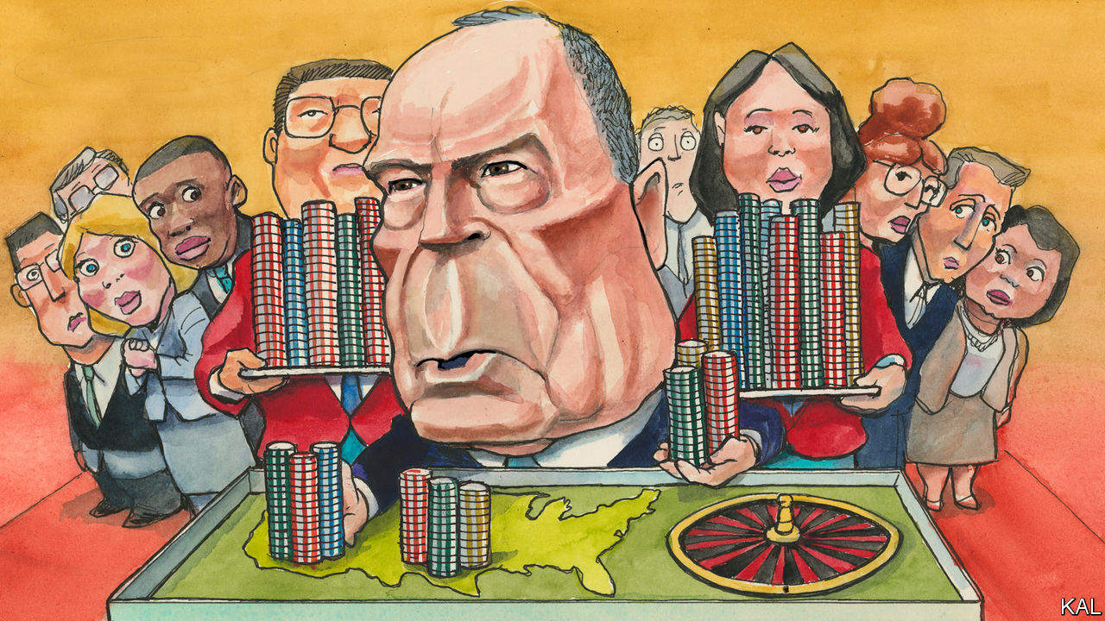

ON A RAINY afternoon in Chattanooga, the queue for Mike Bloomberg trailed around the block. Eleven weeks into his presidential campaign, the former New York mayor and world’s 12th-richest man is already well known in Tennessee. This was his fourth visit to the state, one of 14 that will hold its primary vote on March 3rd. He is also dominating its airwaves, with television ads touting his criticisms of Donald Trump, mayoral record and philanthropic support for gun control and climate-change policy running on a loop. “It’s almost like it was with Obama,” said a sodden Chattanoogan retiree, marvelling at the size of the crowd.

The back-to-front oddity of Mr Bloomberg’s campaign has drawn a lot of scorn. Presidential primaries have traditionally been decided by the first four early-voting states which, because of his late entry to the race, he is sitting out. His politics, as a former Republican, once synonymous with racially insensitive policing, also looked hopeless to many leftist commentators. Yet self-made billionaires tend not to be bad at reckoning their odds. And, sure enough, while Mr Bloomberg’s rivals knocked lumps out of each other in Iowa and New Hampshire, his aggressive campaigning in the Super Tuesday states has produced the biggest, fastest polling surge of the contest.

He sits third in The Economist’s national polling aggregate, on 16%. And with Joe Biden falling, he may soon be second to Senator Bernie Sanders, the winner in New Hampshire. This has already attracted an impressive ripple of endorsements, including from three members of the Congressional Black Caucus—hitherto Mr Biden’s biggest champion—this week. And if the primary were indeed to start looking like a face-off between Mr Bloomberg and the widely mistrusted Mr Sanders, many more would follow. Diminutive, prickly and poor at public speaking, Mr Bloomberg is almost nothing like Barack Obama—save potentially in one regard. Unlike their more uniform opponents, Democrats’ first concern is to find a leader capable of uniting their party’s ethno-politically divided coalition. Mr Obama did so magnificently—which is why Mr Biden, his bumbling deputy, has been afforded such an extended stab at assuming the role. The nascent enthusiasm for Mr Bloomberg, before he has contested a primary or debated any of his Democratic rivals, suggests he might soon be auditioned for it.

There are two reasons for his rise. First, the vastness of his spending. He is estimated to have splurged over $300m on TV, radio and digital advertising alone. To put that in perspective, Amy Klobuchar, a rival moderate, recently had $5m in hand. Mr Bloomberg has also assembled a huge and talented campaign team—with so far 2,100 employees, many of whom earn twice what other campaigns pay. The resources and professionalism of his rallies are on a different level from his rivals’. When it became clear that the venue in Chattanooga could not accommodate at least 200 of those queuing, his technicians rigged up a sound system outside the building within minutes. At a later event in Nashville, over 1,000 attendees were served a barbeque supper and all the “I like Mike” badges and T-shirts they could carry.

The second thing in Mr Bloomberg’s favour is that the verdict of the earliest states is far from decisive. The centre-left is currently split between Pete Buttigieg, Ms Klobuchar and the fading Mr Biden. This has made Mr Sanders, through his dominance of the smaller left-wing faction, a weak front-runner. To challenge him, either Mr Biden would have to rally his erstwhile non-white supporters, or else Mr Buttigieg or Ms Klobuchar would have to win them. Yet Mr Biden looks blown. And, notwithstanding their attributes, Mr Buttigieg and Ms Klobuchar are still giving many voters pause. Neither a gay mayor nor a woman has yet made it to the White House. The fact that Mr Bloomberg is himself a “short, divorced Jewish billionaire from New York”, as he once self-deprecatingly termed himself, does not now seem disqualifying.

In reality, no candidate looks able to unite Democrats as Mr Obama did: Mr Bloomberg would certainly alienate many Sandernistas. Yet the best argument for his candidacy may be that he is unusually able to focus wandering Democratic minds on the common enemy: Mr Trump. The many symmetries between the two New Yorkers are glaring and unfailingly to Mr Bloomberg’s credit. He is a self-made billionaire; Mr Trump inherited his wealth and bankrupted his companies. Mr Bloomberg has a record of improving government by bringing business-like efficiencies to it; the president is a wrecker. Mr Bloomberg is one of America’s most generous philanthropists; Mr Trump used his family foundation to buy a portrait of himself to hang in one of his golf clubs. And if Democrats doubt that such comparisons are important, they should reflect that, if Mr Bloomberg were his opponent, Mr Trump would think about little else. A recent quip by Mr Bloomberg about Mr Trump’s lesser wealth (asked about the prospect of two billionaires vying for the presidency, he asked: “Who’s the other one?”) was plainly intended for an audience of one.

## Bloomberg terminal

There are still huge questions about his candidacy. His support has been inflated by high name-recognition in places where his opponents are absent. If he performs badly in his first clashes with them—starting with a televised debate in Las Vegas on February 19th—it could shrivel. Having been largely ignored by his rivals thus far, he is also due some potentially damaging attention. The unearthing this week of some past thuggish remarks by Mr Bloomberg in support of his controversial policing was an early taste.

A bigger fear is that, instead of capitalising on the Democrats’ divided field, he may fracture it further. He could nab enough of Mr Biden’s support with non-whites to stop Mr Buttigieg or Ms Klobuchar uniting the centre-left, yet be unable to do so himself. Perhaps his qualities are worth the risk. But if it backfires, he will have done more than almost anyone to make Mr Sanders the nominee.■

Dig deeper:  
Sign up and listen to Checks and Balance, our new [newsletter](https://www.economist.com/checksandbalance/) and [podcast](https://www.economist.com/podcasts/2020/02/07/checks-and-balance-our-new-weekly-podcast-on-american-politics) on American politics  
[The Democratic primaries will be a contest between radicals and repairers](https://www.economist.com/leaders/2020/02/06/the-democratic-primaries-will-be-a-contest-between-radicals-and-repairers)[Who will be Donald Trump’s most forceful foe?Bernie Sanders and Pete Buttigieg emerge from New Hampshire as the Democrats’ favourites](https://www.economist.com/united-states/2020/02/01/who-will-be-donald-trumps-most-forceful-foe)

This article was downloaded by calibre from <https://www.economist.com/united-states/2020/02/15/mike-bloombergs-very-expensive-moment>

|  |  |  |  |
| --- | --- | --- | --- |
| Previous | Articles | Sections | Next |

|  |  |  |
| --- | --- | --- |
| United States | Sections | Asia |

The Americas

Canadian health care: Justin Trudeau’s drug problem

.

El Salvador: Bukele up

.

Bello: “What is Peronism?”

.

|  |  |  |
| --- | --- | --- |
| United States | Sections | Asia |

|  |  |  |  |
| --- | --- | --- | --- |
|  | Articles | Sections | Next |

#### Justin Trudeau’s drug problem

# Canada ponders a federal programme for pharmaceuticals

The country’s vaunted public health-care system has a big gap

Feb 15th 2020 | TORONTO

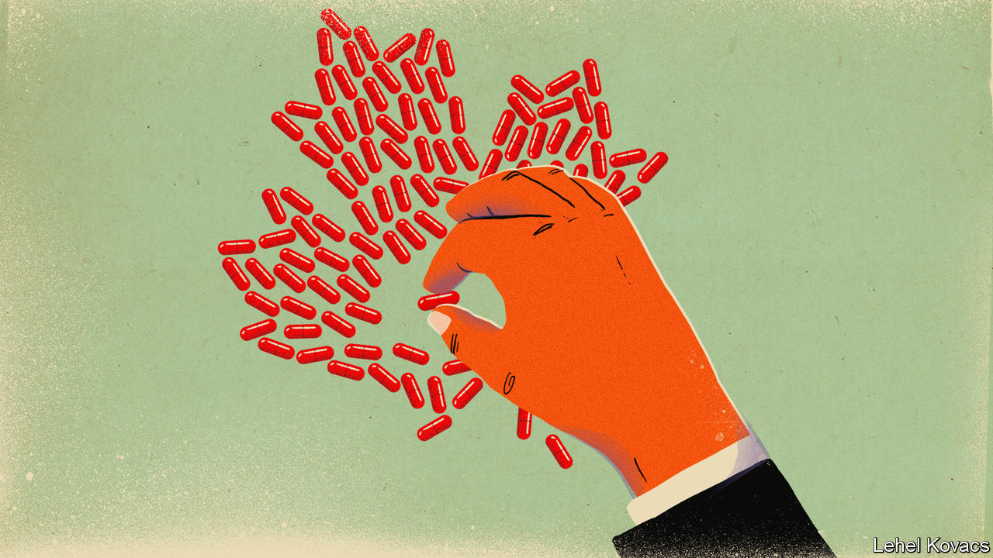

IN JULY Bernie Sanders hopped on a bus in Detroit with some Americans who have diabetes. They rode across the Canadian border to buy insulin at a tenth of the price they would pay at home. For Mr Sanders, who won the New Hampshire primary on February 11th, joining an “insulin caravan” had obvious appeal. He promises “Medicare for all”, suggesting that every American should enjoy the lavish public health spending that the elderly receive. He praises Canada for its tough negotiations with drug firms. “We should be doing what the Canadians do,” he declared.

Canadians have their doubts. Canada’s pharmaceutical prices are 25% higher than the average in the OECD, a club of 36 mainly rich countries. American prices are higher still, largely because the United States has powerful drug firms, no price-setting regulator and lots of citizens who receive health insurance through their employers and have little idea how much it costs. Unlike Canada, the United States also lets drugmakers advertise directly to consumers. As a share of GDP, Canada’s pharmaceutical spending is the fifth-highest in the OECD (see chart).

It is the only country with publicly financed universal health care that does not provide universal coverage for prescription drugs. A fifth of Canadians have no drug insurance. Nearly 1m say they spend less on food or heating to pay for them. Hundreds of people die and tens of thousands harm their health because they stop taking medicines, according to a report in 2018 by a nurses’ union.

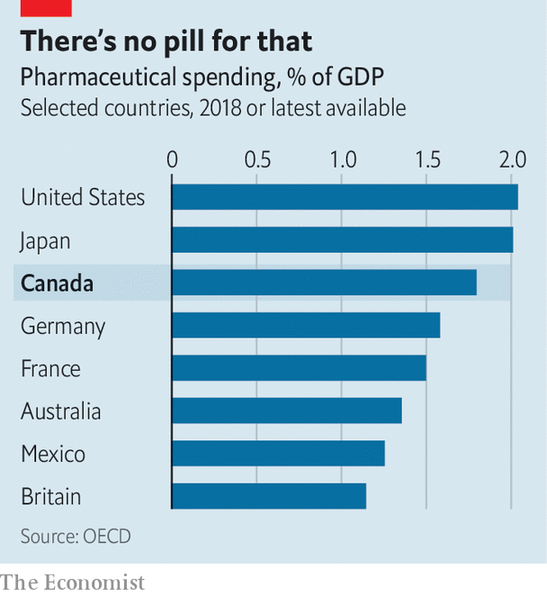

Politicians now agree that Canada has a drug problem. Justin Trudeau, the Liberal prime minister, who has led a minority government since a parliamentary election in October, calls drug prices a “terrible financial barrier”. In December the government said it would introduce “national pharmacare”, some sort of federal drug-insurance benefit. That leaves big questions unanswered. Just how Mr Trudeau goes about fixing drug coverage will be one of the biggest decisions of his second term.

Currently, most Canadians get drugs through a patchwork of public and private insurance schemes. Around 60% are enrolled in one of more than 100,000 private plans, mostly through their employers. Provincial governments provide insurance to groups such as old or jobless people, and in some cases to poor families. The federal government covers indigenous Canadians and members of the armed forces. This fragmented system leaves people out, including many low-wage and self-employed workers.

A federal board sets a ceiling on prices for patented drugs, using international benchmarks to determine what is excessive. Provincial governments collaborate with each other and with the federal government to bargain prices down further. But Canada’s complex public-private system weakens its negotiating power. It does not have the market clout of England’s National Health Service, almost the sole buyer of prescription drugs in its market.

The main question facing Mr Trudeau is whether to fill in the gaps with a modest federal scheme, or replace the patchwork with a universal plan. He is under pressure to pick the bolder option. Two-thirds of voters want a universal plan. The left-leaning New Democratic Party (NDP), whose votes Mr Trudeau will sometimes need, backs universality. So did a government-appointed panel in June. “Every single darn study always comes to the same conclusion,” says Don Davies, the NDP’s health spokesman.

The panel forecast that a universal plan would reduce overall spending on prescription drugs, which is around C$34bn ($26bn) a year. By 2027 Canada would spend 10% less than currently projected. That is because the federal government could negotiate lower prices for bulk purchases of drugs, said the panel. It could also speed up the switch to (much cheaper) generics when patents expire. Employment costs would fall by C$750 a year per worker, because employers would no longer feel obliged to pay for drugs. Other things being equal, this should translate into higher wages. Families’ out-of-pocket expenses would also fall by C$350. Other health-care costs would also drop. Patients who skip medication tend to get sicker and need to go to hospital. This is much more expensive than taking the drugs would have been, and the taxpayer picks up the tab.

But Mr Trudeau is wary of an ambitious national plan that would push up federal spending. The advisory panel reckons that universal coverage would eventually cost the federal government an additional C$15bn a year, more than half this year’s expected budget deficit. It would probably also lead to an increase in taxes. Opponents make an argument that will sound familiar to Americans: people with private insurance get better coverage than they would under a public scheme. As in the United States, few Canadian workers realise that the high cost of employer-provided health insurance comes out of employees’ wages, collectively.

Provinces and territories, which are in charge of public health care, might also resist drug reform. In 2011 the federal government, then led by the Conservatives, cut in half the annual increase in its contribution to provincial and territorial health budgets. Provincial governments suspect that pharmacare will be used to dump more costs on them. It is the “most expensive and disruptive option” for provinces, says Tyler Shandro, the health minister of Alberta, a western province governed by Conservatives. Provincial leaders have already said they want the right to use the money that would be spent on universal pharmacare for their own health-care priorities.

Before the election Mr Trudeau promised a C$6bn “downpayment” on pharmacare over four years, far less than needed for a universal programme. Support for a more modest plan could come from the Bloc Québécois, a nationalist party from Quebec that has more seats in Parliament than the NDP. Quebec is the only province with universal public coverage for citizens who lack private insurance. The Bloc is unlikely to endorse a federal programme that replaces it.

The government has begun an economy drive. It is lowering price ceilings by removing the highest-cost countries, such as the United States, from federal benchmarks. That will reduce national spending on drugs by a modest C$130m a year on average over the next decade, it expects. The government also plans to establish a national drugs agency to improve co-ordination with provinces in bargaining with pharmaceutical firms and to consider ways to standardise and expand drug coverage. But this may take years. Until then, Canada will not be quite the role model that Mr Sanders thinks it is.■

Correction (February 13th): A previous version of this story mis-named the New Democratic Party. This has been changed.

This article was downloaded by calibre from <https://www.economist.com/the-americas/2020/02/15/canada-ponders-a-federal-programme-for-pharmaceuticals>

|  |  |  |  |
| --- | --- | --- | --- |
|  | Articles | Sections | Next |

|  |  |  |  |
| --- | --- | --- | --- |
| Previous | Articles | Sections | Next |

#### Bukele up

# El Salvador’s president summons the army to bully congress

Nayib Bukele may get his way, at the price of damaging democracy

Feb 15th 2020 |



NAYIB BUKELE, the president of El Salvador, draws notice outside his country for his youth, his jet-black beard and his mastery of social media. Now his authoritarianism is a trending topic. The sight of Mr Bukele entering the National Assembly on February 9th, alongside soldiers toting machine guns, shocked onlookers at home and abroad. He plonked himself in the empty chair reserved for the president of congress. “I liked seeing those empty seats,” he tweeted. “It made it easier for me to imagine them full of honest people who work for the people.”

Congress accused the president of staging an “attempted coup”. The Constitutional Court rebuked Mr Bukele. El Faro, a Salvadorean news website, called his stunt “the lowest moment that Salvadorean democracy has lived in three decades”. He retorted, not very reassuringly, “If I were a dictator, I would have taken control of everything.”

Eight months into his presidency Mr Bukele, who at 38 is the world’s second-youngest head of state, has an approval rating of 90%. But his left-leaning New Ideas party, founded in 2018, has not had a chance to win seats in congress. The legislature is dominated by two parties: the left-wing FMLN, the successor to a guerrilla movement that fought a decade-long civil war in the 1980s, and the right-wing Arena party, which defended the government in that war. Mr Bukele has so far used his popularity to get his way in congress, persuading it to enact a budget, for example.

But for three months the legislature has failed to approve a loan that would finance Mr Bukele’s security plan. Tired of waiting, he ordered lawmakers to convene for an extraordinary session. When no quorum was reached, he summoned the army and thousands of supporters, invoking an article of the constitution that gives citizens the right to “insurrection”.

Congress had already consented to more than $400m of spending for his security plan, which includes a strategy for fighting gangs, more money for social programmes and an upgrade of equipment for the police. So far, though, congress has withheld approval of a $109m loan from the Central American Bank for Economic Integration, a multilateral bank based in Tegucigalpa, Honduras, to be used to buy equipment. Some lawmakers worry about reports that a $26m contract to supply cameras will go to a Mexican firm that gave free flights on a private jet to the deputy justice minister. (He denies wrongdoing.)

Mr Bukele’s popularity will depend partly on his success in fighting gangs, which earn most of their money by extorting it from ordinary Salvadoreans. In 2015 El Salvador’s murder rate of more than 100 per 100,000 people was the world’s highest. Lately violence has fallen. In 2019 the murder rate was a third of its peak. In January this year there were 120 killings, fewer than in any month since the end of the civil war in 1992. That is not just the president’s doing. Violence has dropped in all the countries of the Northern Triangle (which includes Honduras and Guatemala). But there is little evidence that extortion has declined in El Salvador. Mr Bukele’s security plan is aimed at curbing non-lethal crime as well as murder.

During his brief tenure, he has behaved both like a technocrat and a populist showman. This month he announced that Ricardo Hausmann, an economist at Harvard University, would advise his government. But his proposed anti-corruption commission looks as if it will have little power.

Mr Bukele could have been more patient. He will probably gain control over congress in legislative elections due next year. Rather than wait, he has triggered a constitutional crisis and memories of military dictatorship and the civil war, in which 75,000 people died.

Mr Bukele eventually called off the army, and grudgingly agreed to comply with an order by the Constitutional Court that he keep the soldiers out of congress. The president may have delighted some of his supporters by bullying the legislature. Salvadoreans who care about the health of their democracy are rightly worried. ■

This article was downloaded by calibre from <https://www.economist.com/the-americas/2020/02/15/el-salvadors-president-summons-the-army-to-bully-congress>

|  |  |  |  |
| --- | --- | --- | --- |
| Previous | Articles | Sections | Next |

|  |  |  |  |
| --- | --- | --- | --- |
| Previous | Articles | Sections | Next |

#### Bello

# “What is Peronism?”

Argentina’s president tries to explain to the German chancellor

Feb 15th 2020 |



ON FEBRUARY 3RD Argentina’s new Peronist president, Alberto Fernández, joined Angela Merkel for dinner at the German chancellery in Berlin. According to press reports, Mrs Merkel asked her guest a question: “What is Peronism? I don’t understand. Are you on the left or the right?” Bello imagines a conversation that might have followed.

Mr Fernández laughed. He was used to foreigners not knowing much about Argentina besides Evita, tango and hyperinflation. But something about Mrs Merkel suggested that she was only feigning ignorance. “Let me explain,” said Mr Fernández cautiously. “First of all, we’re not populists. That was an invention of Mauricio Macri, my neo-liberal predecessor. We don’t just stir up the masses.”

“Really?” asked Mrs Merkel, sounding unconvinced.

“Really. I’m a social democrat,” the president insisted. “The base of Peronism is the trade unions and the poor, whom we always look after. But we also have the industrialists behind us. They liked General Juan Perón’s protectionism 75 years ago and they like it today. And we have the pope.”

“As always, Perón himself put it best,” Mr Fernández continued. “In 1972 he told a journalist: ‘Look, in Argentina, 30% are Radicals…30% are conservatives and a similar amount Socialists.’ ‘So where are the Peronists?’ asked the journalist. ‘Ah,’ replied Perón, ‘we are all Peronists.’”

“Perhaps we should try this Peronism thing,” mused his host. Slightly alarmed, an aide to the chancellor intervened. “We have done some research,” he said. “And we have read ‘What is Populism?’ by Jan-Werner Müller, a German political scientist. The professor writes that ‘populists claim that they, and they alone, represent the people.’” The aide went on: “Perón said that his movement ‘has ceased to be the cause of one man to become the cause of the people’. He also said ‘true democracy is where the government does what the people want and defends a single interest, that of the people.’”

“Quite,” said Mr Fernández. “That’s why we have no social explosion in Argentina.”

“The first problem,” replied the pesky aide, “is who decides who constitute ‘the people’? Do those who disagree with you belong or not? What is clear to us is that Peronism is a populist way of exercising power, and that’s why you can be both left- and right-wing. Herr Professor also writes that populist governments usually try to hijack the state apparatus, are prone to corruption and practise ‘mass clientelism’. We have seen this in Argentina.”

Faced with such cold Weberian logic, Mr Fernández changed tack. “We are the people who know how to run the state and the economy,” he chipped in. “We are the professionals.” He explained that in 1989 and 2002 Peronists had inherited economic chaos. “And that’s what Macri left me, too,” he complained.

“True,” intervened the aide. “But it was the Peronists who created the mess in the first place. You have dominated Argentina since 1946. In that period the country has moved from the first world to the third.” There was an awkward silence. The chancellor cut in: “President Fernández…or may I call you Alberto?”

“Cristina does,” came the reply.

“Cristina? Oh, your vice-president, Cristina Fernández de Kirchner, who used to be president herself. Yes, I met her. Her government asserted in 2015 that there was more poverty in Germany than in her Argentina, which was nonsense. And she claimed to have abolished inflation by changing the head of the statistics institute. Germans would never stand for that. There’d be a revolution.”

“We are not hiding inflation,” said Mr Fernández. “I’ve frozen most pensions for a few months, so inflation will get rid of the fiscal deficit just as your bankers want me to. We’ve also negotiated a wage freeze with our union allies. As the Argentine saying goes, ‘Some bums will bleed more than others.’”

“Our companies tell me they won’t invest in Argentina until you lift exchange controls and open up the economy,” added the chancellor.

“I am a moderate,” said Mr Fernández. “I know that dollars don’t grow on ombu trees. Argentina should join the world. But you are asking me to dance the tango while I’m still in intensive care.”

As she finished her rabbit, Mrs Merkel said consolingly: “I can see that it’s not easy to be a Peronist social democrat.” “It isn’t,” said Mr Fernández. “The economy is a mess, everyone expects a Peronist president to shower them with money, and I don’t have any. I don’t normally drink, but I need a glass of Malbec.”

This article was downloaded by calibre from <https://www.economist.com/the-americas/2020/02/15/what-is-peronism>

|  |  |  |  |
| --- | --- | --- | --- |
| Previous | Articles | Sections | Next |

|  |  |  |
| --- | --- | --- |
| The Americas | Sections | China |

Asia

Social conservatism in the Philippines: Papal power

.

Duterte v America: A treaty for a visa

.

Ethnic tensions in Kazakhstan: Fire and fury

.

Elections in Delhi: Capital loss

.

Banyan: Belt and roadblock

.

|  |  |  |
| --- | --- | --- |
| The Americas | Sections | China |

|  |  |  |  |
| --- | --- | --- | --- |
|  | Articles | Sections | Next |

#### Papal power

# Why the Philippines is the only country where divorce is illegal

Except the Vatican, of course

Feb 15th 2020 | MANILA

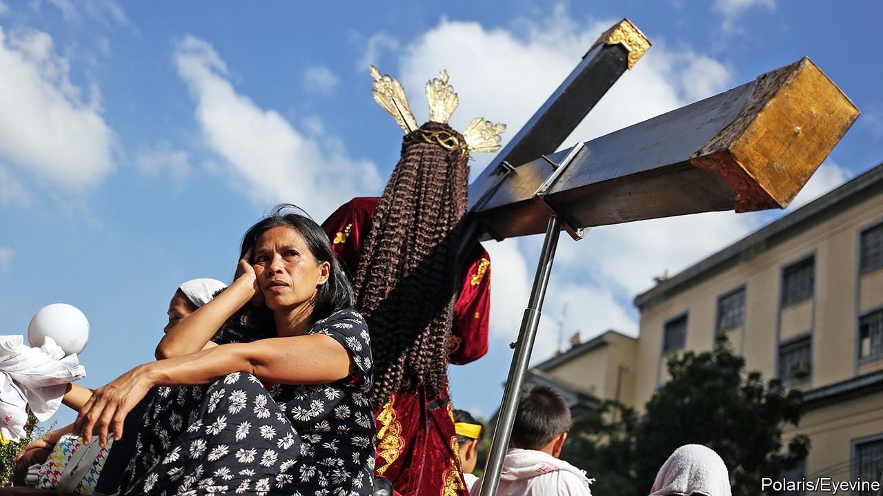

“YOU HAVE to lose before you can win,” explains Jesus Falcis. He is referring to the Supreme Court’s decision to dismiss, on procedural grounds, a petition he filed in 2015 challenging a law which proclaims that marriage can occur only between a man and a woman. Mr Falcis finds a silver lining in the fact that the judges did not see any obvious constitutional impediment to same-sex marriage. But he has little doubt that the effort to secure it will take decades, just as it did in rich countries.

Even by the standards of former Spanish colonies, the Philippines has extremely socially conservative laws. It is the only country in world, bar the Vatican City, to outlaw divorce (except for Muslims). The only way of ending a marriage, short of dying, is to have it annulled, but that can be done only on narrow grounds and at great expense. Abortion is illegal, too, and anyone undergoing or performing one risks up to six years in prison. Contraceptives, although not banned, are the subject of fierce legal battles, as opponents try to prevent the state from distributing them.

This is not simply a legacy of colonialism or a reflection of Filipinos’ piety. Compared with Mexico, say, another country long ruled by Spain where four-fifths of the population considers itself Catholic, the Philippines is uptight. A constitutional amendment and new laws adopted in 1974 guaranteed Mexicans’ access to contraception. Mexico City legalised civil unions for same-sex couples in 2006 and abortion in 2007. A further 17 Mexican states have since legalised gay marriage.

Moreover, Filipinos seem less conservative than the laws that govern them. More than half think divorce should be legal, according to surveys conducted in 2017 by Social Weather Stations (SWS), a pollster. Seven in ten support a law allowing the government to distribute contraceptives to the poor, which was enacted in 2012 but has yet to be implemented fully. Lots of Filipinos are openly gay. Manila’s annual gay pride parade attracted 70,000 participants last year, despite rain. Gay Filipinos enjoy success in all manner of careers, from music to sports. In 2016 a transgender woman won election to Congress. Last year she was re-elected with 91% of the vote.

So why are Filipinos’ views so poorly represented in national legislation? The explanation lies in an unfortunate mix of politics and faith. About three-quarters of Filipinos consider religion “very important”, SWS found in 2018. A study the same year suggests that almost four in ten voters are likely to cast their ballots for a candidate endorsed by their church or religious movement.

In recent years the clout of the Catholic church has diminished somewhat. The share of Catholics attending church weekly has dropped from 66% in 1991 to 46% in 2017. Father Jerome Secillano of the Catholic Bishops’ Conference of the Philippines worries that an erosion of traditional values is under way. The church has struggled to respond to the wild popularity of President Rodrigo Duterte, who has called God “stupid”, the Pope “a son of a whore” and says that a priest molested him as a boy. The Catholic hierarchy has opposed Mr Duterte’s signature policy, a war on drugs that involves cops shooting thousands of suspected dealers, to little avail.

But Catholics’ declining influence over politics has been offset by the growing importance of various Protestant sects. Although only about 10% of Filipinos, or roughly 10m people, describe themselves as Protestants or evangelicals, their relative fervour makes them a political lobby to be reckoned with. They tend to espouse a literal interpretation of the Bible and so are fiercely opposed to divorce, same-sex marriage and abortion, says Jayeel Serrano Cornelio of Ateneo de Manila University.

The most influential movements, which took hold in the late 1970s and 1980s, include Jesus Is Lord, perhaps the country’s largest evangelical movement, as well as the megachurches Victory Christian Fellowship and Christ’s Commission Fellowship. Iglesia Ni Cristo, an indigenous Christian movement founded more than a century ago, also has around 2m adherents in the Philippines. It owns the biggest indoor arena in the world, located near Manila, where 55,000 people can worship at the same time.

Whereas Catholic prelates have become more reluctant to hector politicians, evangelicals often mix religion and politics without compunction. Eddie Villanueva, for example, a deputy speaker of the House of Representatives, is also a prominent television evangelist and the founder of Jesus Is Lord. Manny Pacquiao, who parlayed a career as a boxer into a seat in the Senate, is famous for his zealotry. He has called people in same-sex relationships “worse than animals”.

The nature of the Philippine political system allows such conservatives to thwart liberal reforms fairly easily. Parties are weak, which makes it difficult to build momentum for controversial causes. And the Senate, which must approve all bills before they become law, presents an especially daunting obstacle. Its 24 members are elected in brutally competitive elections from a single, nationwide constituency. Mobilising votes across a country of 106m people is a huge undertaking, making it unwise for candidates to alienate any big, influential group. Small wonder that the opening of a museum dedicated to Iglesia Ni Cristo in September drew no fewer than half the country’s senators. Even the body’s wealthiest member, Cynthia Villar, decided she could not miss it.

Fierce religious opposition helped to delay by 13 years the passage of the law allowing the government to distribute contraceptives. Even after it passed, Congress refused to fund it adequately, leaving many poor Filipinos without access to modern birth control. The Catholic church, meanwhile, persuaded the courts to issue an order to restrict the sorts of contraception that could be provided under the law, on the grounds that some methods were tantamount to abortion.

The ongoing battle bodes ill for the bill to legalise divorce that is currently under consideration in Congress. Mr Duterte’s own marriage was annulled, after a court found he was so prone to affairs that his wife of 27 years had only been a nominal one. Yet so strong is the religious opposition to the bill that not even Mr Duterte supports it. Nonetheless, argues Carlos Conde of Human Rights Watch, a pressure group, the continuing attempts to introduce liberal bills despite their small chances of success are an encouraging sign in themselves. ■

This article was downloaded by calibre from <https://www.economist.com/asia/2020/02/15/why-the-philippines-is-the-only-country-where-divorce-is-illegal>

|  |  |  |  |
| --- | --- | --- | --- |
|  | Articles | Sections | Next |

|  |  |  |  |
| --- | --- | --- | --- |
| Previous | Articles | Sections | Next |

#### A treaty for a visa

# The Philippines tears up a defence pact with America

President Rodrigo Duterte has finally acted on his anti-American rhetoric

Feb 15th 2020 | MANILA

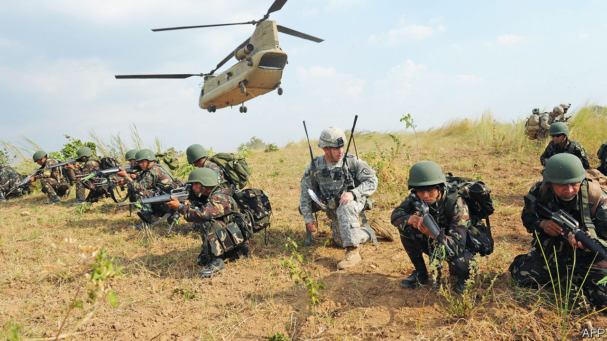

SINCE HE BECAME president in 2016, Rodrigo Duterte has talked loudly and often about his disdain for America, which is a former colonial power in the Philippines. But never before have his grievances translated into action. On February 11th he cancelled the Visiting Forces Agreement (VFA), a military pact between the two countries that enabled American troops to participate in joint exercises in the Philippines. The American embassy in Manila declared the decision “a serious step with significant implications for the US-Philippines alliance”.

It also has implications for the region’s security. The VFA adds practical weight to the two countries’ mutual defence pact, which remains in force. Scrapping it might encourage adventurism from South-East Asia’s jihadists (which worries Mr Duterte) and China (which may not). In 2017, when fighters allied to Islamic State captured the centre of the southern city of Marawi, Philippine forces expelled them with the help of intelligence gathered by American soldiers. By the same token, Philippine and American forces have conducted joint exercises in the South China Sea, where China’s expansive claims overlap with the Philippines’. The cancellation of the VFA imperils such co-operation.

“It’s about time we rely on our own resources,” explained Salvador Panelo, the president’s spokesman. “We have to strengthen our own capability as a country relative to the defence of our land.” But there is another explanation: Senator Ronald dela Rosa, a former national police chief who led Mr Duterte’s bloody war on drugs, was recently barred from visiting America. Mr Duterte had threatened to cancel the VFA in retaliation. In January he also banned members of his cabinet from travelling to America. Whether Mr Duterte really intends a strategic pivot to China, or is simply unpredictably irascible, remains as opaque as ever.

This article was downloaded by calibre from <https://www.economist.com/asia/2020/02/15/the-philippines-tears-up-a-defence-pact-with-america>

|  |  |  |  |
| --- | --- | --- | --- |
| Previous | Articles | Sections | Next |

|  |  |  |  |
| --- | --- | --- | --- |
| Previous | Articles | Sections | Next |

#### Fire and fury

# An ethnically motivated attack alarms multi-ethnic Kazakhstan

A Kazakh mob has attacked Dungans, a minority group of Chinese origin

Feb 15th 2020 | MASANCHI

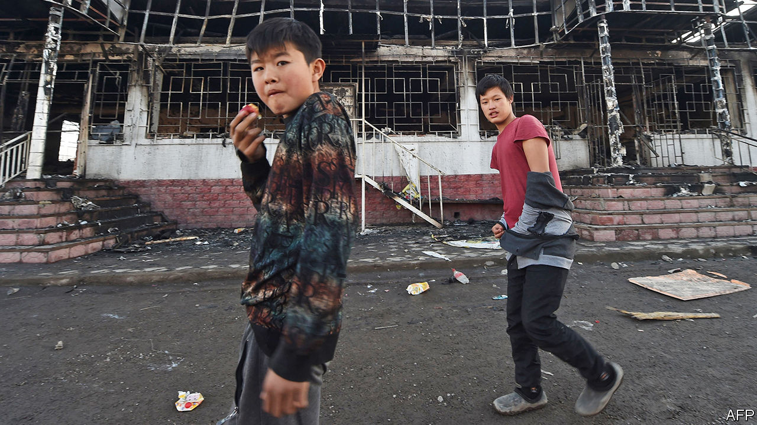

IN A BUCOLIC setting, fringed by the snow-cloaked mountains of south-eastern Kazakhstan, lie two adjoining villages separated by a field of bleating fat-tailed sheep. This week the ethnic Kazakhs of Qarakemer were going about their business as usual, a man trotting down the main street on a horse, children lugging milk home in pails. Their neighbours in Masanchi, a ten-minute walk away, were contemplating a scene of devastation. A distraught villager whose shop had been torched in a mob attack over the weekend gestured at two intact businesses among the charred ruins lining the main street. “Look at that shop, and that one,” he said. “Their owners are Kazakh. They didn’t touch them. Only the Dungans’ shops.”

On the night of February 7th Kazakhs armed with hunting rifles, iron bars, sticks and stones went on the rampage in Masanchi and nearby villages inhabited by Dungans—Muslims of Chinese descent, who have lived in Kazakhstan for centuries but number just 72,000, or 0.4% of the population. The spark for the violence seems to have been a row between drivers about who had the right of way. A rumour spread that Dungans had attacked an old Kazakh man. The attackers beat and shot Dungan villagers and set fire to homes and businesses. Ten people—nine Dungans, one Kazakh—were killed; 178 were wounded, including 19 police officers. Some 24,000 people fled to nearby Kyrgyzstan seeking refuge, although many have since returned.

Such savagery is rare in Kazakhstan, which considers itself a model of ethnic harmony. It is home to more than 100 different minorities. Nursultan Nazarbayev, the president from independence in 1991 until his resignation last year, who still pulls the political strings, decreed this bewildering ethnic mix to be an essential part of the national identity. His intention was to reassure ethnic Russians, in particular, who in 1991 were almost 40% of the population (nowadays they are less than 20%). His laudably inclusive stance helped ward off ethnic strife—no small thing in Central Asia. Hundreds died in communal clashes in Kyrgyzstan in 2010, for instance.

But the ostrich-like taboo on discussing ethnic tensions has not made them disappear. Some Kazakhs, conscious that in Soviet times they became a minority within their own country, feel that they should now be pre-eminent. Minorities, naturally, fear a surge in Kazakh nationalism, especially since Mr Nazarbayev’s semi-retirement has introduced an element of uncertainty into politics.

Kassym-Jomart Tokayev, Mr Nazarbayev’s successor, has reacted forcefully, promising that those guilty of mob violence will be punished and denouncing “criminals” who “shout pseudo-patriotic slogans”. Yet most of the 90-odd suspects arrested during the rampage have been released without charge, and the authorities will not say how many remain in custody. Keeping both Kazakhs and minorities happy while dispensing something that resembles justice will not be an easy task. ■

This article was downloaded by calibre from <https://www.economist.com/asia/2020/02/15/an-ethnically-motivated-attack-alarms-multi-ethnic-kazakhstan>

|  |  |  |  |
| --- | --- | --- | --- |
| Previous | Articles | Sections | Next |

|  |  |  |  |
| --- | --- | --- | --- |
| Previous | Articles | Sections | Next |

#### Capital loss

# India’s ruling party receives a drubbing in Delhi

Voters seem to have disliked the BJP’s nakedly sectarian campaign

Feb 13th 2020 | DELHI

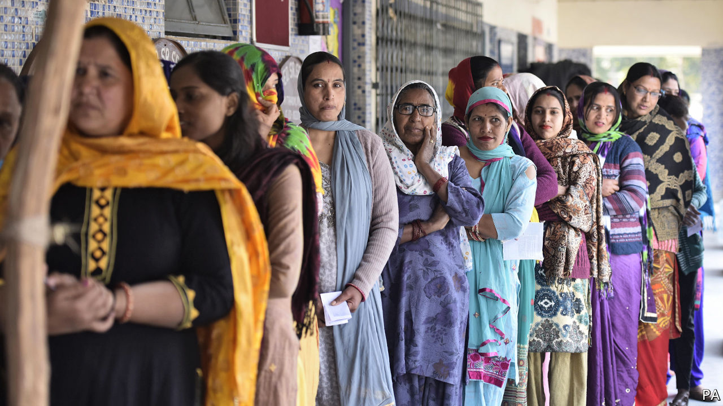

IN MAY Narendra Modi won a triumphant second term as India’s prime minister, with a thumping majority in the Lok Sabha, the lower house of parliament. His Hindu nationalist Bharatiya Janata Party (BJP) did especially well in Delhi. It grabbed all seven of the National Capital Territory’s parliamentary seats. Yet just nine months later, in elections to the territory’s assembly on February 11th, the BJP won a scant eight out of its 70 seats.

This drubbing may be dismissed as a small dent in the Modi juggernaut. Delhi’s 20m people are less than 2% of India’s population, and the party that thrashed the BJP is politically irrelevant beyond the city limits. Even so, the vote represented an early plebiscite, in a part of the country where the BJP has deep roots, on the divisive social policies Mr Modi has adopted in his second term, as well as on his handling of an increasingly shaky economy. It also represented a test for a new, more aggressive style of campaigning. At the hustings the BJP dropped any pretence of inclusivity, engaging instead in one of the loudest and ugliest displays of sectarian bigotry ever witnessed in Indian politics.

There are two obvious explanations for the party’s slide. The one Mr Modi might prefer is that Delhi’s voters draw an unusually stark distinction between national and local elections. There is much truth to this. The local Aam Aadmi Party (AAP), a newish political force that grew out of an anti-corruption movement and has run the city since 2015, has cleaned up schools, built hundreds of affordable local health centres and curtailed petty graft. The image it projects is of folksy modesty with a social conscience. But the AAP’s symbol, a broom, suggests better housekeeping. It does not inspire voters, as Mr Modi does, with visions of national grandeur.

The last time Delhi-wallahs voted for their local assembly, in 2015, the AAP did even better, taking 67 out of 70 seats, again just months after the BJP had snatched all seven of the city’s parliamentary seats. And it is true that despite its failure to increase its seat tally substantially in this week’s election, the BJP did boost its vote share, from just 32% to 39%. The AAP’s share remained much the same, at 54%.

Yet a world of difference separates the two Delhi polls. In 2015 Mr Modi’s party was also relatively fresh and inexperienced. Now it is a behemoth. Not only does the BJP enjoy the lion’s share of political funding and command a pack of gleefully partisan television stations. Its control of central ministries gives it bullying rights over such crucial institutions as the Delhi police and the national election commission.

That the BJP lost despite these advantages suggests that at least some weight should be given to the other explanation for its poor showing: many voters were put off by its campaign. The contest took place against a backdrop of broad national unrest. This was precipitated by new citizenship rules that many Indians, especially minorities, fear will ultimately strip them of rights and erode the secular principle of equality before the law. Among many forms of protest, one particularly noisy challenge has been mounted by hundreds of women in Shaheen Bagh, a working-class, largely Muslim neighbourhood of Delhi, who since mid-December have occupied a busy thoroughfare, refusing to move until Mr Modi backs down. Thousands of others have joined their round-the-clock vigil, turning it into a carnival of opprobrium that has spawned scores of copycat sit-ins across the country.

In its campaign the BJP strove to depict Shaheen Bagh’s mothers and housewives as dangerous incubators of treachery and terrorism. “This fire can anytime reach the households of Delhi,” fulminated Parvesh Verma, one of the party’s MPS. “These people will enter your house, will abduct your sisters and mothers, rape them, kill them!” Mr Verma even screeched that Arvind Kejriwal, the bespectacled, cardigan-wearing former tax inspector who heads the AAP, was a dangerous terrorist. Another MP, the junior minister of finance, whipped a rally into a frenzy against the prime minister’s critics, leading the crowd to chant, “Shoot the bastards! Shoot the bastards!”

Such excesses sparked little adverse comment from the fawning television channels that dominate Hindi-language broadcasting. When the dismal results began pouring in, these outlets tried to explain them away. Commenting on the BJP’s defeat, Sudhir Chaudhary, an anchor on Zee TV, launched a tirade against the voters of Delhi, implying that they were somehow paving the way for the Muslim minority to take over the country, as Muslim invaders did centuries ago. “They do not care that Mughal rule will return…nor are they worried that the country will break up,” he lamented. “The people of Delhi are completely caught up in their daily lives and don’t care two hoots for what happens to the rest of the country.” Mr Chaudhary has it backwards. If the rest of India was watching the BJP’s effort to pump up sectarian fury in Delhi, it might conclude that it was the ruling party that was trying to break up the country. ■

This article was downloaded by calibre from <https://www.economist.com/asia/2020/02/13/indias-ruling-party-receives-a-drubbing-in-delhi>

|  |  |  |  |
| --- | --- | --- | --- |
| Previous | Articles | Sections | Next |

|  |  |  |  |
| --- | --- | --- | --- |
| Previous | Articles | Sections | Next |

#### Banyan

# Indonesia’s government wants to get on with China in private

While pandering to anti-Chinese sentiment domestically

Feb 15th 2020 |

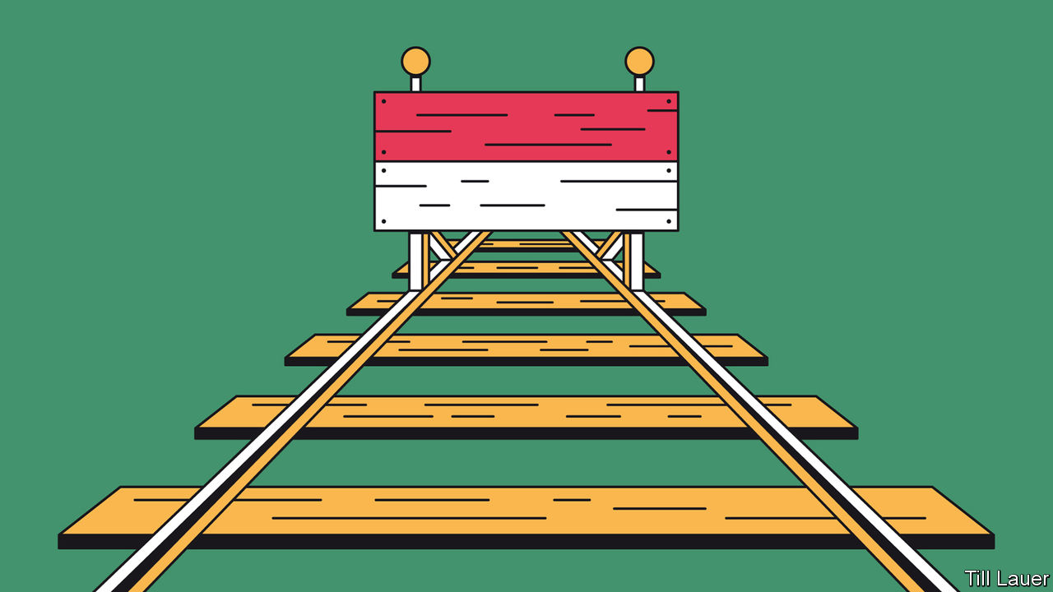

WHEN CHINA’S president, Xi Jinping, launched the Belt and Road Initiative (BRI) in 2013, Indonesia was seen as essential to its success. So much so that he went to Jakarta, its capital, to launch the maritime dimension of his world-girdling programme of infrastructure investments. But then a funny thing happened: very little. Nearby Cambodia has been overrun by Chinese involvement in its economy and politics. In Pakistan BRI and its local iteration, the China-Pakistan Economic Corridor (CPEC), are held up as proof of a relationship “as close as lips and teeth”—even as CPEC goes off the rails. In contrast, most Indonesians have never heard of China’s signature foreign policy. Banyan’s recent informal poll of residents of Jakarta was nearly unanimous: BRI is a financial institution, Bank Rakyat Indonesia.

China’s involvement in Indonesia is growing, but it got going late. One reason is the long slow process of getting any project off the ground. Public consultations drag on, land is a nightmare to acquire, bureaucrats block licences and sleazier ministers wonder what is in it for them. One minister under President Joko Widodo, or Jokowi, admits that the Indonesian way is hardly ideal, but at least the country avoided many of the reckless, grandiose projects and poor financial terms embraced by faster-moving neighbouring countries. The only real albatross, a planned high-speed railway from Jakarta to Bandung, is a cautionary tale. In 2015 China beat Japan in the bid for its construction by not insisting on government guarantees for its loans. Quickly the usual problems emerged: even the air force, with a base in the path of the train, objected. Last year all the land was at last acquired. But the project is years late and over budget. Since no broader high-speed network is envisaged that offers economies of scale, the 150km line will never pay for itself. The railway is China’s flagship project in Indonesia, but Indonesian ministers do not want to talk about it.

The railway is also a lesson in the sometimes ugly sensibilities over the nearly 3m Indonesians of Chinese origin, which in turn shape Indonesia’s engagement with China. Chinese have been doing business in Indonesia for centuries, and today form a big part of the entrepreneurial class. Anti-Chinese antagonisms date back at least to colonial times, when the Dutch appointed ethnic Chinese as tax farmers even as they encouraged occasional pogroms against Chinese traders, builders and sugar-mill workers. In the 20th century some Indonesian nationalists defined themselves in part by their anti-Chineseness. After independence, hatred boiled over in 1965 following an alleged left-wing coup attempt. Ethnic Chinese were seen by many as communist sympathisers. Chinese Indonesians were among those targeted in army-directed massacres in which hundreds of thousands of people died. Anti-Chinese riots erupt around the archipelago from time to time. And in 2017 the ethnic-Chinese and Christian governor of Jakarta, Basuki Tjahaja Purnama, or Ahok, an ally of Jokowi, was jailed on trumped-up charges of blasphemy. A rabble-rousing politician, Prabowo Subianto, who said Ahok should “know his place lest the Indonesian Chinese face the consequences of his action”, is now the minister of defence.

The railway was also criticised, caught in a broad surge of anti-Chinese sentiment. The government has drawn its own conclusions. All the other big projects backed by China are to be built far from the Javanese heartland where, one official explains, “a lot of the religious conservatives and Muslim hardliners are collected”. They include an oil refinery in northern Sumatra near the Malacca Strait, a smelter on Sulawesi that allows Indonesia to process its nickel ore for the first time, and planned hydropower plants in northern Kalimantan to encourage aluminium smelters to move from China.

Indonesia, then, mostly engages with China on its own terms—and a Chinese commitment for a training college to teach Indonesians about nickel processing is further proof of that. At times it will even be seen to stand up to China, as in a maritime spat last month in which the navy and coastguard expelled a Chinese fishing fleet from Indonesia’s exclusive economic zone. The move led some observers to imagine that Indonesia will unite its South-East Asian neighbours against China in the South China Sea. But that is wishful thinking. Jokowi must appear robust to anti-China forces at home. But, for the economy to grow, he must court Chinese money.

This article was downloaded by calibre from <https://www.economist.com/asia/2020/02/15/indonesias-government-wants-to-get-on-with-china-in-private>

|  |  |  |  |
| --- | --- | --- | --- |
| Previous | Articles | Sections | Next |

|  |  |  |
| --- | --- | --- |
| Asia | Sections | Middle East and ... |

China

The virus and the economy: Business in paralysis

.

The virus and politics: The hard men

.

Chaguan: Death of an everyman

.

|  |  |  |
| --- | --- | --- |
| Asia | Sections | Middle East and ... |

|  |  |  |  |
| --- | --- | --- | --- |
|  | Articles | Sections | Next |

#### Business in paralysis

# China’s official holiday ends, but not the woes of its firms

It is hard to keep factories going when workers are stuck in the countryside

Feb 13th 2020 |

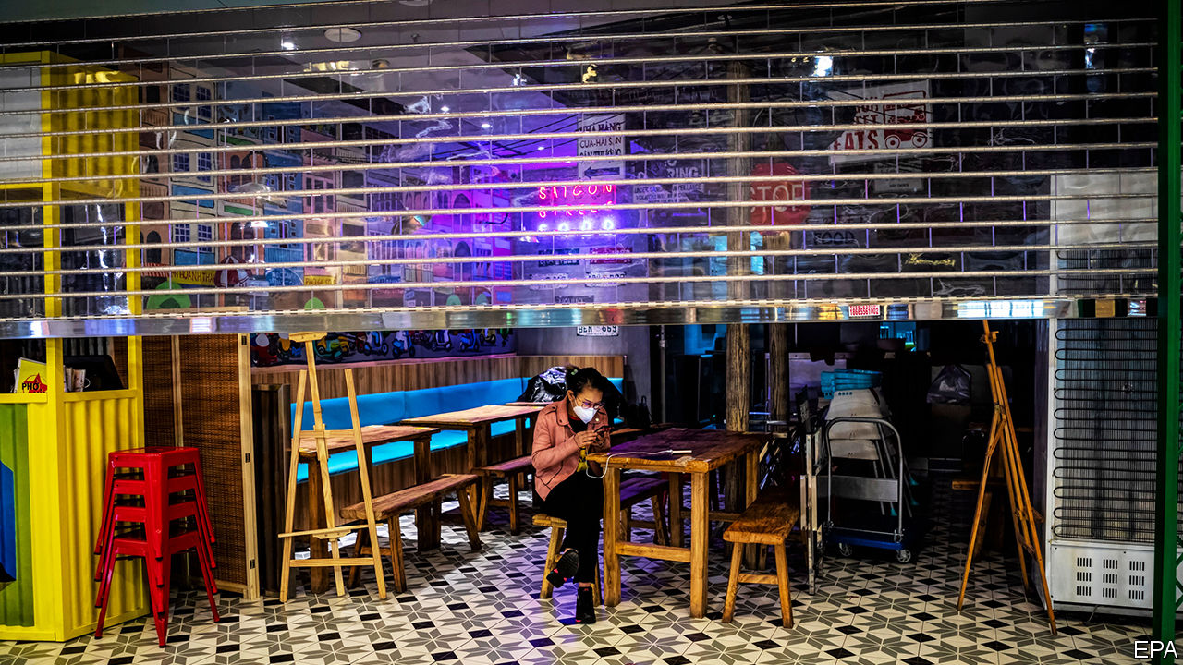

RED BANNERS and an enormous QR code flank the iron gates of a compound for recruitment agencies in Waigaoqiao, a north-eastern district of Shanghai. “Scan with WeChat and get jobs”, the banners urge visitors, who are normally migrants from the countryside. In any other year, on the first day of work after the lunar new-year holiday, people would stream to this complex after celebrating the festival in their ancestral villages. But this time, on February 10th, it was all but deserted.

One firm, Yongbing Labour, had reopened. But its boss said only three people had made inquiries there, compared with over 100 on the first day back last year. Maybe the lack of jobseekers was for the best. He said he had found no work even for those three. In fact, he had received no requests from any factory for labour, and was thinking of closing for the rest of the week.

No one expected that business would resume as normal this year. China is battling a new coronavirus that was detected in December in the central city of Wuhan and has spread swiftly nationwide and to more than two dozen other countries. Many local governments had extended the holiday by ten days in an effort to contain the outbreak. But when that period expired, officials seemed torn. They worried about the virus’s damage to the economy, but also about how a return to work might affect the pathogen’s spread. In many places they urged people to work from home. Surging downloads of video-conferencing apps suggest that is happening, but many firms remain closed. The streets of major cities remain eerily quiet.

Official data imply that few people are back behind desks and conveyor belts. The number of trips taken on February 9th, the last day of the holiday (for most) and usually a peak time for travel, was 85% lower than the equivalent day last year. Huatai Securities, a broker, reckons that, of those working in China’s main cities before the holiday, only 15-30% have returned from their holiday trips elsewhere. Shanghai and Beijing, among others, have stopped arrivals and departures of long-distance buses, the favoured mode of transport for migrant labourers from the countryside.

In many cities, including Shanghai and Shenzhen, companies need official permission to restart. Few have been given it. Across from Yongbing Labour is the sprawling Waigaoqiao Free Trade Zone. Just 120 of its 4,000 firms were back at work on the first day after the holiday. To qualify, businesses must have, for instance, an adequate stock of face masks for their employees. That is a tall order given there is a huge nationwide shortage of them, points out Gavekal Dragonomics, a consultancy. Some firms, including Foxconn, which makes Apple’s iPhones, have started making their own masks.

Some companies that have been allowed to resume work are struggling. Just one in ten of Foxconn’s workers reported for duty at its plants in Zhengzhou and Shenzhen on the first day, reports Reuters news agency (see article). Part of the problem is that Zhengzhou, the capital of Henan province, requires those entering the city to undergo a 14-day quarantine. Migrant workers arriving at Shanghai’s central railway station say they expect similar confinement.

Some places have adopted even more draconian measures. Wuxi and Yangzhou in Jiangsu province, which borders on Shanghai, have barred travellers from seven provinces. Yiwu, a hub for wholesale traders in Zhejiang province, Shanghai’s other neighbour, appears to have barred all out-of-towners. Wenzhou, an entrepreneurial hotspot there, has cancelled every train out of the city.

Such restrictions have alarmed higher-level governments. Zhejiang’s has accused some cities of “spontaneously escalating control measures” and told them to stop. The capital’s government has told districts not to require companies to seek permission to open. But local officials continue to err on the side of caution, for fear of being punished for letting the virus spread.

Halted production could cause another problem that officials fear: a spike in unemployment. Liu Kaiming of the Institute of Contemporary Observation, an NGO in Shenzhen, says many blue-collar migrant workers could lose their jobs if travel and quarantine restrictions are not lifted within two weeks. Last week the Office for Migrant Workers, a government agency, told firms that they were not allowed to terminate contracts if work had to be suspended because of virus-related “emergency measures”. China’s leader, Xi Jinping, promised this week that the government would do its utmost to prevent “large-scale lay-offs”.

Local governments are giving tax breaks, waiving rental fees and postponing levies on firms for social security. But most businesses say they are already suffering much more than during SARS, another coronavirus, which hit in 2003. Bernstein, a research firm, points out that sales by Yum China, a restaurant giant, dipped by no more than a third for two or three weeks back then. Now, nearly a third of its stores are closed and sales at those still open have fallen by almost half.

Many migrant workers are choosing to stay put. On the outskirts of Baoding, an area near Beijing that is a big source of workers for the city, Chen Yixiu, a 26-year-old who had a job at a wholesale flower market in the capital, says she worries about falling ill should she return to Beijing—migrant workers usually have no access to health coverage in cities where they work. What of the government’s promises that it will cover her treatment should she fall sick from the virus? Ms Chen says she is sceptical. Others might well be of officials’ predictions that many will be back at work in the next few days. ■

This article was downloaded by calibre from <https://www.economist.com/china/2020/02/13/chinas-official-holiday-ends-but-not-the-woes-of-its-firms>

|  |  |  |  |
| --- | --- | --- | --- |
|  | Articles | Sections | Next |

|  |  |  |  |
| --- | --- | --- | --- |
| Previous | Articles | Sections | Next |

#### Big changes in Hubei

# Xi Jinping sends in the hard men to deal with the Wuhan virus

He fires the local bosses who failed to get to grips with the covid-19 outbreak

Feb 13th 2020 | BEIJING

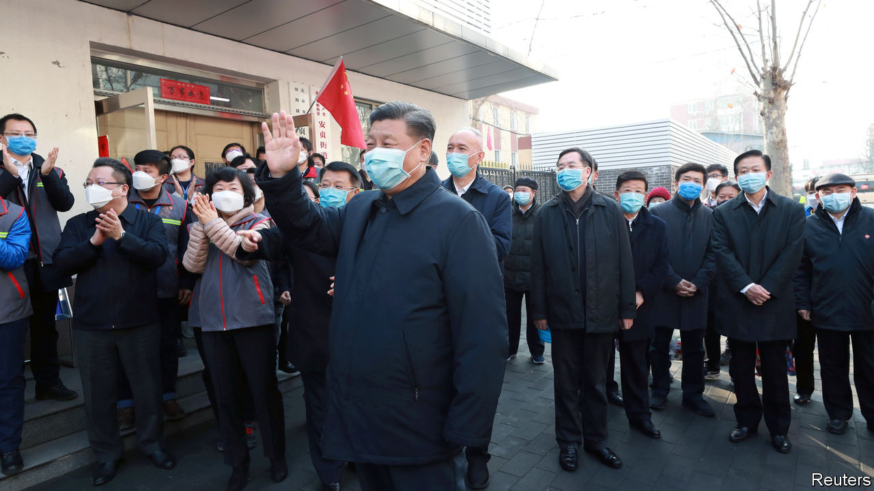

WHEN SECRETIVE, Leninist parties have bad news to get out of the way, they do not hang about. In the space of a single day, February 13th, China’s ruling Communist Party fired the officials who run the province and city at the heart of the epidemic of covid-19, announced a big jump in the number of recorded virus infections there, and sent in hardliners close to Xi Jinping, the country’s supreme leader, to clean up the mess.

The unusually brutal reshuffle saw the top party post in the central province of Hubei, where more than 48,000 infections and 1,310 deaths had been recorded as The Economist went to press, handed to the mayor of Shanghai, Ying Yong, who is 62. Mr Ying’s background is in public security, the law courts and the feared discipline-inspection commission that roots out malfeasance by officials. He earned Mr Xi’s trust while serving as a police chief and discipline inspector in the coastal province of Zhejiang, when Mr Xi was Zhejiang’s party boss from 2002-07.

Public anger is seething over weeks of bungling and cover-ups by officials responsible for fighting the virus in Hubei and Wuhan, the provincial capital. A handful of brave doctors, academics and relatively outspoken journalists have been pleading with national leaders to allow for more openness and free debate to avoid further deadly policy blunders. Mr Xi and his inner circle appear to have granted half that request, offering greater transparency about virus numbers, matched with sterner party discipline.

State media are at pains to note that new cases outside Hubei have been growing less common since February 4th. But on February 12th Hubei reported 14,840 new infections, a sharp rise. This followed instructions from the central government to count not just cases confirmed by nucleic acid tests performed on nose or throat swabs (kits for that are in short supply and not always reliable), but also patients whose lungs show telltale signs of covid-19 on CT scans.

Hubei’s new chief, Mr Ying, indicated his preferred approach to governing a province in remarks he made in Shanghai a few days before his transfer. He praised “non-sloppy” administrations that are brave enough to endure strict supervision. Mr Xi’s war on sloppiness will be fought in Wuhan, a city of 11m people that has been under lockdown for weeks, by Wang Zhonglin, who has taken over as the city’s new party chief. He is also an ex-cop.

After some days of hesitation, when Mr Xi was unusually absent from state media, the Chinese president and party chief appeared on February 10th in Beijing to inspect a hospital and address hard-pressed doctors in Wuhan by video link (see picture). Wearing a face mask and submitting to a nurse who took his temperature, Mr Xi pledged victory in a “people’s war” against the virus, but also expressed concern about the economic costs of nationwide quarantines. His emphasis on the party’s absolute leadership is reflected in the latest personnel moves. During a deadly outbreak of the SARS virus in 2002-03, the health minister and the mayor of Beijing were sacked. The reality has always been that such government officials are outranked by party leaders at each level of administration. The reshuffle in Hubei makes that explicit.

Other officials with experience of high office in Zhejiang are being deployed. One of them is Chen Yixin, the secretary-general of the Central Political and Legal Affairs Commission, the party’s main law-enforcement body. He has been sent as Mr Xi’s envoy to oversee virus-control work in Wuhan. Meanwhile Xia Baolong, who was Mr Xi’s deputy in Zhejiang, has been appointed head of the central government’s Hong Kong and Macau Affairs Office, putting a Xi loyalist in charge of another crisis—anti-government unrest that has roiled Hong Kong since June.

Among China’s embattled Christian community, both Mr Chen and Mr Xia are notorious for leading a campaign to strip crosses from the roofs of churches in Zhejiang. When trouble strikes in Mr Xi’s China, the party sends for the hard men. ■

This article was downloaded by calibre from <https://www.economist.com/china/2020/02/13/xi-jinping-sends-in-the-hard-men-to-deal-with-the-wuhan-virus>

|  |  |  |  |
| --- | --- | --- | --- |
| Previous | Articles | Sections | Next |

|  |  |  |  |
| --- | --- | --- | --- |
| Previous | Articles | Sections | Next |

#### Chaguan

# Li Wenliang’s death exposes the costs of China’s authoritarianism

Public anger over the virus-related tragedy will fade, but those who feel the ground shake never forget

Feb 15th 2020 |

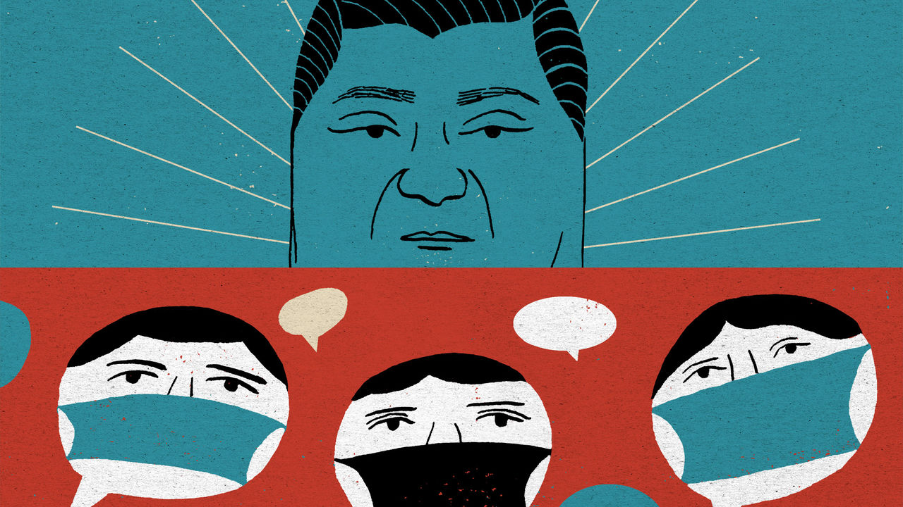

THE DEATH of Li Wenliang has shaken China like an earthquake. He was a young doctor who was reprimanded by Chinese police for alerting colleagues to a new virus that has now killed more than 1,300 people, Dr Li among them (see article). There was nationwide soul-searching when the ophthalmologist told Chinese media, days before his death on February 6th in Wuhan, Hubei province, that silencing truth-tellers can make a country sick. “I think there should be more than one voice in a healthy society,” he said.

There is special outrage that this everyman-physician died with the charge of rumour-mongering still on his police file. “What kind of society have we created?” asked Chinese netizens, with a mixture of anger and shame. In the hours after Dr Li’s death nearly 2m of them shared or viewed a hashtag meaning “I want freedom of speech”, before it was deleted by censors. Open letters and petitions have called on the Communist Party’s leaders to honour the constitution’s neglected guarantee of free expression, arguing that truth-telling saves lives. “We should learn from Li Wenliang’s death,” said an academic in Wuhan behind one petition.

Party leaders will not learn to embrace free speech or political pluralism. They know their history and that in Chinese tradition the death of an honest man, wronged by those in power, can be a potent, dangerous event. Many times over the centuries, public gatherings to mourn such people have sparked political crises, including in Communist times. Party chiefs have duly rushed to co-opt Dr Li as a hero whose suffering should be blamed on isolated, local wrongdoing. To bolster that idea, officials have been sent from Beijing to look into his case. Global Times, a nationalist tabloid, has stressed in its reporting that Dr Li was a loyal party member. It alleges that calls to honour Dr Li’s memory are being whipped up by “anti-China forces” abroad and in Hong Kong.

After a few days in which Xi Jinping, the country’s leader, was relatively invisible, the propaganda machine has now cleared front pages for accounts of his virus-control work. Mr Xi made a rare public appearance, visiting hospital and community offices in Beijing. Three days later he reshuffled the leadership of Hubei, the worst-hit area. The state news agency, Xinhua, called him the “commander of the people’s war against the epidemic”. To some readers, the martial title may sound stirring. Others may fear it leaves little room for scientific debate or scrutiny by outsiders such as journalists, notably those brave Chinese reporters who have done remarkable work in recent weeks in their efforts to cover the virus’s spread. In a war instructions from the top are orders.

Censorship is being tightened, ending a brief period of unusual liberty for social-media users. The country’s largest internet platforms have been placed under “special supervision” by cyber-regulators, with extra controls on anything resembling citizen journalism. Yet shows of authority cannot stop the public from brooding about Dr Li. As millions of Chinese read and share accounts of his short life and tragic death, they are being forced to devote unusual attention to their social compact with the country’s authoritarian rulers.

Sometimes adherence to that compact seems almost painless—for instance last October, when many Chinese expressed deep, unfeigned pride on the 70th anniversary of a People’s Republic with shiny mega-cities, high-speed trains and aircraft-carriers that awe the world. Unbidden, many Chinese credit one-party rule with offering efficiency and stability, especially when democratic countries seem mired in dysfunction.

Such confidence is harder now. Dr Li’s last weeks on Earth oblige his fellow citizens to confront the costs of a system without free speech, an uncensored press or independent legal system. Many have read the humiliating letter that police in Wuhan made him sign, agreeing that his truth-telling was in fact a lie that “gravely disturbed social order”. Not content with forcing the doctor to deny reality, police added school-bully phrases, asking him to write “I can” and “I understand” when asked if he would now calm down and heed the police, or face legal penalties.

Lots of patriotic, law-abiding Chinese have glimpsed for themselves the casual, swaggering sadism of a system without accountability, in which the law is just another instrument for frightening the defenceless. They can see how, when agents of the state fear no external checks and balances, it is rational for them to bury bad news, right up until a crisis becomes too big to hide: a dynamic that builds instability into the way China is run.

## Then they came for the Weibo users

Even today’s tight censorship is teaching bleak lessons to millions of apolitical folk who normally never see their posts deleted, or notice when news reports vanish after causing too much fuss. Some may be comforted by familiar propaganda about good national leaders let down by bad apples in the provinces. Such tales draw on traditions with deep roots, involving virtuous, faraway emperors and local tyrants. The gains are short-term, however. Each attack on local corruption or bungling stokes public distrust and makes the case for further centralisation. But China is too big to be ruled from its capital, let alone by one man. Even those who think Mr Xi a great commander know that he needs good lieutenants.

None of this presages a revolution. The virus is a hard test for the party, but it has survived worse. A vanishingly small number of Chinese see a viable alternative to the social compact that binds them to their rulers. Still, Dr Li’s death has obliged an unusually broad range of citizens to contemplate the unhappy compromises needed merely to survive in a bossy, paranoid dictatorship. After some good years, a fresh crisis has reminded millions of Chinese that their rulers define truth as they see fit. Public anger about Dr Li’s fate will fade, just as countries recover from earthquakes. But those who feel the ground shake never forget or trust in its solidity the same way again. ■

This article was downloaded by calibre from <https://www.economist.com/china/2020/02/15/li-wenliangs-death-exposes-the-costs-of-chinas-authoritarianism>

|  |  |  |  |
| --- | --- | --- | --- |
| Previous | Articles | Sections | Next |

|  |  |  |
| --- | --- | --- |
| China | Sections | Europe |

Middle East and Africa

Diplomacy: Frustrated are the peacemakers

.

Qatar: Tamim the gloriously tolerant

.

Religious politics in Israel: Shabbat riders

.

Kenya: I shot the DJ

.

The International Criminal Court: A day of reckoning nears

.

|  |  |  |
| --- | --- | --- |
| China | Sections | Europe |

|  |  |  |  |
| --- | --- | --- | --- |
|  | Articles | Sections | Next |

#### Frustrated are the peacemakers

# Why the United Nations cannot end wars in the Arab world

It’s not for lack of trying

Feb 15th 2020 | BEIRUT

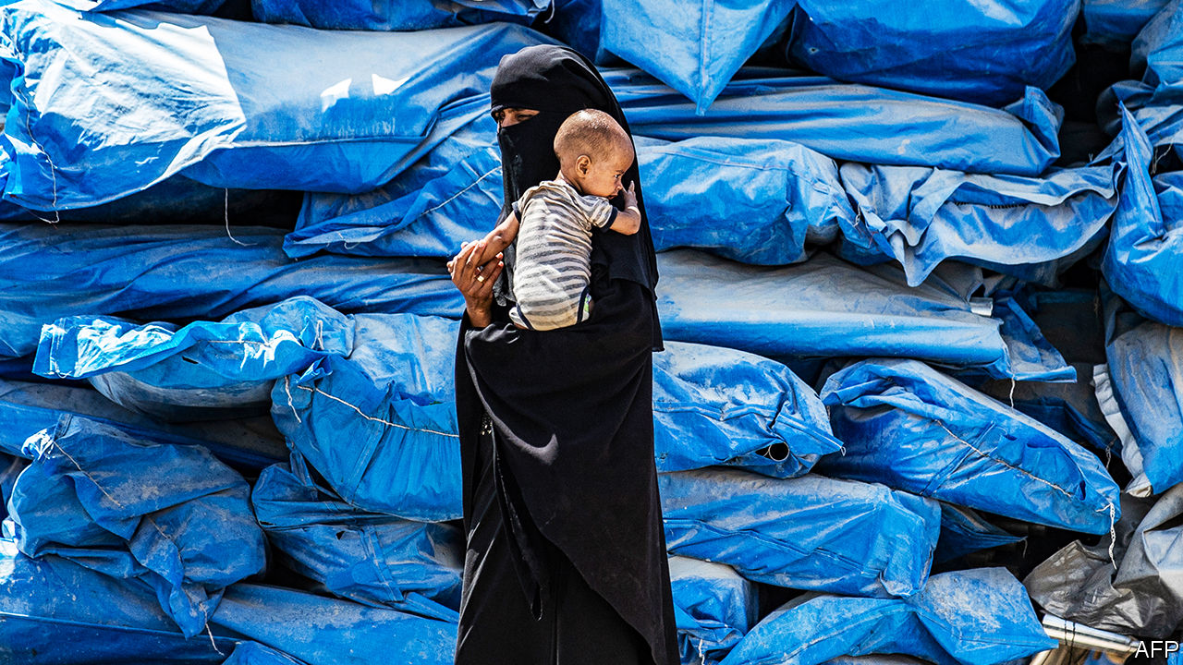

EVEN AFTER nearly a decade of carnage, Syria’s civil war still manages to shock. More than 700,000 people have fled a regime offensive in Idlib, the country’s last rebel-held pocket. Shelter is scarce; with temperatures near zero, families sleep rough on the roadside. Desperate to keep millions of refugees from crossing its southern border, Turkey has deployed thousands of troops to slow the Syrian advance, risking conflict with Russia, which backs Bashar al-Assad, Syria’s dictator, with jets in the sky and mercenaries on the ground. At least a dozen Turkish soldiers have been killed.

Against this backdrop Geir Pedersen, the United Nations special envoy, is pressing ahead with a committee meant to redraw Syria’s constitution—a body Mr Assad has already said he will ignore. As the regime draws closer to Idlib, as another 1m civilians prepare to flee, the UN has staked time and prestige on an effort that was doomed from the start.

Since 2011, 13 UN envoys have tried to play healer in the Middle East’s civil wars: four in Syria, six in Libya and three in Yemen. None has succeeded. The war in Syria is winding down only because the regime has slaughtered its enemies. Libya and Yemen are failed states. At best the UN’s efforts have been ineffective. At worst, in Syria, they helped tip momentum towards one of the warring parties.

There is a large body of academic research on how wars end. One study finds that including women in negotiations makes them more likely to succeed. Another posits a link between failed ceasefires and subsequent success, which seems a verbose way of saying that if at first you don’t succeed, try again.

Mostly, though, wars end when at least one party decides that the cost of continuing outweighs the possible benefits. That is a hard choice for the losing side to make in a civil war. Combatants cannot simply lay down their arms and go home. Defeat can mean annihilation. In 1997 Barbara Walter of the University of California analysed half a century of resolved conflicts. She found that just 20% of civil wars ended in a peace deal, compared with 55% of inter-state conflicts. “Groups fighting civil wars almost always chose to fight to the finish,” she wrote.

If outsiders want to broker a deal, they must change this calculation. The Dayton accords, which America negotiated in 1995 to end the war in Bosnia, are often cited. But America and its NATO allies were not mere negotiators. They were also dropping bombs on one of the belligerents. In Syria, by contrast, “I’m conscious that I have almost no leverage,” says Mr Pedersen. Even when backed with weapons, diplomatic efforts often fail. America could not bring durable peace to Afghanistan or Iraq, despite its might.

In peacekeeping, unlike peacemaking, the UN has often succeeded. The territorial dispute in Cyprus, though still unresolved, has not caused any deaths since the 1990s. But there must be a peace to keep. The UN has only rarely authorised outside countries to shoot their way in to impose one. Failing that, with one belligerent (like Mr Assad) on a roll, there is no incentive to stop fighting and let the blue helmets in.

So the UN set its sights lower. The former special envoy, Staffan de Mistura, pursued local ceasefires—“freeze zones”, as he called them. A tally in 2018 by the Atlantic Council, a think-tank, looked at 18 such truces in the Damascus suburbs. The median agreement held for just ten days; only three lasted longer than a month. They allowed Mr Assad to regroup. He did not have enough men to fight on all fronts, and the men he had were often bad at fighting. Though the regime could not tolerate well-armed rebels in the suburbs of Damascus, neither could it afford to throw troops into meat-grinder urban warfare. With the UN’s help, Mr Assad cut deals in the suburbs, then starved residents into submission.

A similar approach in Yemen focused on Hodeida, a strategic port that has seen a lot of fighting. In December 2018 the warring parties struck a deal in Stockholm that called for an immediate ceasefire and a redeployment of forces. A year later, aid agencies reported that Hodeida was still the most dangerous governorate for Yemeni civilians, accounting for one-quarter of all casualties.

Though the UN focuses on creating safe zones, none of the Middle East’s civil wars is truly local. Iran and Russia intervened to support Mr Assad. Gulf states sent arms and money to his rebel opponents and laid waste to Yemen with American support. The situation in Libya is so chaotic that even dirt-poor Chad has become a player.

But the UN looks powerless to halt such support. Syria is not subject to an arms embargo, while restrictions in Yemen apply only to certain groups, such as the Houthis (whose Iranian patrons ignore the edict). The Security Council, where America, Russia, China, France and Britain hold vetoes, would probably fail to impose a blanket ban on either state. UN members such as Turkey and the United Arab Emirates suffer no consequences for violating the organisation’s arms embargo on Libya.

Officials say they are doing all they can. At a conference in Rome in December, Mr de Mistura compared himself to a doctor working on a chronic case. “You cannot cure everything. Some diseases are difficult—but would you abandon the patient?” he asked. “You try to reduce the pain until the treatment is found.”

Yet the UN often fails to do even that. Unable to stem the flow of weapons, it is left to preside over talks ever more divorced from reality. It took more than a year just to agree on the members of Syria’s constitutional committee. Mr Assad said his delegation to its first meeting was not there in an official capacity. Still the talks lurch on—not even a palliative, in Mr de Mistura’s metaphor. More like a placebo.■

This article was downloaded by calibre from <https://www.economist.com/middle-east-and-africa/2020/02/15/why-the-united-nations-cannot-end-wars-in-the-arab-world>

|  |  |  |  |
| --- | --- | --- | --- |
|  | Articles | Sections | Next |

|  |  |  |  |
| --- | --- | --- | --- |
| Previous | Articles | Sections | Next |

#### Less than tolerant than it seems

# Qatar, the Gulf emirate famed for openness, is silencing critics

The emir is threatening those at home who stir up dissent

Feb 15th 2020 | DOHA

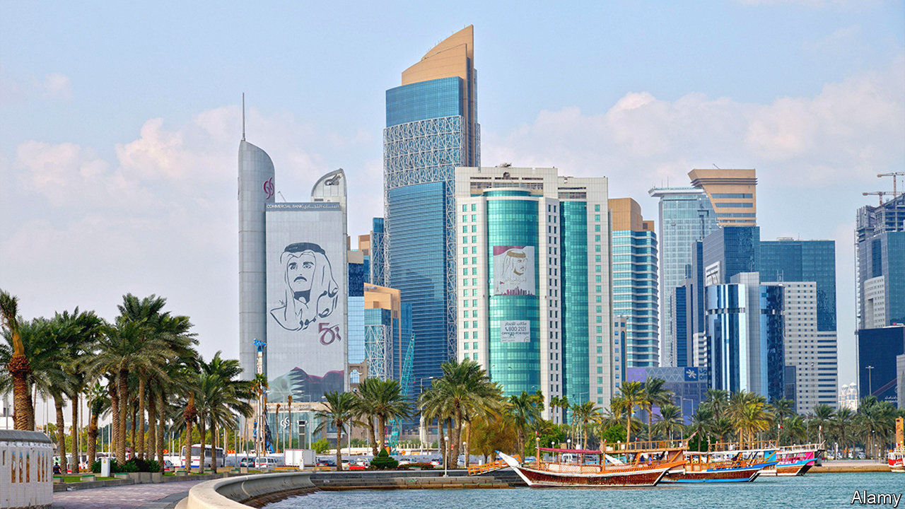

FOR DECADES Qatar has promoted itself as a beacon of openness in a repressive region. It hosts Al Jazeera, a popular Arab satellite station that broadcasts opinions suppressed elsewhere in the Middle East. And it is a haven to those fleeing Arab despots. But its emir, Tamim bin Hamad Al Thani, is less tolerant of criticism directed at him. Last month he issued a decree threatening five years’ imprisonment or a fine of $27,000 for “anyone who broadcasts, publishes or republishes false or biased rumours, statements or news…with the intent to harm national interests, stir up public opinion or infringe on the social system”. The leading state-controlled daily newspaper reported on the decree—then nervously retracted its report.

In Doha, the image of the emir is as ubiquitous as Saddam Hussein’s once was in Baghdad. “Tamim the Glorious”, reads the slogan underneath. Qatar’s newspapers often have the same front-page stories, with near-identical headlines. The lead story on January 23rd, about a police graduation ceremony, mentioned the emir nine times. Academics who step out of line risk being dismissed. “I can’t even organise a workshop,” says a writer returning from a civil-rights seminar in Kuwait.

The institutions tasked with holding the government to account are window-dressing, say critics. The Consultative Assembly, Qatar’s parliament, sits in a gleaming white building laced with arabesque. But its 45 appointees wield little power. Elections promised in 2003 never took place. Al Jazeera “is free to criticise other countries but never to criticise Qatar”, says a media-watcher in the emirate. The state-funded channel trumpets the Saudi women seeking asylum in the West, but keeps mum about Qatar’s own women seeking asylum in Britain. “There’s no Qatari opposition,” says its acting director, Mostefa Souag, when asked to explain the lack of Qatari dissent on his programmes.

Qataris have doubts about the emir’s decisions. They wonder why he squandered billions on foreign ventures and arms deals and struggles to reconcile with Saudi Arabia, which has led a blockade on Qatar since 2017. “We want freedom of speech for the people of the region and they’re not happy with that,” says the emir, unironically. Most Qataris stay mum. “We’re scared,” says Najeeb Nuaimi, a former justice minister who is under a travel ban. “They’ll take your passport or your property and leave you stateless if you talk.”

The muttering is only likely to grow. Qatar adheres to Wahhabism, the same conservative school of Islam as Saudi Arabia. But it is hosting football’s World Cup in 2022. Locals worry about drunken fans, Israeli flags and public displays of affection, among other things. “Each day we get closer to the opening brings more discontent,” says Abdelhamid al-Ansari, a former dean of Qatar University.

Qatar’s rulers have transformed Doha from a sandpit into one of the Gulf’s most stylish cities. It has a corniche of glitzy skyscrapers, the only underground to be found anywhere between Cairo and Tehran, and stunning museums. Just a generation ago women were kept hidden. They still cannot travel without permission, but now there are female ministers, judges and ambassadors. Yet Qatar cannot claim to be a beacon of openness until it stops trying to silence critics. Enlightenment begins at home.■

This article was downloaded by calibre from <https://www.economist.com/middle-east-and-africa/2020/02/15/qatar-the-gulf-emirate-famed-for-openness-is-silencing-critics>

|  |  |  |  |
| --- | --- | --- | --- |
| Previous | Articles | Sections | Next |

|  |  |  |  |
| --- | --- | --- | --- |
| Previous | Articles | Sections | Next |

#### Sabbath riders

# Secular Israelis on buses strike a blow for religious freedom

Transport on the Sabbath could have implications for Israel’s election

Feb 15th 2020 | JAFFA



AT THE Clock-Tower Square in Jaffa, dozens of Israelis wait in the winter sun for a bus home after a Saturday afternoon in nearby restaurants and bars. Any other day of the week this would be normal, but for today’s passengers there is a subversive thrill.

For over 70 years buses and trains have not run in most of Israel from sundown on Friday to nightfall on Saturday. Before Israel’s founding in 1948, its first leader, David Ben-Gurion, won support from ultra-Orthodox rabbis for statehood by promising that public services would not operate on Shabbat. Every Israeli government since has adhered to the agreement, against public wishes: 71% of Jewish citizens favour public transport on the Sabbath, a survey finds.

In November 2019 Tel Aviv and neighbouring towns established a privately run bus network. It has proven wildly popular, and more towns have joined in. Local governments were reluctant to challenge the government of Binyamin Netanyahu, which relies on ultra-Orthodox coalition partners. They depend on budgets from the interior ministry, which is in the hands of Shas, an ultra-Orthodox party. But Mr Netanyahu now heads a mere caretaker government. Though religious cabinet members lambast the Sabbath buses, the ministry cannot change levels of funding.

Tel Aviv and many of its suburbs are relatively secular. In the two stalemated elections held in 2019, their residents tended towards centre-left opposition parties. Neither Mr Netanyahu nor Benny Gantz, an opposition leader, could form a coalition. On March 2nd Israel will hold its third election in 12 months.

Mr Gantz is targeting “soft-right” voters souring on Mr Netanyahu. Dahlia Scheindlin, a pollster, thinks some might be attracted to “the murky concept of a liberal government”, meaning enforcing the rule of law, tackling corruption (Mr Netanyahu is under indictment) and defying religious coercion. According to her surveys, between one-quarter and one-third of Likud voters are concerned about these issues. Who knows where a taboo bus ride might lead?

This article was downloaded by calibre from <https://www.economist.com/middle-east-and-africa/2020/02/15/secular-israelis-on-buses-strike-a-blow-for-religious-freedom>

|  |  |  |  |
| --- | --- | --- | --- |
| Previous | Articles | Sections | Next |

|  |  |  |  |
| --- | --- | --- | --- |
| Previous | Articles | Sections | Next |

#### I shot the DJ

# One law for the mighty in Kenya

The country’s leaders make a mere show of holding wrongdoers to account

Feb 15th 2020 | NAIROBI

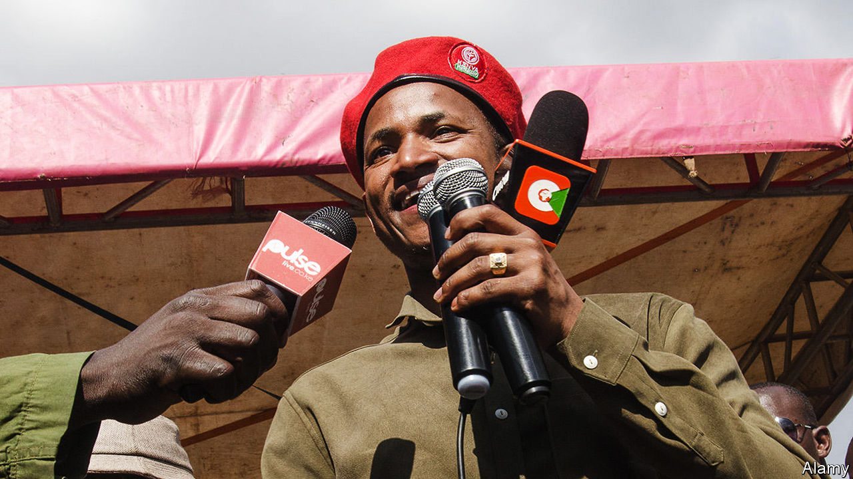

NAIROBI’S B-CLUB is popular with Kenya’s gilded classes. Those unfortunate to live within earshot are less keen, and last October won a court ruling revoking its licence. But legal orders matter little to politically connected nightclub owners. Few Kenyans were surprised when CCTV footage emerged on January 17th showing an MP, Paul Ongili (pictured), propping up B-Club’s bar at seven in the morning.

The MP did find himself in a spot of bother, though, when the clip then showed him raise a pistol and shoot the club’s DJ through the neck. Mr Ongili, better known as Babu Owino, was arrested and charged with attempted murder, which he denies.

He was held for ten days. A judge then set him free on bail, requiring that he pay his victim’s hospital bills. He will remain free during a trial that will presumably weigh his claim that he mistook the DJ, Felix Orinda, for an assassin, against witnesses’ suggestions that they argued over penis size. (After surgery, Mr Orinda remains too unwell to give his version of events.)

If history is anything to go by, a trial could take years and never reach a verdict. This is typical for members of the political elite who get themselves into trouble, a fellow MP says wearily. While the press watches, judges sternly remand them into custody. But as attention wanders, they are freed pending a trial destined to remain perpetually snagged in procedure. “Babu Owino has already served his sentence,” the legislator concludes.

Once bail has been posted, there is no end to the ways in which matters can be strung out. Chris Okemo, a former energy minister, and Samuel Gichuru, the ex-head of Kenya’s state power utility, have managed to drag out a case seeking their extradition to Jersey on corruption charges (which they deny) for nearly nine years. No bigwig has gone to jail for decades.

Kenya’s president, Uhuru Kenyatta, likes to blame corrupt judges for the absence of convictions. But lawyers say prosecutors are at least as responsible, suggesting that they leave loopholes or make blunders for defence lawyers to exploit. It is a system, cynics say, designed to benefit the government in two ways.

For starters, the government can show that it is responding to public anger over corruption by arresting a big fish or two without having to worry about them actually ending up in jail. Last year corruption charges were brought against Henry Rotich, a former finance minister, and Mike Sonko, the governor of Nairobi, which they deny. Some hailed the charges as evidence of Mr Kenyatta’s intent to toughen up. Others saw the arrests as an example of what Wachira Maina, a constitutional lawyer, calls “motion without movement”.

Second, it can be useful for the government to leave politicians squirming on a hook. Charges that have been shelved can be dusted off if a politician steps out of line, says one MP arrested on suspicion of graft. “It’s a good way of keeping us quiet.”

It also ensures that impunity flourishes. Beyond the usual corruption, accusations of violent crime by politicians are becoming more common. Last year an MP was briefly held on suspicion of shooting her political rival’s uncle. The trial of a governor accused of murdering his pregnant girlfriend in 2018 meanders on.

Justice is less kind to ordinary Kenyans. A policeman last month stopped a motorist, Mildred Owiso, for using her mobile phone while driving and climbed into her car. Mrs Owiso, a strong-willed social activist, protested: policemen usually only get into vehicles when they want a bribe and she had no intention of paying. A fracas ensued and members of the public came to help her, sending the policeman packing.

People power did not prevail for long. That night, ten tear-gas-lobbing officers raided her house and arrested Mrs Owiso and her husband on charges of incitement to violence. For good measure, they also killed her dog. ■

This article was downloaded by calibre from <https://www.economist.com/middle-east-and-africa/2020/02/15/one-law-for-the-mighty-in-kenya>

|  |  |  |  |
| --- | --- | --- | --- |
| Previous | Articles | Sections | Next |

|  |  |  |  |
| --- | --- | --- | --- |
| Previous | Articles | Sections | Next |

#### A day of reckoning

# Omar al-Bashir, Sudan’s ex-dictator, could at last face justice

The ICC accuses him of genocide. Sudan may even let him be tried

Feb 13th 2020 |

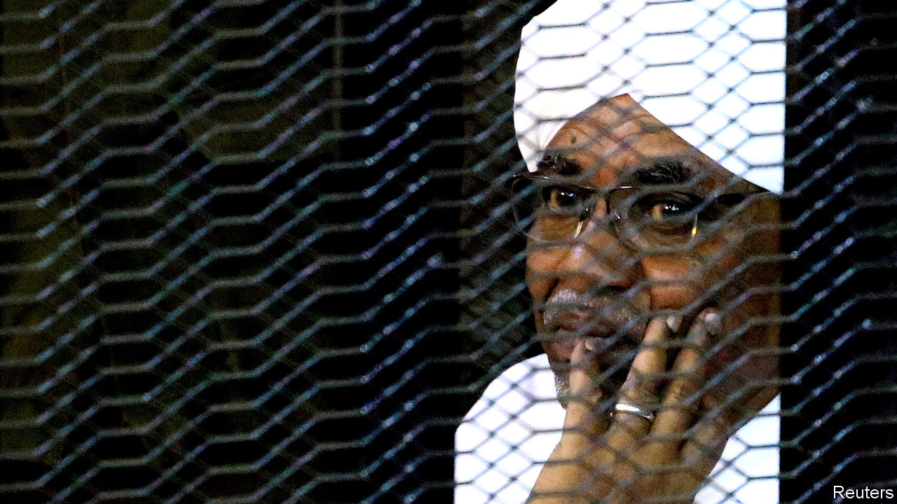

FOR MORE than a decade, Omar al-Bashir gaily thumbed his nose at the International Criminal Court (ICC). After he was indicted for war crimes, crimes against humanity and genocide in the country’s western region of Darfur, his defiance badly damaged the young court’s credibility. On February 11th, however, Sudan’s former dictator was pushed a step closer to justice, as the new Sudanese government agreed that he would appear before the ICC. Where, and when, that might happen remains unresolved. But if it happens, it will chip away at the culture of impunity that emboldens despots everywhere.

Mr Bashir, who seized power in 1989, now languishes in a Sudanese prison after being swept from office last April in a popular uprising. The decision to let him appear before the ICC was taken by the country’s new joint military and civilian council during talks with Darfuri rebel groups in Juba, the capital of South Sudan. Handing Mr Bashir over to the ICC has been one of the rebels’ long-standing demands.

Violence in the region continues. In January for instance, the United Nations reported that at least 54 people had been killed and another 40,000 or so displaced in a fresh bout of intercommunal fighting. In all, since the Darfur conflict erupted in 2003, perhaps 300,000 people have died, mostly of war-induced hunger and disease. More than 2m have been made homeless. The bulk of the blame rests with the Arab-dominated Sudanese army and its mass-raping mounted militia, the janjaweed. Mr Bashir’s government claimed that it ran a limited campaign to crush a rebellion. In fact, it is accused of a widespread campaign of ethnic cleansing targeting black-African groups such as the Masalit, Fur and Zaghawa. Hence the genocide charges: Mr Bashir, in the words of the ICC, deliberately inflicted on each target group “conditions of life calculated to bring about the group’s physical destruction”.

But how exactly Mr Bashir and those indicted with him are to appear before the ICC has yet to be worked out. The transitional government is sensitive to the national humiliation some Sudanese would feel if Mr Bashir were sent to The Hague, where the ICC sits. That looks unlikely to happen. Instead, officials are exploring ways in which Mr Bashir and the others could appear in front of ICC judges, or perhaps a hybrid court, in Sudan itself. It will be up to the ICC to decide whether such a court in Sudan would be sturdy enough.

The possible transfer of Mr Bashir will reignite controversy about the ICC’s role in Africa, where many countries accuse it of bias, pointing out that most of the cases, and all the indictments, have been against Africans. The indictment in 2009 of Mr Bashir caused particular anger; he was a sitting head of state and Sudan is not a member of the ICC. President Yoweri Museveni of Uganda, a member country, went so far as to call the court “a bunch of useless people”. Some have simply ignored the court’s demands. Member states have an obligation to arrest those who are charged but, before the revolution in Sudan, Mr Bashir roamed ICC member countries in Africa untroubled, sometimes even at the invitation of host governments. In 2010, a month after he was indicted for genocide, he joined the celebrations in Nairobi for Kenya’s new constitution.

## African defendants, African victims

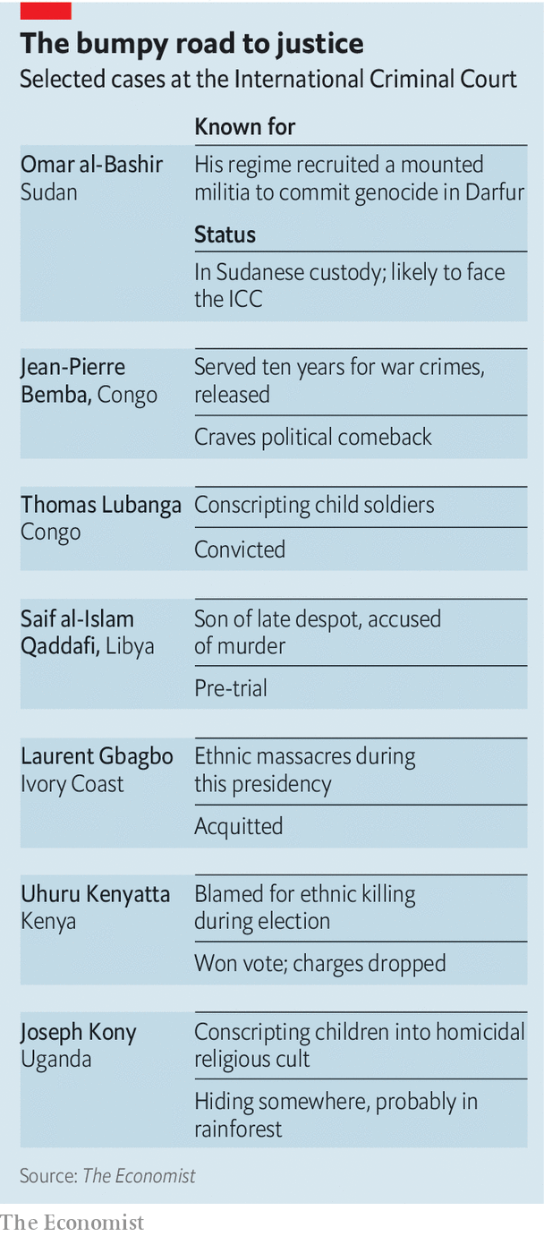

African criticisms of the court came to a head in 2016 when South Africa, Burundi and the Gambia announced plans to withdraw. Burundi was upset by the opening of an investigation into crimes in Burundi. South Africa was miffed when the court reprimanded it for failing to arrest Mr Bashir when he visited in 2015. Fears grew of an exodus of African states, co-ordinated by the African Union. Yet the court’s legitimacy in Africa is not as shaky as it seems. Though Burundi has left, South Africa has not followed through; the Gambia changed government and rapidly changed its mind. Other African countries came to the court’s defence. Nigeria, the most populous, vocally supports it. The new Sudanese government’s co-operation with the ICC would be a remarkable further step.

It helps that the ICC’S chief prosecutor, Fatou Bensouda, is a Gambian, trained in Nigeria. She points out that most of the cases against Africans were referred by African governments themselves. They were often willing to co-operate as long as the court investigated political opponents or rebels, but got jumpy when the court turned to crimes by state armed forces.

Mr Bashir’s fate suggests a novel path to the ICC; a revolution followed by the new government calling in the court to help prosecute former leaders. That might worry Saif al-Islam Qaddafi, the son of Libya’s former despot, indicted for crimes against humanity by the ICC (see table).

Yet Sudan’s willingness to bring in the ICC will not alone fix the court’s troubles in Africa. Paradoxically, the likelihood of stronger co-operation by African governments rests more on the ICC’s ability to pursue cases outside of Africa. The ICC has moved that way, opening preliminary investigations into abuses by British forces in Iraq and pushing for an investigation into all sides in Israel-Palestine.

The fight against impunity in Africa faces other problems, too. The ICC in practice is only able to try political losers, not those in power. It risks being used as a tool by the mighty to remove rivals while remaining untouched themselves. One lesson some leaders will take, says Phil Clark of the School of Oriental and African Studies in London, is “don’t lose power.”

The prosecution of Mr Bashir might deter other despots from slaughtering inconvenient ethnic groups. But only if it succeeds. The court has had more cases collapse before or during trial than it has completed. The kind of people it goes after are the kind who terrify witnesses. For years, Mr Bashir did everything he could to hinder the work of the ICC. And even now, to have a chance of a successful trial, the court first needs to get its hands on him. ■

This article was downloaded by calibre from <https://www.economist.com/middle-east-and-africa/2020/02/13/omar-al-bashir-sudans-ex-dictator-could-at-last-face-justice>

|  |  |  |  |
| --- | --- | --- | --- |
| Previous | Articles | Sections | Next |

|  |  |  |
| --- | --- | --- |
| Middle East and ... | Sections | Britain |

Europe

Germany’s government: Trouble at the top

.

Kosovo: A new start

.

Russia: Show trials

.

France: The emoji wars

.

Charlemagne: Making Europe boring again

.

|  |  |  |
| --- | --- | --- |
| Middle East and ... | Sections | Britain |

|  |  |  |  |
| --- | --- | --- | --- |
|  | Articles | Sections | Next |

#### Trouble at the top

# Angela Merkel’s presumed successor quits as party boss

Annegret Kramp-Karrenbauer’s resignation starts a scuffle for power

Feb 15th 2020 | BERLIN

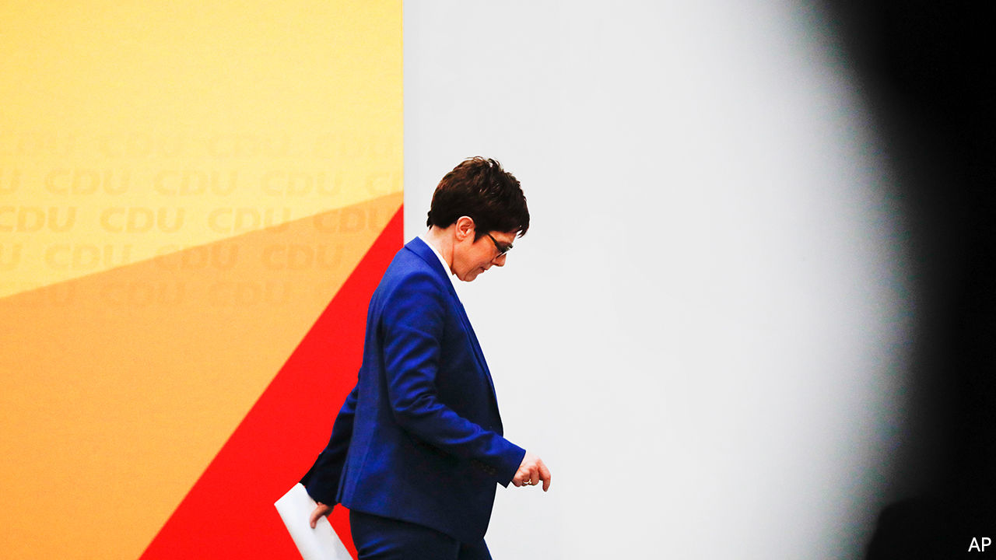

FOREIGN NEWSREADERS might have celebrated. But otherwise there was little to cheer when Annegret Kramp-Karrenbauer, universally known as AKK thanks to her tongue-twisting name, announced on February 10th that she would resign as leader of Germany’s ruling Christian Democrats (CDU) and not stand as its candidate for chancellor at the next election. By forcing her party to confront its deep divisions, Ms Kramp-Karrenbauer has thrown German politics into a new era of uncertainty.

Ms Kramp-Karrenbauer was tripped up by a debacle in the east German state of Thuringia, where the CDU had voted with the far-right Alternative for Germany (AfD) to install a member of a third party as state premier. This “dam break”, the first time AfD votes had secured such an office, so horrified Germany that Ms Kramp-Karrenbauer had to try to repair the damage. But her efforts floundered, the party split and she was undermined when Angela Merkel, the chancellor, chimed in to condemn the result from a state visit in Pretoria, over 5,000 miles (8,000km) away. Ms Kramp-Karrenbauer’s unsteady leadership had already left her future in doubt. A recent appointment as defence minister, a job she will retain, did little to help. But Thuringia tipped the balance. The decision, she said, had “matured in her for some time”.

In 2018 Mrs Merkel quit the CDU leadership after 18 years. When the party elected Ms Kramp-Karrenbauer to succeed her, the road to the chancellery looked clear. Her decision to bow out thus blows German politics wide open. What happens next is unclear. Ms Kramp-Karrenbauer wants to remain in charge while the party follows an old timetable to choose its candidate for chancellor at the next election, due in autumn 2021. But that could mean she hangs around until a CDU congress in December, and few MPs believe their party can dither that long. Markus Söder, leader of the Christian Social Union (CSU), the CDU’s Bavarian partner, urges a faster pace, fearing an extended airing of the CDU’s agonies would affect his own party’s fortunes.

Mrs Merkel’s decision in 2018 to split the job of chancellor and party leader is starting to look like a grave misjudgement. In a rare, if camouflaged, flash of disloyalty towards her mentor, Ms Kramp-Karrenbauer said as much in her resignation speech. The positions of leader and chancellor-candidate should now be fused, she said.

Yet aside from the procedural complexities (the CSU must back a joint chancellor-candidate but has no role in the CDU’s leadership race), whoever takes up the job will face the same problem that bedevilled Ms Kramp-Karrenbauer: how to retain authority when real power resides with a chancellor who may be in office until the end of next year. With her succession plans in ruins, some say the best way for Mrs Merkel to clean up the mess she caused would be to resign, probably triggering an election.

But this is unlikely in stability-obsessed Germany. And so the contenders to lead the CDU/CSU into the next election will have to tread carefully. Besides Mr Söder, who is probably happy with his perch in Munich, three names stand out. Start with Armin Laschet, the premier of North Rhine-Westphalia. Affable, moderate and subtly subversive, Mr Laschet’s biggest asset is his control of Germany’s most populous state (and the CDU’s largest branch); as a country it would be the EU’s sixth-biggest economy. In style and substance Mr Laschet would represent the closest thing to continuity Merkel, which is precisely what puts off a large chunk of the CDU membership.

A flintier proposition would be Friedrich Merz, a former leader of the CDU’s parliamentary group. The plain-speaking Mr Merz quit politics for business in 2009 only to make a spectacular return in 2018, when he gave Ms Kramp-Karrenbauer a close run for the party leadership. He has maintained a steady profile since, flying to party meetings around Germany (often personally: he has a pilot’s licence), where adoring crowds lap up his pro-business, socially conservative line. Mr Merz reckons that fishing in the pool of AfD support can restore the CDU to over 35% of the vote. Early polls give him a head-start (see chart).

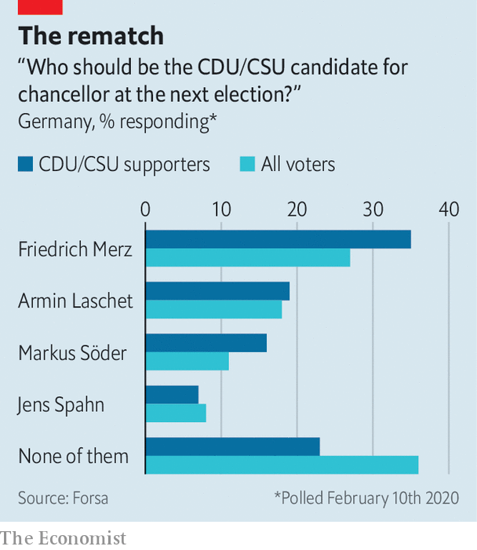

The final contender is Jens Spahn, the 39-year-old health minister, who also stood in 2018. Mr Spahn made his name as an abrasive right-winger on economics and migration, but has mellowed into a hard-working official with a loyal following. Unlike Mr Merz, who carries an unmistakable whiff of the 1990s, Mr Spahn can credibly claim to stand for a new start.

The air in Berlin is thick with scheming and the CDU is quivering with anxiety. Germany’s original Volkspartei (people’s party), capacious enough for everyone, now risks splintering across its many faultlines: centrist v conservative; for and against Merkelism; how to handle the AfD in the east—Thuringia remains unsolved, and may not be a one-off. Some in the party fear further infighting might cause the CDU to fall behind the surging Greens.

That seems unlikely; for all its problems the CDU is still likely to provide Germany’s next chancellor. That will give the succession race the fevered air of a party primary in a safeish seat. Yet there is a palpable contrast with 2018, when Messrs Merz and Spahn immediately declared their interest and the prospect of internal competition electrified the CDU. So far, the same pair have merely hinted at possible candidacies, while Mr Laschet has kept his counsel. As all three hail from North Rhine-Westphalia, CDU peacemakers hope they might broker a deal among themselves rather than air the party’s cleavages in a public contest. “There is zero appetite among my colleagues to go into a divisive leadership election, because it risks tearing us apart,” says Andreas Nick, a CDU MP.

During Mrs Merkel’s long reign the CDU’s repeated election wins trumped concerns over her mushy centrism and lethargic leadership. Now the CDU must ask itself what sort of party it wants to be in a far more complex political scene. “The disruptive potential is much bigger than most realise,” says Andreas Rödder, a historian at the University of Mainz and CDU member. For many months the tensions inside the CDU have been bubbling away like subterranean magma. After Ms Kramp-Karrenbauer’s decision, they threaten to erupt. ■

This article was downloaded by calibre from <https://www.economist.com/europe/2020/02/15/angela-merkels-presumed-successor-quits-as-party-boss>

|  |  |  |  |
| --- | --- | --- | --- |
|  | Articles | Sections | Next |

|  |  |  |  |
| --- | --- | --- | --- |
| Previous | Articles | Sections | Next |

#### New face, old grudges

# Albin Kurti’s new start in Kosovo

Can the new prime minister end the stand-off with Serbia?

Feb 15th 2020 | PRISTINA

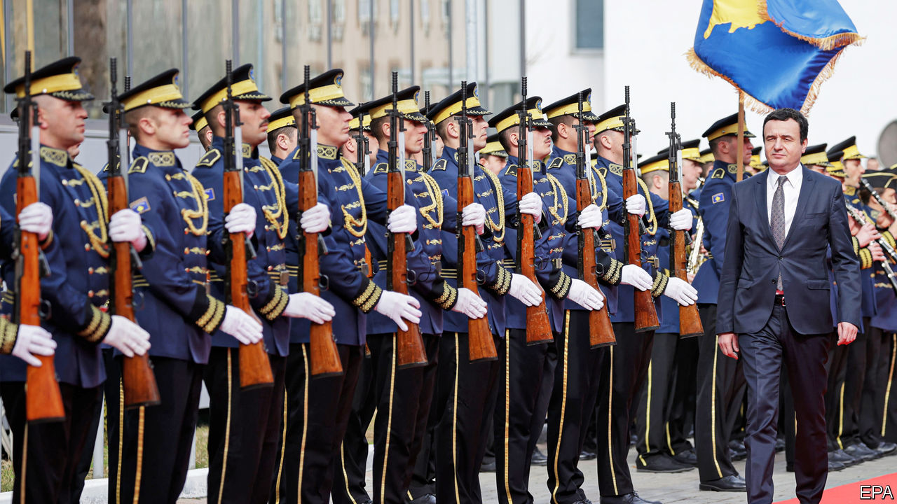

THINGS ARE stirring in Kosovo. Since February 3rd this tiny new country has had a dynamic new prime minister, who wants to drive out of politics the guerrillas who fought for independence in the 1990s but then, he says, took to looting the state. Albin Kurti, 44, says his government’s task is to “liberate our state from within”.

Many hope he will also be flexible enough to end the stand-off with Serbia, which is one of Europe’s last remaining territorial disputes. Kosovo, most of whose people are ethnic Albanians, has been independent since 2008. Most other countries recognise it, but Serbia, its old master, as well as Russia and five EU countries, does not.

America and the EU are keen to revive the stalled dialogue between the two countries. In 2018 Serbia’s diplomats successfully thwarted Kosovo’s third attempt to join Interpol, the international police organisation. Serbia has also persuaded a dozen countries to rescind their earlier recognition of Kosovo. In revenge Kosovo imposed a 100% tariff on the import of Serbian produce, which Serbia’s president says has cost it €435m ($480m). He says it will not resume dialogue until the tariff is revoked.

Mr Kurti was a student leader in the twilight years of Serbian rule. After the war between Serbia and NATO over Kosovo ended in 1999, he was a political prisoner in Serbia for almost three years. On his return he led a ferocious campaign against what he regarded as the colonial presence of the United Nations, which administered the country from 1999 to 2008, and against the EU’s law-and-justice mission there after that. He also resolutely rejected any negotiations with Serbia.

During 23 years in opposition Mr Kurti earned a reputation for being intelligent and principled, but also a dogmatic leftist and an advocate of Kosovo uniting with Albania. That demand terrifies many international policymakers, who believe that changing Balkan borders is a recipe for war. In October 2019 Mr Kurti’s party won enough votes to prise the former guerrilla politicians of the Kosovo Liberation Army (KLA) from power. He wooed voters by trading in his usual T-shirts for suits and by tempering his language. Today he says union with Albania can wait, adding that a strong Kosovo needs to be built first.

Foreign diplomats are increasing the pressure on Mr Kurti to lift the 100% tariff in order to restart the dialogue. He is reluctant to be pushed into a one-sided move. More important for him are education reform, the economy, the environment and rooting out what he says is a small and corrupt clan that has captured the state. He is willing to drop the tariff only if Serbia will reciprocate, which is unlikely as it would amount to a form of recognition. Currently, goods with paperwork marked “Republic of Kosovo” cannot be sold in Serbia. But the Trump administration, eager for a foreign-policy success before America’s presidential election, is thought to be pressing Mr Kurti to make a deal.

His domestic challenges are huge, too. For years, civil-service jobs have been doled out to supporters of the parties that grew out of the KLA. One incoming minister says he is only mildly worried that resentful officials will sabotage his plans. A bigger problem, he says, is that vast numbers of people in his ministry are unqualified, having been hired nepotistically. Mr Kurti’s honeymoon will not last long. ■

This article was downloaded by calibre from <https://www.economist.com/europe/2020/02/15/albin-kurtis-new-start-in-kosovo>

|  |  |  |  |
| --- | --- | --- | --- |
| Previous | Articles | Sections | Next |

|  |  |  |  |
| --- | --- | --- | --- |
| Previous | Articles | Sections | Next |

#### Network of nothing

# How Russian show trials expose imaginary plots

Vladimir Putin’s tactics are getting crueller

Feb 15th 2020 |

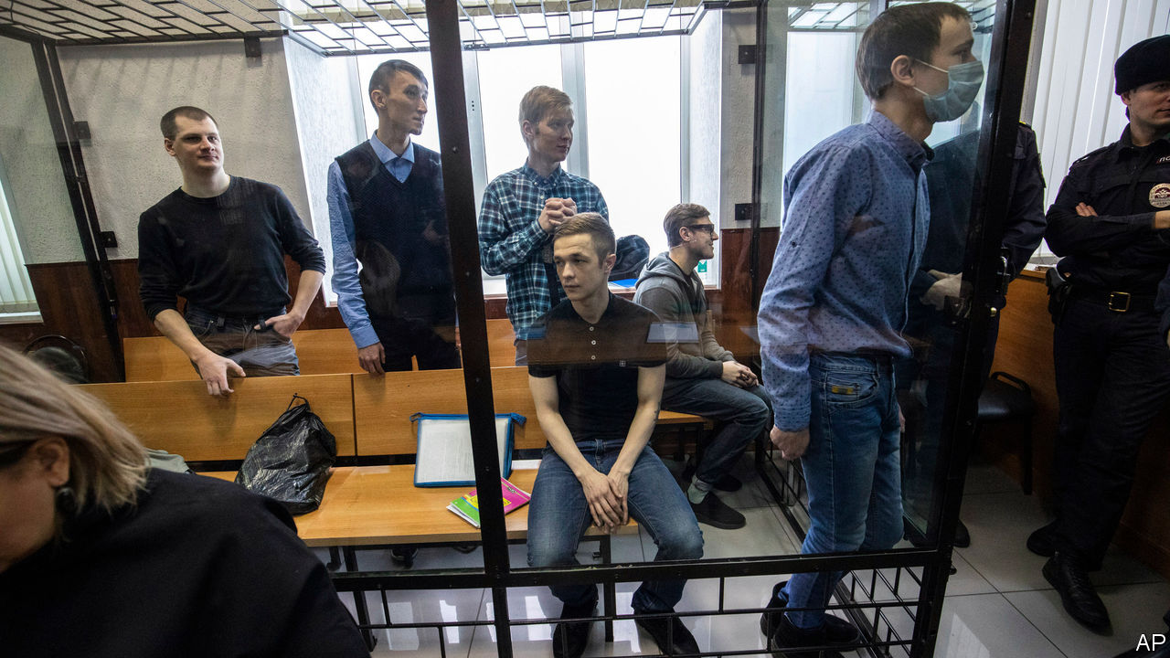

SIX OR SEVEN men in balaclavas walked into a prison cell in Penza, a provincial Russian town 400 miles (650km) south-east of Moscow. They told their 25-year-old prisoner to undress. They gagged him, tied his legs to a bench and connected wires to his big toes. Then they started to electrocute him. “My muscles started to contract, causing a paralysing pain,” he recalled. “I started to scream and hit my head against the wall, but they carried on. Ten seconds seems like an eternity.” The masked men then tried to connect more wires to his genitals. Terrified and in pain, he repeated what his torturers told him to say: “Yes, I am the ringleader. Yes, we were preparing terrorist attacks.”

This is not a story from the Soviet Union in the 1930s, when Stalin’s secret police, the NKVD, tortured and killed millions of innocents while uncovering imaginary plots. It is the testimony of Dmitry Pchelintsev, one of 11 men who were arrested in October 2017 in Penza and St Petersburg and charged with forming a terrorist group to disrupt Vladimir Putin’s presidential re-election and the football World Cup in 2018. On February 10th seven of them were sentenced to between six and 18 years in prison camps.

Just as in the trials of that earlier time, the entire case was fabricated. There was no act of terrorism and no plan for one. The case rests on confessions obtained through torture and later retracted in court. According to prosecutors, these men “in an unidentified place proposed to unidentified anarchists to take part in the inter-regional terrorist organisation ‘Network’ with the aim of forcibly changing Russia’s constitutional order.” The organisation’s “charter”, which the prosecution cited in evidence, mysteriously appeared on the hard drives of the “terrorists” after they had been seized by security services.

According to Memorial, Russia’s most eminent human-rights organisation, there is no evidence that Network ever existed. In fact, some of the members of the made-up network did not know each other until the arrests. What linked them were their anarchist views, their anti-fascist activism and their penchant for airgun combat games, which the FSB, a successor to the NKVD, said was training for terrorism. Living in a provincial backwater, unprotected by money, status or the Moscow-centred media, they were easy targets.

The case (and the torture) were the work of the FSB’s notorious “service for the protection of constitutional order and the fight against terrorism”. In a bitter irony, the sentencing coincided with an assault on Russia’s constitution from Mr Putin himself, who is rewriting it to suit his goals of staying in power indefinitely and isolating Russia from international laws and conventions that buttress human rights.

Neither draconian sentences nor torture are new in Russia. What is new about this case, says Kirill Rogov, a political analyst, is its political logic. “Putin has appropriated Stalin’s method of engineering cases to impose terror, particularly among young people, to criminalise political activism,” he says. The Network case was launched soon after tens of thousands of youngsters took to the streets in some 80 Russian cities, protesting against the Kremlin and corruption. The Kremlin took notice; the FSB took what they call “prophylactic” measures to strike fear. In a similar case, its provocateurs and informers trapped ten young people, including two teenage girls, in an engineered extremist organisation called “New Greatness”.

It is unclear whether these tactics will deter or radicalise the protesters. The big difference with the Stalinist era, however, is the public reaction. Russians on social media are seething. Young people in Moscow are coming out one by one to stand in front of the FSB headquarters holding protest placards. There are collective open letters of support. To be effective, repression must either be so widespread that it is hard to avoid or so cruel that it strikes fear into dissident hearts. Mr Putin’s regime is not totalitarian and cannot snoop on the same scale as China’s government; perhaps that is why he is getting crueller. ■

This article was downloaded by calibre from <https://www.economist.com/europe/2020/02/15/how-russian-show-trials-expose-imaginary-plots>

|  |  |  |  |
| --- | --- | --- | --- |
| Previous | Articles | Sections | Next |

|  |  |  |  |
| --- | --- | --- | --- |
| Previous | Articles | Sections | Next |

#### Not just a smiley face

# The struggle to give Brittany its own emoji

A proud French region, home of Asterix, wants its flag in every phone

Feb 15th 2020 | PARIS



THE FRENCH foreign minister, Jean-Yves Le Drian, is a man of few words and many air miles. When he does comment, it is usually to deplore events in Syria, say, or Iran. But on February 9th the minister let his inner passion get the better of him. The reason? An emoji. “The countdown is on!” Mr Le Drian tweeted excitedly. All Bretons, he urged, should mobilise on social media by tweeting a hashtag, as part of a campaign to secure an emoji for the Brittany flag, known as the Gwenn ha du. “Go on, tweet our #emojiBZH and don’t let up!”

Mr Le Drian, born in the Brittany town of Lorient, was merely the latest to join an effort to turn the black-and-white striped Brittany flag into a digital icon. Promoted by www.bzh, which runs the Breton internet domain name, and the Brittany region, the campaign first stirred interest in 2017. On “world emoji day” that year, to Bretons’ delight, the Gwenn ha du was voted the second most-wanted emoji worldwide. (It narrowly lost to mate, an infusion popular in Latin America.) Last month a fresh effort was made to demonstrate to the Unicode Consortium, a global tech-backed body that approves new emojis, popular backing for the Brittany flag. Within hours, the hashtag #emojiBZH was trending at the top of Twitter in France.

Competition for new emojis is fierce. Raclette, an Alpine melted-cheese dish, was rejected as too obscure. Unicode says approximations preclude the need for certain additions. A squirrel, it insists, can be represented by a chipmunk emoji. Requests for an emoji for the Tibetan and Catalan flags are still pending—although there is one for the Isle of Man, and the French island of La Réunion.

An independent kingdom in the 9th century, Brittany became part of France in 1532. But regional identity has been fiercely defended, with periodic revolts, ever since. Today Breton pride and powerful networks endure. François Pinault, a luxury-goods tycoon, flies the Breton flag from the Venetian palace that houses his art collection. In 2018, when introducing Mr Le Drian to the pope, President Emmanuel Macron joked that “Bretons are everywhere, it’s the French mafia!” Now, though, Mr Macron has swung behind the emoji. When his official photographer, a Bretonne, tweeted in its favour, he gave it the presidential “like”.

This article was downloaded by calibre from <https://www.economist.com/europe/2020/02/15/the-struggle-to-give-brittany-its-own-emoji>

|  |  |  |  |
| --- | --- | --- | --- |
| Previous | Articles | Sections | Next |

|  |  |  |  |
| --- | --- | --- | --- |
| Previous | Articles | Sections | Next |

#### Charlemagne

# Make Europe Boring Again!

The EU celebrates an outbreak of dull stability by having petty rows

Feb 15th 2020 |

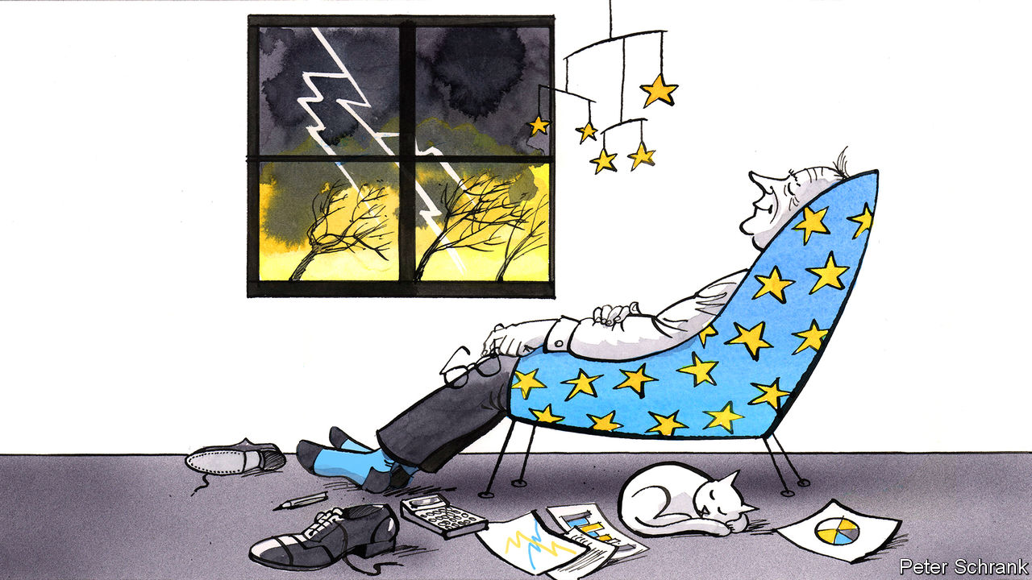

FOR MUCH OF the past decade, if you asked a Eurocrat: “What’s on your mind?”, the response was usually dramatic. At the start of the decade the euro teetered on the edge of collapse. In the middle of it, Greece came close to being kicked out. A crisis flared when nearly 3m asylum-seekers arrived from Syria and other troublespots. Shortly after that, Britain, then the EU’s second-largest economy, voted to leave without a serious plan for doing so. Meanwhile, populists from across the spectrum itched to upturn the comfy order that those in Brussels were attempting to build. In short, life in Brussels was exciting. For years, officials had treated the city like a visit to a proctologist: necessary but disagreeable. Suddenly, the EU’s de facto capital became like a political rollercoaster—terrifying, but strangely thrilling, too.

Those days are over. Brussels has become reassuringly dull again. Ask a passing Eurocrat what’s up and the answer is prosaic: haggling over the EU’s budget. When EU leaders next visit Brussels on February 20th, it will be to discuss the bloc’s spending. Britain’s departure has left a hole of €60bn in the EU’s funding. Spread over seven years and between 27 countries, the sum becomes easier to swallow. The upshot is that, to keep spending roughly the same, EU countries are being asked to cough up between 1% and 1.1% of gross national income—only a whisker more than last year.

To spice things up, diplomats from both ends of the debate are behaving as if a gap of 0.1% of their income—the equivalent of a cold snap in winter or a few wet weeks in summer—is a fiscal Mariana Trench. A hard-core gang consisting of the Netherlands, Denmark, Sweden and Austria have demanded that the EU spend no more than 1% of its members’ GNI. Another group, led by those countries from central and eastern Europe that gorge on handouts from Brussels, are refusing to sign off on anything so paltry as a budget of 1%. “They want the till to open!” despaired one diplomat from the tightwad camp. With no agreement in sight, leaders from 27 member-states will spend at least two days arguing over a pitiful amount of money, like monks having a punch-up over the number of angels dancing on the head of a pin.

Charles Michel, who has the task of stewarding the meeting as European Council president, has threatened to keep the negotiations running until they are resolved. Unfortunately, no one believes him. At one summit during the height of the Greek crisis, Donald Tusk forced leaders to stay and hammer out a deal on bail-out terms rather than risk Greece falling out the bloc. This time, heads of government are well aware that they can simply come back in a few months and try again. Politics often takes time. In his former life, Mr Michel was a Belgian prime minister. Negotiations for him to secure that job took 138 days.

Such pettiness could be seen as the EU at its worst. Rather than deal with great affairs of state, EU leaders will waste time fighting over pocket change. The fiscal fight is a near-perfect example of Sayre’s law, named after Wallace Stanley Sayre, an American political scientist: “In any dispute the intensity of feeling is inversely proportional to the value of the issues at stake.” If the net contributors are routed and surrender at every turn, the budget will be about 1% of gross national income. If the Frugal Four emerge triumphant, the budget will be about 1% of gross national income.

But there is a more positive way of looking at it. An outbreak of internal stability means the EU has space to sweat the small stuff. The haphazard, shantytown of economic policy erected during the financial crisis has proven relatively sturdy. Gatherings of the Eurogroup, the club of finance ministers that once dictated the fate of nations, are now as dramatic as a meeting featuring the finance ministers of Finland and Luxembourg ought to be. Steps taken during the migration crisis to stem the number of people entering Europe, such as bunging Turkey cash and turning Greek islands into de facto prison camps for migrants, were horrifying but effective. EU officials now, perhaps overconfidently, pooh-pooh any prospect of a repeat of the migration crisis of 2015-16. Brexit, once seen as a schism in the Western alliance and the first raindrops of a populist storm, is now a dry debate about the mundanities of data transfers, equivalence of financial rules and fish. Boredom surely beats crisis.

## Dull is dandy

There are no legislative big bangs expected from the European Commission. The EU no longer rips up its treaties, the fundamental rules of the bloc, every five years or so as it did from the early 1990s, leaving voters discombobulated or angry. Such grand projects are now the preserve of a few federalists in the European Parliament, and no longer the near-universal mission of the continent’s elite. Rather than a bold new frontier, projects such as the commission’s “green deal”—a glut of green legislation due in early March—are simply the EU functioning as it should, coming up with collective policies to deal with a collective problem.

An emphasis on the more humdrum aspects of the bloc’s existence comes as the EU’s problems have inverted. For years, the EU’s most pressing problems were internal, from its collapsing currency to its half-baked migration strategy. The cry of alarm was coming from inside the house. Now, the threats are external. A ring of instability surrounds the EU, from Russia to Africa via Turkey. It now even includes Britain, given its geopolitical mid-life crisis. While national capitals jealously guard their foreign policies, those in Brussels are left to feast only on political scraps, rather than the main course. Schemes to “Make Europe Great Again” are thin on the ground. Instead, Eurocrats are happy to have made Europe boring again. Better a brawl over the budget than over something more consequential. As the past decade more than demonstrated, excitement is overrated. And it may yet come roaring back. The problems of the 2010s may have simmered down, but they have not been solved. Enjoy the boredom while it lasts. ■

This article was downloaded by calibre from <https://www.economist.com/europe/2020/02/15/make-europe-boring-again>

|  |  |  |  |
| --- | --- | --- | --- |
| Previous | Articles | Sections | Next |

|  |  |  |
| --- | --- | --- |
| Europe | Sections | International |

Britain

Northern Ireland: Blessed are the merciful

.

Competition policy: Ripping into the rip-off merchants

.

Reshuffle: Number 11’s new incumbent

.

Restitution of cultural artefacts: Spears and spires

.

Politics: Leftward ho!

.

Growth: Keeping down with the trends

.

Public toilets: Spending a penny

.

Public transport: Omnibus no longer

.

Bagehot: The perils of Lennonism

.

|  |  |  |
| --- | --- | --- |
| Europe | Sections | International |

|  |  |  |  |
| --- | --- | --- | --- |
|  | Articles | Sections | Next |

#### Northern Ireland

# Atonement and forgiveness in Belfast

Northern Ireland faces a choice in dealing with past wrongs. It is taking the more dangerous path

Feb 13th 2020 | BELFAST



JUDE WHYTE’S mother Peggy was a devout Catholic and part-time taxi driver, well-known in the market district of Belfast. In 1983, a member of a Protestant paramilitary group tried to bomb the family home and injured himself horribly in the attempt. She nursed him as he lay in the street. Her son thought this kindness might spare the family further attacks, but a year later the same group attacked the house again, this time killing Peggy and a policeman.

Yet Mr Whyte, a social-work lecturer, says that if he knew the name of his mother’s killer, he would not tell the police. He sees no benefit in incarcerating a man who would now probably be around 60, like himself, and can hardly have understood the conflict in which he was involved. “In my mother’s name, I forgive him,” he says, explaining that although he has not inherited his mother’s faith he tries to emulate her empathy.

On the Northern Irish spectrum, Mr Whyte is an extremist in his advocacy of forgiveness. A commoner position is that of Alan McBride, a Protestant whose wife and father-in-law were killed, along with eight others, when republicans bombed a fish shop in the Shankill Road, the heartland of loyalism, in 1993. He cannot quite forgive Sean Kelly, the surviving bomber, but says he has no desire to see him suffer. After a struggle to overcome bitterness, he has come to the point where what happens to the bomber is a “matter of indifference” to him, and no longer keeps him awake at night. He devotes much of his life to counselling victims of the 25-year conflict and to advocating reconciliation between the communities.

Jim Wells, an evangelical Protestant politician whose views on sexuality proved too hardline even for the socially conservative Democratic Unionist Party, is—like many of the more intensely religious participants in this debate—at the opposite end of the spectrum to Mr Whyte. By the lights of his faith, he says, a wrongdoer can seek forgiveness only by owning up to his misdeeds, begging the pardon of those he has wronged, accepting the penalty that is due and mitigating the damage done. “That is how our Baptist congregation would treat a member who did wrong,” he says. In a land in which there is no consensus on what amounts to a misdeed, that bar is hard to reach.

Like most places recovering from violent conflict, Northern Ireland is divided on the question of whether past wrongs should be forgiven or atoned for. Forgiveness may help a peace process, but leave justice undone. Atonement may satisfy the wronged, but punishing wrongdoers risks reviving conflict: among the issues that could blow apart the newly re-established power-sharing government in Stormont, the cluster of questions known as “legacy” ranks high. And on the scale between forgiveness and atonement, Northern Ireland is moving towards atonement.

Both the Democratic Unionist Party (DUP), which is backed by most Protestants, and Sinn Fein, the Irish republicans who reliably gain a plurality of Catholic votes, have trenchant views on legacy, a catch-all term which includes judicial redress, truth discovery and financial compensation for people affected by the Troubles. Neither talks much about empathy for the other side, let alone forgiveness. Both sides want their set of grievances aired. And the direction of travel in Northern Ireland suggests that both are going to get their way.

When the Good Friday agreement was signed in 1998, Tony Blair, the then prime minister, gave secret written assurances to 200 or so top members of the Irish Republican Army that they would not be prosecuted. But last December a court overturned that assurance in the case of John Downey, who is awaiting trial for the killing of two part-time soldiers. That case has given momentum to the DUP’s demand for other prosecutions, and police have said that some may be imminent. Sinn Fein, meanwhile, is anxious to seek judicial redress for what it calls “state killings” and to demonstrate that the army and police worked in collusion with loyalist paramilitary groups to kill ordinary Catholics.

As part of the deal that restored power-sharing last month, it was announced that a raft of legacy-related institutions, first agreed to in 2014, would be established under a law that Britain vowed to introduce within 100 days. The most contentious of the proposed agencies is a powerful new Historical Investigations Unit which would function outside the police (critics call it a parallel police force) and work to reopen unresolved cases. Whatever the original intention, the unit is now widely seen as an instrument for investigating the behaviour of British security forces during the Troubles. Arlene Foster, the DUP leader and first minister, has proposed that its remit should be curbed, whereas her deputy Michelle O’Neill, from Sinn Fein, wants it to be robust and wide-ranging.

Boris Johnson is said to feel “blindsided” by the legacy aspects of the power-sharing agreement, and his concerns are reported to be behind the sacking of Julian Smith, the Northern Ireland secretary, as part of a cabinet reshuffle on February 13th. The government has promised to protect old soldiers who served in Northern Ireland from “vexatious” prosecutions related to historic incidents. It wants, in other words, to minimise the number of cases like that of “Soldier F”, the only paratrooper charged in relation to the killing of 13 civilians in Derry-Londonderry in 1972.

Denis Bradley, a former Catholic priest who has played an important role in legacy debates, shares the widespread fear that clashes over dealing with the past could wreck the fragile new experiment in power-sharing. “The past has always been a mucky field, and it now risks turning into a swamp,” he says.

Given that the DUP and Sinn Fein face opposing pressures from their voters, the best hope of a constructive approach to the legacy issue lay in London and Dublin continuing to play an active role in balancing truth discovery with vindictiveness, says Mr Bradley. But if Sinn Fein becomes a partner in the Irish government, as looks possible after the election on February 8th, and if the British Conservatives are determined above all to protect their soldiers, the two governments’ ability to act jointly as honest brokers will diminish fast. ■

This article was downloaded by calibre from <https://www.economist.com/britain/2020/02/13/atonement-and-forgiveness-in-belfast>

|  |  |  |  |
| --- | --- | --- | --- |
|  | Articles | Sections | Next |

|  |  |  |  |
| --- | --- | --- | --- |
| Previous | Articles | Sections | Next |

#### Competition policy

# Ripping into the rip-off merchants

Why competition policy is getting more political

Feb 15th 2020 |



POLITICAL CROSS-DRESSING is often a good indicator of a change in a party’s identity. So it was with the Tory party’s attitude to business. When Ed Miliband, then Labour leader, called in 2013 for energy prices to be capped it was described as “Marxism”, but within five years Theresa May had introduced a price freeze.

Under Boris Johnson, the Conservative Party’s shift away from business has taken a more economically literate turn. The Tory manifesto in last year’s general election pledged to give the Competition and Markets Authority (CMA) “enhanced powers to tackle consumer rip-offs and bad business practices”. Polling shows declining trust in large firms and, as a former government adviser puts it, “using competition and consumer policy to give them an occasional whack is pretty popular”—hence the announcement on Feb 7th that the CMA would review the state of competition in Britain.

In Britain, as in much of the rich world, corporate concentration has been on the rise. A report from the Resolution Foundation, a think-tank, in 2018 found that concentration ratios in product markets (the combined market share of the top firms) had risen since 2000. Markups have also increased, suggesting that consumers may be paying the price. A recent Bank of England study found that markups across the British economy rose from around 1.2 in 1987 to almost 1.6 in 2017 (meaning that firms were charging 60% more than their incremental production costs). Economic theory suggests that in well-functioning markets markups should be a little over 1 in the long run.

The increase in markups was above the average rise found in the G7 group of advanced economies, but below that in America. And it was concentrated among the largest and most successful firms (see chart). That tallies with similar findings in global studies conducted by the IMF and OECD. The finding is more intriguing when paired with another Resolution Foundation finding: that concentration in labour markets has fallen, with the largest 20 firms in a sector employing 42% of that sector’s workforce on average, down from 46% in 2003-04. In combination these findings paint a picture of employment-light, successful firms pulling away from the rest and exploiting their market power to boost profits.

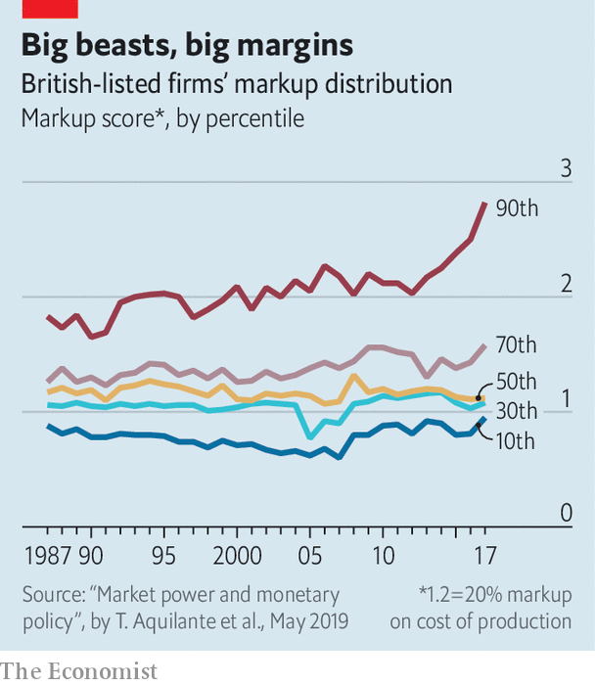

But concentration and markups are only partial measures of competition. Concentration can reveal only so much because what matters are not industries but markets. Firms may compete with rivals from another industry; and, in an open economy like Britain, international competition plays a large role. The British car industry is highly concentrated but many cars are imported. There are few British supermarkets but the business is fiercely competitive. Markups, for their part, require careful interpretation, because they involve trying to disentangle a firm’s variable and fixed costs—a tricky job. If high markups are not accompanied by abnormally high profits, it suggests something has gone wrong in the calculation. And in recent years Britain’s firms have not, on the whole, enjoyed the unusually high profits that have been apparent in corporate America.

What might the future of Britain’s competition policy look like? Now that it has left the EU, powers over large mergers, which had been ceded to Brussels, return to Westminster. In practice, they are unlikely to be used much, since in a major cross-border merger the EU and America will call the shots. But there is plenty of scope for the review to bring about innovation and improvement.

Asking the CMA to map the state of competition across the economy as a whole could be a useful exercise if it helps identify specific markets where there are problems. “This stuff isn’t hard,” argues a competition lawyer, “you just look for sectors where firms or senior management keep earning a lot and then go poke around a bit.” But some worry that the regulator could lose focus. “There’s no point in trying to map out some abstract idea of competition across the economy as a whole. What matters are individual markets,” says a former policymaker.

In any event it would be sensible to implement the recommendations of the Furman Review on digital competition, carried out for the Treasury in 2019. It had good ideas on how to develop a code of competitive practice for the dominant firms in digital industries as well as how to incorporate personal data concerns into policy.

British regulators would do well to look at innovations in mainland Europe, too: the Germans have, for instance, lowered the threshold for investigating tech mergers, on the grounds that mergers involving tiddlers—such as Google’s with YouTube and Facebook’s with Instagram—can turn out to be troubling. And there is a strong case for increasing both the CMA’s investigatory powers and its budget. Muscular competition policy isn’t just good for the government: it’s also necessary for restoring public trust in business. ■

This article was downloaded by calibre from <https://www.economist.com/britain/2020/02/15/ripping-into-the-rip-off-merchants>

|  |  |  |  |
| --- | --- | --- | --- |
| Previous | Articles | Sections | Next |

|  |  |  |  |
| --- | --- | --- | --- |
| Previous | Articles | Sections | Next |

#### Reshuffle

# Number 11’s new incumbent

Boris Johnson’s sacking of the chancellor consolidates his power

Feb 15th 2020 |

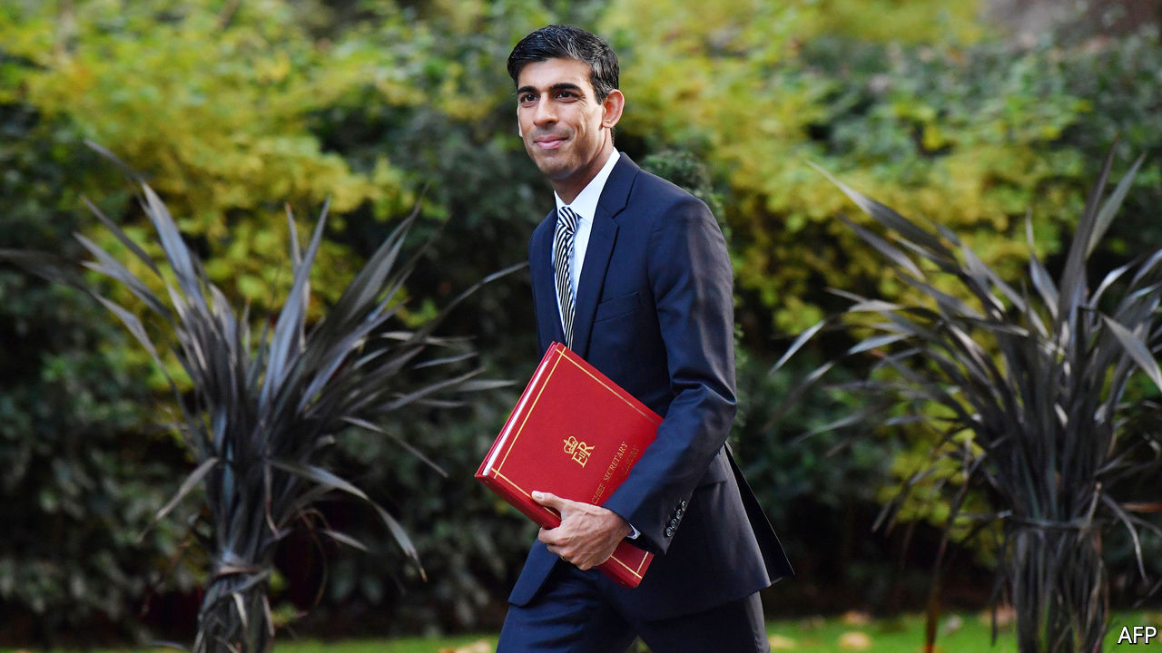

ASIDE FROM their families’ South Asian origins, Sajid Javid, the outgoing chancellor of the exchequer, and Rishi Sunak, the incoming one, have little in common. Mr Javid’s father came to Britain with £1 in his pocket and made his living as a bus driver. Mr Sunak’s father was a doctor, and he went to Winchester College, one of the country’s most exclusive schools, and subsequently to Oxford University. More importantly, neither Boris Johnson nor his chief adviser, Dominic Cummings, had much time for Mr Javid, and both have a great deal of respect for Mr Sunak.

Mr Javid’s resignation on February 13th lent drama to a reshuffle that was expected to be routine. The immediate cause of his departure was a row over his senior advisers: Number 10 said that he could only stay on if he sacked the lot of them and he refused. But there were two deeper causes. The first is a smouldering feud between Mr Cummings and Mr Javid over the broad direction of policy. Mr Cummings has lost a series of high-profile battles recently over HS2, Huawei and restructuring government. Mr Javid’s resignation is proof that he remains a formidable player.

The second reason is a shift in the balance of power between the prime minister and the Treasury. Under Philip Hammond, Theresa May’s chancellor, the Treasury exercised tight control over government domestic policy, much as it did under Gordon Brown when Tony Blair was prime minister. But under Mr Javid the Treasury has been weaker than it has been in decades. The new plan, to create a joint unit of special advisers to service both Numbers 10 and 11, will consolidate Number 10’s hold over policy.

Mr Johnson used his first appointments to demonstrate that he would brook no internal dissent and then won an 80-seat majority that has made him invulnerable. His instincts are to have his cake and eat it—spending big on infrastructure while also keeping taxes down. Mr Javid is a much more orthodox figure who puts a premium on balancing the budget.

Mr Sunak is the golden boy of the 2015 intake and has received nothing but plaudits from people who have dealt with him from his first job in local government onwards. He has been chief secretary to the Treasury since July 2019. He also has a business and finance background as a former investment banker with Goldman Sachs and a graduate of Stanford Business School. He is an enthusiastic Brexiteer who sees the future in Asia and the United States rather than Europe.

Mr Sunak’s seat in the northern constituency of Richmond, William Hague’s old seat, is a source of strength. He has a massive majority and a knowledge of the north of England—home of the marginal seats which brought Mr Johnson his victory in the general election. But whether he will be happy with Number 10’s power grab, or indeed its have-your-cake-and-eat-it philosophy, remains to be seen. His demeanour is not that of a big spender, and his popularity with bureaucrats suggests that he is likely to prove a powerful chancellor.

This reshuffle has sent out a clear message. A split between Numbers 10 and 11 is often regarded as the sign of a weak prime minister. Mr Johnson has no intention of being viewed in that light. ■

This article was downloaded by calibre from <https://www.economist.com/britain/2020/02/15/number-11s-new-incumbent>

|  |  |  |  |
| --- | --- | --- | --- |
| Previous | Articles | Sections | Next |

|  |  |  |  |
| --- | --- | --- | --- |
| Previous | Articles | Sections | Next |

#### Restitution

# Oxford University restores Maasai artefacts

Men with spears come to the dreaming spires

Feb 15th 2020 | OXFORD

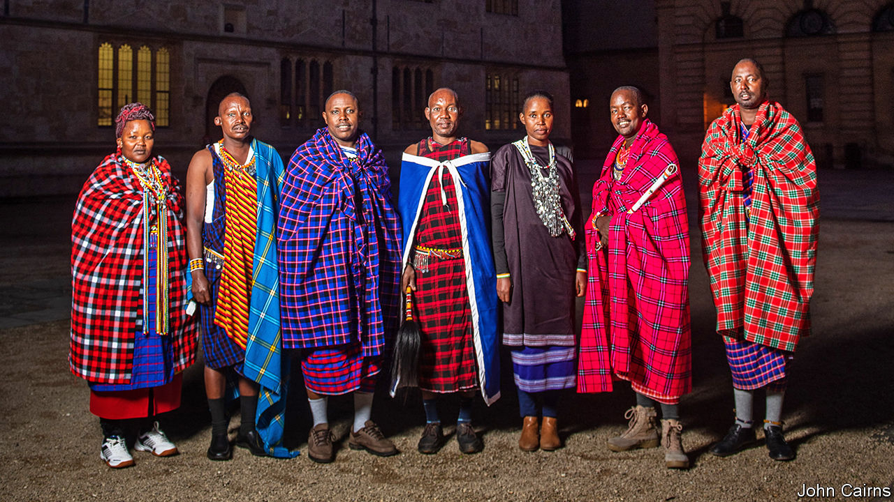

IN THE OAK-PANELLED Bookbinders Ale House, a group of Maasai tribespeople gathers the day before returning to Tanzania and Kenya, to sip cappuccinos and bitter and to chew over the results of a two-week visit to Oxford. Despite the vile February weather, they are satisfied with their trip, for they are closer to getting back sacred objects that are held by Oxford’s Pitt Rivers Museum.

Former colonial powers have tended to take a defensive attitude to requests from formerly subject peoples for the return of objects that may have been stolen. In Britain, France and elsewhere, laws prevent museums from letting stuff go.

But in 2017, Emmanuel Macron, the French president, said that he wanted to see the return of pilfered artefacts to Africa within five years. Since then, the movement for restitution has gathered steam. Universities are not constrained by the legislation that binds national collections, and several have started to return objects.

The Pitt Rivers, which holds the university’s archaeological and anthropological collections, is in the vanguard. It has returned 28 objects, all of them human remains. But Dan Hicks, curator of archaeology at the museum, believes that the movement needs to accelerate, for “museums are sites of colonial violence”.

Rather than deal with national governments, which can make for tricky politics, the Pitt Rivers is engaging directly with indigenous peoples. The Maasai visit came about after Samwel Nangira, a Maasai from Tanzania, visited the Pitt Rivers when he was at a conference. He questioned the labelling of some of the objects in the museum: “what does ‘collected’ mean? Like when you find something in a forest, so not donated, and not robbed?”

One of the problems with restitution claims is establishing provenance. The Maasai have come at the invitation of Laura van Broekhoven, director of the Pitt Rivers, and InsightShare, an NGO, to establish where and when the objects were taken. To that end, they have brought Lemaron ole Parit, a laibon—a spiritual leader with mystical powers. His family has been providing spiritual leadership for generations. The most famous of his forebears is Mbatian, his great-great-grandfather, who is remembered for foretelling the British arrival. Nick Lunch, InsightShare’s organiser, is impressed that Mr ole Parit has been talking with his father, Mokompo ole Simel, who holds ultimate spiritual power in the tribe but stayed at home, “not just on WhatsApp, but also through his dreams.”

Sitting on the floor of Mrs van Broekhoven’s office, Mr ole Parit breathes into an enkidong vessel packed with stones and snuff tobacco. He then shakes out the stones, whose patterns reveal the artefacts’ history to him. “I’ve identified the circumstances under which objects were taken,” he explains. “The times when they were taken, and how many hands they went through.” Out of the 188 artefacts Mr ole Parit viewed, he has identified only five he thinks are culturally sensitive enough to warrant a return.

Artefacts matter to the Maasai, in part because they represent the continuation of a dead person’s life. Mr ole Parit says an isurutia—a necklace—was taken from a woman who was killed while she was carrying her baby. “If somebody dies, we treat the artefacts as equally as important as a dead body,” says Amos Leuka, a member of the delegation. If an object has been taken violently from somebody, their spirit cannot rest. The Maasai’s ancestors are therefore said to be joining the negotiations.

So is Oxford’s vice-chancellor, Louise Richardson: once the Pitt Rivers has approved a claim, it is sent to her. Her attitude to this unusual method of establishing provenance has not yet been divined. But Mrs van Broekhoven says that the way knowledge systems are judged needs to be liberated. “Real decoloniality is to see each other’s knowledge systems as equal.” British colonial catalogues, she points out, are not models of accuracy. “All we have are labels with question-marks. It would be quite disingenuous to say, ‘Your knowledge system is inferior to ours’.” ■

This article was downloaded by calibre from <https://www.economist.com/britain/2020/02/15/oxford-university-restores-maasai-artefacts>

|  |  |  |  |
| --- | --- | --- | --- |
| Previous | Articles | Sections | Next |

|  |  |  |  |
| --- | --- | --- | --- |
| Previous | Articles | Sections | Next |

#### Politics

# Why Britain’s Conservative government is shifting leftward

Boris Johnson seems strangely attracted to the policies of Ed Miliband, the former Labour leader

Feb 15th 2020 |

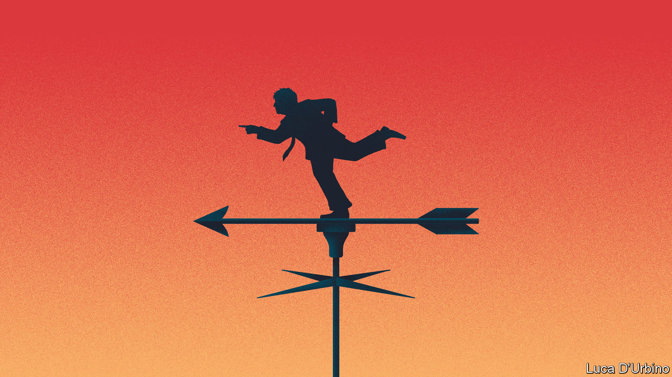

DENIS HEALEY, the Labour chancellor of the exchequer in 1974-79, supposedly said that he wanted to squeeze the rich until the pips squeak. Thanks to New Labour’s conversion to the gospel of wealth, and the party’s dismal electoral record since in the post-Blair era, it is a long time since the nation echoed to the sound of squeaking. But the new Conservative government may be about to change that.

The government is said to be contemplating two radical moves in the budget due on March 11th—imposing a “mansion tax” on owners of expensive homes and cutting pension tax relief for higher earners. The mansion tax may take the form of an annual levy on expensive homes or a higher council tax band. The pension reform may mean cutting tax relief on people who earn more than £50,000 a year from 40% to 20% to raise an extra £10bn a year. Other raids on capital gains, inherited money and profits are reportedly being considered.

These particular speculations may be hot air, but there are other straws in the wind. Boris Johnson has publicly aired his ambivalence to business, and his manifesto commitment to revitalise competition policy—never a friend of capitalists—is already bearing fruit (see article).

In the longer term, two ineluctable forces will force him to raise taxes on the rich. The first is fiscal: the government needs to raise money to finance ambitious infrastructure projects such as the HS2 rail link to the north. The second is political: the government needs to revise its tax-and-spend policies to reflect the fact that the Tories are now the party of ex-mining towns such as Blyth as well as well-heeled shires such as Buckingham. To hold onto those northern gains, Johnsonian Conservatism will need to be more open-handed than the Cameroonian variety.

This points to one of the oddities at the heart of British politics: that even as the Tory party consolidates its grip on the country—it has been in power either as part of a coalition or in its own right since 2010 and is likely to remain so until 2025—politics is moving to the left, at least on economics. In 2015 the Tories mocked “Red Ed” Miliband for proposing crazy socialist measures such as nationalising railways and imposing a mansion tax. Now the government has nationalised Northern Rail, may do the same to other rail companies and is expected to bring the whole network under tighter state control.

The government’s embrace of Milibandism is causing alarm among Tory MPs (particularly in the more affluent parts of the country) and Tory activists (particularly on the Thatcherite right). The Bruges Group tweeted that “had we wanted Labour we’d have voted for Corybn”. The head of the Taxpayers’ Alliance has warned the government that voters want lower taxes and smaller government. The Daily Telegraph has run a series of splenetic articles and editorials, including one warning that the mansion tax might have a devastating impact on the owners of country estates, illustrated with a picture of a 40-bedroom Elizabethan country house and its unhappy-looking owner. There is more fury to come, as the party discovers that fulfilling Disraeli’s dream of One Nation Conservatism comes with a heavy price tag. ■

This article was downloaded by calibre from <https://www.economist.com/britain/2020/02/15/why-britains-conservative-government-is-shifting-leftward>

|  |  |  |  |
| --- | --- | --- | --- |
| Previous | Articles | Sections | Next |

|  |  |  |  |
| --- | --- | --- | --- |
| Previous | Articles | Sections | Next |

#### Growth

# Why trend growth is collapsing in Britain

The economic speed limit has fallen more sharply than elsewhere

Feb 15th 2020 |

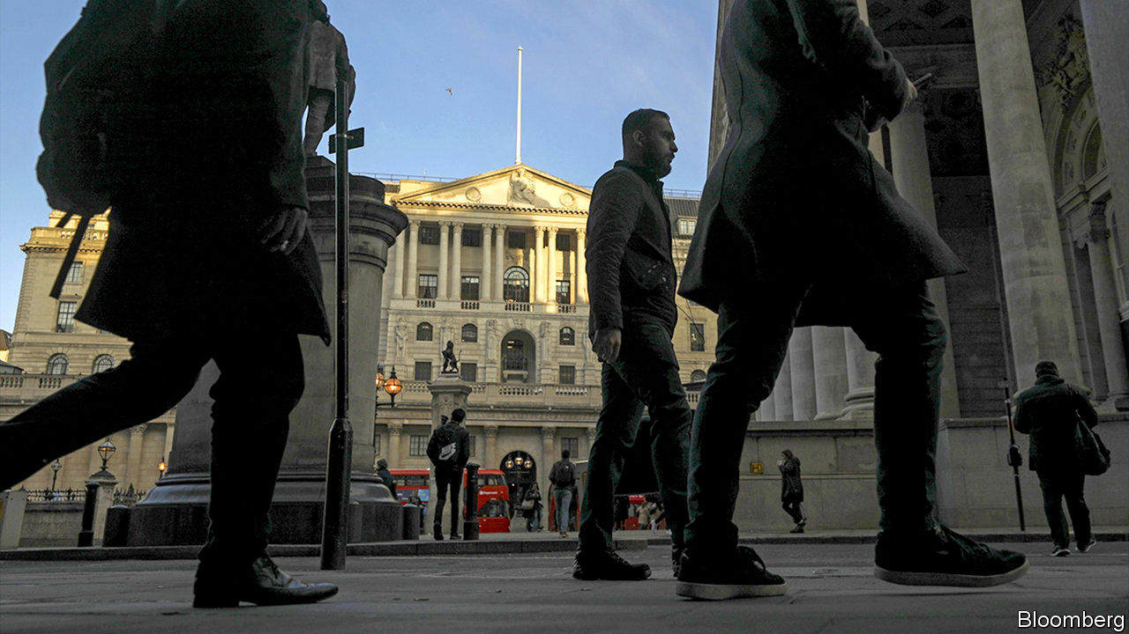

OVER THE past decade Britain has combined sluggish growth with booming employment. The government has been keen to talk up “the jobs miracle” and less keen on its counterpart: weak productivity growth. The latter can often be dismissed as a long-run problem, less pressing than immediate concerns like unemployment or inflation. But the long run may at last have arrived.

In its most recent forecasts, the Bank of England has pencilled in the medium-term potential growth rate at just 1.1%—less than half of what was thought possible ten years ago. Potential output growth can be thought of as an economy’s natural speed limit, the pace at which it can grow without pushing up prices.

Estimates of potential trend growth have fallen globally, but the decline in Britain is sharper than in other major economies. In part, it reflects a lower forecast for population growth, as immigration drops after Brexit. But mainly it results from a gloomier view of productivity. Private-sector forecasters are more upbeat than the Bank: they think the British trend rate is around 1.5%.

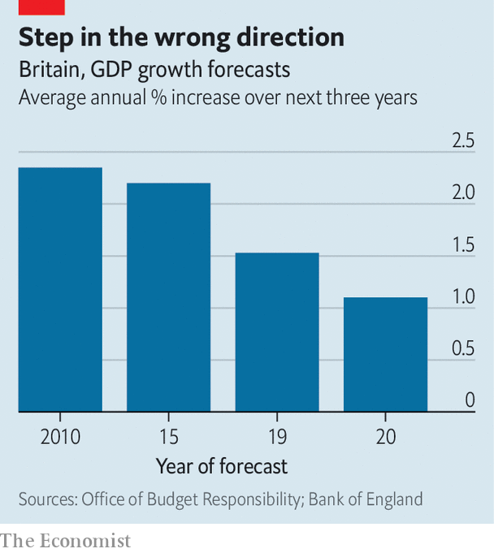

If the Bank is right, in the short term lower potential growth will keep up the pressure on the public finances, as tax receipts have less room to grow. The medium-to-longer-term picture is more worrying still. Weaker output growth means slower improvement in living standards. To avert that, policymakers will have to focus on solving the great British productivity puzzle.

This article was downloaded by calibre from <https://www.economist.com/britain/2020/02/15/why-trend-growth-is-collapsing-in-britain>

|  |  |  |  |
| --- | --- | --- | --- |
| Previous | Articles | Sections | Next |

|  |  |  |  |
| --- | --- | --- | --- |
| Previous | Articles | Sections | Next |

#### Spending a penny

# Why Britain’s public conveniences are anything but

Campaigners want Britons to be able to “pee for free” in private loos

Feb 15th 2020 |

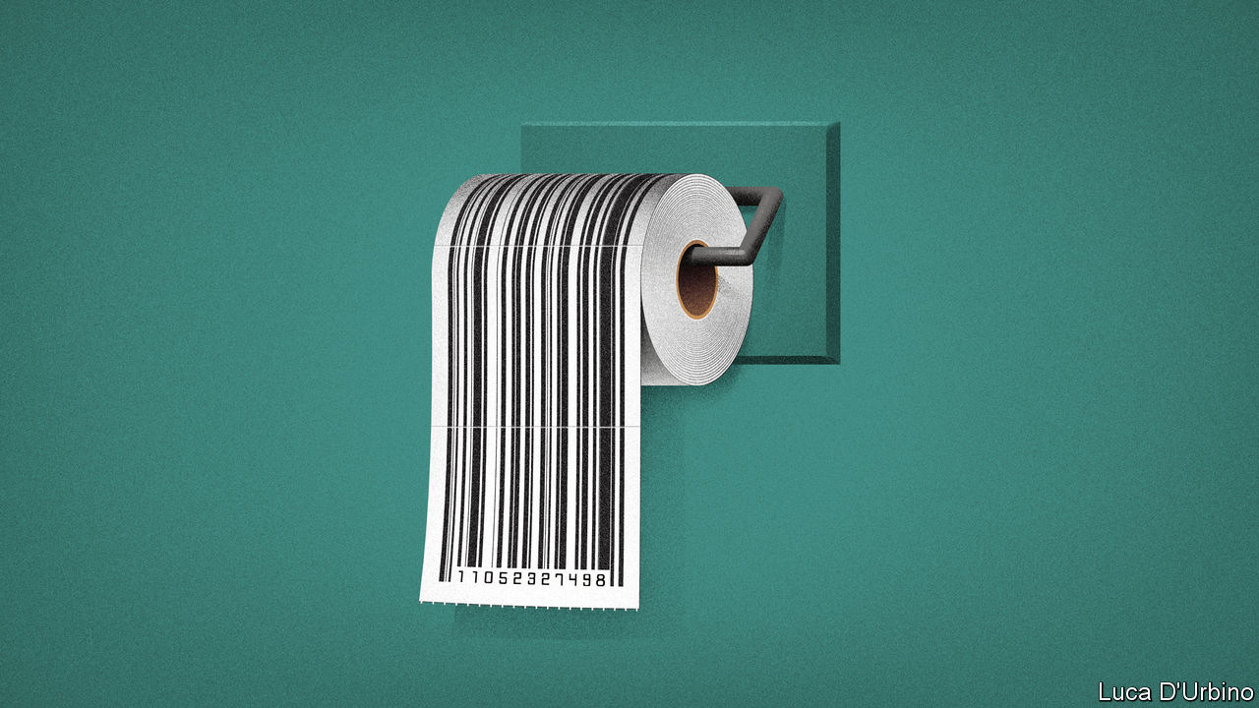

ANTOINETTE, A ROUGH sleeper in the Finsbury Park area of north London, doesn’t feel safe going to the toilet. The one public toilet nearby is often dirty, she says, and people take drugs in there. A pub near the underground station allows non-customers in, but men use it for another kind of relief. She prefers a branch of Costa, a coffee chain, but the door requires a passcode that is handed out only to customers. So she relies on friendly baristas slipping her the code.

A guerrilla Twitter campaign called London Loo Codes aims to help. It collects and distributes codes for toilets across London, to allow more people to “pee for free”. It has collated a list of more than 175 facilities in the capital, including ones that are already unlocked. The initiative has trickled down to other cities, including Edinburgh, Sheffield and Oxford.

Most firms turn a blind eye, reluctant to be seen as heartless toilet gatekeepers. Some, though, have taken to changing their codes more often. Staff in the Costa branch that Antoinette frequents are unenthusiastic about the influx, since they have to clean up its consequences.

The campaign is on to something. Public toilets were once a source of municipal pride. George Jennings, an engineer, showed off the country’s first flushing public toilet in Hyde Park in 1851. The Victorians, famous for their sanitation fascination, developed a network of public loos.

But councils are under no legal obligation to provide toilets and, after budget cuts under successive governments, town halls are hardly flush. Toilets, which are costly to keep in good nick, provide a convenient target for cost-cutters. In 2017 the City of London’s spent nearly £1m running four loos, despite charging users between 20p and 50p each time. London councils have stopped maintaining 13% of conveniences since 2010, according to the BBC. Several Victorian lavatories have been refashioned as quirky cocktail bars. One, in Clapham, is still called WC, though that now stands for wine and charcuterie rather than “water closet”. Nobody knows exactly how many public loos London has, but the number would fall way short of Paris’s 400.

After Bristol City Council closed all of its public toilets in 2018, it replaced them with a “community toilet scheme”, under which a group of local businesses has opened 84 loos to non-customers. But many of the firms listed on the scheme’s website do not display signs in their window indicating that their toilet is free to use. Staff in two of the businesses that signed up had only dimly heard of the initiative. If such schemes are not publicised, they will go down the pan. ■

This article was downloaded by calibre from <https://www.economist.com/britain/2020/02/15/why-britains-public-conveniences-are-anything-but>

|  |  |  |  |
| --- | --- | --- | --- |
| Previous | Articles | Sections | Next |

|  |  |  |  |
| --- | --- | --- | --- |
| Previous | Articles | Sections | Next |

#### Public transport

# The paradox of Britain’s buses

Everybody wants buses. They just don’t want to use them

Feb 15th 2020 |



NEVER MIND the snazzy, expensive railway line that the government grudgingly approved on February 11th. What really stirs politicians’ hearts is the humble bus. Both the chancellor of the exchequer, Sajid Javid, and the mayor of London, Sadiq Khan, are the sons of bus drivers, as they are not shy of saying. Boris Johnson, the prime minister, claims to love buses so much that he models them out of wine crates. This week he promised to throw more money at them.

This will go down well. Buses account for more public-transport trips than trains, tubes and trams put together. People love them, in theory: one poll by Transport Focus, a consumer group, found that 74% of young people think they are a good way of getting around and 85% believe it is important for a place to have a good bus service. There is just one problem. In practice, Britons are taking buses less and less (see chart). Powerful forces are driving this trend—probably too powerful to be counteracted with a dollop of public money.

Until recently, the decline in bus use could be put down to bad policies and austerity. In 1986, with Margaret Thatcher in her pomp, bus transport outside London was privatised and deregulated. Bus companies piled in to the best routes; the less popular ones were neglected, especially after the financial crisis, when subsidies were cut. Fares have risen, which deters more people from taking the bus. “It’s a cycle of decline”, says Darren Shirley of the Campaign for Better Transport.

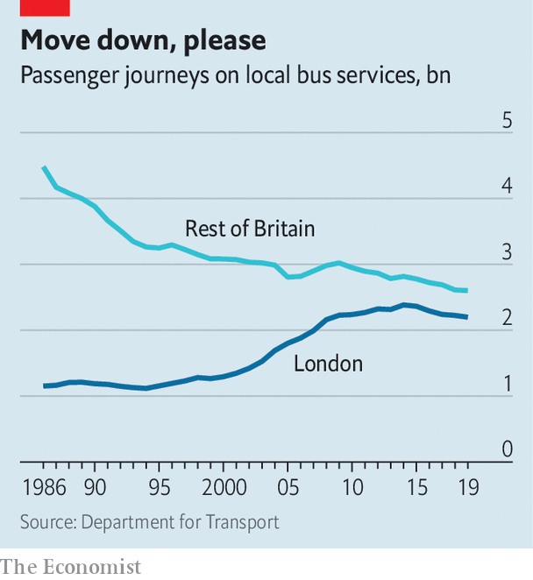

But if deregulation, service cuts and higher fares are the problem, why are London buses emptier? They have suffered none of those things. Yet the decades-long rise in bus trips in the capital—which was driven by good management, subsidies, a booming economy, rapid population growth, ever more unpleasant driving conditions and costly parking—appears to have reversed. Something else is up.

One thing that has changed is young people’s behaviour. The young are heavy bus users when they travel. But, increasingly, they do not travel. According to Transport for London, the average 17- to 24-year-old took 2.3 transport trips per day in the fiscal year 2011-12 but only 1.7 in 2018-19. The National Travel Survey confirms that no group has cut back harder on travel since the early 2000s than teenagers. Young people are more diligent these days, and stay in school for longer. They can do the things that young people love to do—flirting and cracking up their friends—on their phones, without going out.

The other big bus users are the poor (who have few other options) and the old (who can travel for nothing). Especially outside London, both are shunning buses for cars. Since 2002 the proportion of households in the poorest quintile who have no car has fallen a bit, from 49% to 46%. The fall among the second-poorest quintile is sharper: 36% to 28%. Relaxed lending standards have made cars easier to acquire; a fuel-tax freeze and frugal engines make them cheaper to run. Cars are ever more comfortable and idiot-proof, with parking-assist technology and lane-drifting alerts to help doddery drivers. Outside London, the average free bus pass was used 90 times in the fiscal year 2010-11 but only 74 times in 2018-19, according to the Department for Transport.

Finally there is the gig economy. Online shopping and Uber probably substitute for bus trips as well as private car journeys. And they put new vehicles on the roads, which slows everything down. The number of light-goods vehicles in London has risen by 28% since 2012. Tony Travers of the London School of Economics points out that bus speeds have fallen slightly in the capital, even though private cars have almost been purged from the city centre. The average London bus now travels at 9.3 miles per hour. Just as people become less inclined to run after buses, they are becoming easier to catch.■

This article was downloaded by calibre from <https://www.economist.com/britain/2020/02/15/the-paradox-of-britains-buses>

|  |  |  |  |
| --- | --- | --- | --- |
| Previous | Articles | Sections | Next |

|  |  |  |  |
| --- | --- | --- | --- |
| Previous | Articles | Sections | Next |

#### Bagehot

# The perils of Lennonism

Labour will not return to power until it changes its ideas about class

Feb 15th 2020 |

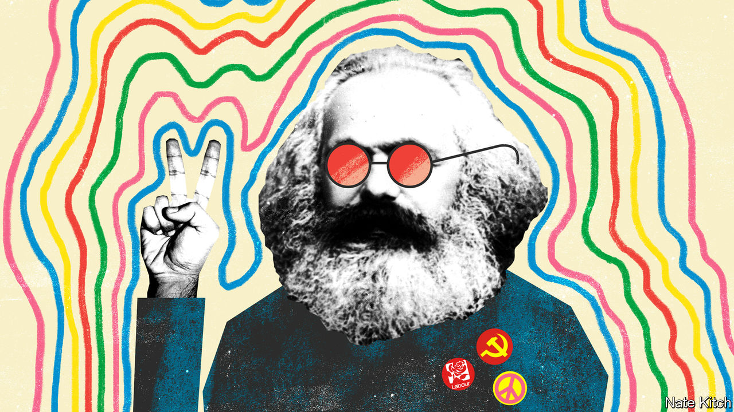

“A WORKING-CLASS HERO is something to be,” sang John Lennon. That certainly seems to be the view of the candidates for the Labour Party leadership, for they never miss an opportunity to boast about their proletarian credentials. Sir Keir Starmer’s father was a toolmaker who named his son after the Labour Party’s first MP, Keir Hardie. “I actually never had been in any workplace other than a factory until I left home for university,” he told the BBC. “I’d never been in an office.” Emily Thornberry was so poor when she was growing up—on a council estate, naturally—that her family had to have their cat put down to save money. Rebecca Long Bailey is the daughter of a dock-worker and trade-union activist; she insists that the next Labour leader should be “as comfortable on the picket line as at the dispatch box”.

The Labour Party can be forgiven some of its obsession with class given the shock of its defeat in the general election. It went into the election offering the biggest transfer of power to the workers in history only to see more workers vote for an Old Etonian with the middle name of de Pfeffel than for Comrade Corbyn. It lost working-class seats in the Midlands and the north that are not just bits of land but parts of its soul. This year’s Durham Miners’ Gala—a celebration of working-class culture and Labour Party muscle—will take place surrounded by Conservative-held seats. A period of mourning is in order.

But mourning should not permanently cloud thinking, and a celebration of working-class identity should not degenerate into a replay of the Monty Python’s “Four Yorkshiremen” sketch. The Labour Party’s naive Lennonism is blinding it to radical changes in Britain’s class structure. Its leadership candidates still talk as though Big Capital faced Big Labour across a battlefield of picket lines, ignoring the transformation of the economy brought about by globalisation and technology. In 1987—the last time the Tories saw a victory comparable to Mr Johnson’s—62% of Britain’s electorate was working-class (defined by people whose heads of household held or had held a manual job). Today the figure is 43%, according to Peter Kellner, former president of YouGov, a pollster. Companies have embraced flexible production and contracting out. Trade unions have shrunk and migrated to the public sector. A rise in general affluence has gone hand-in-hand with an increase in the number of people who are homeless or using food banks.

The biographies of the leadership candidates reflect these changes. Sir Keir and Ms Long Bailey may have been born working-class, but they rocketed up the social hierarchy: Sir Keir spent five years as director of public prosecutions; Ms Long Bailey, a solicitor, lives in a fancy Manchester suburb. Ms Thornberry, aka Lady Nugee, knew poverty as a child because of divorce rather than deprivation: her father was a United Nations official who dumped his family. She became a successful barrister and married an even more successful one. Lisa Nandy, an outsider on whom the odds are shortening, is a red princess whose immigrant father became a professor and helped to found the Equal Opportunities Commission, and whose grandfather was a distinguished Liberal MP.

The party’s membership has undergone a similar transformation. Almost 80% of members are now middle-class. Activists in Crouch End in London are so worried about the middle-class takeover that they have suggested creating separate working-class sections in constituency parties to ensure that the voice of the proletariat is not drowned out; the branch secretary is an emeritus professor at London Metropolitan University. If Jeremy Corbyn reversed Blairism ideologically, he intensified it sociologically, making the party even more middle-class and southern. The big difference is that Mr Corbyn’s middle-class tribunes are under the illusion that they’re working-class heroes sticking it to The Man.

Lennonism is also blinding the party to the emergence of a new form of class struggle from the ashes of the old. These days social class is defined less by relationship to the means of production than by educational qualifications. And class struggle is driven by quarrels about identity and values rather than about remuneration and working conditions. In his new book “The New Class War: Saving Democracy from the Managerial Elite”, Michael Lind, of the New America Foundation, a think-tank, argues that the clash between the credentialled and the non-credentialled is shaping politics across the world. This is particularly true of Britain, which enthusiastically embraced policies favoured strongly by the credentialled elites (globalisation, free markets, social liberalism), only to summon up a mighty backlash in the form of Brexit.

In this new class war the Labour Party is on the side of the “haves” rather than the “have nots”. The majority of the party’s members have university degrees. Party activists pride themselves on their cosmopolitan values: they associate nationalism with xenophobia, strongly oppose Brexit and wage ceaseless war on all forms of bigotry. Harold Wilson once said that the Labour Party is “a moral crusade or it is nothing”. These days the moral crusade frequently takes the form of members of the cognitive elite ticking off non-members for being insufficiently enlightened. That is good for mobilising the votes of the educated but not for much else: in December the Labour Party beat the Tories among degree holders by 43% to 29% but lost among people who have only GCSEs (or lower) by 25% to 58%.

In many ways Boris Johnson’s majority is built on sand. The Tory dream of a property-owning democracy is dying: new figures from the Office of National Statistics show that people in their mid-30s to mid-40s are three times more likely to rent than they were 20 years ago. The shock of Brexit is yet to hit: Michael Gove, the chancellor of the Duchy of Lancaster, this week warned companies that they will have to prepare for border checks on goods flowing into and out of Europe from next January. But the Labour Party has no chance of winning power until it abandons Lennonism and works out what it is for in a post-industrial society. ■

This article was downloaded by calibre from <https://www.economist.com/britain/2020/02/15/the-perils-of-lennonism>

|  |  |  |  |
| --- | --- | --- | --- |
| Previous | Articles | Sections | Next |

|  |  |  |
| --- | --- | --- |
| Britain | Sections | Business |

International

Covid-19: Curbing the Asian contagion

.

Covid-19 and trade: A deadly disease disrupts

.

|  |  |  |
| --- | --- | --- |
| Britain | Sections | Business |

|  |  |  |  |
| --- | --- | --- | --- |
|  | Articles | Sections | Next |

#### Curbing the Asian contagion

# China’s neighbours are rushing to contain the spread of the new coronavirus

Singapore is a model for others

Feb 13th 2020 | JAKARTA, SINGAPORE AND TOKYO

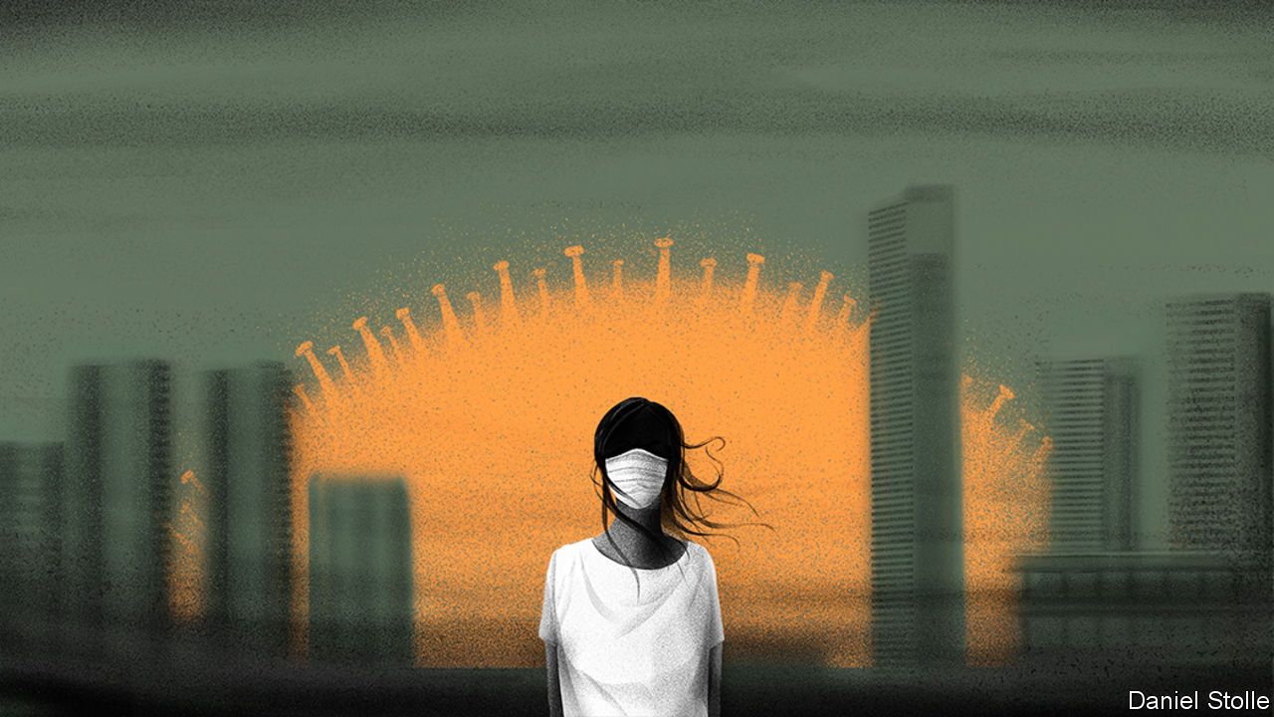

THE DIAMOND PRINCESS, an 18-deck cruise ship, has been marooned in the waters off Yokohama, a port city near Tokyo, since February 3rd. Japanese officials in protective suits have brought fresh supplies on board. No passengers are permitted to disembark. Some 3,700 holidaymakers and crew have been quarantined since an 80-year-old passenger, who left the ship in Hong Kong, tested positive for the new coronavirus sweeping China. Since then, 218 of those on board have been infected. Any infection spreads rapidly on such vessels so passengers are mostly confined to their cabins. Some are relying on sudoku puzzles delivered to their rooms by staff for entertainment. Others have had wine delivered by drone. All are anxiously counting the days until February 19th, when their two weeks of isolation should end.

Most confirmed infections of covid-19, as the World Health Organisation has just renamed the disease, are in China. But the disease is now spreading throughout Asia. Singapore confirmed its first infection on January 23rd. It has since detected 49 more. The first 14 identified had all travelled there from Wuhan, the Chinese city where the outbreak began. The first cases of local transmission, traced to a traditional medicine shop frequented by Chinese tourists, were announced on February 4th.

The arrival of the new coronavirus in the city-state was predictable. China is Singapore’s largest trading partner. But it is spreading elsewhere. Japan says 28 people have been infected—not including those confined to the Diamond Princess. Thailand has identified more than 30 and Malaysia 18. Along with Singapore they have all confirmed cases of local transmission. So has Vietnam, where 16 people have caught the disease and 10,000 have been quarantined. In the Philippines one person has died—one of two known deaths outside mainland China. Laos and Myanmar, which share long land borders with China, say they are dealing with only a few suspected cases, though the numbers will surely rise. Armed insurgent groups in Myanmar, such as the Kachin Independence Organisation, have launched public-health campaigns promoting handwashing.

Others insist they are unaffected by the virus. Indonesia, with its 6,000 inhabited islands and 267m people, denies it has a single case. That would be surprising (see chart), given that 2m Chinese tourists visit every year. Some 5,000 Chinese visitors to Bali extended their stay there, fearful of returning home and exposing themselves to the virus. Amin Soebandrio, director of the Eijkman Institute for Molecular Biology in Jakarta, maintains that the country is more than able to detect anyone infected. And yet 238 Indonesians who were evacuated from Wuhan were quarantined but not tested for covid-19. The health ministry said that this was because the arrivals appeared healthy and the tests are expensive.

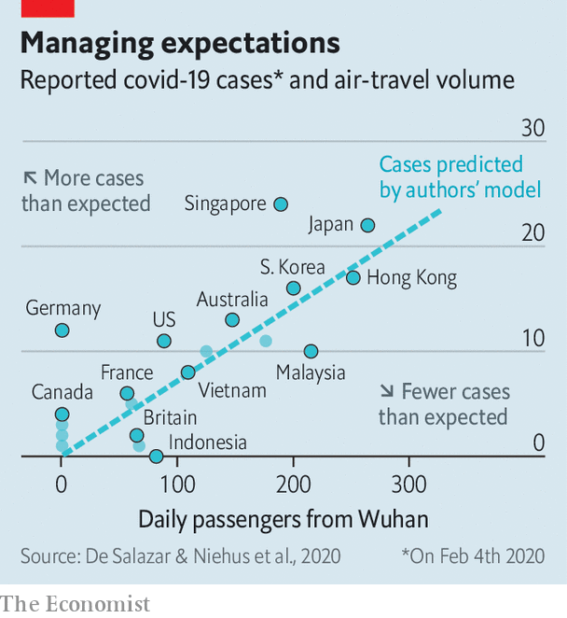

Experts suspect there are many more infections than have been reported. “Any country that has significant travel back and forth with China and hasn’t found cases should be concerned,” cautions Marc Lipsitch, a professor of epidemiology at Harvard University. Covid-19 has arrived in Singapore; it would be foolish to think that it has not spread more widely, he says.

The disease has killed over 1,300 people and infected around 60,000 in China (there is great uncertainty over the totals). It seems to be transmitted through droplets from coughs and sneezes, and mostly as a result of close contact with someone who is already ill. But experts fear that some people with no symptoms could infect others. Tracing the contacts of those who have been infected is like “looking through the dark”, says Oshitani Hitoshi, an expert in infectious diseases at Tohoku University in Japan. Rich countries such as Singapore are particularly well placed to monitor and care for those who are ill and people in contact with them. But poorer countries with weaker health systems will struggle.

Singapore has prepared for an outbreak of this kind since SARS caught Asia unawares in 2003. The country has raised its outbreak alert to orange, the second-highest threat level. It has barred those who have been to China in the past 14 days from entering the country. Quarantine awaits anyone who has been in close contact with an infected individual. And people entering hospitals and offices must have their temperature taken first. Inter-school sports fixtures have been cancelled until the end of March. The largest dormitory for migrant workers in the country stands ready if any of its occupants need to be quarantined. Pink pillows lie on single beds, empty so far, widely spaced to ensure that any patients are more than two metres apart in designated rooms. Singapore is using a tough new law against fake news to try to prevent the spread of inaccurate information, such as a rumour that the country has run out of face masks.

Japan is taking many similar steps. The government is scared that the virus might wreck the Olympic Games in Tokyo this summer. Earlier this month it banned foreigners who had visited Hubei, the province in China where the outbreak originated, and those with passports issued there, from entering Japan. The country’s two biggest airlines have stopped all flights to Beijing from one of Tokyo’s international airports and halved their flights from another.

So far India has detected cases only in Kerala. This may be because Kerala is the Indian state with the strongest health-care system, so cases there are more likely to be detected. Infections elsewhere may simply not have been noticed yet. However, India’s government has been quick to react. It was among the first countries to evacuate its citizens from Wuhan and is monitoring almost 10,000 people for covid-19. Also, India is less well connected to China than air hubs such as Singapore and Thailand, and its relative isolation may protect it somewhat. Indeed, it has sent medical equipment including masks and protective clothing to China. The government has, however, also claimed that ayurvedic remedies and homeopathy could help manage the disease, suggestions for which evidence is entirely lacking. Meanwhile Pakistan has told its citizens in Wuhan to stay put. Its health system is already strained and China is one of its most vital allies.

All countries must balance their fear of the human and economic costs of the virus against the damage caused by measures to contain it. For less well-off countries, the trade-off is especially painful. Tourism generates more than a tenth of Thailand’s GDP. In 2018 about a quarter of the 38m holidaymakers who visited the country were Chinese. In desperation, Thailand has neither restricted Chinese tourists from entering the country nor stopped giving them free visas on arrival.

“We wish to reaffirm our solidarity with the people of China and wish you every success in overcoming this grave situation,” wrote King Maha Vajiralongkorn in a message to China’s leader, Xi Jinping. Hun Sen, the president of Cambodia, where China has invested more money than any other country in recent years, went further. He travelled to Beijing to meet Mr Xi, demonstrating his loyalty in the face of adversity.

China’s embassies have attacked foreign governments for imposing travel bans. Its ambassador in Jakarta warned Indonesia that “overreaction” would have “a direct impact” on relations. But such bullying may not work. Covid-19 comes after a devastating outbreak of African swine flu on Chinese pig farms and amid a trade war between China and America, and protracted protests in Hong Kong. These upheavals have dented China’s reputation in the region. The epidemic has exposed China as a country of great strengths and weaknesses, says Bilahari Kausikan, a Singaporean former diplomat: “Quite a lot of the gloss has worn off the Chinese story.” ■

This article was downloaded by calibre from <https://www.economist.com/international/2020/02/13/chinas-neighbours-are-rushing-to-contain-the-spread-of-the-new-coronavirus>

|  |  |  |  |
| --- | --- | --- | --- |
|  | Articles | Sections | Next |

|  |  |  |  |
| --- | --- | --- | --- |
| Previous | Articles | Sections | Next |

#### A deadly disease disrupts

# The new coronavirus could have a lasting impact on global supply chains

Multinationals have failed to take seriously the risk of disruption

Feb 15th 2020 | NEW YORK, PARIS, SHANGHAI AND TOKYO

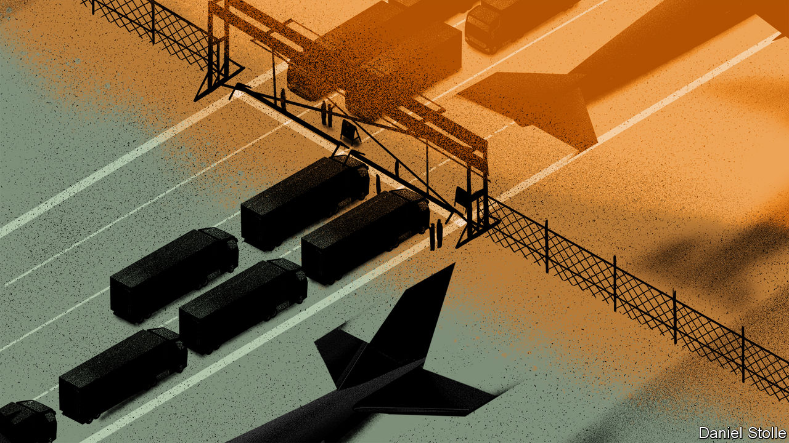

TO GLIMPSE THE impact of the new coronavirus on global businesses, consider Apple. Such is the American tech titan’s reliance on the Chinese mainland for parts and assembly that United Airlines typically shuttles some 50 of its executives between California and China each day. But not at the moment. United and other carriers have suspended flights to and from China. A lack of workers meant that after the end of the lunar new-year holiday Foxconn, which makes most of Apple’s iPhones in China, could not get its assembly plants back to full capacity this week. Analysts reckon that the virus could lead to Apple shipping 5-10% fewer iPhones this quarter and could scupper its plans to ramp up production of its popular AirPods.

As covid-19 spreads, its effect on business is amplified. Tourism into and out of the mainland has plunged. Some 400,000 Chinese tourists are forecast to cancel trips to Japan by the end of March. One large cruise ship in Asia was turned away by five countries because scores on board are infected (Cambodia at last allowed it to dock). The Singapore Air Show earned the city-state some $250m in 2018, but far less this week owing to cancellations by 70 companies including Lockheed Martin, an American defence giant. The Mobile World Congress, a giant telecoms conference due to take place in Barcelona this month, has been cancelled after companies from Vodafone and BT to Facebook and Amazon pulled out. It is increasingly clear that the virus could damage global supply chains, costing the world’s economy dearly.

Most multinational firms have been caught by surprise. This is not the first time they have suffered shocks to their Asian supply chains. The tsunami that hit Japan in 2011 and devastating floods in Thailand the same year disrupted production for many big firms. More recently, Donald Trump’s trade war with China has exposed the risks of supply chains that rely too heavily on the mainland. But the bosses of such businesses have done little to prepare for shocks such as that inflicted by the outbreak of the new coronavirus.

Investors are punishing companies for this failure. The shares of American firms with strong exposure to China have underperformed the S&P500 index by 5% since early January, when news of the outbreak first broke (see chart).

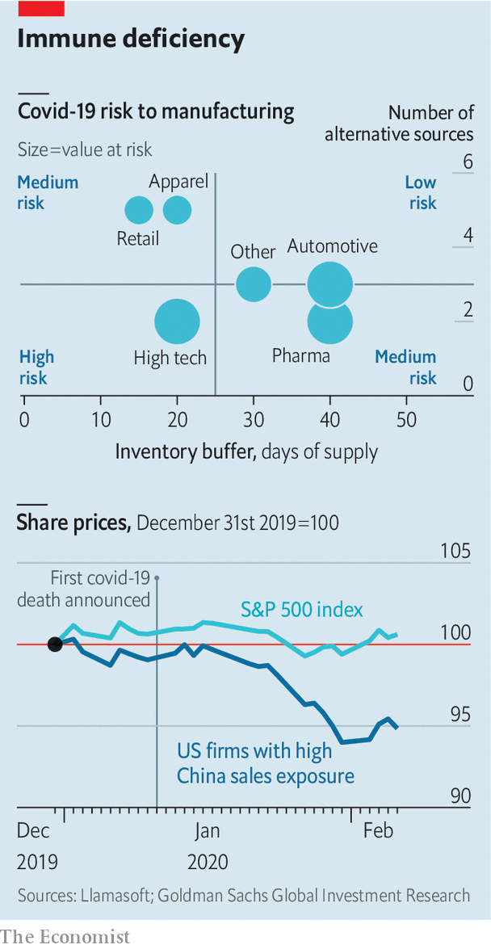

There are three reasons to think the coming months could prove even more unpleasant for many firms. First, big multinationals have left themselves dangerously exposed to supply-chain risk owing to strategies designed to bring down their costs. For example, many keep only enough stock on hand to last a few weeks, confident that they can always replenish their inventories “just in time”. That confidence is misplaced, argues Bindiya Vakil of Resilinc, a consultancy.

The second vulnerability arises from the fact that giant firms are much more reliant on Chinese factories today than they were at the time of the SARS outbreak in 2003. China now accounts for 16% of global GDP, up from 4% back then. Its share of all exports in textiles and apparel is now 40% of the global total. It generates 26% of the world’s furniture exports. It is also a voracious consumer of things such as metals, needed in manufacturing. In 2003 China sucked in 7% of global mining imports. Today it claims closer to a fifth.

Koray Köse of Gartner, a research firm, points out that it is not only the increase in size of China’s manufacturing base that matters. Since 2003 factories have spread from the coast to poorer interior regions like Wuhan, where the epidemic broke out. Workers from such places now toil at factories all over China—and travel home for the holidays. That interconnectedness increases supply-chain risks, argues Mr Köse. So does the rising interdependence of many firms. Mainland suppliers no longer simply assemble products; they make many of the parts that go into them as well.

The third reason to think that big companies may experience a supply-chain shock is that the regions worst affected by covid-19 and the subsequent government lockdowns are particularly important to several global industries. The electronics industry is most at risk, according to Llamasoft, a supply-chain analytics firm, because of its relatively thin inventories and its lack of alternative sources for parts.

Hubei province, where Wuhan is located, is the heart of China’s “optics valley”, home to many firms making components essential for telecoms networks. Perhaps a quarter of the world’s optical-fibre cables and devices are made there. One of China’s most advanced chip-fabrication plants, which makes the flash memory used in smartphones, is found there, too. Analysts worry that the epidemic in Hubei could reduce global shipments of smartphones by as much as 10% this year.

The car industry has also been hit. The lack of parts from mainland-based suppliers forced Hyundai to shut all its car plants in South Korea (it is now partially reopening them). Nissan has temporarily closed one in Japan, and Fiat-Chrysler has warned that it could soon halt production at one of its European factories.

Fears of the virus are now affecting the global oil price. Chinese refiners are slashing output in anticipation of shrinking demand at home. Slowing Chinese demand is further darkening what was already a dismal outlook for natural gas. Chinese copper buyers have asked Chilean and Nigerian mining firms to delay or cancel shipments. Mongolia has suspended deliveries of coal to China.

Some Chinese firms are panicking. Dozens have received official “force majeure certificates”, which they hope will allow them to slip out of contracts without incurring penalties. They may not. Faced with faltering demand as well as closed ports and roads, CNOOC, a Chinese energy giant, recently used such tactics to avoid accepting LNG shipments. Total and Royal Dutch Shell, European oil majors, are rejecting the move.

What happens next? Big firms want to ramp up production quickly. But it is unclear how soon workers will be allowed to return to factories. However, factory dormitories are crowded. Foxconn’s workers are packed eight to a room at its Shenzhen plant. If that leads to renewed infections plants may be forced to shut down again. Senior bosses will return soon, but some worry that mid-level expatriate managers with young children will not.

Even when plants are up and running, moving goods around and out of China will remain difficult. Alan Cheung of Kerry Logistics, a big provider in Asia, reports that his drivers are getting stopped across the mainland because the Chinese government is still trying to prevent lorries moving around unless they are delivering food or other necessities. The longer shipping volumes are depressed, the bigger the backlog when China Inc returns to work. That will probably lead to bottlenecks and a surge in freight rates.

In the longer term the epidemic could dampen the love affair between multinationals and China. Big companies had long assumed that their mainland supply chains were reliable and easy to manage. Surveys have found that only a minority of firms across all industries regularly assess their supply-chain risks carefully. For years bosses have devolved responsibility for sourcing to mid-level managers, typically instructed to extract an extra percent or two from costs each year. The covid-19 outbreak has exposed the risks of doing so, especially since America’s trade war with China is not exactly resolved. Tsunamis and floods came and went and firms simply thought they could manage, says Jochen Siebert of JSC Automotive, a consultancy. He predicts that the epidemic will put the question of supply-chain management squarely on the desks of their CEOs. ■

This article was downloaded by calibre from <https://www.economist.com/international/2020/02/15/the-new-coronavirus-could-have-a-lasting-impact-on-global-supply-chains>

|  |  |  |  |
| --- | --- | --- | --- |
| Previous | Articles | Sections | Next |

|  |  |  |
| --- | --- | --- |
| International | Sections | Finance and ... |

Business

Armsmakers in the Middle East: From muskets to missiles

.

Restaurants: Chasing Ronald

.

Remote advertising: Hoarding cash

.

Elliott v SoftBank: Singer-Son time

.

Bartleby: Teenage picks

.

Business education: MBAs with Chinese characteristics

.

Schumpeter: The Qualcommunist manifesto

.

|  |  |  |
| --- | --- | --- |
| International | Sections | Finance and ... |

|  |  |  |  |
| --- | --- | --- | --- |
|  | Articles | Sections | Next |

#### From muskets to missiles

# The battle for the Middle Eastern arms market is heating up

Chinese, Russian and local companies want to conquer market share from Western defence giants

Feb 15th 2020 | DUBAI

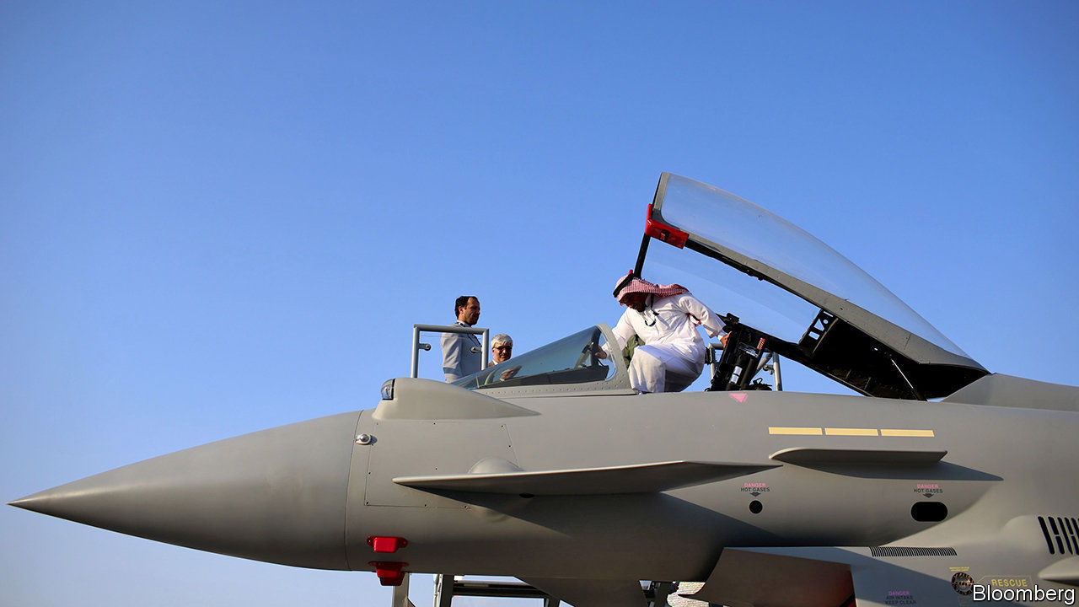

THE FLOW of foreign arms to the Arabian peninsula began in earnest 150 years ago. As European armies adopted modern breech-loading rifles, a stock of old-fashioned weapons was left surplus to requirements. Rivalries among Arab tribes created a ready-made market for ageing arms. A combination of the region’s chronic instability and oil riches has since continued to fuel weapons sales. Most of them still come from the West. Now the shifting sands of geopolitics have left an opening for others.

At the Dubai air show last November Viktor Kladov of Rostec, a state-run firm that handles exports from Russia’s defence companies, told The Economist that Russian weapons exports to the Middle East apparently hit an all-time high of $13.7bn in 2018. With a candour unusual in his industry, Mr Kladov put this down to Russia’s willingness to sell most things to most people. Europeans and Americans can indeed be queasy about sending some weaponry to places with mixed human-rights records. The war in Syria, Mr Kladov said, was a chance to “showcase” Russian arms. Chinese firms, similarly unconstrained, are also piling in. And Middle Eastern countries are keen to build their own defence industries. The battle for the world’s fastest-growing arms market may be about to heat up.

## War powers

Big Western defence firms mostly rely on their domestic markets for sales and profits. Exports account for less than a third of revenues for Lockheed Martin, the world’s biggest armsmaker. But the global export market is big—and getting bigger. The Stockholm International Peace Research Institute (SIPRI), a think-tank, put it at $100bn in 2018. Overseas revenues help smooth over downswings in domestic defence budgets and support the gargantuan investments required for big projects.

A growing share of these revenues comes from the Middle East. In 2014-18 the region received a third of the world’s arms exports, second only to Asia Pacific, according to SIPRI (see chart). Countries there imported 87% more weapons in that period than they had in the previous five years. In 2018 Saudi Arabia splurged $68bn on military kit, more than anyone bar America and China. The United Arab Emirates (UAE) was the seventh-biggest spender in 2014-18; tiny Qatar and Oman made the top 20.

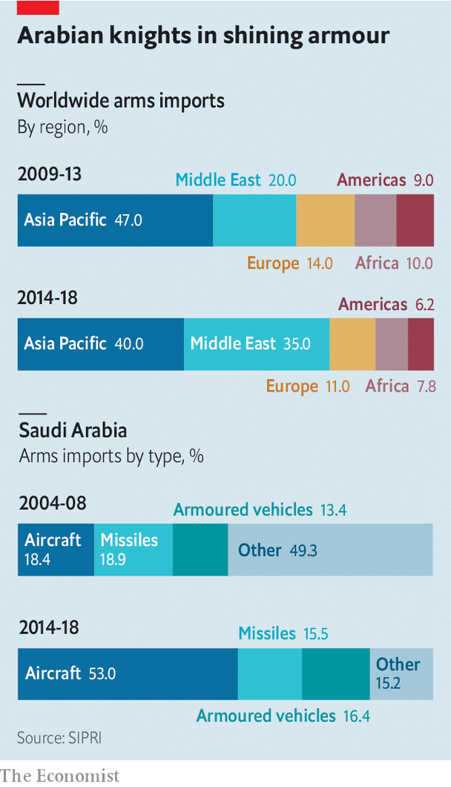

America’s massive weapons-makers, whose home market is responsible for 36% of global defence spending, dominate the industry. All but eight of the world’s 20 biggest defence firms by sales are American. America’s industry accounted for 36% of global exports in 2014-18, reckons SIPRI. Countries in the Middle East snapped up over half of American exports in that period, as well as 60% of Britain’s, 44% of France’s and 25% of Germany’s. In 2018 the Middle East contributed $3.6bn, or around 7%, to the revenues of Lockheed Martin. Raytheon, the fourth-biggest producer, made 15% of its overall sales in the region (including north Africa), which were worth roughly $4bn.

Most Middle Eastern cash goes on air power. Buying, arming and maintaining combat jets is an expensive business, accounting for nearly two-thirds of global exports in the past decade. Saudi Arabia has amassed the world’s eighth-largest fleet of combat aircraft. A contract signed in 2011 for 84 new F-15 fighters and upgrades to 70 existing planes is worth $24bn to Boeing and its suppliers, which include Raytheon and Britain’s BAE Systems. BAE sold 72 Typhoon jets to the desert kingdom in 2007 in a deal said to be worth around $7bn (which the firm is keen to extend). Saudi Arabia has procured antimissile systems from Lockheed Martin and Raytheon.

But there are some things that American firms will not—or cannot—sell. International arms treaties to which America is party bar signatories from exporting ballistic missiles, as well as certain cruise missiles and armed drones. China, which has stayed away from these compacts, faces no such constraints. Once limited to supplying communist revolutionary movements with small arms, it has become one of the world’s biggest arms exporters.

## Dragon flies

Strategic rivals like India (the world’s second-biggest arms importer behind Saudi Arabia), will not touch Chinese wares. But China’s armsmakers are making forays into Africa and the Middle East, especially with armed drones. Although these may not be as advanced as American ones, they can be just as effective—in 2018 the UAE used a Chinese drone to kill a Houthi rebel leader in next-door Yemen, where it is fighting an insurgency in a Saudi-led coalition. And they cost a quarter as much.

Peter Navarro, President Donald Trump’s trade adviser, has complained that the Wing Loong II, made by the Chengdu Aircraft Industry Group, is a “a clear knock-off” of the Predator drone built by America’s General Atomics (GA). Rainbow CH-4 drones, developed by the China Aerospace Science and Technology Corporation, look an awful lot like GA’s smaller Reaper. Mr Trump has sought to ease restrictions on exports of the American models. Nevertheless, points out Pieter Wezeman of SIPRI, the deals allow the Chinese to build relationships in the region, paving the way for future sales of other systems. Qatar already has Chinese-made ballistic missiles.

Russia, with domestic sales in decline since 2016, also covets more Middle Eastern custom. Like Chinese kit, some of its technology is cut-price and comes with no strings attached. Though a lot of it is no match for the best European or American equipment, “it’s good enough”, sums up one industry insider.

Russian firms have yet to break into the Gulf’s lucrative market; in Dubai the affable Mr Kladov seemed keenest to flaunt non-military kit, such as a wine-storage system made of military-grade materials and a Kalashnikov passenger hydrofoil. But they have been supplying deadlier products to Egypt, temporarily denied American arms after a military coup in 2013, as well as to Syria and Iraq. Russia’s government says it is in talks to sell Sukhoi’s SU-35 combat jets to the UAE (though Emirati airmen would prefer, and will probably get, America’s snazzier F-35s). The Saudis are discussing acquisition of the S400 anti-aircraft missile systems made by Russia’s Almaz-Antey. America would be miffed if the kingdom turned to Russia. When Turkey (a NATO ally) agreed to buy the S400s, America reacted by refusing to sell it F-35s.

Chinese and Russian firms also look poised to benefit from an arms embargo which some northern European countries have imposed on Saudi Arabia over its conduct of the war in Yemen and the murder of a dissident journalist. Germany has banned weapons made or co-developed by German firms, or containing German components, from going to the Saudis. Canada’s government is under pressure at home to block an $11bn contract to furnish Saudi Arabia with armoured vehicles made by General Dynamics. Britain has suspended new export licences for equipment that might be used by the Saudi-led coalition in Yemen. BAE’s £5bn ($6.5bn) deal to sell more Typhoons may be in jeopardy.

The last threat to Western dominance may come from the importers themselves. Big defence contracts typically involve joint ventures with local companies. These, says Lucie Béraud-Sudreau of the International Institute for Strategic Studies, another think-tank, enable the customers to develop weapons themselves. Australia, Pakistan, South Korea and Turkey have all developed local defence industries from scratch, notes Strategy&, a consultancy, partly through offsets but also because of policies to help domestic suppliers.

At the Dubai show the UAE unveiled Edge, a consortium of 25 defence firms. Saudi Arabian Military Industries (SAMI), another national group, was set up in 2017. The Saudis want to localise half their spending on arms by 2030, from 2% in 2017. They are enlisting foreign executives and experts. China has built a drone factory there; SAMI is run by a German. It will be a while before local companies rival the Western giants. But the days when the West could sell the sheikhs out-of-date muskets are not coming back.■

This article was downloaded by calibre from <https://www.economist.com/business/2020/02/15/the-battle-for-the-middle-eastern-arms-market-is-heating-up>

|  |  |  |  |
| --- | --- | --- | --- |
|  | Articles | Sections | Next |

|  |  |  |  |
| --- | --- | --- | --- |
| Previous | Articles | Sections | Next |

#### Chasing Ronald

# Burger King’s owner tries to regain its sizzle

Fast food does not automatically equal fast growth

Feb 15th 2020 |

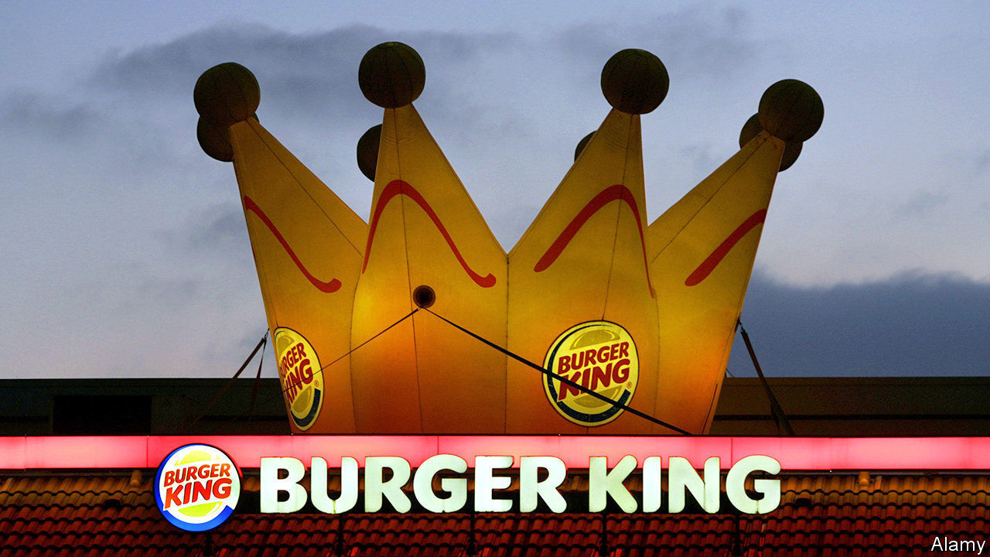

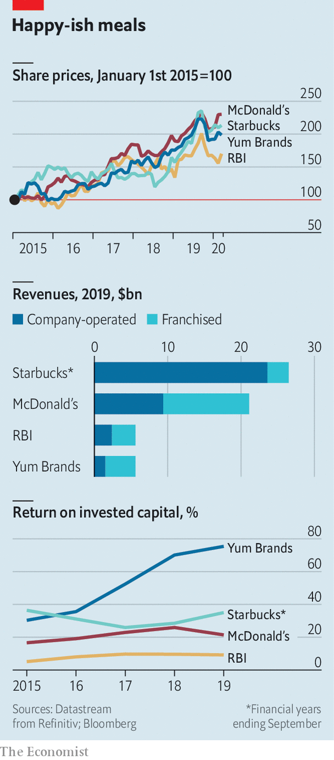

THE OWNER of Burger King had a less than royal 2019. After a sizzling start to the year Restaurant Brands International (RBI) shed a fifth of its market value between August and December. Although it earns 58% of revenues from a capital-light franchise business, a bigger slice than McDonald’s, its return on invested capital is lower, partly owing to a string of pricey acquisitions (see chart). On February 10th investors once again digested disappointing quarterly results from Tim Hortons, a Canadian doughnut chain which accounts for 60% of RBI’s sales. The group’s overall earnings beat forecasts thanks to Popeyes, another of its chains. RBI needs more spinach to catch up with rivals such as Yum Brands (owner of KFC, Pizza Hut and Taco Bell) and Starbucks—let alone McDonald’s, whose market value and net income are roughly that of the other three firms combined. ■

This article was downloaded by calibre from <https://www.economist.com/business/2020/02/15/burger-kings-owner-tries-to-regain-its-sizzle>

|  |  |  |  |
| --- | --- | --- | --- |
| Previous | Articles | Sections | Next |

|  |  |  |  |
| --- | --- | --- | --- |
| Previous | Articles | Sections | Next |

#### Hoarding cash

# Admen have a clever new way to trick sports fans

Stadium ads need no longer be one-size-fits-all

Feb 15th 2020 |



WHEN FERNANDO MARÇAL scored a risible own goal in a match against Paris Saint-Germain on February 9th, his Lyon football team’s supporters watching on television screens prayed their eyes had deceived them. And deceive them they did—just not in the way that would answer their prayers. The advertising hoardings they saw around the pitch’s perimeter were not those seen by Lyon fans unlucky enough to witness Mr Marçal’s howler in person at the stadium. The televised versions were conjured up virtually.

Virtual advertising works by placing invisible infrared signals in signs to distinguish them from other objects in the foreground. Images can then be superimposed onto them in a live TV broadcast. Viewers in Tianjin might see the logo of a local bank behind the penalty area, while those in Tijuana are tempted by a Mexican beer.

Football clubs are understandably keen. Commercial income, made up mostly of sponsorships and advertising, earned Europe’s top 20 teams €3.6bn ($3.9bn) last year. Allowing companies to tailor their pitch-side messages to specific audiences could boost this by 40%, reckons the boss of one sports-marketing company.

Last month Real Madrid appointed IMG, a sports-management company, to sell this unreal estate on its behalf. Teams elsewhere in Europe have begun to use the technology in recent seasons. So, too, have top-flight ice-hockey and basketball leagues in North America.

Tailoring ads to all tastes has limits. Too many sponsors may hurt a team’s brand, says Jean-Paul Petranca of the Boston Consulting Group. Manchester United, which raked in £173m ($224m) in sponsorships last year, has been mocked in the past for endorsing everything from bedding to instant noodles.

Still, virtual hoardings are here to stay. In the future, says James Gambrell, boss of Supponor, a supplier of the technology, sponsors could target an audience based on its demographic profile or the device or platform of choice (owners of Apple’s gadgets are generally better-off than those using Android devices).

For the time being, it can help clubs keep controversial partners while placating an irate public. Last week British bookmakers, which bankroll half of the teams in the Premier League, announced that they are considering withdrawing from advertising on the side of the pitch after vocal criticism from anti-gambling campaigners. In France Lovebet, a big gambling company that sponsors Paris Saint-Germain, uses virtual advertising to reach viewers in Asia, where placing bets is legal and popular, but not in Europe, where it is restricted in some markets. This can spare clubs plenty of jurisdictional headaches—if not blushes for blunders like Mr Marçal’s.■

This article was downloaded by calibre from <https://www.economist.com/business/2020/02/15/admen-have-a-clever-new-way-to-trick-sports-fans>

|  |  |  |  |
| --- | --- | --- | --- |
| Previous | Articles | Sections | Next |

|  |  |  |  |
| --- | --- | --- | --- |
| Previous | Articles | Sections | Next |

#### Singer-Son time

# Elliott Management guns for SoftBank

The activist investor wants the Japanese technology group to reform. Good luck

Feb 13th 2020 |



MOST BOSSES dread Elliott Management, an American activist hedge fund whose tactics the traumatised chairman of a German company once described as “psycho-terror”. After news leaked on February 6th that Elliott had taken a 3% stake, worth over $2.5bn, in SoftBank Group, a Japanese telecoms-and-tech conglomerate, its flamboyant founder, Son Masayoshi, seemed less perturbed. As he presented SoftBank’s results on February 12th, Mr Son professed to be “thankful that such a distinguished investor has joined us as a friend”. He has reason to sound welcoming. SoftBank’s languishing share price leapt by 7% on the news of Elliott’s stake.

Elliott’s main focus at SoftBank is the Vision Fund, Mr Son’s $99bn tech-investment arm. Although SoftBank’s stake in the fund amounts to only 13% or so of the group’s total gross assets, the vehicle is causing a crisis of confidence. Last year its handling of WeWork led to the scuttling of the loss-making property firm’s listing, followed by a costly bail-out. That is when Elliott began to build its stake in earnest.

SoftBank’s earnings also disappointed. Overall the group eked out only $24m of operating profit. The Vision Fund lost $2bn in the last quarter, better than the $8.9bn loss in the previous three months but far worse than the market was expecting. This month, one Vision Fund investment, an e-commerce startup from San Francisco called Brandless that received around $100m from Mr Son two years ago, became the first in the portfolio to fold. A rare bit of good news came on February 11th when an American judge approved the $26bn takeover of Sprint, a mobile operator majority-owned by SoftBank, by T-Mobile, a competitor. The merger would allow SoftBank to shed about $40bn of Sprint debt. SoftBank’s shares gained 12% the next day, though reports later surfaced that T-mobile might want to renegotiate the deal.

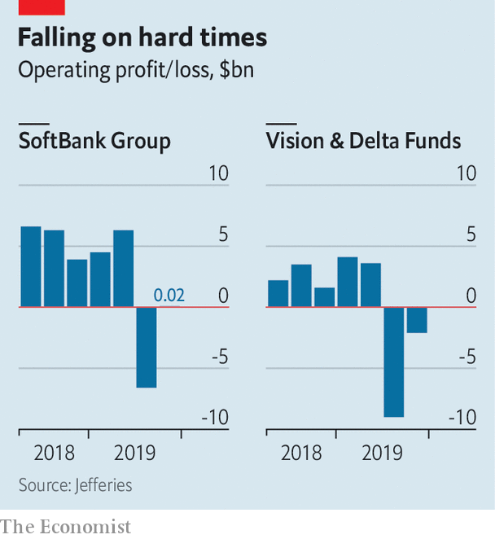

Even that leaves the firm’s market value, at ¥11trn ($104bn), well below what its assets would imply. It owns $270bn-worth of stakes in big listed companies (Alibaba, Sprint and its Japanese telecoms firm) and unlisted firms like Arm, a British chip-design firm. SoftBank is trading at a discount to fair value of around 60% after accounting for debt. To close the gap Elliott’s boss, Paul Singer, is urging the firm to buy back as much as $20bn of its shares—and to improve its corporate governance.

A buy-back is likely after the Sprint deal is complete, says Chris Lane of Bernstein, a broker. SoftBank will probably add independent directors at its shareholder meeting in June; it currently has two. Mr Son may refrain from deploying a second, $108bn Vision Fund, after it became clear that the original’s troubles put off big institutional investors. SoftBank could instead use a small bridge fund to carry on investing, Mr Son said on February 12th.

Elliott wants SoftBank to create a new board committee to guide Vision Fund investments, which Mr Son has sometimes directed with little regard to opposition from colleagues. Mr Singer could agitate for the fund to be reduced in size over time.

If SoftBank’s shares keep gaining in value, Elliott might simply cash in and exit. That would be easier than forcing the strong-willed Mr Son, who owns roughly a quarter of SoftBank, to reform. But Mr Singer is unlikely to depart without trying some of his signature psychological warfare. ■

This article was downloaded by calibre from <https://www.economist.com/business/2020/02/13/elliott-management-guns-for-softbank>

|  |  |  |  |
| --- | --- | --- | --- |
| Previous | Articles | Sections | Next |

|  |  |  |  |
| --- | --- | --- | --- |
| Previous | Articles | Sections | Next |

#### Bartleby

# Youngsters’ job preferences and prospects are mismatched

Teenage picks

Feb 15th 2020 |

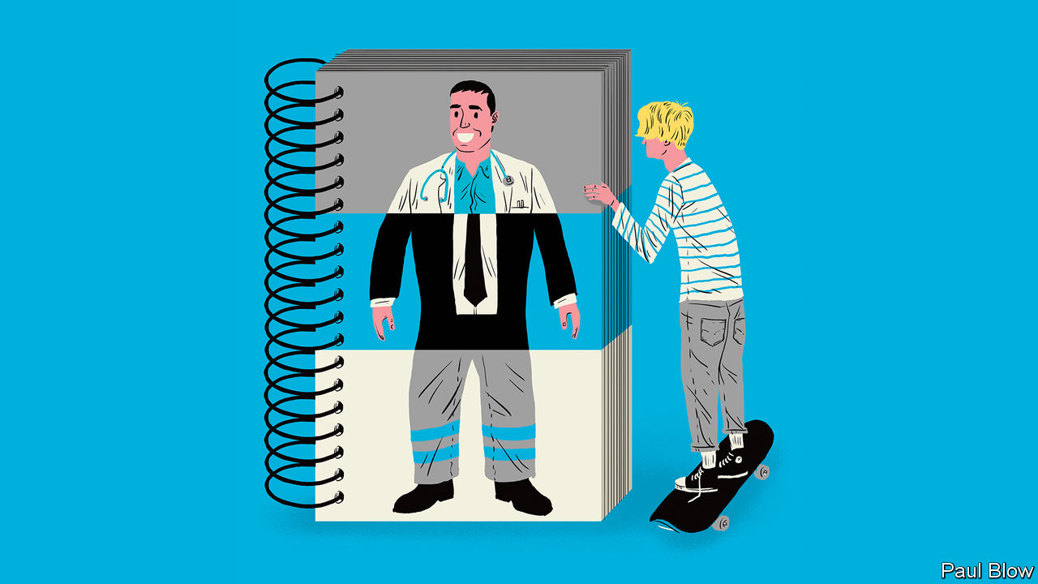

THE WORLD of work is changing. Are people ready for the new job outlook? A survey of 15-year-olds across 41 countries by the OECD, a club of mostly rich countries, found that teenagers may have unrealistic expectations about the kind of work that will be available.

Four of the five most popular choices were traditional professional roles: doctors, teachers, business managers and lawyers. Teenagers clustered around the most popular jobs, with the top ten being chosen by 47% of boys and 53% of girls. Those shares were significantly higher than when the survey was conducted back in 2000.

The rationale for this selection was partly down to wishful thinking on the part of those surveyed (designers, actors and musical performers were three of the top 15 jobs). Youth must be allowed a bit of hope. When Bartleby was a teenager, his ambitions were to play cricket for England and become prime minister; neither ambition was achieved (a lucky escape for the country on both counts).

Furthermore, teenagers can hardly be expected to have an in-depth knowledge of the minutiae of labour-market trends. They will have encountered doctors and teachers in their daily lives. Other popular professions, such as lawyers and police officers, will be familiar from films and social media. But many people end up in jobs they would not have heard of in their school years. You settle for what is available.

The OECD points out that some of the fastest-growing occupations are rarely mentioned by young people. But surely the surprise is not that “user support technician” is ranked only 158th out of 543 professions and “computer user support specialist” appears in 229th place. Rather, it is astonishing that young people know that such jobs exist at all.

At least teenagers who want to tackle climate change, as many profess to, are in luck. America’s Bureau of Labour Statistics (BLS) predicts that the two fastest-growing occupations over the next few years will be solar-photovoltaic installers and wind-turbine technicians.

Some parts of the OECD survey are disturbing. Even though top performers in maths or science are evenly matched among males and females, a gender gap persists in terms of aspiration. More boys than girls expect to work in science or engineering—the average gap across the OECD is more than ten percentage points. The problem continues in higher education; with the exception of biological and biomedical sciences, degrees in STEM subjects (science, technology, engineering and maths) are male-dominated. In America women earn just 35.5% of undergraduate STEM degrees and 33.7% of PhDs.

Things are even worse in technology. In Britain only one in five computer-science university students is a woman—a big problem at a time when the World Economic Forum predicts that technology will create more than a quarter of all jobs in newly emerging professions. But women are underrepresented in some important fields of technology; they have only 12% of jobs in cloud computing, for example. Something about the tech industry puts off female applicants.

Women play a much bigger role in the health- and social-care sectors, which are also poised for expansion. The BLS forecasts that eight of the 12 fastest-growing jobs in America over the next few years will be in those areas, with roles ranging from occupational-therapy assistants to genetic counsellors. The snag is that some of these jobs are not very well paid. Home-health and personal-care aides (with the third- and fourth-fastest growth rates, respectively) had median annual salaries in 2018 of just over $24,000.

Some jobs in health care are extremely lucrative, of course. But another gender imbalance emerges here: women make up only one-third of American health-care executives. In contrast, they tend to dominate the poorly paid social-care workforce. In Britain 83% of social-care workers are female. That suggests men shun the field, perhaps because they do not perceive caring to be a masculine trait.

The biggest problem in the labour market, then, may not be that teenagers are focusing on a few well-known jobs. It could be a mismatch: not enough talented women move into technology and not enough men take jobs in social care. Any economist will recognise this as an inefficient use of resources. Wherever the root of the problem lies—be it the education system, government policy or corporate recruiting practices—it needs to be identified and fixed.

This article was downloaded by calibre from <https://www.economist.com/business/2020/02/15/youngsters-job-preferences-and-prospects-are-mismatched>

|  |  |  |  |
| --- | --- | --- | --- |
| Previous | Articles | Sections | Next |

|  |  |  |  |
| --- | --- | --- | --- |
| Previous | Articles | Sections | Next |

#### MBAs with Chinese characteristics

# Chinese management schools are thriving

Thanks to a mixture of Western and local traits

Feb 15th 2020 | SHANGHAI

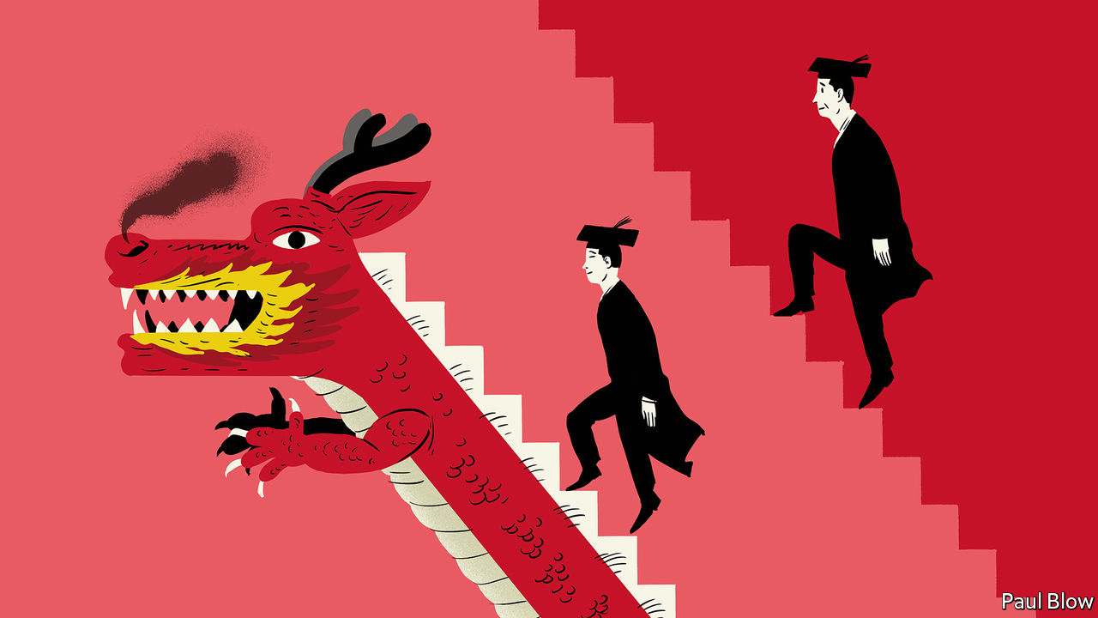

WHEN THE China Europe International Business School (CEIBS) was established in Shanghai’s Pudong district in 1994, its campus abutted mostly nondescript warehouses and tracts of marshy farmland. Today the area is among the city’s ritziest—and gives it its iconic skyline. CEIBS, too, has become something of an icon in the quarter-century since its founding as a joint venture between the European Union and the Chinese government. Last month it held on to its fifth place in the annual ranking of the world’s 100 best MBAs by the Financial Times, a newspaper. Only heavyweights such as Harvard Business School, Wharton, Stanford’s Graduate School of Business and INSEAD of France scored better.

Business education in China is booming, and not just at CEIBS. When the FT first published its list in 1999, no Asian school made the cut. This year 17 have done, nine of them Chinese. Seven Chinese institutions are among the 90 or so worldwide to boast the coveted “triple crown” of accreditations—from bodies in America, Belgium and Britain. In 2012 the American one, AACSB International, accredited 13 Chinese schools, seven of them in Hong Kong. Today it certifies 39, including 31 on the mainland (see chart). Between them, China’s home-grown business schools—not counting branches of Western ones it also hosts—offer more than 200 MBA programmes. Competition for places is fierce. Nearly 200,000 people applied last year, close to twice the number in 2016. Fewer than one in four typically get in.

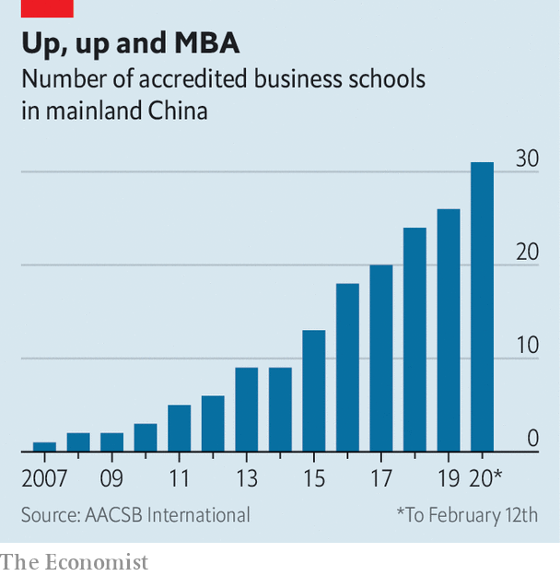

In many ways, the best Chinese business schools look a lot like their Western rivals. CEIBS has aped foreign peers like INSEAD, which has branches in Singapore, Abu Dhabi and, since last year, San Francisco, by creating satellite campuses—at home, in Beijing and the southern boomtown of Shenzhen, and abroad, in Ghana and Switzerland. Many professors possess Western experience. Chen Fangruo, dean of Antai College of Economics and Management at Shanghai’s Jiaotong University, taught at Columbia Business School in New York for 25 years before returning to China. Their classroom manner is no different from their Western counterparts’: sleeves rolled up, approachable, engaging, witty. (When, in response to a question about cost allocation in producing an MBA degree, a student suggests that staff salaries are a considerable expense, a CEIBS professor quips that “we would rather be treated as assets”.)

## Teaching to the test

Crucially, programmes have Western rigour—a must for those prized global accreditations, says Zhao Ying, who runs WhichMBA.net, a big Chinese tracker (not to be confused with Which MBA?, The Economist’s own annual ranking, which places only one Chinese school, at Sun Yat-sen University in Guangzhou, in the world’s top 100; CEIBS stopped submitting data for our list in 2016). “Our curriculum must meet international standards,” says the dean of one top institution.

Perhaps recognising this, the Communist party has allowed business schools to grow unfettered. Although, as the same dean adds, “we need to please the ministry of education”, institutions like his have been mostly spared from curbs on the use of imported textbooks which the authorities have imposed on other places of higher learning. They are not expected to teach Xi Jinping Thought, as the Chinese president’s philosophy, enshrined in the country’s constitution three years ago, is officially known. The ministry does oversee the Chinese management schools’ governing committee, which consists of 30 deans, two or three officials and a few business executives. But meetings are sporadic and contentious topics rare, according to an insider. The last big directive came down in 2014, when Mr Xi forbade bureaucrats and bosses of state-owned firms to attend “high-priced training courses” as part of a broad crackdown on graft. MBAs had previously been all the rage among party cadres.

In important ways, however, China’s management schools are growing more distinct from those in the West. This is true both in terms of what they teach and the career boost they offer.

The teaching first. In the past, Chinese students saw an MBA as a path to joining a foreign company and launching an international career. No local firm was prepared to pay the salary a good MBA commanded. Now China Inc has become “global, richer and ready to recruit our students”, says Ding Yuan, dean of CEIBS. Roughly half of full-time MBAs from CEIBS join Chinese firms. Some go on to Chinese companies that have either recently expanded abroad or acquired a foreign business. Others are young heirs taking charge of family firms as the country’s first generation of entrepreneurs retires. These have often gone to university in the West and want to “recharge themselves” in China, in Mr Ding’s words. The last big group are bosses who missed out on a business degree in their youth. CEIBS has 700 of these enrolled at its MBA for active executives, compared with around 170 students for its regular MBA course—inverting the proportions typical at Western schools. Applications for its English-language Global Executive MBA are growing by 20% a year.

Courses cater to this Sinocentric student body. At Antai some professors use ancient Chinese texts (and not just Sun Tzu’s “The Art of War”) to teach their own brand of management theory. Marxism, which many schools still include among their foundation courses, is used as a way to tell students how to navigate capitalism with Chinese characteristics. Schools do not offer explicit modules on relations with the government, which still dominates the commanding heights of China’s economy. Few students, many of whom are in their mid-30s, with a startup or two under their belt or some other real-world experience, think that would be useful. As entrepreneurs, they know far more about dealing with officials than any professor can. But they are still keen to learn how to make the most of regulations. This “policy dividend”, as one prominent dean calls it, is “embedded in everything that we teach”.

Not all divergences from Western MBAs are so subtle. Mr Chen is changing Antai’s syllabus to organise courses by industry—with modules on fintech, health care, self-driving cars and other thriving Chinese industries—rather than by discipline (accounting, marketing and so on), as in the West. CEIBS’s Beijing campus is located in the capital’s Zhongguancun district, which is China’s answer to Silicon Valley.

Above all, students want professors to teach case studies on home-grown firms, not some “old Southwest Airlines case”, Mr Ding explains. “It’s even worse if you bring up GE.” Instead, they want to know how Western theories apply to China’s buzzy native firms. Schools are churning out new local cases about firms such as Ichido, a 20-year-old bakery chain, or Luckin Coffee, a Starbucks wannabe set up in 2017. CEIBS leads a consortium of a dozen or so Chinese institutions aimed at creating common criteria to write them.

## Wealth management

Like MBA students everywhere, Chinese ones expect the degree to confer advantages besides pure knowledge. One is a boost to career prospects. Graduates of Western schools typically double their pre-MBA pay. Antai and Fudan University’s School of Management, also in Shanghai, triple it (albeit from a lower base and adjusted for living costs). Both boast near-perfect job-placement rates. CEIBS runs a course for corporate human-resources managers on how to make the most of their graduates.

Many business schools now also run startup incubators to help students with a clever idea for a business. Some graduates co-found startups. Fellow alumni also benefit from the schools’ unusually close ties to China’s leading entrepreneurs. A stamp of excellence from a leading school is a good way to impress deep-pocketed domestic investors. A Chinese MBA has become “one of the real secrets of entrepreneurs’ success”, observes Rupert Hoogewerf, compiler of the Hurun Rich List, a Who’s Who of the ultra-wealthy.

A chance to rub shoulders with captains of China’s private sector is a big draw even for seasoned executives. Ye Kai, a serial entrepreneur from Shanghai who runs a restaurant chain and a group of urban ski schools, and who attended an executive MBA in the late 2000s, says he still meets up with old classmates every other month.

CEIBS claims to have the “largest and most prestigious network” of alumni in China—over 22,000, including more than 3,000 chief executives. Among them are Dong Mingzhu of Gree, a maker of air-conditioners, and Richard Liu of JD.com, a big e-merchant. In Beijing the Cheung Kong Graduate School of Business, founded in 2002 by Li Ka-shing, Hong Kong’s richest tycoon, claimed in 2016 that former students ran one-fifth of the 103 Chinese firms then in the Fortune Global 500 list of the world’s biggest corporations by revenue. They included Jack Ma, the now-retired boss of Alibaba, China’s e-commerce titan and its largest listed firm. The local press has dubbed the school “the rich club”. Members certainly enjoy rich benefits. Jia Yueting, founder of LeEco, an indebted tech giant, was able to rustle up $600m from about a dozen classmates in 2016.

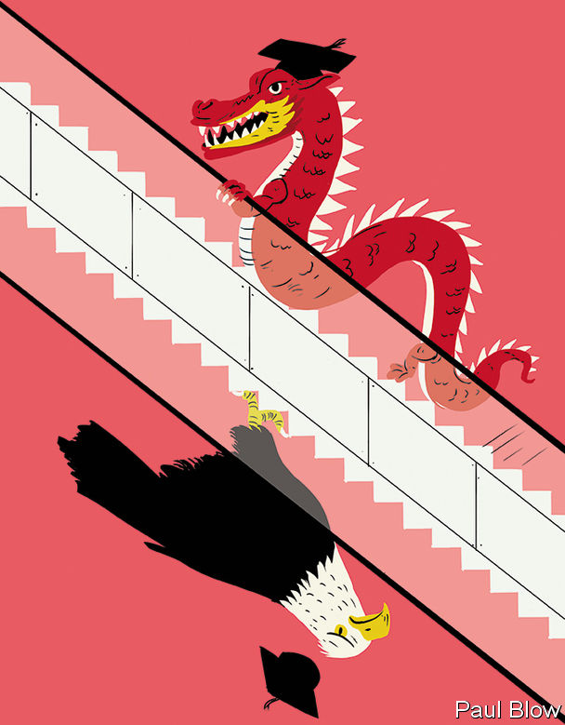

But graduates say that the network’s true value lies in the intangible perks that other groupings do not offer. “In the classroom entrepreneurs are allowed to be weak, and nobody will look down on them,” explains Ms Zhao of WhichMBA.net. “Classmates tell you the truth.” Mr Ye thinks that, in terms of trust, it has no equivalent in China’s business world. Members swap inside details which they would normally never share, he says. After-hours get-togethers can be especially useful to compare notes on delicate subjects like dealing with officials or state-run firms. There is “no textbook to manage this kind of relationship”, says Mr Ye.

Given all these blessings, going abroad for an MBA is increasingly seen as a “huge opportunity cost” by Chinese students, says Mr Chen. In some sectors it can be a liability, by keeping them out of China’s fast-changing market for too long. Henry Zhan, a 29-year-old manager at Fangduoduo, a booming online service connecting homebuyers and sellers, chose CEIBS over top American schools because of its ranking and popularity among Chinese property moguls (including Fangduoduo’s founders). He thinks CEIBS’s 428,000 yuan ($60,000) tuition fee, excluding a monthly boarding fee of $400, will be a better investment than Columbia Business School, which he also considered, and which would set him back well over $100,000.

## Luring laowai

Foreign students are taking note. Even as international applications fell at seven out of every ten American business schools in 2018—in part because of stricter visa requirements—Asian schools reported a 9% rise in the number of applicants. Demand has risen for immersive Chinese modules taught in China itself. CEIBS recently educated a crop of South Korean executives from Hyundai, Japanese ones from Toyota and French from Michelin and Total. Already over a third of its MBA students are foreign. Rose Luo of INSEAD (which opened a campus in Singapore in 2000) says that several Western schools have enhanced their offerings with double degrees, popular with domestic and overseas students alike—and boosted the prestige of their Chinese partners. She runs one in Beijing, at Tsinghua University’s School of Economics and Management.

The chasm in quality between China’s most prominent schools—Tsinghua’s counts the bosses of Tesla, Microsoft and Facebook among its board members and, since last year, Tim Cook of Apple as chairman of its advisory committee—and its dozens of hangers-on is much wider than in the West, Ms Luo notes. Those unable to get into the best Chinese schools may prefer a decent one abroad. Some of the most ambitious executives at Chinese firms going global will still often plump for a renowned Western institution. But with the rise of CEIBS, Tsinghua, Antai and others, the decision is no longer the no-brainer it once was.■

This article was downloaded by calibre from <https://www.economist.com/business/2020/02/15/chinese-management-schools-are-thriving>

|  |  |  |  |
| --- | --- | --- | --- |
| Previous | Articles | Sections | Next |

|  |  |  |  |
| --- | --- | --- | --- |
| Previous | Articles | Sections | Next |

#### Schumpeter

# American state capitalism will not beat China at 5G

The Qualcommunist manifesto

Feb 15th 2020 |

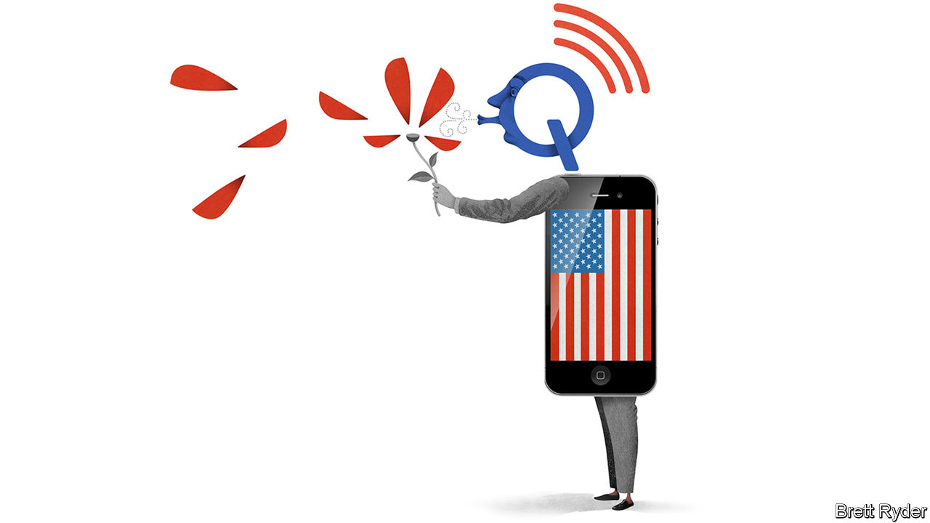

IF IMITATION IS the best form of flattery, one can only imagine the mandarins in Beijing blushing bashfully on February 6th as they eavesdropped on William Barr, America’s attorney-general, firing the latest shots in the tech cold war. One of America’s main concerns, he told a think-tank in Washington, DC, was Chinese dominance of fifth-generation (5G) wireless technology by Huawei. It had achieved this with totalitarian central planning. “As a dictatorship”, he said, “China can marshal an all-nation approach—the government, its companies, its academia, acting together as one.”

Mr Barr’s response to this threat? Central planning, also involving the state, business and academia, but in support of American goals, not Chinese ones. He said America and its allies should decide which “horse we’re going to ride in this race”. That might mean, he went on, that America’s government or its companies should buy controlling stakes in Huawei’s European rivals, Finland’s Nokia, Sweden’s Ericsson, or both—despite there being no precedent for such a move (at least one that does not involve covert operations). It also meant public and private sectors standing shoulder to shoulder against China’s technological blitzkrieg.

Call it state capitalism, American-style. In full 5G panic, President Donald Trump’s administration wants to co-opt not just other countries’ national champions, but domestic ones, too. One focus of attention is Qualcomm. The company, which is based in San Diego and worth $103bn, is among the world’s biggest 5G chipmakers. In 2018 it received unusual government support, when Mr Trump blocked its takeover by Broadcom, then a Singapore-based rival, on national-security grounds. As The Economist went to press on February 13th, it was due a second round of state-backed reinforcement, this time in a San Francisco courtroom where it is appealing against a landmark antitrust verdict. Its backer was Mr Barr’s Department of Justice (DoJ).

Qualcomm’s relations with the government reveal a lot about the way America is fighting the battle for global supremacy in technology. The Trump administration has two main national-security concerns about 5G. The first revolves around the public telecoms networks. It worries that kit installed by Huawei, which boasts a 30% market share in 5G and is in most places bar America, could be used for surveillance. Huawei insists it will never be. But news reports this week said American officials believe it can access mobile networks via “back doors” meant solely for law enforcement. Nokia and Ericsson are among the next-biggest makers of 5G kit but they lack Huawei’s financial firepower. A deep-pocketed American rival like Qualcomm or Cisco could in principle bolster their balance-sheets. But they show no appetite for building fiddly, low-margin 5G networks.

The government’s second worry is about micro-industrial networks, which is where Qualcomm could play a role. The administration argues that within five years 5G could become the backbone of a vast economic system in which everything from cars to factories to fridges seamlessly streams limitless information. It fears that a dominant China could jam them, monopolise them or suck up all the data they produce for its own artificial intelligence. Qualcomm hopes its modems used in 5G devices, and the licences on its patents, will enable customers around the world to build a web of private 5G networks in this “industrial internet”. But it will have to remain competitive against Huawei, which also makes modems and licenses technology.

So far Qualcomm’s bets on 5G have been ahead of the competition. But its ambitions have been undermined by repeated allegations that it is a monopolist. It was in court this week appealing against an antitrust verdict in a case brought by the Federal Trade Commission (FTC) under Barack Obama. The FTC took aim at a lucrative licensing model that 5G could further strengthen. It is a sign of the Trump administration’s alarm about Qualcomm’s future that the DoJ, supported by the Pentagon and the Department of Energy, is throwing its weight behind the firm’s appeal—on national-security grounds. Hence the strange spectacle of two trustbusting agencies battling each other in court.

The DOJ’s backing may bolster Qualcomm’s case. Much of the national-security argument, though, is rather nebulous. The DoJ argues that a verdict against Qualcomm forcing it to renegotiate its licence fees with customers could hit profits and hamper its ability to innovate, which would put America itself at risk. Yet the lack of competition could be a bigger threat to innovation.

The case highlights a deeper question about America’s approach to 5G. How urgent is it to reduce China’s technological lead? Some advise patience, and think much of the hysteria is a veiled justification for protectionism. At present, 5G capabilities are little different from superfast 4G, and as yet the applications do not exist to make the most of the industrial internet. There is still time for experiment and innovation. Alternatives to Huawei’s hardware-heavy, vertically integrated networks are emerging. Companies in America, Europe and elsewhere are using their strengths in software to build virtual networks that are more open and decentralised. Qualcomm is eyeing such opportunities hungrily, and plans to sell chips for virtualised 5G networks as well as devices.

## Chip on the shoulder

Mr Barr, who has mixed a career in government with one in telecoms, argues that all this would take too long to counter the clear and present threat from China. The message is unambiguous. If only America could play by China’s rules, subsidising domestic champions and hobbling foreign rivals, it could win in 5G. That is a counsel of despair. Qualcomm and other firms may happily lap up government support. They would benefit, too, from an overdue infrastructure upgrade. But ultimately America’s greatest industrial strength is its freewheeling spirit. Rewriting the rules of American capitalism with Chinese characters would not help that at all.■

This article was downloaded by calibre from <https://www.economist.com/business/2020/02/15/american-state-capitalism-will-not-beat-china-at-5g>

|  |  |  |  |
| --- | --- | --- | --- |
| Previous | Articles | Sections | Next |

|  |  |  |
| --- | --- | --- |
| Business | Sections | Science and ... |

Finance and economics

Real estate in America: Tearing down the house

.

The International Monetary Fund: Structural adjustment

.

The World Bank: The Goldberg variations

.

Sustainability-linked debt: Green paper

.

African currencies: Value judgments

.

Buttonwood: Eyeing the storm

.

Free exchange: Trickle-up economics

.

|  |  |  |
| --- | --- | --- |
| Business | Sections | Science and ... |

|  |  |  |  |
| --- | --- | --- | --- |
|  | Articles | Sections | Next |

#### Tearing down the house

# Technology is poised to upend America’s property market

At long last, the world’s biggest asset market will be shaken up

Feb 15th 2020 | DALLAS, LOS ANGELES AND SEATTLE

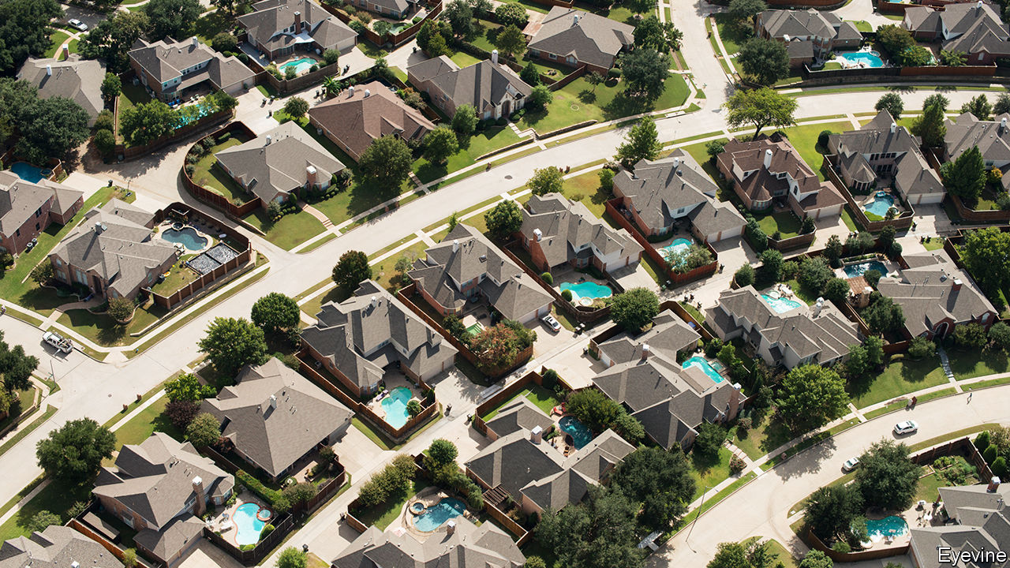

FROM FAR enough away most houses look the same. At cruising altitude over Dallas, Los Angeles and even much of New York, most dwellings are nondescript: beige- or grey-roofed, laid out in neat patterns. In sunnier climes the monotony is punctuated by the bright turquoise oblongs of swimming pools. When it comes to valuing a home, though, the details matter. The site, square footage, number of rooms, the finishing and a thousand other factors determine whether a home is worth $200,000 or $2,000,000.

For this reason real estate has long been a fragmented, local market. There are 2m estate agents in America, according to the National Association of Realtors (NAR), just over 1% of America’s workforce. An agent does a number of tasks—appraising houses, marketing properties, organising tours—for a handful of transactions each year. An agent might dominate the market in a single neighbourhood—a few streets in Beverly Hills, say. But zoom out to Los Angeles and its sprawling suburbs and his market share quickly drops to nearly zero.

Real estate is the biggest asset market in the world. The value of residential property in America—at around $34trn—rivals the market capitalisation of all listed American companies. Throw in commercial and retail property, together worth around $16trn, and its value easily eclipses that of public firms. For decades the market has been characterised by low volumes and extortionate transaction costs (see charte). Just 7% of American homes change hands each year. Homeowners traded property worth $1.5trn in America in 2019, forking over some $75bn in commission to agents, or around 0.4% of GDP. The fees for trading many other financial assets pale in comparison. Around $40trn-worth of stocks are traded annually in America. The fees paid by institutional investors to brokers have halved from their peak, to less than $10bn.

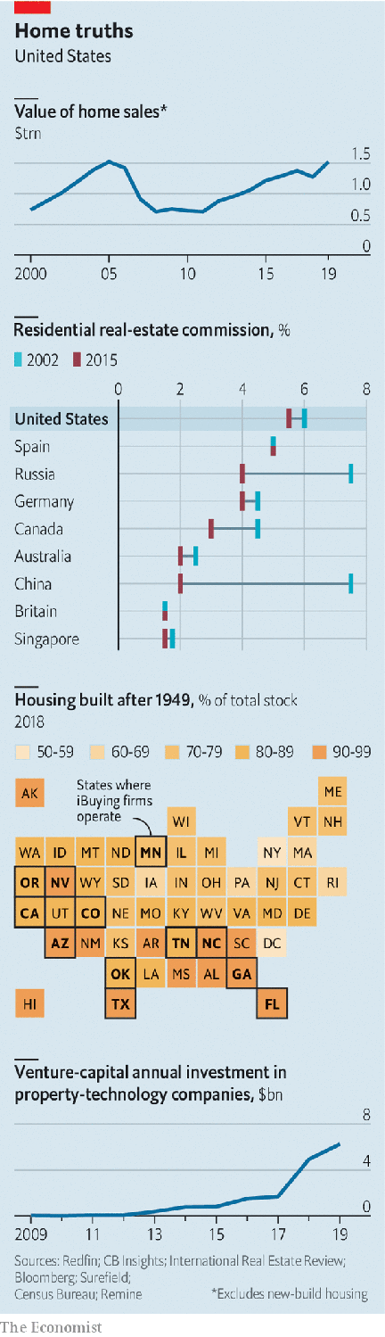

On top of the brokers’ fees paid to sell a home in America, which amount to 5-6% of the price, other levies—government taxes, mortgage fees—mean that the total cost of moving exceeds a tenth of the price. The expense could help explain why owners are staying in their homes for longer. In the 1950s, 20% of households in a county moved each year. Today 9% do.

This antiquated model is on the verge of being disrupted. In America rules on commissions and data-sharing have so far kept fees higher than in other rich countries. But now regulators and courts are considering again whether practices in the real-estate industry are anticompetitive.

Technology also promises to make moving home quicker, easier and cheaper. As recently as 2012 venture capitalists invested just tens of millions of dollars in property technology, or “prop tech”, each year. By 2019 that had climbed to $6bn. The four biggest prop-tech firms, Compass, Opendoor, Redfin and Zillow, have a combined valuation of $23bn. These offer a range of services, from online listings to tools that make estate agents more productive. Some act as “intermediate buyers”, making cash offers to sellers to speed up the process of homebuying.

Technology has already transformed other big asset markets. Fifty years ago trading company shares was opaque, illiquid and expensive. Ray Dalio, who worked on the trading floor of the New York Stock Exchange in the early 1970s before founding Bridgewater Associates, now the world’s largest hedge fund, bemoans practices that were once considered normal. “Dealers had to entertain fund managers, and no one would know what the prices were.” But technology has taken over more and more aspects of trading. Today markets are transparent and liquid. Transaction costs are close to zero.

The market for houses is structurally different from that for stocks. Every share of Microsoft is identical, but no two homes are exactly alike. Emotion plays a bigger role in the decision to move house. Most buyers and sellers are links in a chain. Two-thirds of Americans selling a home are also looking to buy another. A delay at one point in a chain holds up transactions all along it.

But these difficulties cannot justify the fees Americans pay. Fees across the much of the developed world have fallen, thanks to the entry of online platforms that allow would-be buyers to search for properties themselves. American brokers argue that they provide a more holistic service than estate agents elsewhere. But a bigger factor may be the network effects associated with the multiple-listing service (MLS) through which nearly every broker lists and searches for homes, and the NAR, the industry association that regulates it.

All agents that are registered with the NAR must post their listings to the MLS in return for access to other listings. The convention in the industry is for sellers to pay the buyer’s broker, with the listing specifying the fee. Maisy Wong of the Wharton School of the University of Pennsylvania finds that brokers steer buyers away from properties that offer less than 3% commission, keeping fees high.

This used to prevent online platforms from allowing buyers to search for properties, because agents could opt out of having their listings posted on other brokers’ websites. But in 2008 the Department of Justice (DOJ) ruled that MLS listings data could not be restricted this way, and should be shared with online platforms. Zillow and Redfin now publish MLS listings. But commission norms still make it hard for “discount” brokerages to get a footing. Purplebricks, a British company that expanded into America in 2017, offered to sell homes for a fee of around $4,000 regardless of price. After two years of making losses, it withdrew. REX, a brokerage founded in 2015, will return half of the fees it collects to the buyer. But such rebates are illegal in many states.

Disgruntled home-sellers have mounted class-action lawsuits against their estate agents for anticompetitive behaviour. They want to cut the ties between buying and selling fees, arguing that they are forced into paying inflated fees for buyers’ brokers. The DOJ is also investigating anticompetitive practices in the industry. It is looking into whether brokers can search listings by commission rates.

## The new middlemen

A better comparison for real estate might be the market for bonds rather than shares. Bonds vary by tenor (the length of time till they fall due) and coupon (interest) rate. That makes matching buyers with sellers harder. To create liquidity, institutions such as investment banks act as intermediaries, holding an inventory of corporate bonds and guaranteeing to buy from or sell to clients at any time. Fees are a little meatier than those paid to trade stocks—but still much lower than real-estate commissions.

Similarly, intermediaries known as instant buyers, or “i-buyers”, are muscling into the property market. Opendoor, founded in San Francisco in 2014, now operates in more than 20 cities. Zillow and Redfin began i-buying in 2018.

These firms use vast quantities of data and whizzy machine-learning algorithms to appraise homes and make an initial offer, often within hours of a seller asking for one. A couple in Covina, in greater Los Angeles, requested an offer from Zillow on Christmas Eve 2019, had their home inspected on December 26th and accepted the bid the next day. They chose to set a closing date in March 2020, but could have opted for December 28th. Once they move Zillow will sell the house on—often within 30 to 90 days. The fee is typically around 6-7%, almost the same as a seller would pay an agent—but for a much quicker and easier process. Knock, another prop-tech firm, follows a different model, buying a new home for a homeowner and selling the old house once they have moved.

At the national level, i-buyers are still small. They bought 60,000 homes worth $8.9bn in 2019, or around 0.5% of transactions. But in the 18 markets in which they buy, their share is 3%. It is even higher in places like Phoenix, Arizona and Raleigh, North Carolina, where i-buyers have operated for several years.

Some markets are better suited to i-buying than others. The model works best when homes are new and homogenous. Parts of the suburbs of Dallas are packed with cookie-cutter houses. These are easy to price, because it is likely that a similar house has sold recently. Two identical homes built next door to each other in 2010 can only be a little different. By contrast, adjacent Brooklyn brownstones built in the 1920s could be entirely different beasts. Some markets might be too idiosyncratic for i-buying, says Sean Black of Knock. Prices jump in Palo Alto, a town south of San Francisco that is popular with tech workers, when a large company goes public. Loft apartments in Tribeca, a neighbourhood in Manhattan near the downtown financial district, soar in years when banker bonuses are fat.

Alex Rampell of Andreessen Horowitz, a venture-capital firm that has invested in Opendoor, says i-buyers create a pool of liquidity, allowing investors keen to buy rental properties to do so at scale. “Institutional investors buy to achieve a certain rental yield, so they are less sensitive to price uncertainty.”

The success of i-buyers also depends on whether their algorithms get the price right. The most important factor is location, says Bridget Frey of Redfin. It interacts with other factors, too. “You need location to tell the algorithm what weight to put on the thousands of other variables you might look at.” Swimming pools add value in San Diego but tend to decrease it in New Jersey. In Atlanta proximity to a golf course is highly prized. Before Zillow launched there a worker traced every golf course on Google Maps, so that it could be added as a variable. For years Rich Barton, Zillow’s founder, found it odd that the algorithm assigned a negative value to extra bedrooms. “It seemed backwards. But once you’ve factored in square footage, extra rooms actually deduct from the value of a house.”

The process is not entirely devoid of human input. At Zillow’s offices in Seattle a group of youthful workers spend their days on Google Maps zooming in on pictures of houses that sellers have requested prices for, verifying that nothing looks too out of the ordinary. Ms Frey would like to get to a point where the algorithm beats the human. But at present Redfin also uses agents to conduct home inspections, and defers to them if their assessment differs from that of the algorithm.

The bosses of the teams building the algorithms all talk about their “buy-boxes”. Rather than buying the most expensive or the cheapest homes in any neighbourhood, they prefer the 60% or so in the middle. They find it easier to provide an offer for average homes with confidence; over more unusual homes there tends to be greater uncertainty. And the more uncertainty, the lower the offer they might have to make—if they make one at all. “We sometimes can’t quite figure out why that particular home is so much cheaper or more expensive than the rest,” says Stan Humphries of Zillow.

That said, where i-buyers do operate, they seem to get close to offering fair value. Research by Zillow finds that, when sellers decline the firm’s initial offer, their eventual sale price is only 0.2% different. An independent study by Mike DelPrete of the University of Colorado found that, on average, the offers made by Zillow and Opendoor were 98.6% of the price that standard industry models suggest, implying a 1.4% discount compared with the market.

Getting value right is critical to how the model works, says Glenn Kelman, the boss of Redfin. “If we start buying homes cheap, or trying to fix them up too much, our business will start to be valued like a real-estate investment firm. That is the opposite of what we want.” Tech firms tend to trade at higher valuations than property investment companies. I-buyers say they are in the business of providing convenience and liquidity, not flipping homes for profit.

A big question, though, is whether i-buying can be profitable. None of them yet make any money. Zillow’s home-buying business spends $1.40 for each $1 of revenue it receives. The firm makes most of its revenue selling leads on buyers to agents it is partnered with.

## Free agents

Other innovations are nibbling away at the many other tasks that estate agents do. Redfin and Opendoor use remote electronic locks, which can let buyers into a home by themselves. Your correspondent let herself into a lovely two-bedroom flat in Santa Monica using Redfin’s app. Had she wanted to buy it, she could have done so without consulting an agent, by filling out an offer form on the app.

But not all of the biggest prop-tech companies in America are betting on estate agents becoming redundant. Redfin’s focus is on lowering agents’ costs. Sellers who list their home with Redfin pay commission as low as 1%, instead of the usual 3% (though sellers must still pay traditional commission rates to the buyers’ broker).

Compass, which was founded in 2012 and is now worth more than $6bn, is the most focused on helping agents. Its tools take the drudgery out of their work, in order to make them more productive. Its platform for agents analyses the best time to list properties and automatically sends them listings their buyers might like. Robert Reffkin, its founder, claims that agents who use Compass make more deals. “If Compass fails it is because my faith in the role of the agent is misplaced.”

Lower fees, therefore, need not mean a big hit to agents’ pockets. They might boost productivity. They could encourage people to move house more often, offsetting the fall in fee rates. Clients, meanwhile, would undoubtedly benefit. People rank buying a home second only to divorce as the most stressful time of their lives. If it becomes a little less so, and cheaper into the bargain, that would be a welcome change. ■

This article was downloaded by calibre from <https://www.economist.com/finance-and-economics/2020/02/15/technology-is-poised-to-upend-americas-property-market>

|  |  |  |  |
| --- | --- | --- | --- |
|  | Articles | Sections | Next |

|  |  |  |  |
| --- | --- | --- | --- |
| Previous | Articles | Sections | Next |

#### An adjustment programme

# The IMF undergoes structural reform

Kristalina Georgieva makes her mark

Feb 15th 2020 | WASHINGTON, DC

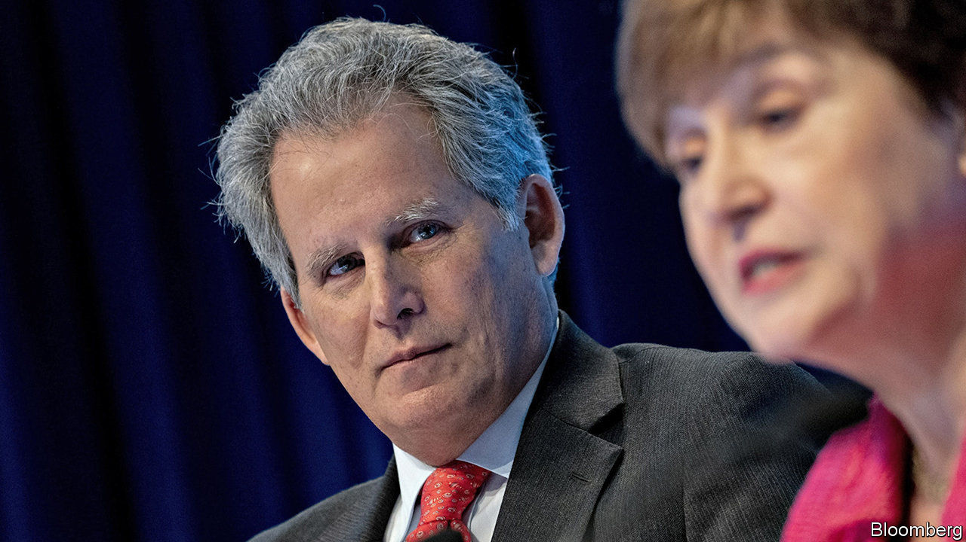

THE IMF is familiar with unwelcome edicts. Its job as the world’s lender of last resort often involves demanding reform. But its staff may be discovering the unpleasantness of being on the receiving end. Kristalina Georgieva, the fund’s boss, is reorganising the institution.

Ms Georgieva took over as the IMF’s managing director in October 2019 on a wave of good publicity. As the first boss from an emerging market, she regaled audiences with her own experiences of an IMF programme—in the 1990s she saw hyperinflation in Bulgaria wipe out her mother’s savings in a week.

She arrived with a reputation for being able to manage large bureaucracies, having previously been chief executive officer of the World Bank. A few months in, she has managed two senior deputies out. On February 7th she announced that David Lipton, the first deputy managing director, and Carla Grasso, another deputy managing director, would leave at the end of the month.

Mr Lipton’s reputation for diligence and technical expertise meant that the news of his early exit—his term had been due to end in August 2021—was not well received by staffers old and new. A rumour swirled that his departure was a ploy by President Donald Trump’s administration to choose his successor. By convention, America appoints the first managing director.

In fact it seems that Mr Lipton’s departure was Ms Georgieva’s doing. Her predecessor, Christine Lagarde, had been content to be the IMF’s public face while Mr Lipton handled much of the day-to-day management. Ms Georgieva, though, is a more hands-on manager, making Mr Lipton’s role, as currently defined, redundant. And so he went. Ms Grasso, whose renewed term had started only five days before her departure was announced, is leaving partly because her job is, unusually, one for which Ms Georgieva can pick a successor.

That would allow her to nominate someone to help realise her vision for the fund, which includes doing more to help fragile states and tackling climate change. In her first speech as the fund’s chief, she called for governments to enact domestic reforms that achieve “stronger and more resilient growth”, and for those with remaining fiscal firepower to deploy it. She has promised to collaborate more with the World Bank, particularly regarding countries that have received the fund’s help. Ms Georgieva may want to remove the impression that theIMF cares only about restoring stability to crisis-ridden countries at the expense of jobs and growth.

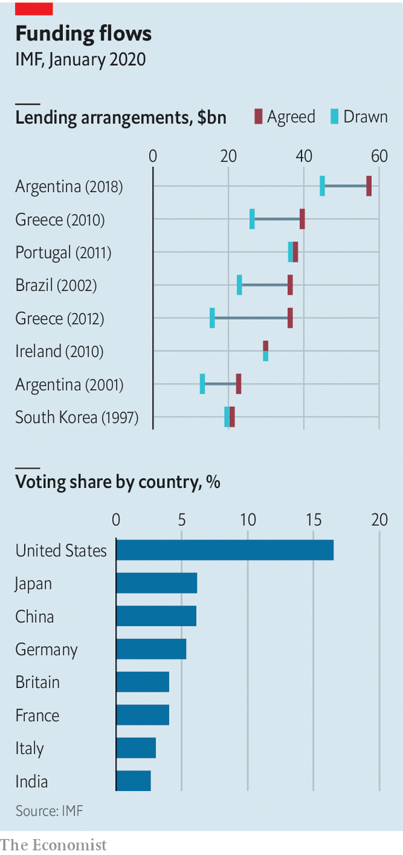

It is hardly unusual for new bosses to make management changes, including at the fund. It could benefit from a shake-up that flattens its hierarchical management structure. Its policies could also be improved. Its programmes sometimes crimp growth, such that countries miss its rosy GDP forecasts. Its engagement with fragile states can be lacklustre.

The risk, though, is that Ms Georgieva’s reforms backfire. If she wants the most able staff to work on fragile states, she will have to butter them up. Mr Lipton’s departure means one fewer set of capable hands to help in a crisis. Some fear that without him there will be an increase in “clientitis”—country directors being too soft when demanding reforms. One near-term challenge is Argentina, the recipient of the fund’s biggest ever loan (see chart). On February 12th fund officials began talks with the government, which is seeking to restructure its debt.

There are also concerns that Mr Lipton might be replaced by someone less capable. The Trump administration has resisted the idea that Mr Lipton’s job be abolished altogether. It is floating the name of Geoffrey Okamoto, an acting assistant secretary of the Treasury, as a potential replacement. For Ms Georgieva’s strategy to work, she needs someone pliable in the role. But if they are too weak, the institution could eventually suffer.

Ms Georgieva still needs to convince some fund-watchers that she is updating its mission not diluting it. New ambitions require resources—or a sense of which old tasks will be cut to make way for new ones. Structural reforms need not do damage. But they should be enacted with care. ■

This article was downloaded by calibre from <https://www.economist.com/finance-and-economics/2020/02/15/the-imf-undergoes-structural-reform>

|  |  |  |  |
| --- | --- | --- | --- |
| Previous | Articles | Sections | Next |

|  |  |  |  |
| --- | --- | --- | --- |
| Previous | Articles | Sections | Next |

#### The Goldberg variations

# The World Bank loses another chief economist

Penny Goldberg leaves after only 15 months in the job

Feb 15th 2020 | HONG KONG

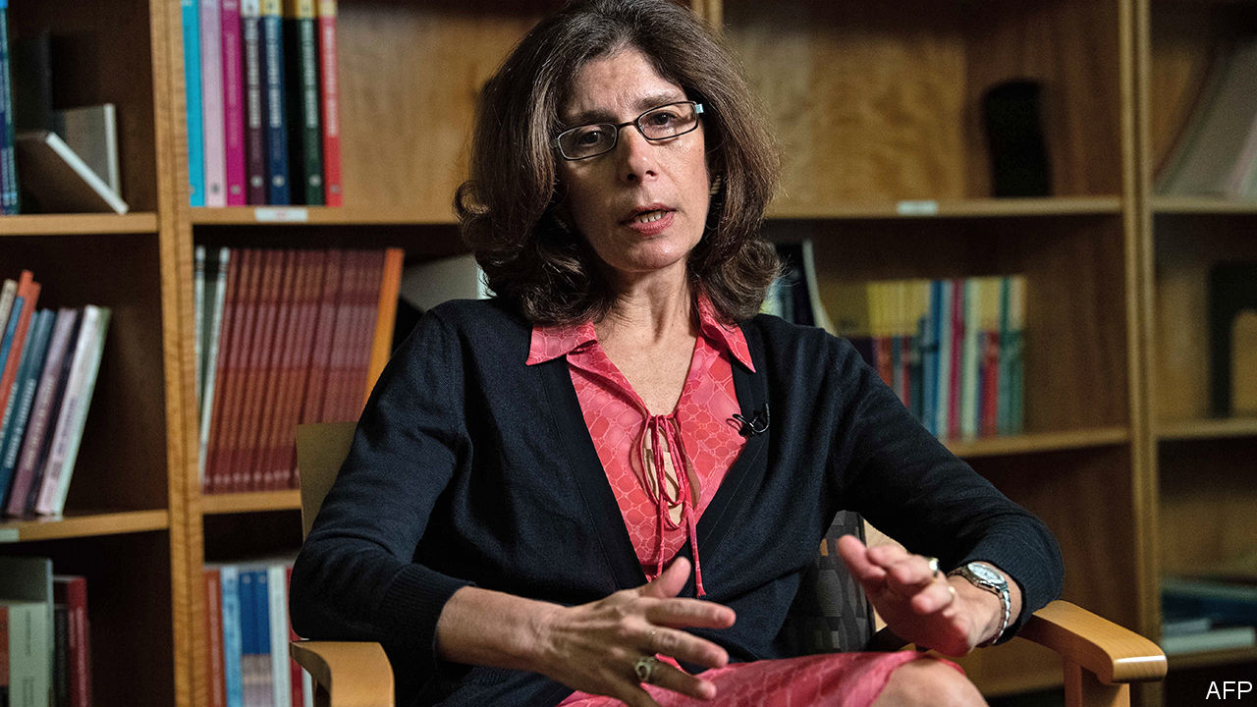

WHEN AUTOCRATIC, oil-rich nations enjoy a windfall from higher crude prices, where does the money go? One place to look is Swiss bank accounts. Sure enough, an increase in oil prices is followed by a spike in deposits held by these countries in financial havens, according to a 2017 paper by Jorgen Juel Andersen of BI Norwegian Business School, Niels Johannesen of the University of Copenhagen and their co-authors.

When Mr Johannesen presented this result at the World Bank in 2015, the audience included Bob Rijkers, a member of the bank’s research group. The two of them joined forces with Mr Andersen to investigate if something similar happened after another kind of windfall: infusions of aid from foreign donors. Their conclusion was dispiriting. World Bank payouts to 22 aid-dependent countries during 1990-2010 were followed by a jump in their deposits in foreign financial havens. The leaks averaged about 5% of the bank’s aid to these countries.

Mr Rijkers is part of a unit that reports to the bank’s chief economist, Pinelopi (Penny) Goldberg. The team publishes working papers on the understanding that their views do not represent the bank’s. But Mr Rijkers’s collaborative effort, which was leaked to The Economist, is not yet among them. It passed an exacting internal review by other researchers in November. But, according to informed sources, publication was blocked by higher officials. They may have been worried about how it would look if the bank’s own researchers said that a chunk of its aid ended up in Swiss bank accounts and the like.

The bank insists a final decision on publication has not been made and that it still has legitimate concerns about the paper. A correlation between aid disbursements and offshore deposits is not proof of causation. And the 5% of “leaks” might include some innocent money, earned by aid contractors who just happen to prefer offshore havens to other financial centres. But the paper had already answered similar objections in the review process.

The integrity of the bank’s research is meant to be safeguarded by its chief economist. The position is typically filled by a well-regarded academic, who has both an external reputation to protect and the internal clout to defend their turf. The job was, however, split in 2017 when Paul Romer, a star economist with little managerial finesse, was relieved of his bureaucratic duties. (He then left the job altogether after only 15 months in the role.) Ms Goldberg was given more managerial power than Mr Romer ended up with, but less than he started with.

This month she said she would be returning to Yale in March, after only 15 months in the job. Her reasons were unclear. A reorganisation of the bank may have been a factor, including the imminent arrival of Mari Pangestu, who will assume oversight of Ms Goldberg’s unit, in an effort to align research more closely with the bank’s country operations. Ms Goldberg may have come to feel that the position carried too much of a managerial burden, but too little power to rule her fief.

But it is also possible that the bank’s decision to block one of her team’s papers grated on her. After aid to a country spikes, money departs for offshore havens. And after a sensitive paper is spiked, Penny departs for New Haven. In both cases, correlation is easier to prove than causation.■

This article was downloaded by calibre from <https://www.economist.com/finance-and-economics/2020/02/15/the-world-bank-loses-another-chief-economist>

|  |  |  |  |
| --- | --- | --- | --- |
| Previous | Articles | Sections | Next |

|  |  |  |  |
| --- | --- | --- | --- |
| Previous | Articles | Sections | Next |

#### Green paper

# Companies are tying their loans to measures of do-goodery

Sustainability-linked loans now accounts for a quarter of green-debt issuance

Feb 15th 2020 |

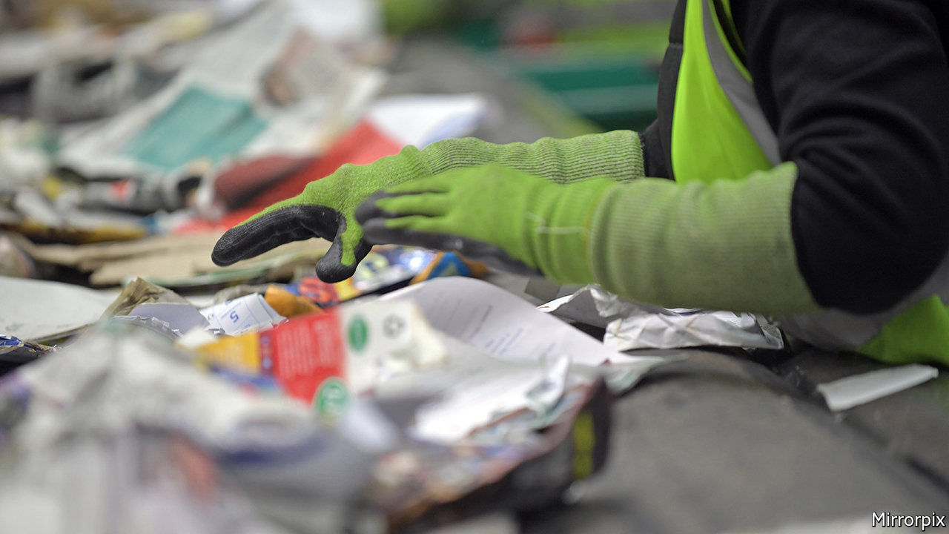

EARLIER THIS month WSP, a mid-size Canadian consultancy, announced that it had amended the terms of a loan of $1.2bn. What made it unusual was that the interest rate hinges on hitting three targets. The company wants to reduce greenhouse-gas emissions from its operations, increase revenues from green sources, such as renewable energy, and raise the share of women in management. For every goal that it meets (or misses), its interest payments will fall (or rise) by a set amount.

Such sustainability-linked loans are booming. The first loan was made in 2017; two years later issuance had risen to $122bn, according to BloombergNEF, an energy consultancy. They now make up a quarter of sustainable-debt issuance (which is itself around 1% of global debt issuance). That is less than green bonds, which tie the proceeds of bond issues to investment in environmentally friendly projects. But the newfangled loans are quickly making up ground.

Sustainability-linked loans are not linked to specific projects. Borrowers simply get rewarded (or penalised) based on their performance on some environmental, social and governance (ESG) measures. Green metrics, such as carbon emissions, are common.

That flexibility over how the money is spent explains why the loans are so popular. Good public relations is another reason. Many firms in industries blamed for the world’s ills have issued loans. The single biggest issuer last year was Shell, an oil giant, with $10bn linked to reducing its carbon footprint. Other borrowers include fast-food chains and airlines. Interest rates may be nudged down by around 0.05-0.1 percentage points for good behaviour.

As with many forms of sustainable finance, greenwashing is a worry. One potential problem is the data on which the change in borrowing costs depend. Mike Wilkins of S&P Global, a credit-rating agency, says that the use of self-reported figures is a concern. Another option is to rely on ESG scores calculated by specialist data firms and some credit-rating companies. Dozens of loans are based on these. But the ESG-raters use opaque methods and rarely agree on which companies are sustainable.

Even with reliable data, it is unclear how ambitious the targets are. Many issuers do not publicly disclose their exact goals, which are usually thrashed out with the lenders. Some companies have started asking if their pre-existing ESG targets qualify them for a cheaper loan, says Dan Shurey, of ING, a bank. Many expect that regulators will eventually set standards.

The idea has spread to the bond market. In September Enel, an Italian energy company, issued the first sustainability-linked bond. If it does not increase the share of renewables in its total generation capacity from 46% today to 55% by 2021, the interest rate will go up from 2.7% to 2.9%.

Investors are keen. Enel’s bond offering was almost three times oversubscribed. A similar bond issue the next month by the company was even more popular. Both big institutional investors and smaller, sustainability-focused ones are getting on board. Linked lending offers them a way to add to their ESG portfolio and burnish their green credentials. And if the company fails to hit its target, they make more money into the bargain. ■

This article was downloaded by calibre from <https://www.economist.com/finance-and-economics/2020/02/15/companies-are-tying-their-loans-to-measures-of-do-goodery>

|  |  |  |  |
| --- | --- | --- | --- |
| Previous | Articles | Sections | Next |

|  |  |  |  |
| --- | --- | --- | --- |
| Previous | Articles | Sections | Next |

#### Value judgments

# African countries like their currencies strong

A tendency for strong currencies is built into the structure of their economies

Feb 15th 2020 | KAMPALA

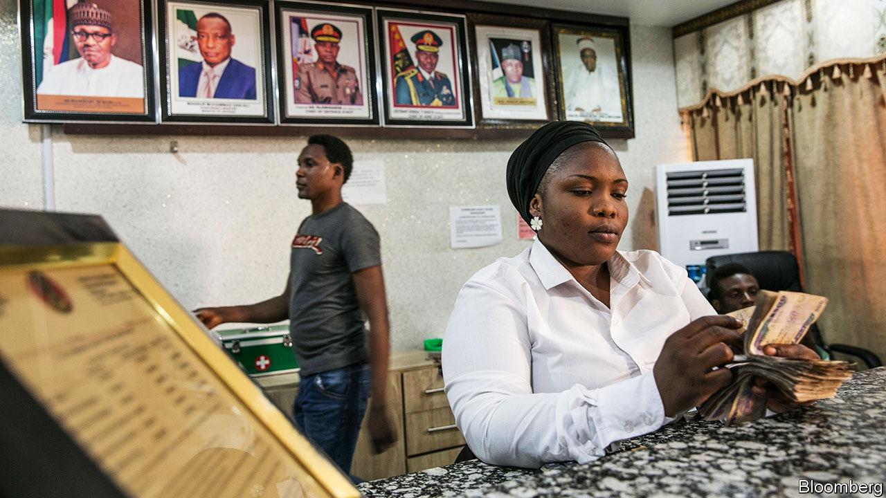

IN 1979 AN IMF negotiator met Julius Nyerere, Tanzania’s socialist president, and urged him to weaken the country’s currency. “I will devalue the shilling over my dead body,” Nyerere fumed afterwards. Over the next decade, many African leaders took similar stands. But faced with worsening terms of trade and foreign-currency shortages, they eventually let their currencies slide. Tanzania bowed to the inevitable in 1986, after Nyerere had left office. Most African exchange rates are now about where markets think they should be.

Could governments go further? An undervalued currency makes a country’s exports cheaper, and so acts as an implicit subsidy to firms that sell abroad. That can counterbalance institutional failures, such as the difficulty of enforcing contracts, which hurt exporters more than they do local businesses—barbers, taxi-drivers and the like. Exposure to world markets also helps companies learn and improve.

Dani Rodrik of Harvard University argues that governments in developing countries should not simply aim for an “equilibrium” exchange rate, as the IMF would urge, but actively engineer undervaluation. That may entail measures such as capital controls or reserve accumulation. Some Asian countries, including China, adopted this strategy as they industrialised. Empirical studies suggest that undervaluation boosts growth, and more so in poor countries than in rich ones.

Strange, then, that those African countries that do manage their currencies are still trying to prop them up. Nigeria restricts access to foreign exchange to keep the naira strong. Ethiopia’s drive to become an Asian-style hub for export manufacturing has been hindered by an overvalued birr (though a new IMF programme could weaken it). A group of eight mostly francophone west African countries are changing the name of their currency but not, tellingly, the rate at which it is pegged to the euro. The last devaluation, in 1994, sparked riots.

A tendency to keep the currency strong is built into the structure of African economies. Commodity exports and aid inflows raise demand for local currencies, making them stronger. Governments fear depreciation because they depend on imported capital to finance infrastructure projects; a weak currency forces them to raise more revenue to pay back foreign debts.

Depreciation also pushes up the cost of imported goods, including food, medicine and fuel. Those are mostly consumed by city folk, who are more prone to protest than those in the countryside. Inflation hits industry, too. Nigerian firms buy much of their machinery and inputs from abroad and so are hurt by higher import prices, says Segun Ajayi-Kadir, the director-general of the Manufacturers Association of Nigeria. Ethiopian factories import about half of their raw materials. Garment firms ship in fabric; shoemakers, leather.

Left unchecked, inflation erodes any boost to exports. Consider a 10% depreciation in the “nominal” exchange rate—that is, the rate advertised in newspapers or at a bureau de change. If domestic prices also rise by about 10% then there is no change in the “real” exchange rate, which measures relative prices of domestic and foreign goods, and that is what counts. In practice prices rarely jump that much: in 2012 IMF researchers estimated that in sub-Saharan Africa a 10% depreciation typically results in domestic price rises of only 4%. But to maintain an undervalued real exchange rate, governments would have to limit inflation by containing local demand, for example by trimming public spending, notes Abebe Aemro Selassie, the director of the IMF’s Africa department. As this is difficult, countries do not typically contemplate strategic undervaluation.

Perhaps this is not a surprise. Much like tackling corruption or fixing the myriad other problems African economies face, strategic undervaluation is hard to pull off. It imposes real wage cuts on the workforce, notes Christopher Adam of Oxford University, so “you’re imposing the cost on current workers and consumers for the benefit of future generations.” No wonder politicians prefer their exchange rates strong. ■

This article was downloaded by calibre from <https://www.economist.com/finance-and-economics/2020/02/15/african-countries-like-their-currencies-strong>

|  |  |  |  |
| --- | --- | --- | --- |
| Previous | Articles | Sections | Next |

|  |  |  |  |
| --- | --- | --- | --- |
| Previous | Articles | Sections | Next |

#### Buttonwood

# Looking at the world through the eyes of options traders

The action that matters is not in the middle but in the fringes

Feb 15th 2020 |

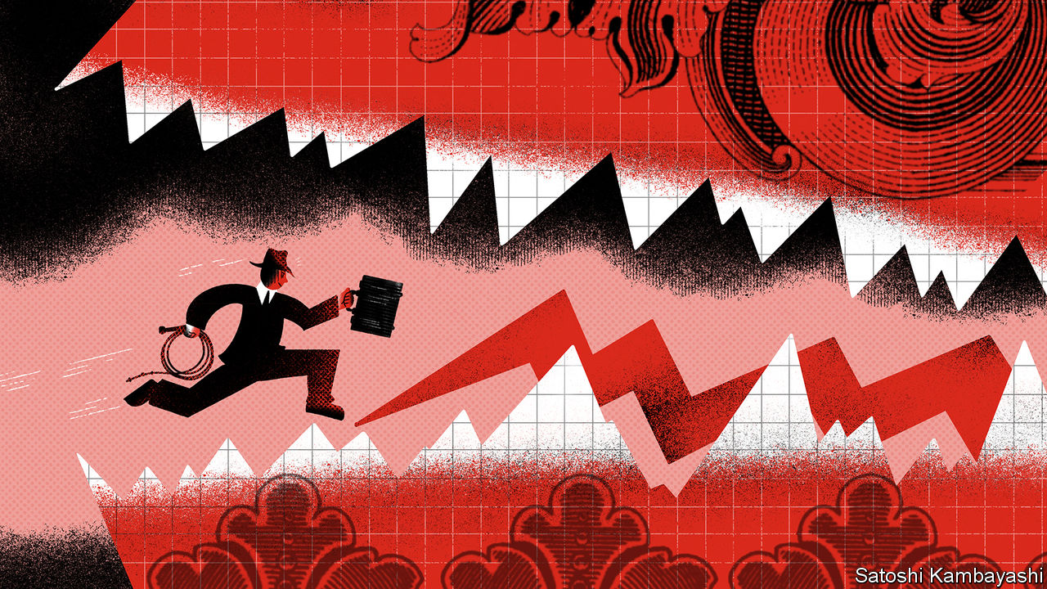

EVERY STONER knows, or has bored you silly, about the third eye. It is the imaginary oracular organ you develop as a side-effect of taking hallucinogens. The data from hazy late-night discussions in college dorms in the 1960s are quite clear on this. The strait-laced are too middle-of-the-road to grasp what is really going on in the world. The third eye allows you to see what they simply cannot.

Every investor could use a third eye. But there is one type who can claim to need it the most: options traders. They have to keep one eye on the most likely outcome and one eye on each of the best and worst scenarios. A lot of the time, the middle outcome—the average, the midpoint, the most common—is a good predictor. But for some things, some of the time, the middle lies on shaky ground. This is the world in which having options—or the right to buy or sell assets at a predetermined price—is most valuable. And the action that matters is not in the middle but at the fringes.

To understand why, imagine you had to bet on the height of the next man to walk into the coffee shop you are sitting in. A good guess would be 1.75m (5ft 9in), which is the average height of an adult male in America. It is likely that you would be wrong, but not by a whole lot. Many of the men who could walk in will be close to average height; very many will be an inch or two below or above it; and only very few will be a lot shorter or taller. The middle—the average—is a good predictor of how something entirely random will turn out.

A throw of two dice is similar. There are 36 possible pairs of numbers. Some throws are more likely than others: there are six ways to throw a seven, but only one way to throw either a two or a 12. If you display each possible throw by how often it occurs, it will follow the outline of a special kind of bell curve, known as a normal distribution (see chart). A lot of very different kinds of measures—IQ, exam scores, height—also look like this. A feature is that the values deviate from the average in an ordered way. Two-thirds of dice throws (24 out of 36) are within one standard deviation of the average throw, ie within a range of five to nine. In a normal distribution, 68% of outcomes are within one standard deviation of the average and 95% are within two.

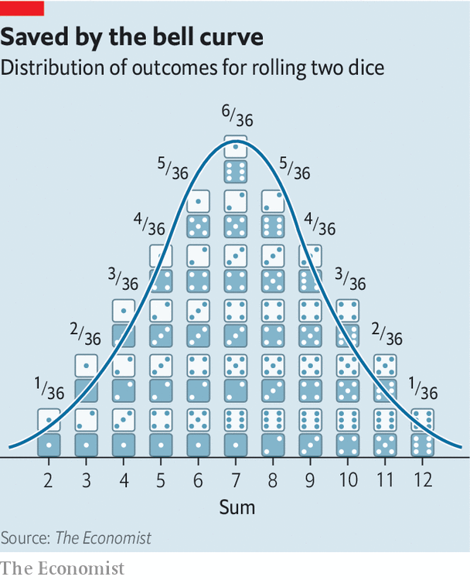

The standard deviation—volatility—is a key concept in options trading. The VIX, or volatility index, is the best-known gauge for it. It is the level of volatility derived from the price of options on the S&P 500 share index. (Put options confer on a buyer the right to sell the index at a specified “strike” price; call options confer the right to buy it.) Key inputs to the value of an option are expected volatility and the gap between the strike price and the index price. The more violently prices move, the more likely the gap between the two will be bridged—in which case the option pays off. If the VIX says that implied volatility is 14, as it does now, traders expect an annual standard deviation of 14% in equity prices.

The level of implied volatility depends on the weight of buyers and sellers. Vol sellers in effect supply insurance. They are betting on the middle, that the world will stay regular and normal, or become more so. People active in the options market describe all investment strategies as if they were options trades. To buy corporate bonds with low spreads, for instance, is like selling volatility: you get a low premium and cross your fingers it doesn’t default. Vol buyers, in contrast, seek insurance. They don’t believe the middle. They think the world will become more disordered. And sometimes they are right. Asset prices are not distributed in as ordered a way as height is. Extreme events, such as market crashes, are more frequent than normal distributions suggest. Volatility has been remarkably low—in stocks, bonds and currencies. Viruses, populism, trade wars, papal abdications and royal bust-ups—nothing seems to move the needle much. But no one can be sure how long the age of placidity will last.

People with squeegee-cleaned third eyes insist that vol must eventually go up. They blame central banks, which have relaxed monetary policy whenever markets panic, for suppressing volatility. The central bankers have been free to do so because inflation, their main obsession, has gone missing. A revival in inflation will one day force them to stop managing the markets. That is the big bet of options buyers. In the meantime, the standard investor will keep his two eyes firmly on the middle.

This article was downloaded by calibre from <https://www.economist.com/finance-and-economics/2020/02/15/looking-at-the-world-through-the-eyes-of-options-traders>

|  |  |  |  |
| --- | --- | --- | --- |
| Previous | Articles | Sections | Next |

|  |  |  |  |
| --- | --- | --- | --- |
| Previous | Articles | Sections | Next |

#### Free exchange

# Wage gains for low earners have helped sustain America’s economic expansion

Trickle-up economics

Feb 15th 2020 | Trickle-up economics

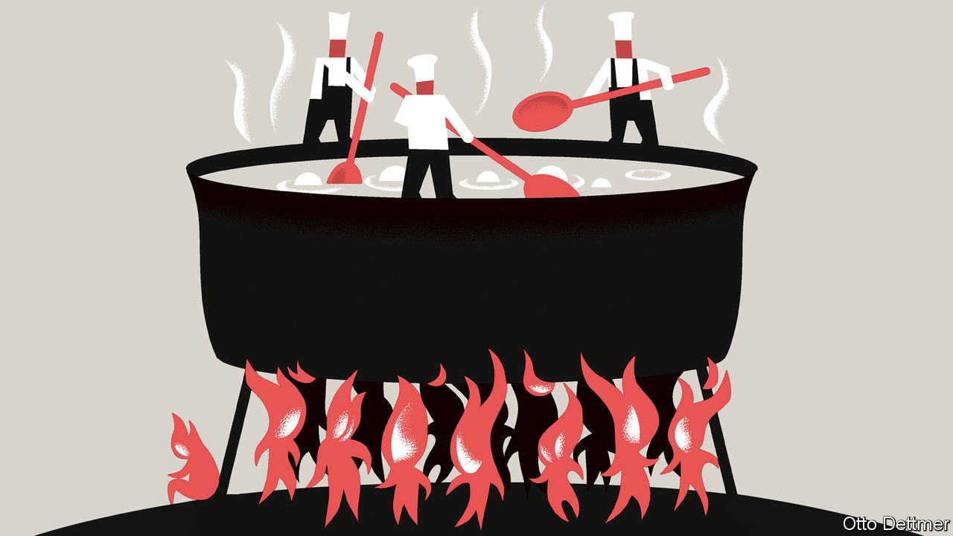

AT 128 MONTHS and counting, America’s economic expansion is the longest on record. Longevity has not come easily. The expansion trundled along despite global manufacturing downturns in 2016 and 2019, conflicts over trade, and a bout of monetary tightening by the Federal Reserve. The recovery ploughed ahead last year even as business investment decelerated and residential-construction investment shrank, thanks to rock-steady growth in personal consumption. The durability of spending is a testament to one of this expansion’s more unusual features: faster growth in wages for workers at the bottom of the income distribution than for high earners. Improved fortunes for low-wage workers may, it seems, be an underappreciated contributor to the sustainability of economic booms.

Since the turn of the millennium demand, not supply, has been the binding constraint on economic growth. Quiescent inflation suggests that spending has only rarely bumped up against the economy’s production capacity over this period. Annual inflation has been just 1.8% on average, down from about 3.5% during the preceding 20 years and 4.5% in the two decades before that. Economists have offered several explanations for chronically weak demand, from the ageing of the workforce to a suppression of investment appetites caused by a slowdown in technological progress. Inequality is also thought to have played an important role.

Richer households are far more likely to save an additional dollar earned than poorer ones. Rising inequality, by raising the income share of the well-off, thus tends to drain the economy of demand. Between 1979 and 2018 the real wages of workers in the 90th percentile of the income distribution rose by 34%, according to a recent analysis by Jay Shambaugh and Ryan Nunn of the Brookings Institution, a think-tank. Pay for those at the tenth percentile, in contrast, rose by less than 5%, and wages for those at the fifth percentile declined. Spending suffered accordingly. In an analysis published in 2012 Alan Krueger, a labour economist, reckoned that, were it not for the increase in inequality between 1979 and 2007, consumption across the American economy would have been 5% higher. That would add stimulus of about $700bn to today’s economy.

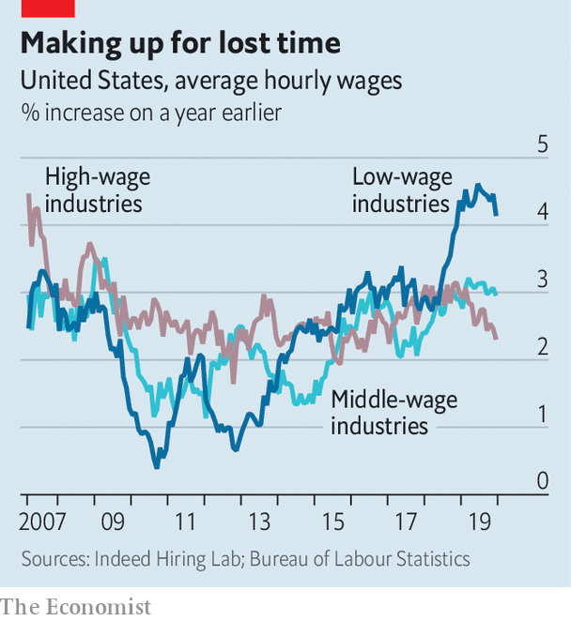

As ever more of the income generated in the economy flowed to thrifty households, the Fed found itself working ever harder to coax enough spending to keep job growth and inflation from falling. The average level of the Fed’s main policy interest rate, which was just under 10% in the 1980s, dropped to below 1% in the 2010s. Purchasing power eventually made its way into the hands of those more likely to spend—but through the extension of credit rather than through fatter pay packets. Household debt in America, as a share of GDP, roughly doubled between 1979 and 2007. It leapt by nearly 30 percentage points between 2000 and 2007 alone, when the flow of money from savers to spenders was turned into a gush by low interest rates, soaring house prices and a collapse in mortgage-lending standards. Without so much borrowing America’s economy might well have only stumbled along in a state of permanent sluggishness.

The recent recovery looks very different from the pattern established in the 1990s and 2000s. From 2014 to 2018 pay in low-wage industries grew about as quickly as that in other parts of the economy, according to a recent analysis by economists at Indeed Hiring Lab, a labour-market research group. And over the past two years wage growth at the bottom has been substantially faster than that in better-paying industries (see chart). Rising pay for low earners has put more cash in the hands of those most likely to spend, supporting consumption and helping the economy weather a soft patch. At the same time household debt, which plunged immediately after the global financial crisis, has continued to fall as a share of GDP over the past few years. Lower debt levels have in turn contributed to a more durable expansion—one that is less likely to be choked off by changing credit conditions or higher borrowing costs stemming from interest-rate increases, like those imposed by the Fed from 2015 to 2018.

## More for your money

Rising wages reflect the gradual tightening of the labour market over the past decade. As the recovery proceeded, the unemployment rate dropped to its lowest level in half a century, forcing firms to search ever harder to find the worker they needed. And as employment growth has continued, the share of working-age adults participating in the workforce has risen. People on the margins of the labour market have been lured in by firms offering more generous wages.

Much of the unusually rapid growth in the pay of low-wage workers, however, is probably due to increases in minimum-wage rates. Although the federal minimum wage has been stuck at $7.25 an hour for over a decade, many state and local governments have in recent years passed increases that push the rate far above it. As a consequence Ernie Tedeschi, an economist at Evercore ISI, a research firm, found in 2019 that the average person working at the minimum wage actually earns close to $12 per hour. This effective wage, once adjusted for inflation, has jumped by roughly a third over the past ten years.

Continued strength in wage growth for low earners cannot be taken for granted. For now, companies are still keen to hire more staff. And political enthusiasm for minimum-wage rises continues to grow. Most Democratic presidential candidates favour a federal minimum wage of at least $15 an hour. But the forces pushing in the direction of higher inequality are mulishly persistent. An analysis published in December by the Congressional Budget Office projects that the share of pre-tax income flowing to the top 1% will have begun rising once more by 2021. Strikingly, and in part due to President Donald Trump’s tax reforms, growth in income after taxes and transfers are taken into account is forecast to be even more skewed in favour of the rich. But policy can change. And the prospect of a strong and sturdy expansion ought to prove powerfully persuasive. ■

This article was downloaded by calibre from <https://www.economist.com/finance-and-economics/2020/02/15/wage-gains-for-low-earners-have-helped-sustain-americas-economic-expansion>

|  |  |  |  |
| --- | --- | --- | --- |
| Previous | Articles | Sections | Next |

|  |  |  |
| --- | --- | --- |
| Finance and ... | Sections | Books and arts |

Science and technology

Metabolites and you: Shed-loads of chemicals

.

Climate change: Goodish news

.

Solar physics: Hot topics

.

Animal behaviour: Lake-bed properties

.

|  |  |  |
| --- | --- | --- |
| Finance and ... | Sections | Books and arts |

|  |  |  |  |
| --- | --- | --- | --- |
|  | Articles | Sections | Next |

#### Metabolites and you

# People leave molecular wakes that may give away their secrets

They shed loads of chemicals

Feb 15th 2020 |



GENES CAN tell tales about you, from who your ancestors were to how likely you are to develop a range of diseases. And it seems probable that in the future they will tell more: your personality type, perhaps, or your intelligence. For these reasons, many countries have laws limiting what use employers and insurance companies can make of such information. America, for example, has the Genetic Information Nondiscrimination Act, which makes it illegal for health insurers and employers to use genetic information to discriminate against customers and employees.

There is much, however, that genes cannot reveal. They are blind to what you eat, how you exercise, how safe the place you live in is, how you unwind at the end of the day and which god you worship. Just as well, you might think, considering how easy it is to obtain samples of DNA from saliva, sweat or hair, and how cheap it is becoming to analyse such samples. But it is not just DNA that people scatter to the wind as they go about their business. They shed a whole range of other chemicals as well, in their breath, their urine, their faeces and their sweat. Collectively, and somewhat inaccurately, these molecules are referred to as metabolites. Some truly are the products of metabolic activity within people’s bodies. Others are substances an individual has come into contact with, or consumed or inhaled. All, though, carry information of one sort or another.

## Blood, tears, sweat and toil

Until recently this did not matter much, for two reasons. One was that, in practice, taking samples for analysis required either voluntary collaboration or legal duress. It could not be done clandestinely. The other was that interpreting the complicated patterns of metabolites is hard. But both of these obstacles are now being overcome.

The most common way of analysing metabolite content is gas chromatography-mass spectrometry. This technique sorts molecules by their weight, producing a pattern of peaks that correspond to different substances. But the same weight can be shared by many molecules, so the results may be ambiguous. Nor, even if a molecule can be identified unambiguously, is its wider significance always obvious to a particular investigator.

There are, however, a lot of information sources out there, in the form of publicly available metabolite databases. And last year a team led by Pieter Dorrestein of University of California, San Diego, invented a way, which they call a metabolite search engine, of linking them up so that a sample can be compared simultaneously with the contents of all of them.

The databases themselves are getting better, too. According to Dr Dorrestein, researchers in the field were able, as recently as four years ago, to identify only 2% of the metabolites found in samples. Today, that has increased to 6% and is climbing quickly. “It is reasonable”, he says, “to assume that in another four years we will be able to annotate 20% of the molecular signatures that we encounter, based on the advances that are being made.”

Another area of progress is the type, size and state of preservation of samples that can be interrogated. No longer are blood, urine or breath required. Sweat, tears, saliva and even dental plaque will do. A study just published by Feliciano Priego-Capote at University of Cordoba, in Spain, for example, shows it is possible to extract much meaningful information from even a dried-up drop of sweat—indeed, Dr Priego-Capote is able to find in dried sweat substances that are undetectable at the moment in fresh perspiration.

Such information can reveal a lot. Your god? Regular exposure to burning incense, and thus frequent visits to a church that uses it, will be detectable from the chemicals in the smoke. Not a Christian? Kosher and halal diets are detectable by the absence of metabolites from certain foodstuffs those diets forbid. Your out-of-office activities? Habits like drinking, smoking and narcotic use are visible as numerous chemicals—not merely the active pharmaceuticals which produce the relevant high or low. Your exercise levels? These are flagged up by lower than normal levels of things like leucine, glycerol and phenylalanine. Your local environment? Breathing in polluted air has a marked impact on the profile of your metabolites. Your general health? Illnesses ranging from Parkinson’s disease (altered levels of tyrosine and tryptophan) to diabetes (sugars and sphingomyelin) leave abundant metabolic traces. “The day is coming soon”, observes Cecil Lewis, a molecular anthropologist at University of Oklahoma, who is studying the matter, “when it will be possible to swab a person’s desk, steering wheel or phone and determine a wide range of incredibly private things about them.”

## Swabbing the decks

In contrast with DNA, the use to which knowledge of metabolites might be put has little legal restriction. Dr Lewis, and others like him, worry about the consequences of this. At the moment, sampling for alcohol or illegal drug use, say, has to be overt, because it involves a blood, urine or breath test. That is true regardless of who is collecting the sample, whether it be the police or an employer. This also keeps purposes clear. A firm might feel it has the right to test employees for drug use, and the law might support that. But techniques like Dr Priego-Capote’s make it easier, as Dr Lewis observes, to sample clandestinely, and bring a temptation to push back the boundaries of what is being searched for. They would, for example, allow companies to detect, if they chose to look, such private matters as whether an employee was taking antidepressants.

Metabolite data, even the sort obtained openly, will also be of interest to medical-insurance companies, who may insist on the provision of samples as a condition of the provision of cover. They, too, might take an interest in matters of diet and exercise, penalising those who do not conform to prescribed healthy regimes.

The police may be tempted to push the boundaries as well. The fourth amendment to America’s constitution protects against unwarranted searches and seizure of evidence. This means it is hard to force someone to give a sample. But if obtaining such merely requires taking a swab of a surface in a public place—perhaps a keyboard someone has just used—the amendment is unlikely to apply.

That is not necessarily wrong, if it means more criminals are caught and convicted. But it needs to be thought about carefully, because many metabolites are sticky. Cocaine is a case in point. Studies have shown that as many as two-thirds of the dollar bills in circulation in America carry traces of this substance, which might thus end up on the fingertips of the innocent, as well as the guilty.

Perversely, this might even help someone who really had taken the drug. The law in many jurisdictions permits employers to fire employees for unlawful conduct, even if it happens outside the workplace. But as Michelle Terry of WKS Law in Los Angeles, observes, given how sticky research has shown cocaine metabolites to be, it is hard to guess how the courts would rule if someone lost their job for testing positive, yet claimed never knowingly to have touched the stuff.■

This article was downloaded by calibre from <https://www.economist.com/science-and-technology/2020/02/15/people-leave-molecular-wakes-that-may-give-away-their-secrets>

|  |  |  |  |
| --- | --- | --- | --- |
|  | Articles | Sections | Next |

|  |  |  |  |
| --- | --- | --- | --- |
| Previous | Articles | Sections | Next |

#### Climate change

# Energy-related emissions of carbon dioxide have stabilised, for now

But the capacity of the Amazon to absorb the gas is falling

Feb 15th 2020 |

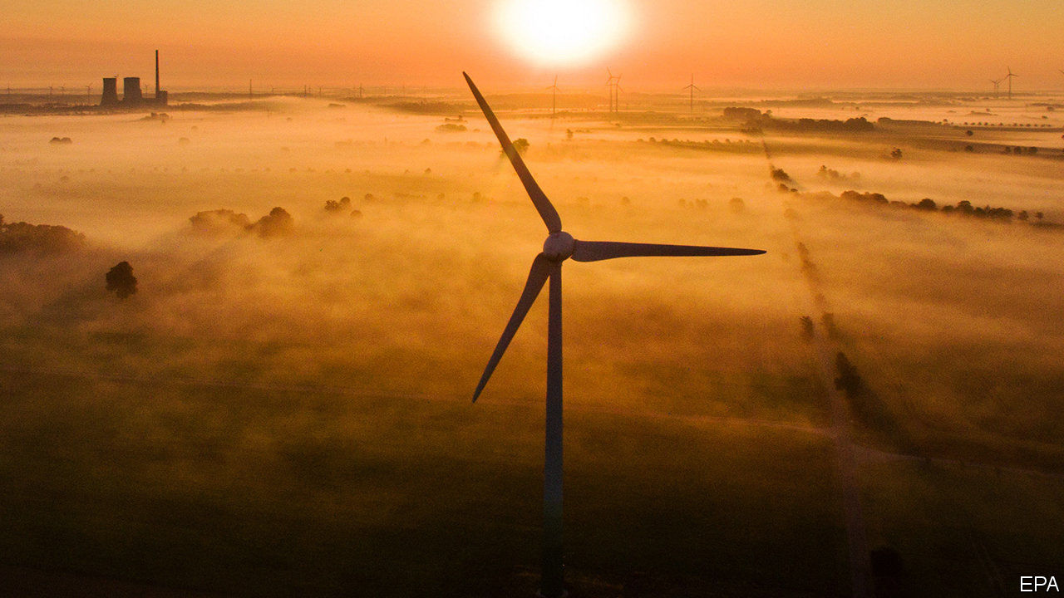

IS IT A peak, a stutter or just a brief pause? Time will tell. But whatever it is, on February 11th the International Energy Agency (IEA), an intergovernmental organisation which collects such data, announced that emissions of carbon dioxide in 2019 which were related to energy had remained the same (33.3bn tonnes) as the previous year’s.

Energy-related emissions, which include those produced by electricity generation, heating and transport, account for more than 70% of the world’s industrial CO2 pollution. The stall seems to have been caused by a decline in coal use, particularly in rich countries, combined with an increase in the use of renewable power.

As a result of this the CO2-intensity of electricity generation—a measure of how much of the gas is emitted per kilowatt-hour of juice produced—fell by nearly 6.5%, to 340 grams of CO2 per kilowatt-hour. It had already been falling, but this is three times the average for the past decade. Such declines more than offset the effect of increased electricity production. The average emission-intensity of power generation in 2019 was “lower than all but the most efficient gas-fired power plants”, according to the IEA.

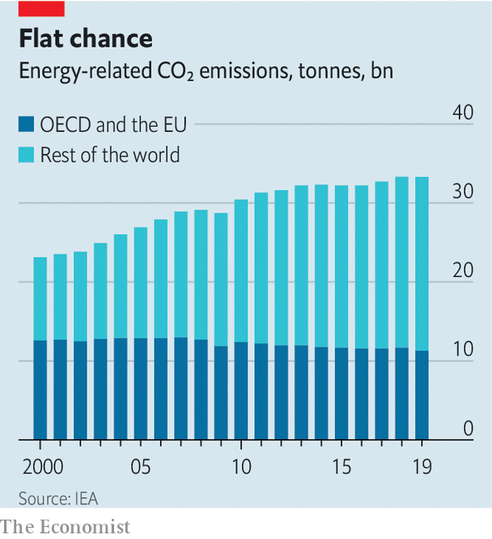

This is not the first time energy-related emissions have plateaued. Between 2013 and 2016 they hovered around 32.2bn tonnes a year, before rising again in 2017 as the use of coal to fuel developing economies increased. This previous plateau was accompanied by excited declarations that such emissions had peaked. Similar comments have been made this week, perhaps also prematurely. In addition to changes in coal use, a sluggish economy may have played a part and the data show that milder than usual weather caused a perceptible drop in emissions from several countries with large, carbon-hungry economies.

The news is also tempered by the latest data from the Amazon rainforest. This, one of the world’s largest woodlands, has acted historically as an absorbing sponge for CO2 by removing it from the atmosphere through photosynthesis. Researchers at Brazil’s National Institute for Space Research have shown that a vast part of the south-east of the Amazon, about one fifth of its area, has lost its ability to soak up the gas and is now a net source of emissions into the atmosphere instead. This land has been widely deforested, so the result is little surprise. But it is disappointing.

This article was downloaded by calibre from <https://www.economist.com/science-and-technology/2020/02/15/energy-related-emissions-of-carbon-dioxide-have-stabilised-for-now>

|  |  |  |  |
| --- | --- | --- | --- |
| Previous | Articles | Sections | Next |

|  |  |  |  |
| --- | --- | --- | --- |
| Previous | Articles | Sections | Next |

#### Solar Orbiter’s launch

# A new spacecraft will examine the sun close up

Solar physics is a hot topic

Feb 15th 2020 |



THE SUN is one of the most-studied objects in the sky, but plenty of mysteries remain. On February 10th a rocket blasted off from Florida carrying Solar Orbiter, a European space probe designed to solve some of them. This craft will spend the next two years performing fly-bys of Venus and Earth, using the gravity of both planets to kick itself into an unusual orbit that will take it well above the ecliptic, the plane in which all of the sun’s planets orbit.

From that vantage Solar Orbiter will peer at the sun’s poles, something no spacecraft has managed before, and do so from close up. At its nearest, it will be just 42m km from the sun—closer than Mercury, the innermost planet, gets. One of its features is, therefore, a heat shield coated with charcoal made from cooked animal bone and designed to endure temperatures up to 500°C. Tiny windows within this will illuminate the probe’s various instruments.

Those instruments are designed to shed light, as it were, on several questions. One concerns the solar wind, a flow of charged particles that streams from the sun at a rate of more than 1m tonnes a second. The solar wind blows at an average speed of 400km a second, but physicists do not know exactly what accelerates those particles to such a velocity. Another mystery is the sun’s magnetic field. Every 11 years or so, for reasons only partly understood, this flips its north and south poles around. Solar Orbiter’s masters hope their charge will observe such a reversal, which is expected to happen within the next few years.

They also hope that Solar Orbiter will advance the nascent science of solar-weather forecasting. The entire solar system is bathed in the solar wind, which means that what happens on the sun can affect conditions around the planets. Solar flares—sudden spikes in the sun’s brightness—boost radiation levels in the neighbourhood of Earth, which can interfere with satellites’ electronics, alter their orbits and pose health risks to astronauts. Coronal mass ejections (CMEs), which are occasional burps of superheated plasma that the sun releases into space, can disrupt radio communications and induce large, potentially damaging electric currents in power grids, communication lines and the like.

These risks are not hypothetical. In 1859 a massive CME caused auroras as far south as the Caribbean and damaged telegraph systems all over America and Europe. Another, in 1989, caused nine-hour blackouts across large parts of north-eastern Canada. Britain’s government lists a direct hit from a big CME on its National Risk Register of potential disasters, alongside floods, pandemic diseases and big terrorist attacks. Early warning of such space-going storms would help resist their effects.

Solar Orbiter is not the only craft soon to endure a close encounter with the sun. In 2018 NASA, America’s space agency, launched the Parker Solar Probe. This will orbit even closer, at a distance of just 6.2m km. Researchers see the missions as complementary. Parker will fly through the corona, a tenuous atmosphere that stretches far out from the sun’s luminous sphere, allowing it to sample the gas there directly. But that is much too close for any kind of direct optical observation, says Richard Harrison, chief scientist at the Rutherford Appleton Laboratory in Britain, and one of Solar Orbiter’s designers. Parker, in other words, suffers from the same limitation as Earthbound human astronomers: it cannot look directly at the blinding light emitted by the object it is studying. ■

This article was downloaded by calibre from <https://www.economist.com/science-and-technology/2020/02/15/a-new-spacecraft-will-examine-the-sun-close-up>

|  |  |  |  |
| --- | --- | --- | --- |
| Previous | Articles | Sections | Next |

|  |  |  |  |
| --- | --- | --- | --- |
| Previous | Articles | Sections | Next |

#### Animal behaviour

# Fish, like people, must pay for their accommodation

Otherwise bad things may happen to them

Feb 15th 2020 |



TENANTS WHO don’t pay the rent are a bane of landlords everywhere. And landlords who use heavy tactics to enforce payment are similarly a bane of tenants. Nor are these problems confined to human beings. Property-owning cichlid fish seem as ruthless about receiving what they are owed as any 19th-century tenement holder in the Lower East Side of New York.

The fish in question, Neolamprologus pulcher, inhabit Lake Tanganyika in east Africa. They are co-operative breeders, meaning that dominant individuals do the breeding and subordinates assist in various ways, in exchange for immediate survival-enhancing benefits that may lead to the ultimate prize of becoming dominant themselves. In the case of N. pulcher the main benefit is having somewhere to live. Dwellings, in the form of shelters dug out from sand under rocks, are controlled by dominant pairs. These dominants permit subordinates to share their accommodation, and those subordinates pay for the privilege by keeping the property in good repair and defending the dominants’ eggs and fry against predators.

Though co-operative breeding by vertebrates has evolved several times (famous examples include the meerkat mongooses of southern Africa and the scrub jays of Florida), the question of how rental payments are enforced has never been definitively settled. The presumption is that dominants punish subordinate defaulters. But it is hard to prove, by observing wild animals, that this is what is happening.

What was needed to clear the point up was an experiment. And fish are easier to experiment on than mongooses or jays. Jan Naef and Michael Taborsky of the University of Bern, in Switzerland, therefore acquired 96 specimens of N. pulcher and created menages of a pair of dominant landlords and a subordinate tenant in sand-bottomed aquaria.

Left alone, the fish behaved much as they would have done in the wild, with the tenant doing the grunt work of maintaining the hollows in the sand, and good relations pertaining between all. However, if a tenant was prevented for a time from fulfilling its duties, by trapping it behind a partition inserted into the aquarium for that purpose, things changed. When the partition was removed, the landlords attacked it, and it showed a big increase in submissive behaviour for several minutes before things returned to normal.

Whether similar treatment would be meted out for a failure to defend the landlords’ eggs has yet to be determined. When prevented by a partition from driving away predators, tenants were not subsequently on the receiving end of aggression from landlords—but since there were no eggs to defend at the time, that may not have been part of the contract. The predators in question, a species called Telmatochromis vittatus, are not a threat to adult specimens of N. pulcher, only to eggs and fry. It is nevertheless clear from Dr Naef’s and Dr Taborsky’s experiment that, for cichlids at least, the rent must be paid in a timely fashion, or punishment will be faced.■

This article was downloaded by calibre from <https://www.economist.com/science-and-technology/2020/02/15/fish-like-people-must-pay-for-their-accommodation>

|  |  |  |  |
| --- | --- | --- | --- |
| Previous | Articles | Sections | Next |

|  |  |  |
| --- | --- | --- |
| Science and ... | Sections | Economic and ... |

Books and arts

Power from the people: Too much of a good thing

.

The Academy Awards: Creepy crawlies

.

Johnson: Original sins

.

Tom Stoppard’s new play: Laughter in the dark

.

|  |  |  |
| --- | --- | --- |
| Science and ... | Sections | Economic and ... |

|  |  |  |  |
| --- | --- | --- | --- |
|  | Articles | Sections | Next |

#### Too much of a good thing

# Why an excess of democracy can lead to poor decisions

Cutting back on people power can be beneficial, thinks Garett Jones

Feb 15th 2020 |

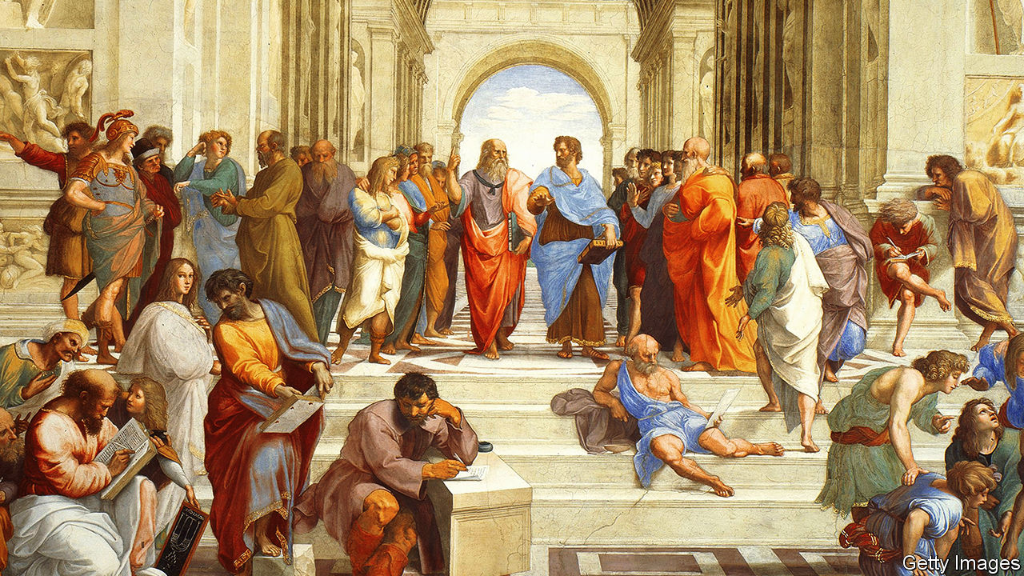

10% Less Democracy: Why You Should Trust Elites A Little More and the Masses A Little Less. By Garett Jones.Stanford University Press; 248 pages; $28 and £22.99.

GARETT JONES, an economics professor at George Mason University in Virginia, knew he was on to a good thing when he got a call from the campus police. A student journalist had written a report on a lecture that he had given suggesting that rich countries would be better off if they were less, rather than more, democratic. The hostile reaction, which spread beyond the university, included a call threatening enough to trouble the university’s private security force. Mr Jones concluded that he had an idea powerful and contentious enough to make into a book. The result is “10% Less Democracy”.

This is a fertile time for critiques of democracy. In light of the use of state apparatus by elected leaders to undermine an opponent in America, murder people in the Philippines, render a religious minority stateless in India, threaten judicial independence in Poland, and rob the public purse in South Africa, the system which has long provided the rich world with a satisfying mix of moral superiority and stable government is looking a bit ropy. A report last month from the Centre for the Future of Democracy at Cambridge University found that support for democracy had declined sharply in most of the world since the 1990s, including in America and western and southern Europe. The world’s biggest autocracy, meanwhile, is bringing prosperity to its own population and extending its influence round the world.

But as Mr Jones discovered, criticising democracy in the West is still a bit like launching a broadside against the pope in 15th-century Europe—or against a modern-day authoritarian president. You can suggest that all is not going to plan, but you will get a friendlier reception if you pin the blame on dodgy advisers or foreign interference, rather than on the concept itself.

David Runciman’s recent “How Democracy Ends” attributed democracy’s woes to decadence. The system was healthier, he argued, when change or conflict—the expansion of the franchise in the first half of the 20th century, the second world war—had given it a shot in the arm. Pankaj Mishra, in “Age of Anger”, maintained that the problem lies in the growing gap between a political system that promises equality and an economic one that leads to inequality.

By contrast, Mr Jones plants responsibility squarely on the shoulders of the voters. As an economist, he approaches democracy as a production system whose output is governance, and examines how it can be tweaked to improve the product. The core of “10% Less Democracy” is thus research on whether more or less democracy produces better or worse outcomes for countries and citizens.

## Early and less often

As the title suggests, Mr Jones’s critique operates within a narrow band. He concedes that massacres and famines are less likely to happen in democracies than in autocracies, and that there is a clear correlation between democracy and prosperity. But he takes issue with Daron Acemoglu’s claim, in the title of a paper published last year, that “Democracy Does Cause Growth”. The paper found that when undemocratic countries became democratic, they grew faster, raising GDP per head by an average of 20% in the long run.

But democracy, Mr Jones points out, is not like virginity: countries can be a bit more or a bit less democratic. No modern country, not even Switzerland, is as insanely democratic as ancient Athens, where citizens voted to recall their military leaders from Sparta. All democracies limit popular participation in collective decision-making, be it by handing over responsibility to elected representatives to make big decisions, or by appointing judges and other public servants. Mr Jones believes that, because people do not always vote for what is good for them, those countries that have made it to the top quartile of the democracy scale should set slightly tighter limits.

A study by Alberto Alesina and Lawrence Summers in 1993, for instance, showed that inflation was lower in countries with independent central banks. There was no cost in terms of growth or employment; it was a free lunch. The trick was simply to hand over responsibility for the money supply to an official who had no interest in using it to boost growth in the run-up to elections. (In the best—or only—joke about central bankers, a student visits his former professor, who has become one. The phone rings. “No…no…no…no…yes…no…no,” says the central banker. Hanging up, he explains that the caller was the finance minister. “What did you answer ‘yes’ to?” wonders the student. “He asked if I could hear him.”)

Likewise, regulators’ backbones are stiffened by independence. A study in Europe showed that the less dependent on politicians they are, the more likely they are to stand up to government-owned utilities. Free trade, too, benefits when farther from democracy. The closer politicians are to an election year, the less likely they are to vote for measures to liberalise trade.

In America, which has historically been devoted to democracy, all sorts of officials are elected. State-by-state variations allow comparison of their performance with the appointed type. It turns out that elected judges make worse judgments and elected city treasurers cost their taxpayers more (though not many are as improvident as the man who consulted a psychic to help him manage the voters’ money—and eventually bankrupted Orange County).

## A price worth paying

Mr Jones musters plenty of convincing evidence that fewer elections and more distance between voters and decisions make for better governance. But he stretches the argument for limiting democracy far beyond that observation. He is attracted by the idea of “epistocracy”, or rule by clever people; he advocates giving an official role in decision-making to bondholders, who already constrain governments’ freedom by raising the costs of lending to badly managed countries.

These arguments expose the flaw at the centre of this interesting and enjoyable book. Mr Jones looks at democracy as an economic system. But for most people, democracy’s moral component is also essential. It is an expression of the belief that everybody is equal in the sight of God or the presence of the ballot box, and that a country’s people should have power over their government. Less democracy may mean more sensible outcomes, but it also means less legitimacy.

Recent events illustrate that point. Hong Kong is in many ways a splendidly governed place, with reliable social order and a thriving economy—and very limited democracy. The result of last year’s election, in which voters supported pro-democracy protesters, was a clear message to the territory’s Chinese overlords that its people wanted more of a say, even at the cost of less stability.

For its part, the European Union is a model of co-operation and rational decision-making. Yet it has just lost one of its larger members, in part because British voters felt no connection with its governance structures. Technocrats may make sensible decisions, but democracy without legitimacy is a ship without a sail. ■

This article was downloaded by calibre from <https://www.economist.com/books-and-arts/2020/02/15/why-an-excess-of-democracy-can-lead-to-poor-decisions>

|  |  |  |  |
| --- | --- | --- | --- |
|  | Articles | Sections | Next |

|  |  |  |  |
| --- | --- | --- | --- |
| Previous | Articles | Sections | Next |

#### Creepy crawlies

# The Oscars triumph of “Parasite”

And of its director, Bong Joon-ho, a persona non grata turned national hero

Feb 15th 2020 | SEOUL

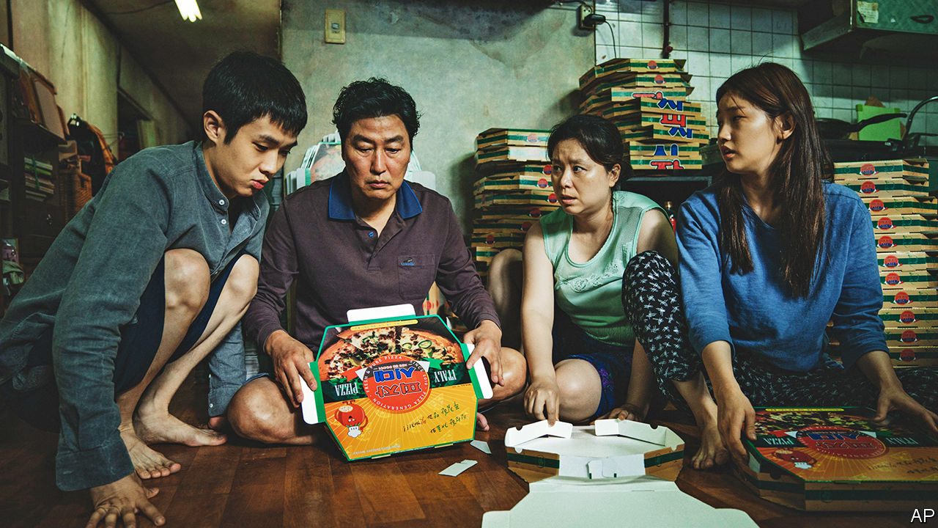

HALFWAY THROUGH “Parasite”, the Kims (pictured), a family of grifters who live in a dank Seoul basement, have by hook and (mostly) crook wangled their way into jobs in the ultrachic mansion of the Parks. Twisty as the plot has already been, viewers know more surprises must be in store—but can scarcely imagine what they will be. The screwball shifts in tone somehow cohere into a biting parable of haves and have-nots. On February 9th this South Korean farce became the first foreign-language film to be crowned Best Picture at the Academy Awards. It also took Best Screenplay, Best International Feature Film and Best Director, for Bong Joon-ho.

“Once you overcome the one-inch tall barrier of subtitles,” Mr Bong has observed, “you will be introduced to many more amazing films.” The success of “Parasite” has been seen as a harbinger of the rise of global cinema in the Anglophone world, and of South Korea’s rich film industry in particular. Perhaps—but, even more than usual, it is a triumph for Mr Bong, who has completed a high-speed journey from subversive extremist to national hero. During the administration of Park Geun-hye, from 2013 to 2017, officials kept tabs on him because of his politics; state funding was unavailable for his work. Being blacklisted in this way, Mr Bong said just three years ago, was a “nightmare”. On February 10th he received a warm congratulatory message from Moon Jae-in, the president today.

His rehabilitation chimes with political changes in South Korea. Ms Park’s lieutenants considered Mr Bong’s films—which include “Memories of Murder”, “Mother” and “Okja”—unacceptably disrespectful of the state; more than 9,000 other artists and writers, many less able to support themselves, got the same treatment. (Mr Bong’s English-language sci-fi flick, “Snowpiercer”, faced a different problem in America: Harvey Weinstein’s distribution firm restricted its release when Mr Bong refused to make the cuts Mr Weinstein wanted.) In the end, the cultural McCarthyism did not help its enforcers. A newspaper revealed the existence of the blacklist in 2016; the resulting outrage contributed to Ms Park’s impeachment and eventual imprisonment for corruption and abuse of power, and the election of Mr Moon.

Some conservatives are still wary of Mr Bong, whose work criticises capitalism and social hierarchies. But despite its themes of inequality and class resentment, South Koreans’ jubilation over “Parasite” transcended politics. The many who had been breathlessly following the Oscars ceremony erupted in pride when the best-picture envelope was opened. Cinemas swiftly added new screenings for the few laggards who had not yet seen the film (more than 10m tickets were sold when it was shown in South Korea last summer). A pizza joint and supermarket that feature in the story were overrun by reporters. The municipal government promoted tours of the film’s locations, including a grimy underpass.

Little good the enthusiasm will do the city’s strugglers—at least, if “Parasite” itself is any guide. Nothing avails the Kims, neither crime nor (when they try it) going straight. Still, for all its fatalism, part of the appeal of Mr Bong’s zany movie is that it is never simplistic. The Kims aren’t saints, and the Parks are more blithe than villainous; they just cannot help noticing the odour that seems to emanate from the servants. If audiences stop to think about it, the grisly denouement is only a slight inflection of a reality in which, sometimes, the poorest are left to feed on scraps. ■

This article was downloaded by calibre from <https://www.economist.com/books-and-arts/2020/02/15/the-oscars-triumph-of-parasite>

|  |  |  |  |
| --- | --- | --- | --- |
| Previous | Articles | Sections | Next |

|  |  |  |  |
| --- | --- | --- | --- |
| Previous | Articles | Sections | Next |

#### Johnson

# The original sins of grammarians still plague the rulebooks

You may not have heard of Robert Lowth. But his prejudices still hold sway

Feb 15th 2020 |

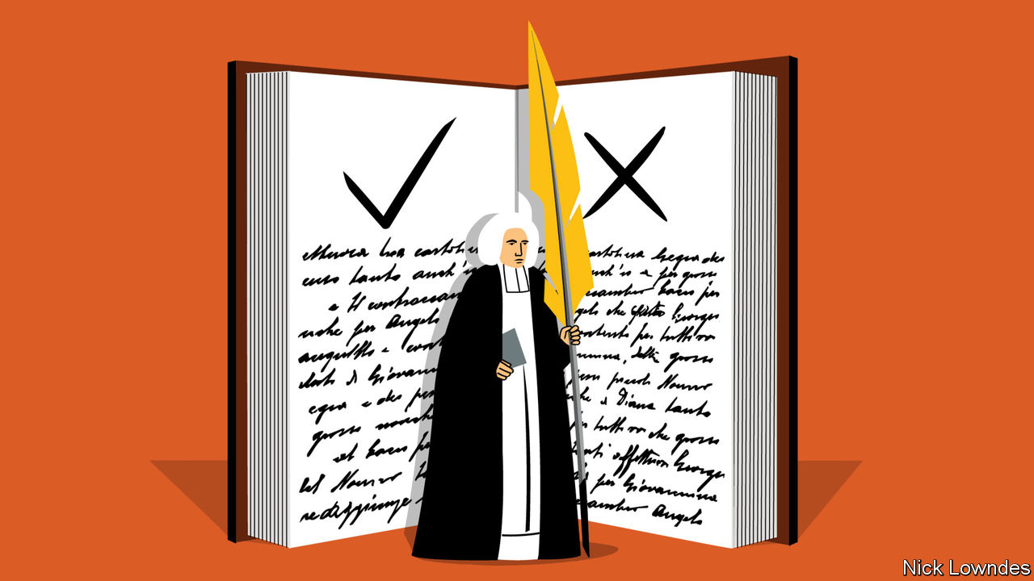

WHERE DO THE rules of grammar come from? Even those who care about the subject rarely, if ever, ask that question. The rules are simply the rules, passed down in good grammar books. But who wrote the first one, and how?

If field linguists study an isolated group to write the first grammar of their language, it will be purely descriptive. They will find out what the natives say, what patterns they use (and avoid), and describe them. But most English-speakers have a notion that grammar cannot be just a description of the habits of ordinary people. Many think of proper grammar as a lofty goal that they may never quite reach. Much of that has to do with the way the first grammars of English were written.

In the mid-18th century there were few studies of English grammar, and none was comprehensive or authoritative. Furthermore, the first major grammarians of English were working before modern linguistic methods—based on evidence and comparison—had evolved. They used a combination of logic, Latin analogies and their own instincts. Unfortunately, some of the missteps they made as a result still hold sway. The now obscure but once feted contribution of Robert Lowth (1710-87) is a case in point.

Lowth’s importance to grammar can be compared to Samuel Johnson’s to lexicography. The two men were contemporaries; Johnson’s dictionary appeared in 1755, Lowth’s “Short Introduction to English Grammar” in 1762. Both would go on to be widely imitated, even copied. Today, Johnson is a household name, whereas Lowth’s is confined to nerdish circles. But his role in the development of English grammar rules means that he should be better known.

His grammar was cannily marketed, says Ingrid Tieken-Boon van Ostade, a Dutch linguist. Its print-run was unprecedented. One reader, William Cobbett, is said to have learned its text by heart, and would himself go on to write a popular grammar in 1818. Another follower, Lindley Murray, plagiarised it shamelessly; his own grammar was a runaway bestseller in both Britain and America. These disciples greatly magnified Lowth’s legacy.

Today academic linguists condemn him twice over: for being a scold, and for getting his scolding wrong. Lowth is considered responsible for some of the hoariest non-rules of the English language—proscriptions that were invalid even when he wrote them, but which have nonetheless been imposed on schoolchildren since. The most famous is the injunction not to end a sentence with a preposition. Another is the notion that two negatives equal a positive, so that “He didn’t say nothing” means “He said something.” A third is that “whose” cannot be used with reference to an inanimate noun, as in “an idea whose time has come”.

All these “incorrect” usages were in rude health among fine English authors in the centuries before Lowth. But he thought even the best authors were often wrong; he copiously cites mistakes (and “mistakes”) that he identified in the King James Bible, Swift, Addison, Dryden, Milton, Pope and Shakespeare.

For all that, the charges against him are overdone. Lowth did not say sentences should never end in a preposition; he said it was more elegant if they didn’t. (Dryden said as much before him.) As for the double negative, he acknowledged it had once been respectable. Ms Tieken-Boon van Ostade says it was already on its way out of standard English earlier in the 18th century, so Lowth’s role was probably not decisive. He is sometimes blamed for the (completely baseless) prohibition of the split infinitive—but he said nothing about it. And though he did make analogies with Latin, he also wrote that English “has little concern” with “the rules of a foreign language”.

In the 19th century philologists made great discoveries about the nature of language, mainly by studying systemic, historical change in European tongues. But the popular market went in a different direction—towards rigid dictums rather than open-minded empiricism. The ambitious middle classes demanded books that told them what to do, memorisable strictures with no exceptions. And the market provided them: Lowth’s followers took his often subtle suggestions and turned them into rigid rules, often with added disdain for those who were not familiar with them. Today, the gulf between professional linguistics and practical advice is wide, as if biologists understood the germ theory of disease but bedside doctors still believed in the four humours.

This article was downloaded by calibre from <https://www.economist.com/books-and-arts/2020/02/15/the-original-sins-of-grammarians-still-plague-the-rulebooks>

|  |  |  |  |
| --- | --- | --- | --- |
| Previous | Articles | Sections | Next |

|  |  |  |  |
| --- | --- | --- | --- |
| Previous | Articles | Sections | Next |

#### Laughter in the dark

# Tom Stoppard’s haunting new play about the Holocaust

Set in Vienna from 1899 to 1955, “Leopoldstadt” tells an acutely personal story

Feb 13th 2020 |



THE ORIGINAL title of his haunting new play, Sir Tom Stoppard confides, was “A Family Album”. The name was changed, but the album survives. The curtain rises on an assimilated Jewish household in Vienna in the winter of 1899, where Hermann, a prosperous convert to Catholicism, and Ludwig, his brother-in-law, are discussing the liberality of Austria and the necessity of Zionism. “To a homeland for the Jews!” they toast. “Happy Christmas!” As children gambol around them, Ludwig’s sister, Wilma, and Grandma Emilia flip through old pictures. “It’s still an amazing thing to me,” Wilma reflects, “to know the faces of the dead!” As for a relative who lived before photography, “no one knows what she looked like any more than if she’d been some kind of rumour.”

The moment, Sir Tom says, “makes explicit something that is part of the play’s fabric”, namely the question of “remembering and misremembering”. “Leopoldstadt”, which opened at Wyndham’s Theatre in London on February 12th, is about memory and forgetting in all their forms. At the most superficial level, the characters keep struggling to pin down how they are related; at the deepest looms the oblivion of the Holocaust. Off-stage, meanwhile, the catastrophe at the play’s heart is passing out of living memory, as the generation that survived it dwindles.

That generation is also the playwright’s, who was born Tomas Straussler in Czechoslovakia in 1937. When Leo, a character in “Leopoldstadt” who is saved as a child—and later writes “funny books” in England—reappears in Vienna in 1955, the drama “superimposes itself on my experience”, Sir Tom says. The parallel is inexact: Leo makes it across the Channel on the eve of the war, whereas, after his parents fled, Sir Tom spent much of it in India. His father was killed in a Japanese bombardment; he moved to England, and became a devoted Englishman, after his mother remarried to a British officer. The play is set in Vienna, not Czechoslovakia, in part to underscore the distinction.

But, like Leo’s, Sir Tom’s own mother “never looked back and never spoke about” what had happened. Which, as he discovered only after communism collapsed and a cousin came to visit, was that all his grandparents, among other relatives, had been murdered.

## Never never never never never

A play takes four years to put together, Sir Tom reckons, so that, if he writes another, he would be pushing 87 when it opened. “Do people write plays at 87? Who knows?” Whether or not it proves a finale, “Leopoldstadt” showcases the motifs of a dazzling career that began even before “Rosencrantz and Guildenstern Are Dead” made him famous in 1967. As with the tortoise in “Arcadia” (1993) there are symbolically recurring objects, as well as multiple time-frames and cerebral dialogue that covers Freud and mathematics as well as politics. Only now has he written directly about the Holocaust, but he has always taken on demanding themes, from philosophy in “Jumpers” (1972) to neuroscience in “The Hard Problem” (2015). And, as always, “Leopoldstadt” is wonderfully, defiantly funny.

Some of the gags are frivolous. “Do you happen to have a cigar-cutter?” asks a smoker who gatecrashes a circumcision and is mistaken for the mohel doing the snipping. “Don’t worry, I can bite it off.” Some are pointed. Leo’s pride in Britain was “ubiquitous” in the post-war years, Sir Tom says, but his paean to the country’s royal family and its hospitality to refugees will sound bitterly ironic to London ears today. Some of the jokes are traps. Hermann makes an anti-Semitic quip to Ludwig. The audience laughs. “Do you mind if I take that back?” Hermann says. But it is too late to take back the laughter. (In Patrick Marber’s production, Ludwig is played by Ed Stoppard, Sir Tom’s son, piquant casting in a story that touches on family businesses and what fathers leave their children.)

The ultimate, savage dramatic irony—the fate that the audience knows but the characters cannot—is foreshadowed in the play’s name. After all, Leopoldstadt is not the fine Viennese district where the cultured family live, but the site of the ghetto that they wrongly think they have escaped. Hermann is confident that the “pogroms, ghettos, yellow patches” have all been “rolled up and dumped like an old carpet”, yet ambitions and romances keep bumping up against the cage of anti-Semitism. “The question of Judaism is in everything if you’re a Jew,” comments Sir Tom. “It enters into every conversation.”

In scenes that unfold and contrast like the movements of a musical score, the action shifts to the political maelstrom of 1924, after some of the characters have fought and died for Austria. By 1938 one is enrolled in a school for butlers in the hope of getting an exit visa as a domestic servant. Finally comes the coda in 1955.

The combination of music and trauma is another Stoppardian motif. A spectral orchestra haunts a Soviet psychiatric institute in “Every Good Boy Deserves Favour” (1977); in “Rock ’n’ Roll” (2006), Czech rockers undermine communism. In the tragic diminuendo of “Leopoldstadt”, the symphony of the early family gatherings subsides to a bare trio, one of whom—Leo, the witty Englishman—carries a trace of the ghetto in his name. The quicksilver repartee for which Sir Tom is renowned is hushed. As he puts it, “the language becomes elementary”, then disintegrates in a way that echoes the ending of “King Lear”. At the close, a single word reverberates: Auschwitz. ■

This article was downloaded by calibre from <https://www.economist.com/books-and-arts/2020/02/13/tom-stoppards-haunting-new-play-about-the-holocaust>

|  |  |  |  |
| --- | --- | --- | --- |
| Previous | Articles | Sections | Next |

|  |  |  |
| --- | --- | --- |
| Books and arts | Sections | Graphic detail |

Economic and financial indicators

Economic data, commodities and markets

.

|  |  |  |
| --- | --- | --- |
| Books and arts | Sections | Graphic detail |

|  |  |  |  |
| --- | --- | --- | --- |
|  | Articles | Sections | Next |

# Economic data, commodities and markets

Feb 15th 2020 |

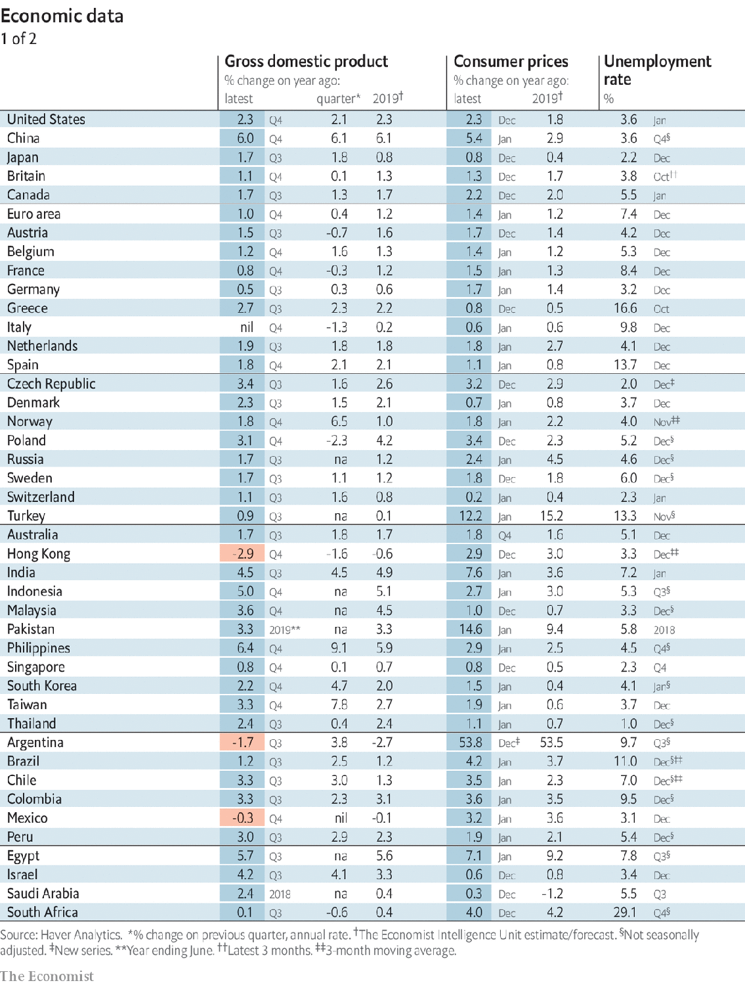

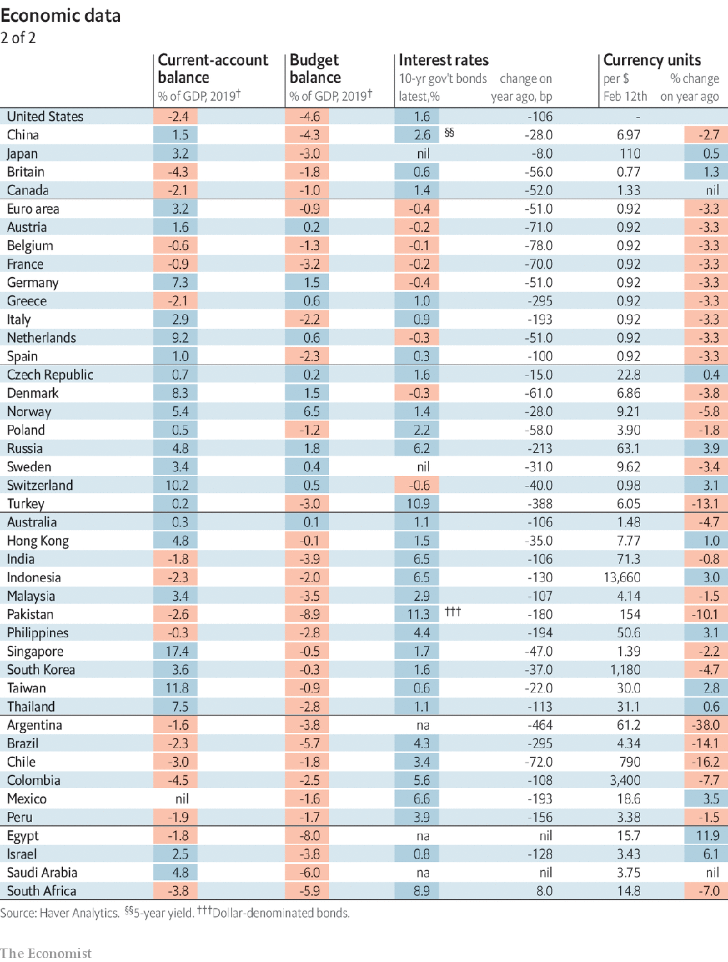

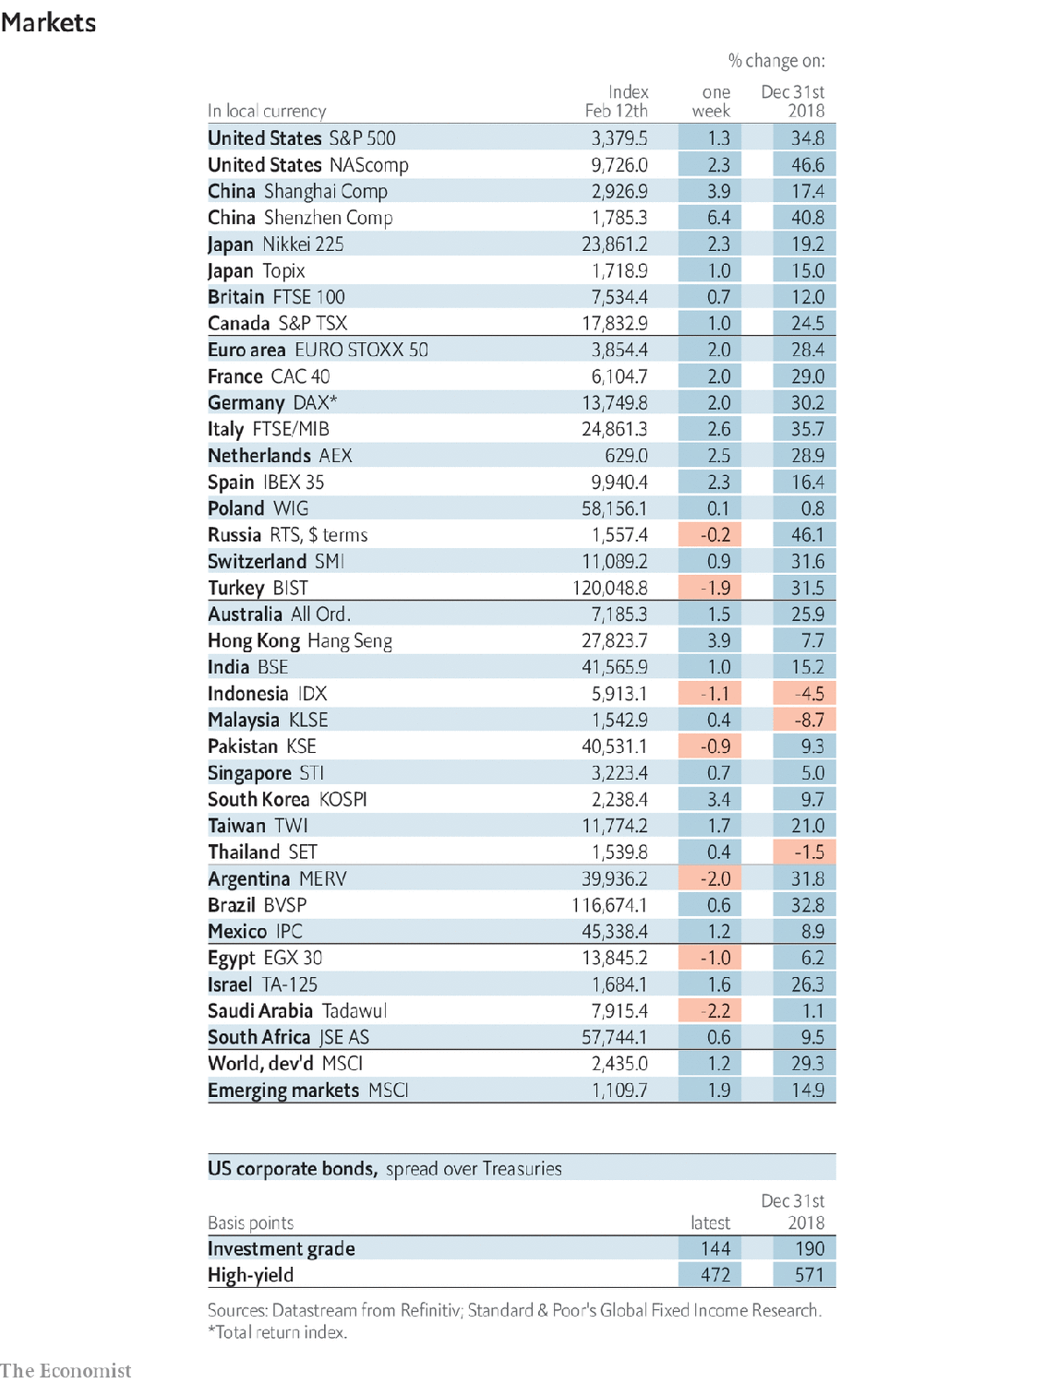

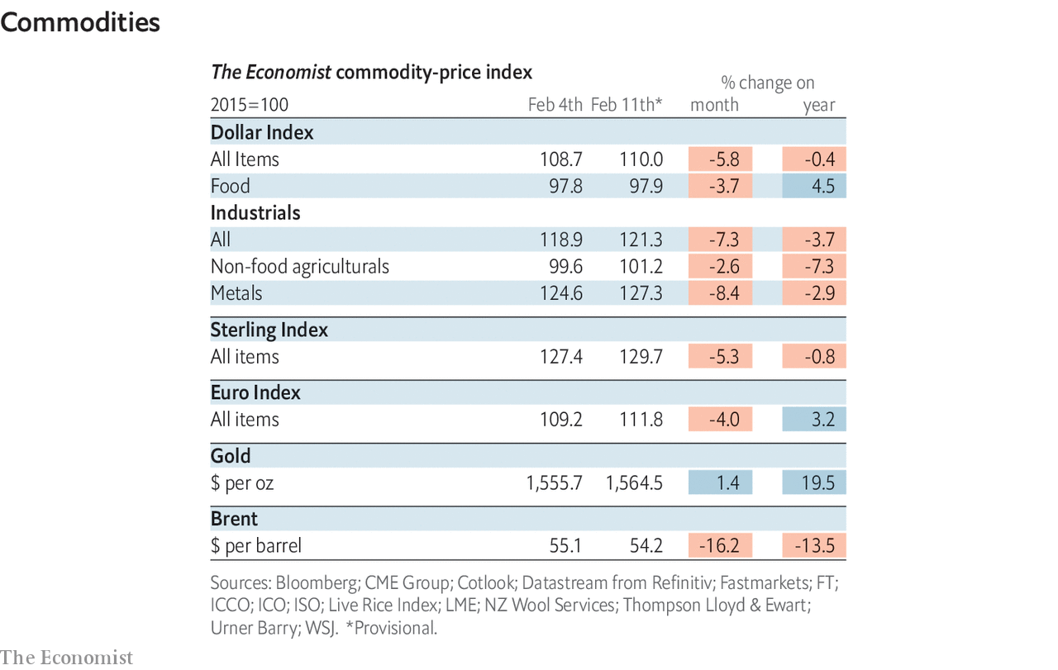

This article was downloaded by calibre from <https://www.economist.com/economic-and-financial-indicators/2020/02/15/economic-data-commodities-and-markets>

|  |  |  |  |
| --- | --- | --- | --- |
|  | Articles | Sections | Next |

|  |  |  |
| --- | --- | --- |
| Economic and ... | Sections | Obituary |

Graphic detail

Behavioural finance: Price and prejudice

.

|  |  |  |
| --- | --- | --- |
| Economic and ... | Sections | Obituary |

|  |  |  |  |
| --- | --- | --- | --- |
|  | Articles | Sections | Next |

#### Price and prejudice

# Analysts’ stock recommendations are coloured by their cultural biases

This is especially true when they evaluate firms named after their country of domicile

Feb 15th 2020 |

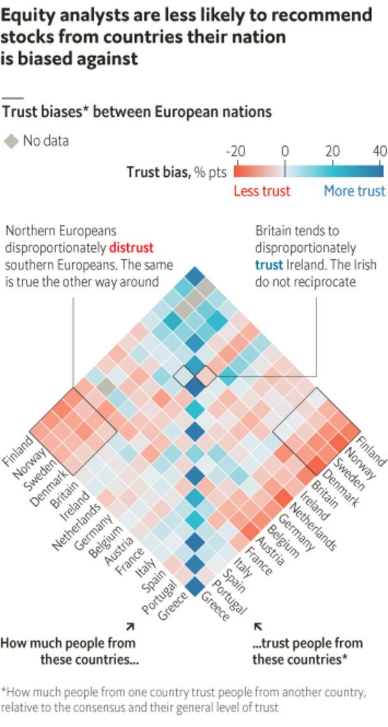

THE “SELL-SIDE” equity analysts who work for investment banks are often accused of being less than completely objective. Because they need to maintain close ties with the companies they cover, they may be too eager to accept managers’ rosy earnings projections. They might also feel pressure to talk up a firm’s prospects because their banks stand to profit from underwriting fees. But professional and economic incentives are not the only possible sources of bias. A new working paper by Vesa Pursiainen of the University of Hong Kong argues that sell-side analysts are also swayed by national prejudices.

The study makes use of a survey conducted by Eurobarometer, which asked residents of 15 European countries how much they thought people of particular nationalities could be trusted. Unsurprisingly, people said they had the most faith in their compatriots. The data also reveal that bilateral trust varies greatly by region. Whereas most Europeans polled tend to see those from the north of the continent as more trustworthy, southern Europeans stand out by considering their fellow Mediterraneans to be the most reliable.

By comparing these levels of bilateral trust across countries, Mr Pursiainen developed a measure of “trust bias”. Finns, for example, show a trust bias against Italians. They do not merely distrust Italians more than they distrust other nations (a view shared by many) but distrust them more than other Europeans do.

Mr Pursiainen then matched these numbers with a database of 1.3m sell-side recommendations issued between 1996 and 2018. He concludes that trust bias is a good predictor of how analysts rate particular stocks. Eurobarometer’s data show that Norwegians are disproportionately likely to trust people from Denmark and Britain. Accordingly, Mr Pursiainen finds that Norwegian analysts, as identified by their surnames, are 8.4 percentage points more likely to recommend Danish stocks than Austrian analysts are, and 6.7 percentage points more likely to recommend British firms than French analysts are. This effect seems to be especially strong in the cases of companies whose names contain the names of their home countries (such as Deutsche Bank).

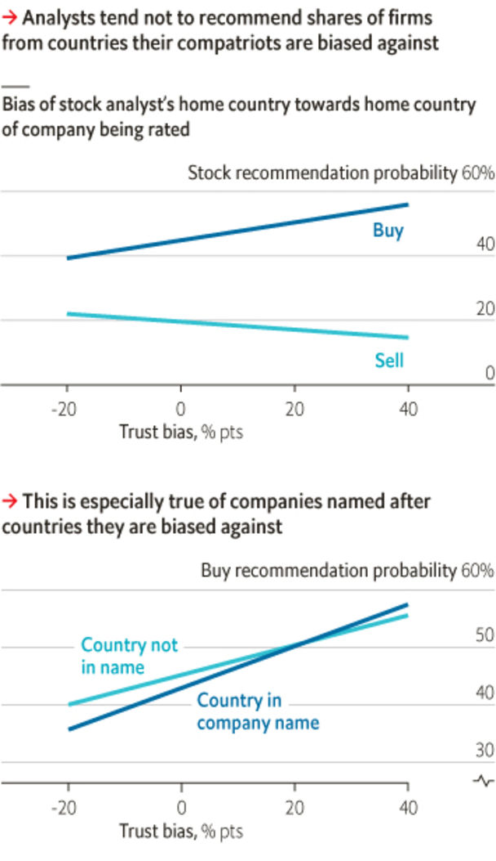

In theory, such a pattern might arise because analysts tend to be better informed about firms based in nearby countries. Yet the study finds that even after accounting for distance, trust bias still seems to influence analysts’ opinions on shares.

The power of trust bias appears to be strongest in times of political or economic turmoil. During the euro zone’s sovereign-debt squeeze in 2011-13, analysts from northern Europe became far more bearish on southern European stocks than their Mediterranean peers were. Ever since their country voted to leave the EU, British analysts have become much more optimistic about domestic firms’ prospects, relative to analysts from the continent.

It is unclear whether analysts are aware of the bias in their recommendations. They may think that a firm’s nationality does not affect their judgment, or that they are correctly accounting for the context in which a company operates. Alternatively, they might be pandering to their audience. As Greece defaulted on bonds held in spades by German entities, it would have taken a brave German analyst to endorse Greek shares. In any case, it is another reason to be cautious about sell-side analysis. ■

Source: “Cultural Biases in Equity Analysis”, by V. Pursiainen, 2020

This article was downloaded by calibre from <https://www.economist.com/graphic-detail/2020/02/15/analysts-stock-recommendations-are-coloured-by-their-cultural-biases>

|  |  |  |  |
| --- | --- | --- | --- |
|  | Articles | Sections | Next |

|  |  |  |
| --- | --- | --- |
| Graphic detail | Sections |  |

Obituary

Li Wenliang: The man who knew

.

|  |  |  |
| --- | --- | --- |
| Graphic detail | Sections |  |

|  |  |  |  |
| --- | --- | --- | --- |
|  | Articles | Sections | Next |

#### The man who knew

# Li Wenliang died on February 7th

The doctor who was one of the first to warn of a new coronavirus was 33

Feb 15th 2020 |

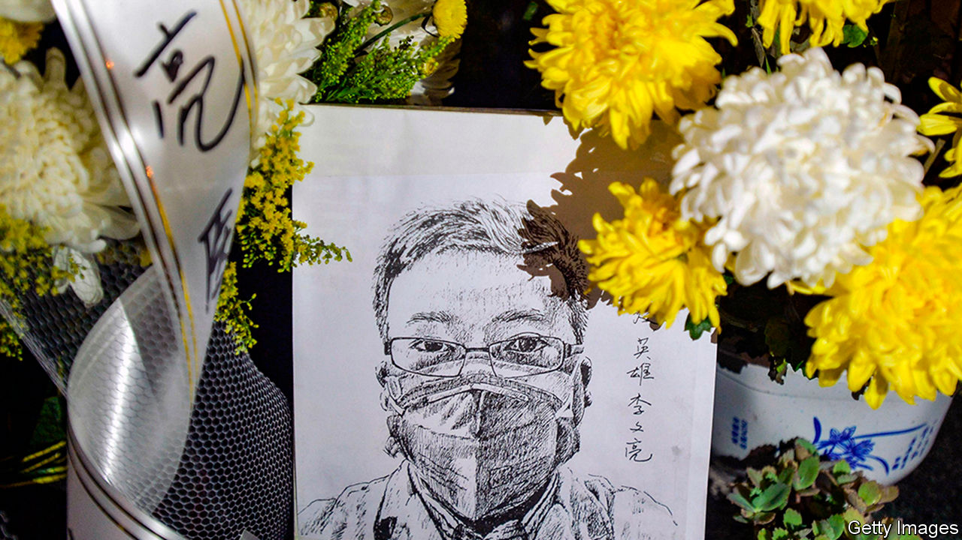

BUSY THOUGH he was as an ophthalmologist at Wuhan Central hospital, rushed off his feet, Li Wenliang never missed a chance to chat about his favourite things on Weibo. Food, in particular. Japanese food with lashings of wasabi, plates of steaming beef noodles, the Haidilao hotpot restaurants that had kept him going when he spent three years in Xiamen just after his medical training—and fried chicken. The drumsticks at the railway station were the best, and he never missed a chance to grab some when he was there; but then the chicken at Dicos fast-food was so delicious that he just had to compliment the chef. A big basket of that, washed down with a Coke, was the peak of his existence.

As a result he got chubby, and as a result of that he tried to do sport, but apart from a bit of badminton early on he mostly exercised by live-streaming snooker, commenting live on Weibo and energetically querying the ref’s decisions. So, though he had once been slim and was still fairly good-looking, he had strayed far away from the willowy baby-faced look of Xiao Zhan, the boy-band actor whose music he loved. But he was a husband now and a father, secure in a stable profession, a man of weight. That had been his aim since his schooldays, when he decided to leave industrial Liaoning in the north-east, where his parents were unemployed, and go to college in the south. At Wuhan Central the pay was bad and the hours punishing, but as long as his patients were satisfied, he was happy. Egg pancakes (that wonderful dopamine hit on his tongue!) got him through the grim night shifts.

Since he shared every passing observation online, it was not surprising that on December 30th he put up a post about an odd cluster of pneumonia cases at the hospital. They were unexplained, but the patients were in quarantine, and they had all worked in the same place, the pungent litter-strewn warren of stalls that made up the local seafood market. Immediately this looked like person-to-person transmission to him, even if it might have come initially from bats, or some other delicacy. Immediately, too, it raised the spectre of the SARS virus of 2002-03 which had killed more than 700 people. He therefore decided to warn his private WeChat group, all fellow alumni from Wuhan University, to take precautions. He headed the post: “Seven cases of sARS in the Huanan Wholesale Seafood Market”. That was his mistake.

The trouble was that he did not know whether it was actually SARS. He had posted it too fast. In an hour he corrected it, explaining that although it was a coronavirus, like SARS, it had not been identified yet. But to his horror he was too late: his first post had already gone viral, with his name and occupation undeleted, so that in the middle of the night he was called in for a dressing down at the hospital, and January 3rd he was summoned to the police station. There he was accused of spreading rumours and subverting the social order. He then had to give written answers to two questions: in future, could he stop his illegal activities? “I can,” he wrote, and put his thumbprint, in red ink, on his answer. Did he understand that if he went on, he would be punished under the law? “I understand,” he wrote, and supplied another thumbprint.

His birthday resolution, posted on Weibo, had been to be a simple person, refusing to let the world’s complications bother him. So much for that. At least he had not been detained, which would have consumed his family with worry. At least his licence to practise had not been revoked. In fact, he had not even been fined. Yet why should he have been? He had been right to raise the alarm. The authorities were still denying that there was human-to-human transmission, and that was just wrong. He had spoken out before, when two trains had crashed in Wenzhou in 2011 with 40 deaths, demanding on Weibo the reinstatement of a journalist who had been sacked for asking about lack of safety on the line. The truth mattered. Public safety mattered. Public power should not be used for excessive interference. In this turmoil, though silent as promised, he went back to work, and then he was careless again.

On January 8th an 82-year-old patient presented with acute angle-closure glaucoma and, because she had no fever, he treated her without a mask. She too turned out to run a stall in the market, and she had other odd symptoms, including loss of appetite and pulmonary lesions suggesting viral pneumonia. It was the new virus, and by January 10th he had begun to cough. The next day he put an N95 mask on. Not wanting to infect the family, he sent them to his in-laws 200 miles away, and checked into a hotel. He was soon back in the hospital, this time in an isolation ward. On February 1st a nucleic-acid test showed positive for the new coronavirus. Well, that’s it then, confirmed, he wrote on Weibo from his bed.

He was an optimistic sort. Though the household finances were pretty stretched, he felt sure he would win the big prize in the online lucky grab-bag run by Luo Yonghao, the founder of the Smartisan tech company (whose products he much coveted), and got that same lucky feeling when he tried to win a pair of AirPods Pro, though he ended up with neither. When it came to this new virus, though it might take him half a month to regain full lung function, he would soon be back on the front line fighting. After all, he was the man who in 2012—when the world had been supposed to end—had announced on Weibo that he was going to save it. (“Though if the sun rises as usual…don’t thank me. I’m just doing my duty.”)

His fame had spread far and wide, too. Reporters, even from the New York Times, wanted interviews. These had to be done by text and via WeChat, since from late January he could not breathe on his own and was hooked up to continuous-flow oxygen. It didn’t help as much as he expected—his blood-oxygen saturation levels got no better. But online he could go on making defiant and upbeat remarks. There had to be more transparency. The truth was important. A healthy society should never have just one voice. And to the young woman reporter who wanted a selfie of him (as if he was Xiao Zhan, ever perfectly groomed, cute and slim), he sent an apology along with the photo of his masked, tubed and haunted face: sorry, he hadn’t washed his hair for a while. ■

This article was downloaded by calibre from <https://www.economist.com/obituary/2020/02/15/li-wenliang-died-on-february-7th>

|  |  |  |  |
| --- | --- | --- | --- |
|  | Articles | Sections | Next |